BRANDI CARLILE PERFORMS “RIGHT ON TIME” AT 64TH ANNUAL GRAMMY AWARDS
“BEYOND THESE SILENT DAYS” HEADLINE TOUR CONFIRMED
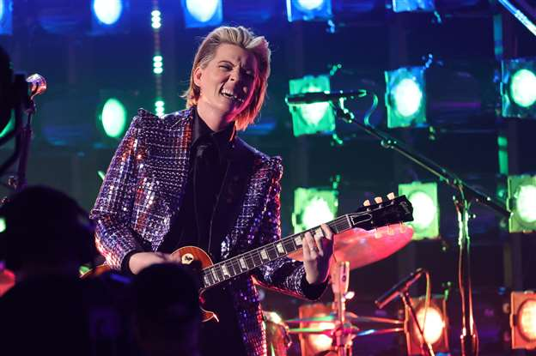
Photo credit: Getty for The Recording Academy
April 5, 2022—Six-time Grammy Award-winning singer, songwriter, performer, producer and New York Times Best Selling author Brandi Carlile performed her song, “Right On Time,” during the 64th Annual GRAMMY Awards, where she was also nominated for five awards. Watch/share HERE.
The performance adds to yet another monumental year for Carlile, who will return to the road this summer with her extensive “Beyond These Silent Days” headline tour. Upcoming stops include Los Angeles’ Greek Theatre (two nights), Nashville’s Ascend Amphitheater (two nights), Santa Barbara Bowl, Austin’s Moody Amphitheater, Chicago’s Huntington Bank Pavilion at Northerly Island, Colorado’s Red Rocks Amphitheatre (two nights) and New York’s Madison Square Garden among many others. Special guests featured on the tour include Allison Russell, Ani DiFranco, Brittany Howard, Celisse, Indigo Girls, Katie Pruitt, Lake Street Dive, Lucius, Sarah McLachlan, Brittney Spencer, Tanya Tucker and Yola, with additional names to be announced. See below for complete itinerary. Full details can be found at www.brandicarlile.com.
The upcoming tour further celebrates the release of Carlile’s acclaimed #1 new album, In These Silent Days, which is out now via Low Country Sound/Elektra Records (stream/purchase here). In the months since the release, Carlile made her made her debut as the musical guest on NBC’s “Saturday Night Live” (performing “Broken Horses” and “Right On Time”), returned to “The Ellen DeGeneres Show” to guest host and debut “You And Me On The Rock,” and debuted “This Time Tomorrow” on “The Late Show with Stephen Colbert.” Additionally, this past November, Carlile performed Mitchell’s legendary album Blue in its entirety at Carnegie Hall. Of the sold-out performance, Billboard proclaims, “an extraordinary concert…who better to take on this homage but Carlile, who has taken up Mitchell’s still brightly burning torch, as one of the finest songwriters and singers of this era.”
Produced by Dave Cobb and Shooter Jennings, In These Silent Days was inspired by the mining of Carlile’s own history while writing last year’s #1 New York Times Best Selling memoir, Broken Horses (Crown), which will be released in paperback on April 12. Conceived of while she was quarantined at home with longtime collaborators and bandmates Tim and Phil Hanseroth, the ten songs chronicle acceptance, faith, loss and love, and channel icons like David Bowie, Freddie Mercury, Elton John and Joni Mitchell—the latter two who, by some sort of cosmic alignment of the stars, have turned out to be close friends in addition to being her biggest heroes and inspirations.
Of the album, Variety praises, “Carlile effortlessly glides between octaves while, somehow, still sounding completely conversational—the everyday diva we didn’t know we needed until she showed up at our door…a vocal tour de force,” while Billboard asserts, “the emotion that Carlile projects is unbridled, unfettered joy in the face of hard times—and it’s the exact boost of positivity that will make you want to listen again and again” and Vulture declares, ““one of the biggest voices in the genre.” The album also appeared on “Best of 2021” lists at NPR Music, Variety, Rolling Stone, Billboard, Entertainment Weekly, SPIN, USA Today, Stereogum and many more.
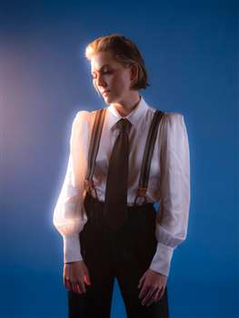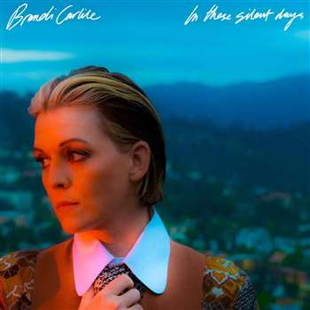
photo credit: Neil Krug // album artwork
In These Silent Days follows Carlile’s 2018 breakthrough GRAMMY Award-winning album, By The Way, I Forgive You, which Rolling Stone declared, “…an Adele-meets Joni Mitchell tour de force.” In the years since—in addition to collaborative projects with Elton John, The Highwomen, Tanya Tucker, Soundgarden, Alicia Keys, Dolly Parton, Barry Gibb, Leslie Jordan, Brandy Clark and more—she has earned six Grammy Awards recognizing her work as a performer, songwriter and producer, was awarded Billboard’s Women In Music “Trailblazer Award,” CMT’s Next Women of Country “Impact Award” and received multiple recognitions from the Americana Music Association Honors & Awards including 2021’s Artist of the Year, 2020’s Album of the Year (Highwomen), Group of the Year (The Highwomen) and Song of the Year (“Crowded Table”) and 2019’s Artist of the Year. Moreover, the audiobook version of Carlile’s memoir was recently highlighted as one of Libro.fm’s top 10 bestselling audiobooks of 2021.
In addition to their work as a band, Carlile and the Hanseroth twins remain committed to social activism and advocacy. Together they are founders of the Looking Out Foundation, which amplifies the impact of music by empowering those without a voice with varied initiatives including campaigns focused on Children in Conflict/War Child, The IF Project, Fund Racial Justice and more. To date, they have raised over $3 million for grassroots causes.
IN THESE SILENT DAYS TRACKLIST
1. Right On Time
2. You And Me On The Rock
3. This Time Tomorrow
4. Broken Horses
5. Letter To The Past
6. Mama Werewolf
7. When You’re Wrong
8. Stay Gentle
9. Sinners Saints And Fools
10.Throwing Good After Bad
BRANDI CARLILE CONFIRMED TOUR DATES
April 22—Miramar Beach, FL—Moon Crush 2022
April 29—Indio, CA—Stagecoach Music Festival
June 11—George, WA—Gorge Amphitheatre*
June 18—Berkeley, CA—The Greek Theatre at UC Berkeley
June 21—Santa Barbara, CA—Santa Barbara Bowl
June 24—Los Angeles, CA—The Greek Theatre†
June 25—Los Angeles, CA—The Greek Theatre=
July 6—Kansas City, MO—Starlight Theatre×
July 8—Nashville, TN—Ascend Amphitheatre‡
July 9—Nashville, TN—Ascend Amphitheatre‡
July 15—Austin, TX—Moody Amphitheater
July 16—Dallas, TX—Dos Equis Pavilion
July 30—St. Paul, MN—Xcel Energy Center+
August 5—Milwaukee, WI—Fiserv Forum¤
August 6—Chicago, IL—Huntington Bank Pavilion at Northerly Island#
August 11—Salt Lake City, UT—Vivint Smart Home Arena
August 18—Columbia, MD—Merriweather Post Pavilion§
August 19—Bethel, NY—Bethel Woods Center for the Arts
August 20—Philadelphia, PA—TD Pavilion at The Mann**
August 30—Lenox, MA—Tanglewood††
August 31—Portland, ME—Thompson’s Point††
September 9—Morrison, CO—Red Rocks Amphitheatre~
September 10—Morrison, CO—Red Rocks Amphitheatre§
September 25—Bridgeport, CT—Sound on Sound Festival
October 21—Boston, MA—TD Garden^
October 22—New York, NY—Madison Square Garden^
*with special guests Sarah McLachlan and Lucius and featuring Celisse
†with special guest Lucius
=with special guest Celisse
×with special guest Katie Pruitt and more to be announced
‡with special guests Indigo Girls and Celisse and featuring Lucius
+with special guests Lake Street Dive and Celisse
¤with special guest Lake Street Dive and more to be announced
#with special guests Ani DiFranco and Celisse
§with special guests Indigo Girls and Allison Russell
**with special guest Allison Russell and more to be announced
††with special guest Indigo Girls
~with special guests Lucius and Allison Russell
^with special guest Brittany Howard

www.brandicarlile.com
FOR MORE INFORMATION, PLEASE CONTACT
ASHA GOODMAN 615.320.7753 OR CARLA SACKS 212.741.1000 AT SACKS & CO., ASHA.GOODMAN@SACKSCO.COM OR CARLA@SACKSCO.COM.

