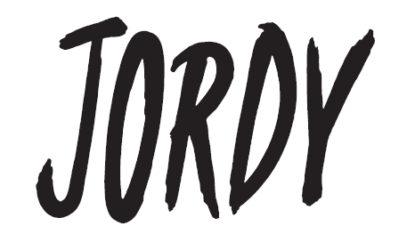
JORDY RELEASES NEW SINGLE “IDK SH!T”
AHEAD OF LOLLAPALOOZA DEBUT THIS WEEKEND
LISTEN HERE | WATCH THE COMPANION MUSIC VIDEO TO FIND OUT “WHICH JORDY ARE YOU?”
CREDIT: LAUREN NIEVES
DOWNLOAD HI-RES IMAGE HERE | ADDITIONAL PHOTOS HERE
“Rising pop sensation” –CONSEQUENCE OF SOUND
“…undeniably joyful pop” –TIME
“…fresh, angel-voiced” –VMAN
“…a sugar-sweet jolt of dopamine to the system” –BILLBOARD
“The vulnerable pop singer we can’t help but fall for” –PRIDE.COM
(July 28, 2022) – LOS ANGELES, CA – Rising pop artist JORDY has released his new single “IDK SH!T,” available now on all streaming platforms. Chronicling the challenges of young adulthood during his twenties, the offering is a bubbly, diaristic pop track showcasing JORDY’s impressive falsetto and knack at crafting anthemic hooks. Produced by frequent collaborator Drew Polovick, the song arrives just in time for JORDY’s hometown debut at Lollapalooza Festival in Chicago this weekend, where he will be playing two performances on Thursday, 7/28 (6:30pm @ Bud Light Seltzer Stage) and Friday, 7/29 (12:45pm @ T-Mobile Stage). The accompanying “IDK SH!T” music video is also out today. Directed by Queerty Award-winning filmmaker Assaad Yacoub, it features various JORDY characters on a dating show, prompting fans to ask, “Which JORDY are you?”
“I remember being a kid and thinking about what it would be like to be an adult: The freedoms, the knowledge, and the experience. Everything about it sounded so cool, but here we are, three years away from turning 30 and I still feel like a child,” JORDY explained about the song’s inspiration. “I feel like life lately has been cycles of calling my parents begging for answers: How do taxes work? How do you jump start a car? Should I be further ahead in my career? How do I find love? The list goes on, but sometimes, they don’t even have the answers. I want to normalize this feeling of not having it ‘together’ because truthfully, nobody fully does. It’s important to remember that in moments when you’re being hard on yourself,” he added.
Mining inspiration from pop staples such as The Spice Girls, Michelle Branch, Avril Lavigne, and contemporaries such as Troye Sivan and Lauv, JORDY’s songs blend the glimmering, bouncy 90s pop sound with sincere, vulnerable, and conversational songwriting. He unveiled his debut album Mind Games in November 2021, along with a companion acoustic EP in February, and Pride anthem “Dry Spell” earlier this summer, which Teen Vogue called “a bright new single… made for the dance floor,” while Billboard lauded it “one of his best produced tracks to date.”
JORDY’s heart-on-his-sleeve approach to modern pop music has resonated with fans nationwide, resulting in 100M+ career streams, sold out shows across the U.S., and a devoted following on TikTok with his 2021 dance-pop hit “Long Distance” that went viral on the platform in 2021. JORDY delivered a stellar performance of the track during his national television debut on The TODAY Show, and earlier this year, he nabbed a nomination at the iHeartRadio Music Awards in the “Social Star” category.
JORDY is in the studio working on his sophomore project, with more details to be revealed soon.
JORDY
“IDK SH!T”
AVAILABLE HERE
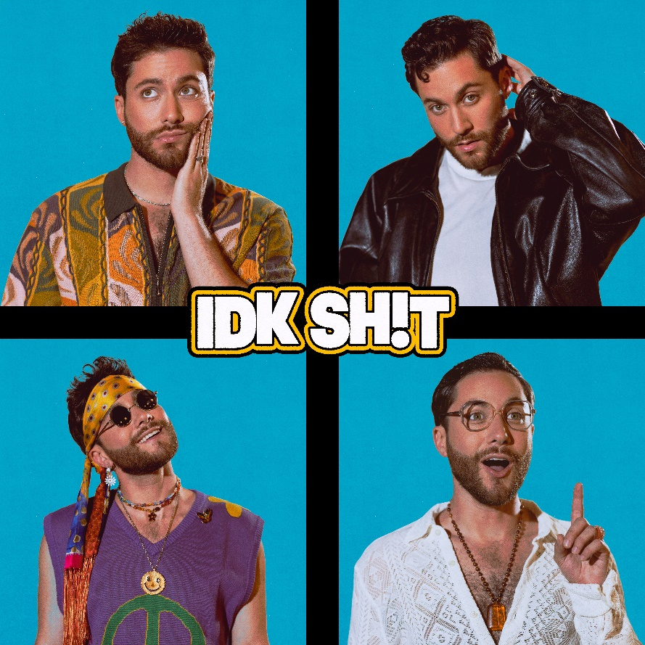
HI-RES ARTWORK HERE
FOLLOW JORDY:
WEBSITE | INSTAGRAM | TWITTER | TIKTOK | FACEBOOK
# # #
MEDIA CONTACT:
Nathalie Rubin
Nathalie.Rubin@300Elektra.com

