Jeris Johnson Releases a New Track Exclusively on Amazon
“Heal”
LISTEN HERE
+Gearing Up For Forthcoming EP+
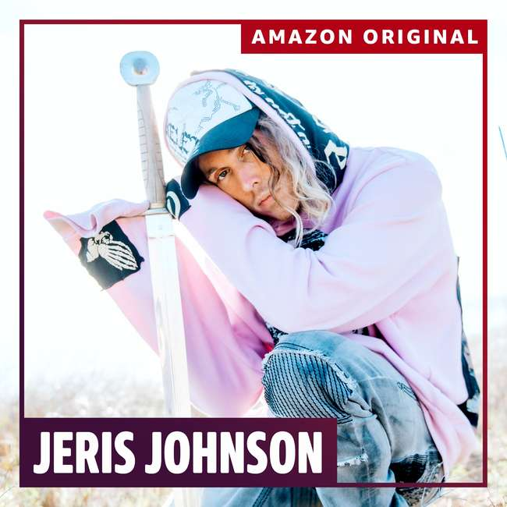
July 1, 2022 – Today, Jeris Johnson unveils an Amazon original track "Heal." The track was originally teased over three years ago when Jeris was getting his start on TikTok. After getting early interest from Amazon, Jeris scoured his archives and jumped on the chance to finalize "Heal." While the verse vocals are re-recorded, the chorus vocals stem from the three-year-old original.
"The lyrics sound like they are about a person or relationship, but they are actually about my own healing journey and what I went through with my health... My producer cried after we made the ending to the song. It felt like it represented a new benchmark for the quality of our songs." - Jeris Johnson
"Heal" comes in the wake of Jeris and ZillaKami's track "Raining Blood." Between the mosh-pit guitar stylings, and Jeris’ infectious vocals, “Raining Blood” is an enthralling medley of calculated chaos.
Additionally, Jeris will be hitting the road with iconic artists Korn, Evanescence, and Helmet from August 16 through August 28. Buy tickets and check out Jeris’ full list of tour dates HERE.
In 2021 Jeris unveiled his first full length project, EP, My Sword, followed by his debut album I WANT BLOOD/i want love. The album encapsulates the two dueling sides of Jeris; ‘blood’ and ‘love’. On one hand, Jeris is a crooning soul searching for the loves of his life. On the other hand, he is brandishing his sword as he chases, in his own words, “blood and money.” The Blood|Love dichotomy is ever-present in I WANT BLOOD/i want love and allows fans to enter the universe of Jeris Johnson. The 11 track-album explores, questions, and dissects what it means to have two internal opposing sides in constant battle.
With 240 million global streams, Jeris is headed full force into this new era and bringing ‘future grunge’ with him.
about Jeris Johnson
With a devout cult following on TikTok, Jeris picked up traction on the platform following the success of perfected reworks of classic tracks. Putting his trap flair on iconic hits and accumulating millions of views, he caught the eyes and ears of the critically acclaimed groups themselves. In 2020, Jeris released his single, “Sticks and Stones”, followed by his TikTok viral single “damn!”, which reached critical acclaim. Chad Kroeger of Nickelback then hopped on the track for a remix after playful banter with Jeris via TikTok. Fans were quick to find a similarity in the two so the artists came together for the “damn!” remix. From there on, Jeris covered Papa Roach's "Last Resort" and formed a fast-friendship with the group. Celebrating the 20th anniversary of certified triple platinum hit "Last Resort," Jeris Johnson & Papa Roach united to breathe new life into an iconic track, with “Last Resort (Reloaded)”. The track quickly made its way to #1 on both the Rock iTunes Chart and the Billboard Hard Rock Chart. It continued to be a busy year for Jeris as he then unveiled My Sword, his debut EP, and a slew of music videos all in a couple months time. The burgeoning star also released "Can You Feel My Heart" with Bring Me The Horizon. Adding to an extensive catalog of hard-hitting tracks, Jeris then welcomed Trippie Redd to the list of acclaimed collaborations / friendships under his belt with “Friday”. Jeris Johnson is breaking into unchartered territory as he redefines genres, pushes boundaries, and creates a whole new sonic wave [coined 'future grunge']. Now, Jeris is excited to show fans his brand new body of work I WANT BLOOD/i want love, out now.
follow Jeris Johnson:
TikTok | Instagram | Twitter

# # #
MEDIA CONTACT:
Koko Black
koko.black@300elektra.com

