Quarters of Change Release New Single “Dead” & Announce Debut Album Into the Rift

LISTEN HERE / WATCH HERE
PRE-SAVE INTO THE RIFT HERE
+contributions from legendary producer Tom Lord-Alge+
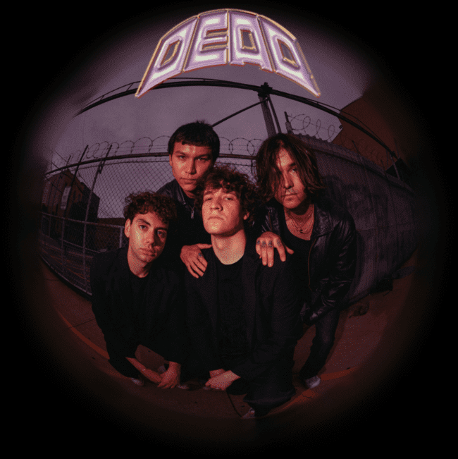
Photo Credit: Josefine Cardoni

New York, NY (July 1, 2022) – Today, Lower East Side quartet Quarters of Change unveil a new single "Dead." Arriving as the fourth single from their upcoming debut album Into The Rift, the breakout rockers have seen an exponential rise in all areas, including a 350% increase in streaming consumption year-to-date.
The versatile track meshes an upbeat melodic chorus with Quarters of Change's quintessential shredding guitar, complete with emotional lyrics that encapsulate the contrived chaos that is "Dead."
"The famous saying goes ‘lead us not into temptation’ - but we’re only human, and sometimes we go without being led. “Dead” is about the way we feel after knowingly choosing the wrong path - everything’s dead. And we thought it’d be ironic to put such a heavy lyric over a dance-y instrumental. It’s almost a nod to the detachment of it all. Maybe that’s why it works? Maybe that’s why you like it?” - Ben Roter"
Additionally, Quarters of Change officially announce their debut album, Into The Rift, is arriving on July 29 - pre-save HERE. Featuring nine electric tracks, Quarters of Change solidify their ability to rock into the future by going beyond the typical conventions and traditional boundaries of genre.
Get a sneak peak of the album and catch Quarters of Change's undeniable stage presence at an upcoming live performance - check out a full list of tour dates HERE.
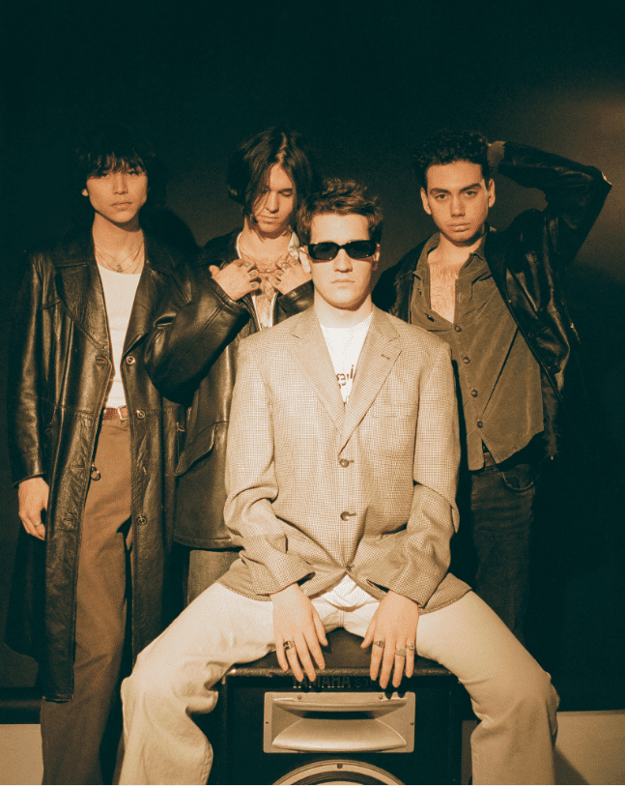
ABOUT QUARTERS OF CHANGE
Quarters of Change is the Lower-East-Side quartet leading the charge on New York City’s rock resurgence, and redefining what it means to be a rock star.
Composed of Ben Acker, Attila Anrather, Jasper Harris, and Ben Roter, Quarters of Change started in 2017 as a high school cover band, performing iconic rock songs of the 90s and 00s. It wasn’t until their junior year that they began writing original material, pulling influence from groups like The Strokes and Rage Against The Machine, and creating their own original sound. Within a year, the band had signed a deal with Warner/300 Entertainment, released streaming favorites like “Kiwi," and played sold out shows at renown venues like Bowery Ballroom and Webster Hall.
Now, armed with a record deal and an undeniable slew of songs, Quarters of Change is poised to be alternative rock’s next big thing. Keep an eye out for their self-written debut LP, Into The Rift, with contributions from legendary producer Tom Lord-Alge, coming Spring 2022.
KEEP UP WITH QUARTERS OF CHANGE
TikTok | Instagram | Twitter

# # #
MEDIA CONTACT:
Koko Black
koko.black@300elektra.com

