CHRISTINA PERRI’S HIGHLY ANTICIPATED NEW ALBUM, A LIGHTER SHADE OF BLUE, OUT NOW!
GET IT HERE

TRIO OF SHOWS TO CELEBRATE ALBUM RELEASE KICKS OFF IN LOS ANGELES TONIGHT

CATCH HER PERFORMANCE ON LIVE WITH KELLY AND RYAN ON JULY 19TH
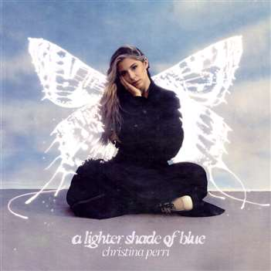

(Los Angeles, CA – July 15th, 2022) Today, multi-platinum singer-songwriter Christina Perri premiered her highly anticipated album, a lighter shade of blue. Get it here! The album has been 8-years in the making with Christina’s last album Head or Heart being released in 2014. The new deeply personal album follows Christina’s healing journey after losing her daughter Rosie. The album features already released tracks, “evergone,” “mothers,” and “home.”

Christina shared, “I am so excited to finally share my third studio album, a lighter shade of blue. It was written and recorded across the last 5 years with so many people I love. These songs were created with emotion and heart and have completely saved me. I hope they help you too.”

Christina also kicks off her trio of shows in Los Angeles, CA tonight to celebrate the release of the album. The intimate shows will see Christina performing the album in its entirety in Los Angeles, CA, New York, NY, and in her hometown of Philadelphia, PA. For all ticket information and more details, please visit www.christinaperri.com.

a lighter shade of blue Tour Dates:
July 15 Hotel Café Los Angeles, CA
July 18 Bowery Ballroom New York, NY
July 20 World Café Live Philadelphia, PA

About Christina Perri
Multi-platinum singer-songwriter Christina Perri has earned critical applause and an increasingly fervent fan following since the arrival of her extraordinary, platinum-certified, 2011 debut, lovestrong, which featured the 6x-platinum certified smash, “Jar of Hearts” and gold-certified “arms.” Perri followed lovestrong. with the worldwide hit single, “A Thousand Years,” exclusively featured on THE TWILIGHT SAGA: BREAKING DAWN – PART 1 & 2– ORIGINAL MOTION PICTURE SOUNDTRACKS. The RIAA diamond certified track was a multi-format radio favorite, and accompanied by an equally popular companion video, now boasting over 2 billion individual views via YouTube alone. HEAD OR HEART, Perri’s acclaimed gold-certified, second album, arrived in 2014, highlighted by the RIAA 3X platinum certified single, “Human.” Perri kicked off 2019 with songs for carmella: sing-a-longs and lullabies, a collection of songs the acclaimed singer-songwriter sang to her daughter everyday, released on Carmella’s first birthday. More recently, Perri released the poignant single “Tiny Victories,” a track she wrote for the HBO documentary FOSTER, which made its premiere in Spring 2019. Most recently, she released songs for rosie in honor of her daughter on what would have been her first birthday. Perri is currently working on her much anticipated, third full length album, a Lighter Shade of Blue. Most recently, Perri released the first tracks from the album including, “evergone” and “mothers.”

###

Elektra Music Group:
Glenn Fukushima
GlennFukushima@elektra.com

