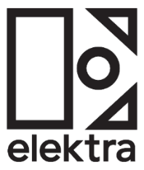
ANNA OF THE NORTH RELEASES "NOBODY"
& ANNOUNCES ALBUM ‘CRAZY LIFE’ ARRIVING NOVEMBER 4
LISTEN HERE
WATCH HERE
ALBUM PRE-SAVE HERE
+ ANNOUNCES NEW PERFORMANCE DATES IN NYC (11.14) & LA (11.16) +
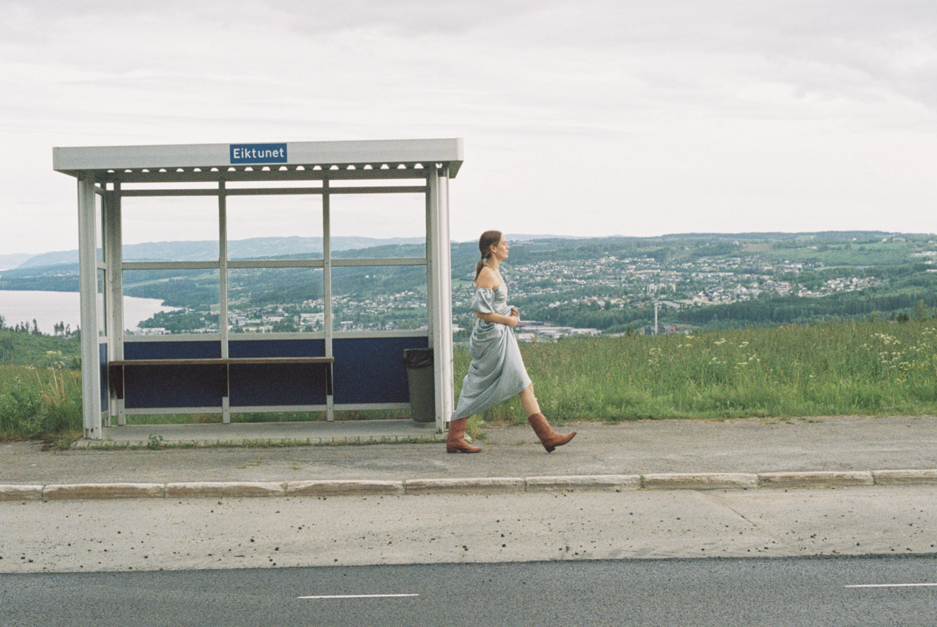
+ PERFORMING AT FIREFLY MUSIC FESTIVAL THIS MONTH +
+ PRIVATE SHOWCASE IN NY (9.22) & LA (9.26) +
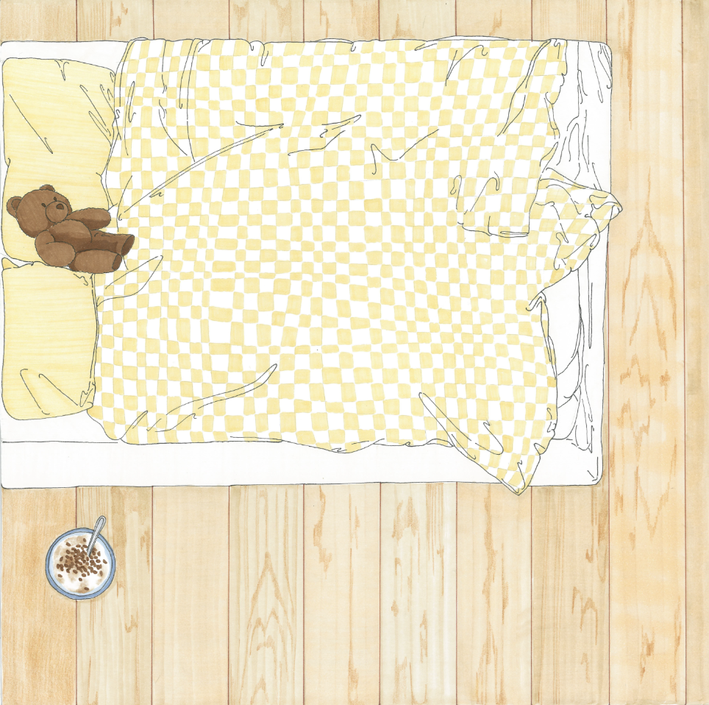
September 22, 2022 – Today, Anna of the North announces the arrival of her third-studio album Crazy Life. Featuring 11 highly anticipated tracks, Crazy Life is an electric body of work displaying the inner workings of Anna of the North’s journey throughout the years. Pre-save the album HERE.
Crazy Life transcends the Norwegian artist’s ability to find comfort in vulnerability by inviting listeners into her world and illustrating exactly how it's done. Uncovering iridescence in mundanity, Anna of the North offers confessional and relatable lyrics with clarity, confidence and a splash of shimmer.
The news is heralded by the release of track “Nobody.” “Nobody” is an anthemic offering from Anna, described as “a feel-good yet melancholic song about missing somebody.” Watch the music video for ”Nobody” HERE.
Joining the ranks of “Bird Sing,” “Dandelion,” and Gus Dapperton collaboration “Meteorite,” the newest addition continues Anna’s journey building a home of her own and inviting you for a visit. While "Dandelion” introduced viewers to Anna’s living room, complete with her fluffy dog and thriving plants, "Bird Sing" captured the image directly outside Anna's bedroom window, giving you a 360- look at Anna's dwelling. “Nobody” gives a stark overview of Anna’s bedroom and the messy bed and leftover cereal that we’ve all been privy to at some point. Working hand in hand with Australian designer Montana Kitching to bring each image ‘to life,’ fans will experience the house in whole on November 4.
Additionally, in celebration of the approaching album release, Anna of the North unveils two intimate performance dates- at Baby’s All Right in New York City on Monday, November 14th and The Moroccan Lounge in Los Angeles on Wednesday, November 16th. Tickets will be available for purchase on Friday, September 23rd.
With 550M+ streams under her belt, co-signs from Tyler, the Creator, Dua Lipa, Alina Baraz, Rejjie Snow, Steve Lazy and more, Anna of the North is the pop star who has been hiding in plain sight.
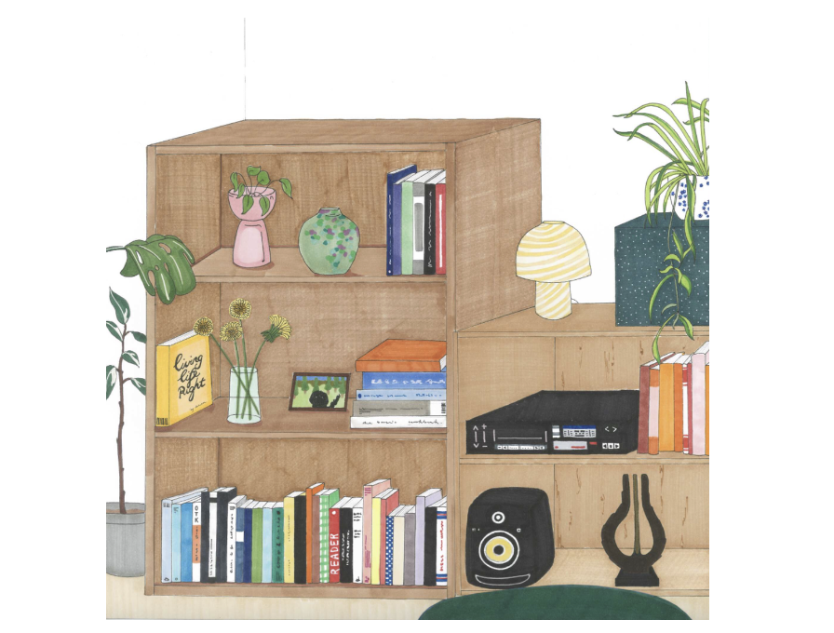
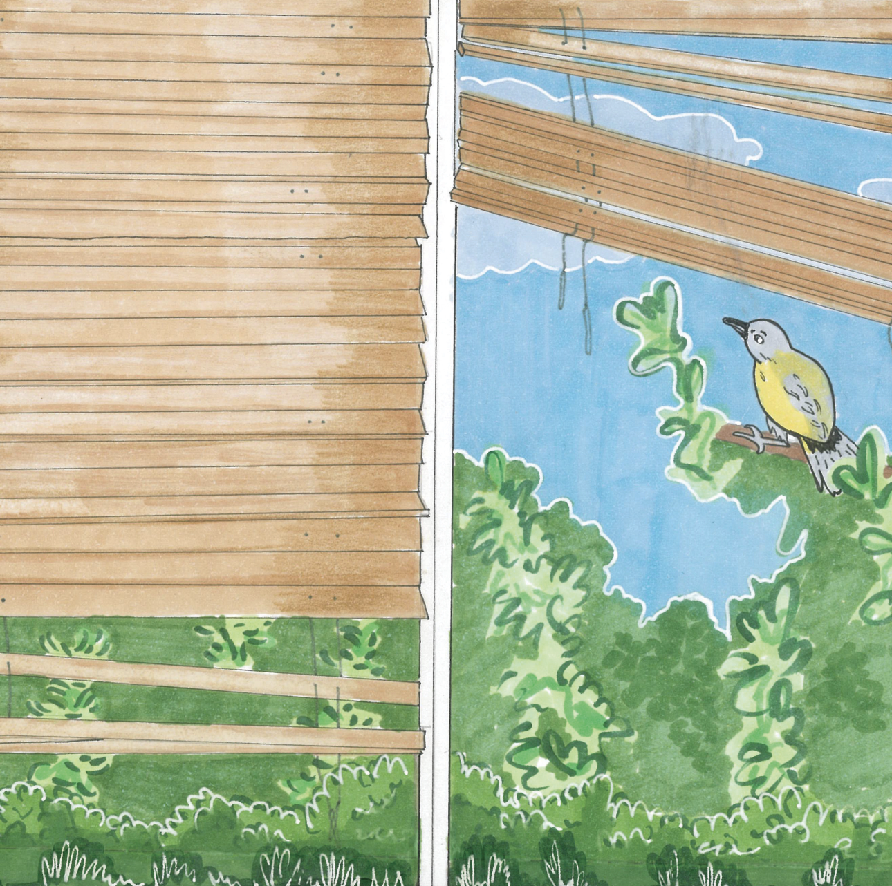

about Anna of the North
Anna of the North strikes an emotional chord regardless of continent, collaborator, or genre and her music has taken on an unexpected life of its own as it finds success in syncs. Anna won a Norwegian Grammy Award (Spellemannprisen) for her music video "Dream Girl," had a track synced to a Global iPad Pro Commercial and joined the reality TV show Hver Gang Vi Mötes. Few modern artists could appear as at home working with Tyler, the Creator (Anna lent her vocals to two tracks on ‘Flower Boy’ alongside Steve Lacy, Frank Ocean, and Rex Orange County) and Rejjie Snow as they are duetting with HONNE or playing with Anderson Paak. All of which has led Anna to where she finds herself in now; a pop star and a fearless young woman who is set to make 2022 her year.

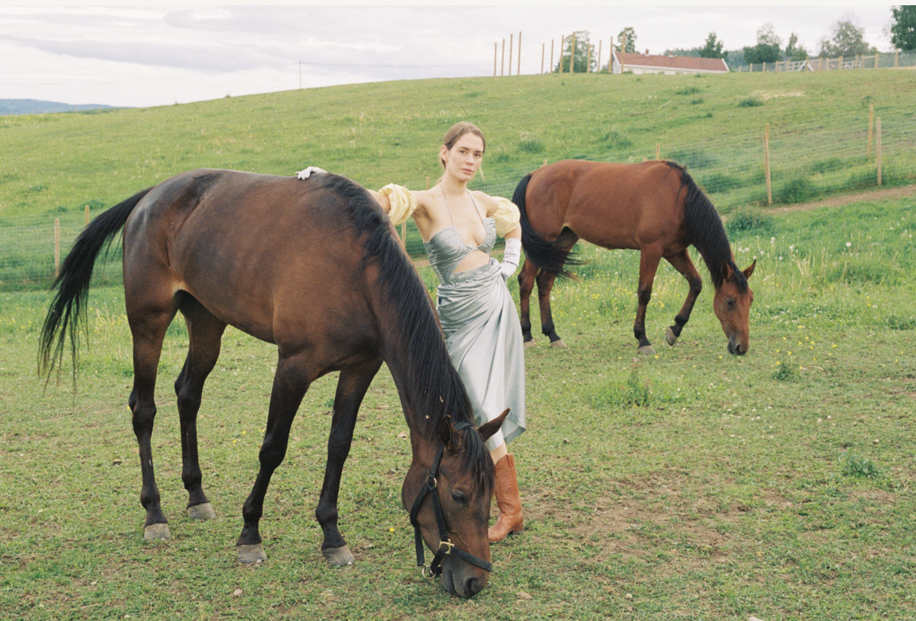
follow Anna of the North:
TikTok | Instagram | YouTube

