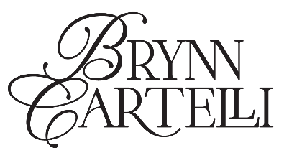
BRYNN CARTELLI UNVEILS ETHEREAL NEW SINGLE
“GIRL CODE”
LISTEN HERE | WATCH THE VISUALIZER HERE
CURRENTLY ON TOUR SUPPORTING ONEREPUBLIC AND NEEDTOBREATHE

MORE NEW MUSIC COMING THIS YEAR
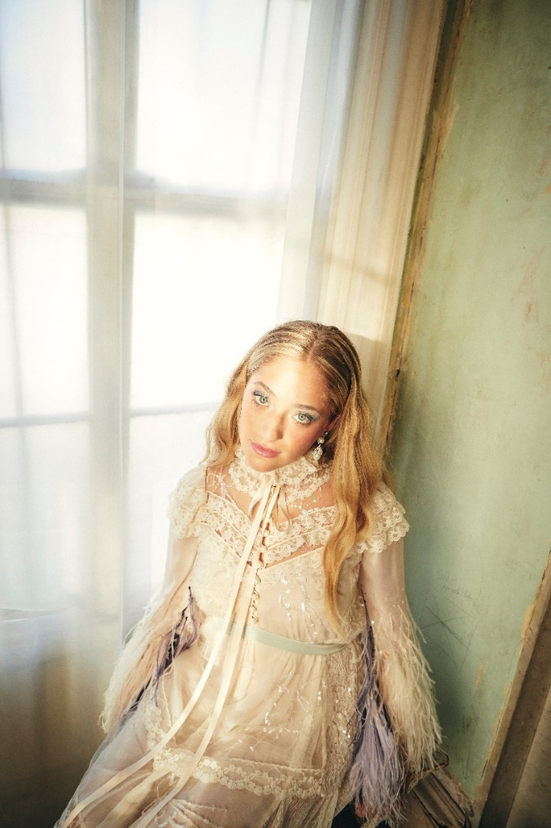
(CREDIT: JIMMY FONTAINE)
DOWNLOAD HI-RES HERE | PRESS ASSETS HERE

“…with a maturity far beyond her years” –PEOPLE

“…marvelous debut” –AMERICAN SONGWRITER
“Cartelli’s voice is wildly impressive” –THE WASHINGTON POST
“The control in Cartelli’s voice is mesmerizing” –ATWOOD MAGAZINE

(August 5, 2022) – LOS ANGELES, CA – Celebrated 19-year-old singer-songwriter Brynn Cartelli today unveiled her ethereal, guitar-driven single “Girl Code.” Written by Cartelli shortly after moving to New York City, the song illustrates the night she met her current boyfriend. Produced by Adam Argyle (Dua Lipa, James Bay), the track is out now on all streaming platforms, with the companion visualizer available to watch HERE.

“I can’t help but write revealing songs about my life, ‘Girl Code’ is a spilled secret about one of my favorite nights in New York City so far,” Cartelli explained.

Flaunting a skyscraping range, undeniable presence, and eloquent songcraft, Cartelli tells relatable stories without filter, but with a whole lot of finesse and fire, as evidenced on her stellar 2021 debut EP Based on a True Story and “Gemini,” her dreamy, first-released single of 2022 and music video directorial debut. In support of the new music, Cartelli is currently on tour supporting OneRepublic and Needtobreathe. Her leg of dates runs throughout the U.S. before wrapping in Salt Lake City on Saturday, August 13. The trek also adds to Cartelli’s impressive touring roster, which includes opening slots for both Kelly Clarkson and Maroon 5. The full itinerary can be found below, with tickets available on her official website.

At age 15, Cartelli’s vocals captivated viewers nationwide when she was crowned the winner of Season 14 of NBC’s The Voice (on Team Kelly) and emerged as the youngest champion in the show’s history. Afterwards, she garnered a nomination at the People’s Choice Awards, captivated audiences with stunning performances on the TODAY Show, Macy’s Thanksgiving Day Parade, The Kelly Clarkson Show, and more. Her fan-favorite track “If I Could” – co-penned with Ben Abraham (Demi Lovato, Sara Bareilles) – has also amassed over 15M+ global streams to date.

Cartelli is currently in the studio working on her next project, slated for release later this year via Elektra Records. More details will be shared soon.

BRYNN CARTELLI
“GIRL CODE”
AVAILABLE HERE
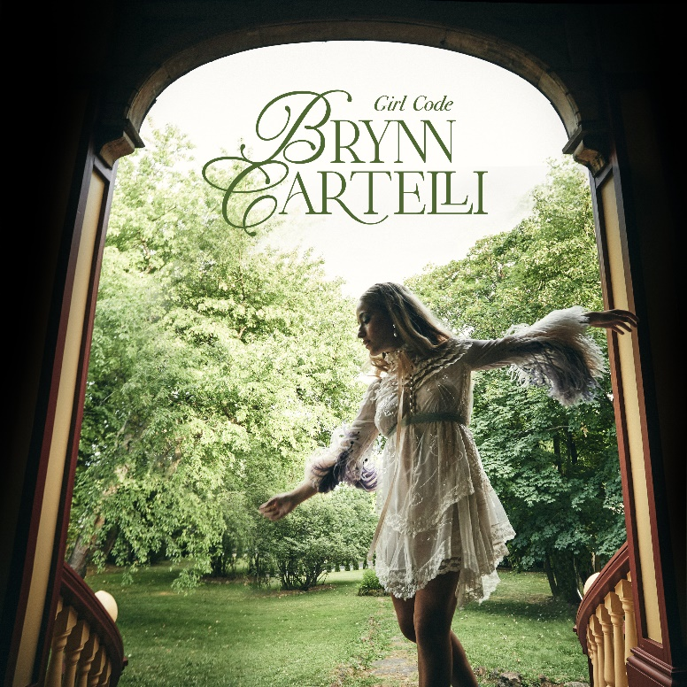
DOWNLOAD HI-RES ARTWORK HERE

ABOUT BRYNN CARTELLI:
At just five-years-old, Cartelli took regular piano lessons, soon learning guitar and developing her chops by performing in talent shows, at coffeehouses, and anywhere else with a stage in her hometown of Longmeadow, Massachusetts. Following her win on The Voice and being crowned the youngest champion in the history of the show, Cartelli returned to her hometown after the surreal experience and became hyperaware of returning to a ‘normal’ life as a teenager. After two years of writing, recording, and honing her craft as a songwriter, Cartelli released her much-anticipated 2021 debut EP Based on a True Story via Elektra Records. Based On a True Story is a snapshot of the time she spent reconnecting with old friends, being observant, and illustrating what youth is about. Across her discography, Cartelli takes seemingly small moments from typical experiences and turns them into candid, anthemic pop ballads that people of all ages can relate to. She is currently in the studio working on new original music for her next project.

BRYNN CARTELLI ON TOUR:
August 5 – Kansas City, MO @ Starlight Theater *
August 6 – Maryland Heights, MO @ Hollywood Casino Amphitheatre *
August 7– Saint Paul, MN @ Xcel Energy Center *
August 9 – Rogers, AR @ Walmart AMP *
August 12 – Denver, CO @ Ball Arena *
August 13 – Salt Lake City, UT @ USANA Amphitheatre *
*Supporting OneRepublic and Needtobreathe
CONNECT WITH BRYNN CARTELLI:
Website | Facebook | Twitter | Instagram | TikTok | YouTube

# # #

MEDIA CONTACTS:
Glenn Fukushima
Glenn.Fukushima@300Elektra.com
Nathalie Rubin
Nathalie.Rubin@300Elektra.com
Sydney Worden
Sydney.Worden@300Elektra.com

