FOR IMMEDIATE RELEASE

SEPTEMBER 23, 2022

**BENDIGO FLETCHER ANNOUNCE NEW *WINGDING*EP**

**OUT OCTOBER 21 ON ELEKTRA RECORDS - PREORDER**[**HERE**](https://bendigofletcher.lnk.to/wingding)

**NEW SINGLE “STRANGE ENCOUNTERS” AVAILABLE NOW**

**LISTEN**[**HERE**](https://bendigofletcher.lnk.to/wingding)**| WATCH**[**HERE**](https://youtu.be/aSDe_qpSSW0)

**NORTH AMERICAN TOUR WITH MADISON CUNNINGHAM CURRENTLY UNDERWAY**

**TICKETS FOR JUST ANNOUNCED FALL HEADLINE TOUR AVAILABLE TODAY**[**HERE**](https://www.bendigofletcher.com/)

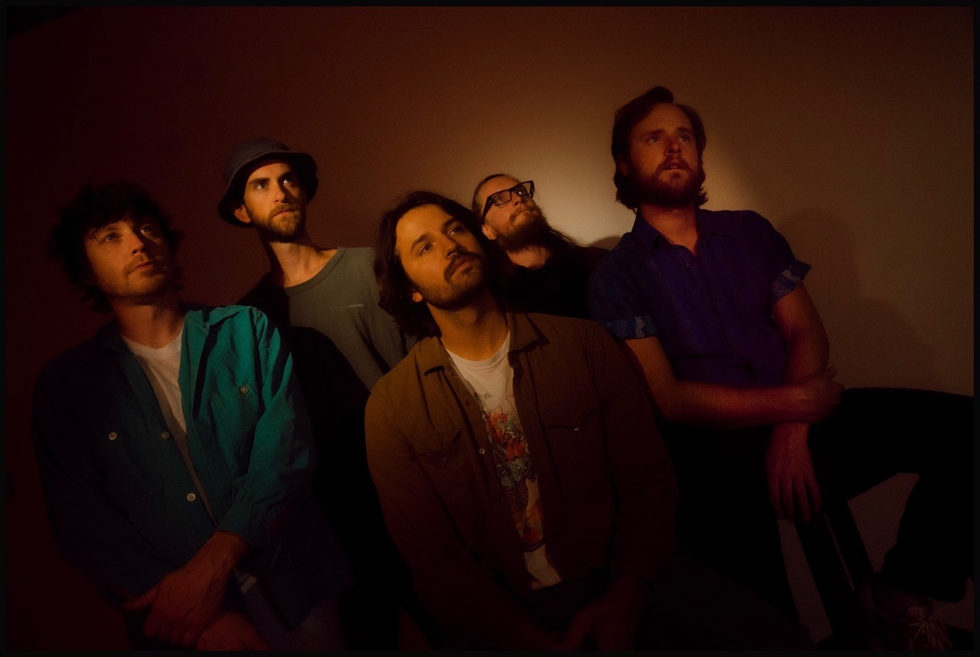

*Photo credit: Aubrey Denis*

Louisville, KY’s **Bendigo Fletcher**have announced their brand new ***Wingding*EP** will arrive on October 21, 2022 via Elektra Records. The EP is available for preorder beginning today [HERE](https://bendigofletcher.lnk.to/wingding). To herald the announcement, the band has unveiled the collection’s opening track “**Strange Encounters**”. The song is available to stream and download now [HERE](https://bendigofletcher.lnk.to/wingding). Watch a visualizer for the track on the band’s YouTube channel [HERE](https://youtu.be/aSDe_qpSSW0).

*“More than a few times, I’ve explored the Wingding font universe as an entertaining break from more pressing tasks. I like the name ‘Wingding’ for a fictional creature, like the Mothman of West Virginia folklore. It’s also another word for party,”*shares frontman Ryan Anderson. *“The songs were my way of coping with the idle uncertainty of the early pandemic months and escaping into a creative space to keep my spirit alive. They come from a more imaginative place where I feel a freedom to process and color some experiences in a productive light.”*

Shapeshifting on an axis between folk, alternative, country, and soul, Bendigo Fletcher’s lofty melodies soar above earthy instrumentationon *Wingding*. Charmed with psychedelic flourishes, yet tightly rooted in tried-and-true songcraft, the Louisville quintet continues to instantly transfix across the EP’s four tracks. Once again, the band teamed with producer and original Wilco/Uncle Tupelo drummer Ken Coomer in his Nashville, TN Cartoon Moon Recording Studio. The band enlisted Grizzly Bear bassist and producer Chris Taylor (tracks 2,3,4) and Geoff Piller (track 1) to mix the EP.

Ahead of their appearance at Newport Folk Festival 2022, Bendigo Fletcher previewed *Wingding*with the release of “[Pterodactyl](https://bendigofletcher.lnk.to/pterodactyl)”, which arrived to praise from *The Bluegrass Situation*, *Entertainment Tonight*, and more. The song is available to stream and download now [HERE](https://bendigofletcher.lnk.to/pterodactyl). Watch the track’s visualizer [HERE](https://youtu.be/mZsX-0SW0VQ).

*Wingding* follows Bendigo Fletcher’s 2021 debut album [*Fits Of Laughter*](https://bendigofletcher.lnk.to/fitsoflaughter). Highlighted by singles “[Sugar In The Creek](https://www.youtube.com/watch?v=kP9RJnmniDU)” and “[Evergreen](https://youtu.be/anSo2V8XADE)”, the album is available [HERE](https://bendigofletcher.lnk.to/fitsoflaughter) via Elektra Records. Beyond amassing millions of streams, the album earned widespread critical acclaim. *FLOOD Magazine* hailed it as *“Somewhere between the post-Woodstock folk scene of the ‘70s and that decade’s burgeoning hard rock movement*,*”*and *Music Connection* dubbed it, *“Alt-rock, country-flecked folk-rock soaked in LSD*.*” American Songwriter* noted it as *“Denser psych-rock with some remaining elements of Bendigo Fletcher’s drifting folk-Americana roots*”, and *Atwood Magazine* praised “*Fits Of Laughter soars with charming passion.”*

Renowned for their inimitable live performances, Bendigo Fletcher supported the release of *Fits Of Laughter*with extensive headline runs and tours supporting Anderson East, Rainbow Kitten Surprise, and Shakey Graves. Bendigo Fletcher is currently on the road in North America supporting Madison Cunningham. The tour will visit major markets across the U.S. and Canada before concluding on October 24 in Chicago, IL at Capital Thalia Hall. Next up, Bendigo Fletcher will embark on a North American headline tour that will kick off on October 26 in Pittsburgh, PA and wrap on December 11 in Jacksonville, FL. Tickets for the band’s headline tour will be available beginning today at 12:00pm ET [HERE](https://www.bendigofletcher.com/). A complete list of upcoming tour dates can be found below.

**BENDIGO FLETCHER - *WINGDING* EP**

[**PREORDER NOW**](https://bendigofletcher.lnk.to/wingding)

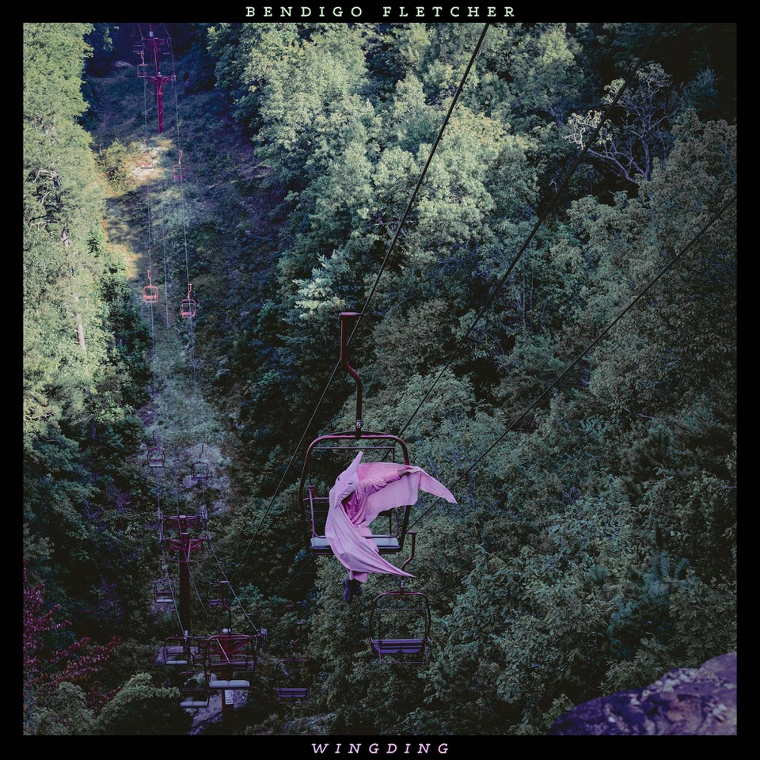

***Wingding* EP Tracklisting**

1. Strange Encounters

2. Juniper Moore

3. Broken Routine

4. Pterodactyl

**Bendigo Fletcher Tour Dates**

**Supporting Madison Cunningham**

September 23, 2022 - Boulder, CO - Fox Theatre

September 24, 2022 - Salt Lake City, UT - The Urban Lounge

September 26, 2022 - Seattle, WA - The Crocodile

September 27, 2022 - Vancouver, Canada - Biltmore Cabaret

September 28, 2022 - Portland, OR - Wonder Ballroom

September 30, 2022 - San Francisco, CA - Café du Nord

October 1, 2022 - Los Angeles, CA - Regent Theater DTLA

October 3, 2022 - Tucson, AZ - Club Congress

October 4, 2022 - Santa Fe, NM - Tumbleroot Brewery and Distillery

October 6, 2022 - Oklahoma City, OK - Beer City Music Hall

October 7, 2022 - Dallas, TX - Deep Ellum Art Company

October 8, 2022 - Fayetteville, AR - George’s Majestic Lounge

October 12, 2022 - Knoxville, TN - Bijou Theatre

October 13, 2022 - Atlanta, GA - Terminal West

October 15, 2022 - Nashville, TN - Brooklyn Bowl Nashville

October 17, 2022 - Saxapahaw, NC - Haw River Ballroom

October 18, 2022 - Charlottesville, VA - Jefferson Theater

October 20, 2022 - Cambridge, MA - The Sinclair

October 21, 2022 - New York, NY - Webster Hall

October 22, 2022 - Washington, DC - Capital Turnaround

October 24, 2022 - Chicago, IL - Thalia Hall

**Fall Headline Tour - On Sale Today at 12:00pm ET**[**HERE**](https://www.bendigofletcher.com/)

October 26, 2022 - Pittsburgh, PA - Club Cafe

October 27, 2022 - Albany, NY - Lark Hall

October 30, 2022 - Burlington, VT - Higher Ground

October 31, 2022 - Toronto, ON - The Garrison

November, 01, 2022 - Buffalo, NY - 9th Ward

November 03, 2022 - Morgantown, WV - 123 Pleasant

November 04, 2022 - Cleveland, OH - Mahall’s

December 01, 2022 - St. Louis, MO - Blueberry Hill

December 02, 2022 - Columbus, OH - The Summit Music Hall

December 03, 2022 - Indianapolis, IN - HiFi Indy

December 07, 2022 - Memphis, TN - 1884 Lounge

December 09, 2022 - Tampa, FL - Crowbar

December 10, 2022 - Charleston, SC - Charleston Pour House

December 11, 2022 - Jacksonville, FL - 1904 Music Hall

Bendigo Fletcher is: Ryan Anderson (lead vocals, guitar, banjo) - Andrew Shupert (backing vocals, lead guitar) - Evan Wagner (backing vocals, keys, guitar, auxiliary percussion) - Conner Powell (bass) - Chris Weis (drums).

[BendigoFletcher.com](https://nam04.safelinks.protection.outlook.com/?url=http%25253A%25252F%25252Fbendigofletcher.com%25252F&data=04%25257C01%25257CSydneyWorden%252540elektra.com%25257C496651e9ae1c4829030008d95e5ab6bc%25257C8367939002ec4ba1ad3d69da3fdd637e%25257C0%25257C0%25257C637644565979480132%25257CUnknown%25257CTWFpbGZsb3d8eyJWIjoiMC4wLjAwMDAiLCJQIjoiV2luMzIiLCJBTiI6Ik1haWwiLCJXVCI6Mn0%25253D%25257C1000&sdata=DwnjXSoisNE7dEIwJsn0Ol9pXmx3ckFc4n%25252BMPRTyboc%25253D&reserved=0)

[Facebook](https://nam04.safelinks.protection.outlook.com/?url=https%25253A%25252F%25252Fwww.facebook.com%25252Fbendigofletcher%25252F&data=04%25257C01%25257CSydneyWorden%252540elektra.com%25257C496651e9ae1c4829030008d95e5ab6bc%25257C8367939002ec4ba1ad3d69da3fdd637e%25257C0%25257C0%25257C637644565979490127%25257CUnknown%25257CTWFpbGZsb3d8eyJWIjoiMC4wLjAwMDAiLCJQIjoiV2luMzIiLCJBTiI6Ik1haWwiLCJXVCI6Mn0%25253D%25257C1000&sdata=NXO3zPwFKZPGOypH4vElUmn%25252BvEY4oQvxFgbugfmiZYo%25253D&reserved=0) | [Instagram](https://nam04.safelinks.protection.outlook.com/?url=https%25253A%25252F%25252Fwww.instagram.com%25252Fbendigofletcher%25252F%25253Fhl%25253Den&data=04%25257C01%25257CSydneyWorden%252540elektra.com%25257C496651e9ae1c4829030008d95e5ab6bc%25257C8367939002ec4ba1ad3d69da3fdd637e%25257C0%25257C0%25257C637644565979490127%25257CUnknown%25257CTWFpbGZsb3d8eyJWIjoiMC4wLjAwMDAiLCJQIjoiV2luMzIiLCJBTiI6Ik1haWwiLCJXVCI6Mn0%25253D%25257C1000&sdata=ZPbgTr7oOdLZKpc9nJeWq8%25252FlxhP7q8X%25252FdCkY%25252BY35bvQ%25253D&reserved=0) | [Twitter](https://nam04.safelinks.protection.outlook.com/?url=https%25253A%25252F%25252Ftwitter.com%25252Fbendigofletcher%25253Flang%25253Den&data=04%25257C01%25257CSydneyWorden%252540elektra.com%25257C496651e9ae1c4829030008d95e5ab6bc%25257C8367939002ec4ba1ad3d69da3fdd637e%25257C0%25257C0%25257C637644565979490127%25257CUnknown%25257CTWFpbGZsb3d8eyJWIjoiMC4wLjAwMDAiLCJQIjoiV2luMzIiLCJBTiI6Ik1haWwiLCJXVCI6Mn0%25253D%25257C1000&sdata=kJRRkKaOhgjDEezX5MFmnHCsNVdAnsYapraqslfWeZI%25253D&reserved=0) | [YouTube](https://nam04.safelinks.protection.outlook.com/?url=https%25253A%25252F%25252Fwww.youtube.com%25252Fchannel%25252FUCqWvWwv7K8kq3PZnygVG1BA&data=04%25257C01%25257CSydneyWorden%252540elektra.com%25257C496651e9ae1c4829030008d95e5ab6bc%25257C8367939002ec4ba1ad3d69da3fdd637e%25257C0%25257C0%25257C637644565979500120%25257CUnknown%25257CTWFpbGZsb3d8eyJWIjoiMC4wLjAwMDAiLCJQIjoiV2luMzIiLCJBTiI6Ik1haWwiLCJXVCI6Mn0%25253D%25257C1000&sdata=je%25252BQcsx%25252FcO5DWK8iMgiiY1CecLP7inplAOftW9IWaqo%25253D&reserved=0)

**Press contact:**

Collin Citron | [CollinCitron@elektra.com](mailto:CollinCitron@elektra.com)