ERIKA SIROLA UNVEILS STUNNING DEBUT EP WHO?
LISTEN HERE

RELEASES OFFICIAL VIDEO FOR LEAD SINGLE “A LITTLE MORE”
WATCH HERE

DOWNLOAD PRESS ASSETS HERE

AUGUST 5TH, 2022 - 23-year-old Finland native Erika Sirola has unveiled her stunning debut EP, Who? via Elektra Records. An elegantly erratic body of work documenting her coming-of-age as an artist, the four-track collection is available now on all streaming platforms and features artwork designed by Sirola herself. Created in Berlin with Swedish producer/songwriter Gustav Nyström (Tove Styrke, Winona Oak), Who?’s spellbinding lead single “A Little More” is a heart-on-sleeve outpouring of regret for risks not taken; fully affirming Sirola’s gift for articulating the most universal emotions with the startling originality and eloquence of a poet. The official video for “A Little More” directed by Nico Poalillo is streaming now on Erika’s official YouTube channel.

Sirola commented, “It’s been a long time coming for my first full body of work to finally come out. I chose these four songs because they each represent a different part of my life in the past – they don’t represent who I am right now. As a result, Who? tells the backstory in the form of lyrical, audio and visual content, to further understand the ‘who’ I am now. Like many books, you get to know the history of the character first before you dive into the now, it lets you understand the process in a different light, and perhaps allows you to dive into the many layers just a little bit better.”

The Who? EP was heralded by singles “All In My Head” and “End Of The Day” - the latter of which arrived alongside an exclusive signing announcement via Consequence, who raved, “‘End Of The Day’ embodies Sirola’s unique voice. Starting as a soft-spoken piano ballad, it soon falls into a world of dramatic synth pads and a drumbeat that sounds like it’s ripped from a club hit — all without losing its emotionality.” The track also racked up praise from Early Rising, who attested, “Sirola’s sultry, strong, and raw vocal abilities are incredibly captivating from the moment the song begins, floating whimsically over the lovesick soundscape. Sirola has the innate ability to turn pain into something beautiful…Her creativity knows no bounds, and this song is just the beginning,” while MUD Magazine declared “Erika Sirola's debut single gives us the most beautiful combination of profound lyricism with a freshly unique sound.”

About Erika Sirola:
For Erika Sirola, the act of creating is an impulse as natural as breathing. Growing up in Helsinki (and spending most summers with her mother’s family in Canada), Sirola first discovered the power of alchemizing pain into art as a young child. A songwriter since the age of eight, the 23-year-old Finland native landed her first record deal at 12 and spent much of her late adolescence and early adulthood living in such far-flung cities as L.A. and Berlin and London, gradually shaping a singular musical identity informed by everything from art-pop to techno to the more esoteric edges of folk, jazz and experimental music. Newly signed to Elektra Records, Sirola centers the beguiling vocal presence she first brought as a featured artist on Robin Schulz’s 2018 smash hit “Speechless” to make her debut with the Who? EP, offering a dazzling first glimpse at the wild expanse of her creativity.

ERIKA SIROLA
WHO? EP
AVAILABLE NOW
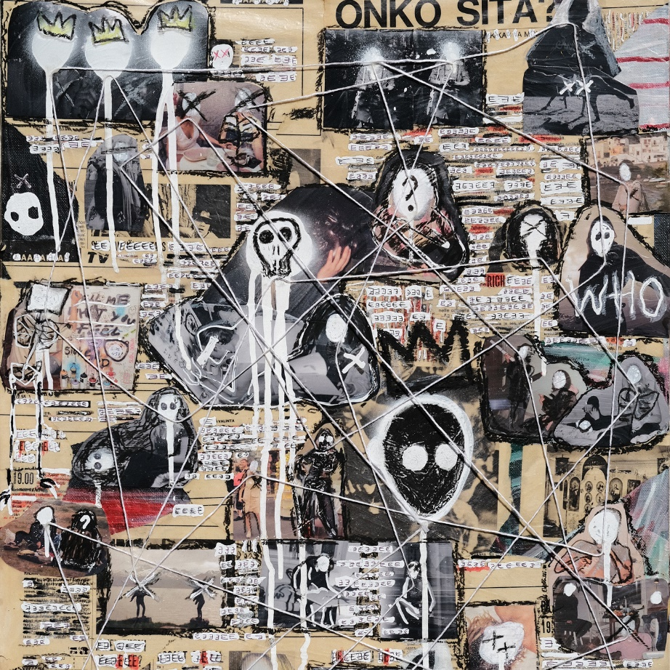

TRACKLISTING
1. All in My Head
2. End of the Day
3. Souvenir
4. A Little More

CONNECT WITH ERIKA SIROLA
Website
Instagram
YouTube
TikTok
Twitter

PRESS CONTACTS:
Sarah Goldstein - sarahgoldstein@elektra.com
Sydney Worden - sydneyworden@elektra.com

