**FOY VANCE TO RELEASE NEW LIVE ALBUM *SIGNS OF LIFE: LIVE FROM THE HIGHLANDS*ON SEPTEMBER 8**

**PRE-ORDER/PRE-SAVE**[**HERE**](https://lnk.to/signsoflifelive)

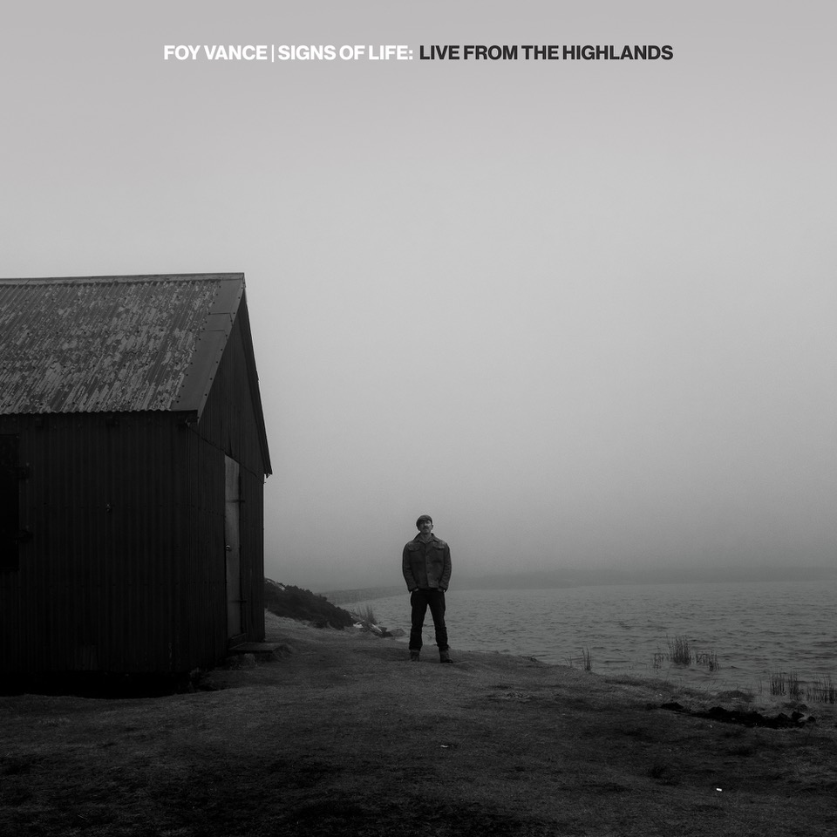

***Download album artwork***[***here***](https://www.dropbox.com/s/dicme9y13i8sco2/FOY%252520LIVE%252520FROM%252520THE%252520HIGHLANDS%252520copy.jpg?dl=0)

**August 22, 2022** -  Award-winning Northern Irish singer/songwriter **Foy Vance** will release a very special new live album on September 8. [*Signs Of Life: Live From The Highlands*](https://lnk.to/signsoflifelive) is a track-by-track live acoustic version of Vance’s acclaimed 2021 album [*Signs Of Life*](https://lnk.to/Signs-of-Life). The live sessions were filmed by Vance’s artistic collaborator Babysweet and recorded in scenic locations in Highland Perthshire, where the Bangor-born Northern Irishman lives with his family. Watch [here](https://www.youtube.com/playlist?list=PLbi9pMEJ_7ykOZanQiF-8dWQQnYvxcD7P).

Earlier this summer, Vance performed ["Be With Me"](https://www.youtube.com/watch?v=hCGGZn-2K4s) from *Hope* and ["Signs of Life"](https://www.youtube.com/watch?v=U--rxAO-1ak), the album’s title track, for The Howard Stern Show on SiriusXM in Los Angeles.

Vance also collaborated with Rag’n’Bone Man on the single [“Sapling”](https://lnk.to/Sapling-RNBM), a powerful new version of the opening track on [*Signs Of Life*](https://lnk.to/Signs-of-Life).  Watch a soulful live performance of “Sapling” by Foy and Rag’n’Bone Man filmed at Vance’s Pilgrim Studio in Aberfeldy in Highland Perthshire [here](https://www.youtube.com/watch?v=Z7arA1jZJ8U).

The follow-up to 2016’s critically acclaimed *The Wild Swan,*[*Signs Of Life*](https://swellpublicity.us3.list-manage.com/track/click?u=6496e494417efb69d31de86b0&id=3990909ecf&e=131cfca90e)is Vance’s fourth studio album and second on Ed Sheeran’s label Gingerbread Man Records.

Later this month, Vance will embark on his first UK tour since 2019, kicking off on August 30 at York Barbican and wrapping on September 9 at Belfast SSE Arena, Vance’s first Arena show in his native Northern Ireland. With 2022 marking the 15th anniversary of his 2007 full-length debut *Hope*, the album is being releasedon vinyl for the very first time. The album is being reissued on double red vinyl with artwork from the original CD packaging, and will include two new acoustic versions of songs from the album. Pre-order [here](https://www.diggersfactory.com/vinyl/259311/foy-vance-hope-15th-anniversary-edition).

***Foy Vance: Live From The Highlands*: Tracklisting**

1. Sapling
2. We Can't Be Tamed
3. Signs Of Life
4. Roman Attack
5. People Are Pills
6. Time Stand Still
7. If Christopher Calls
8. System
9. Hair of the Dog
10. Resplendence
11. Republic of Eden
12. It Ain't Over
13. Percolate

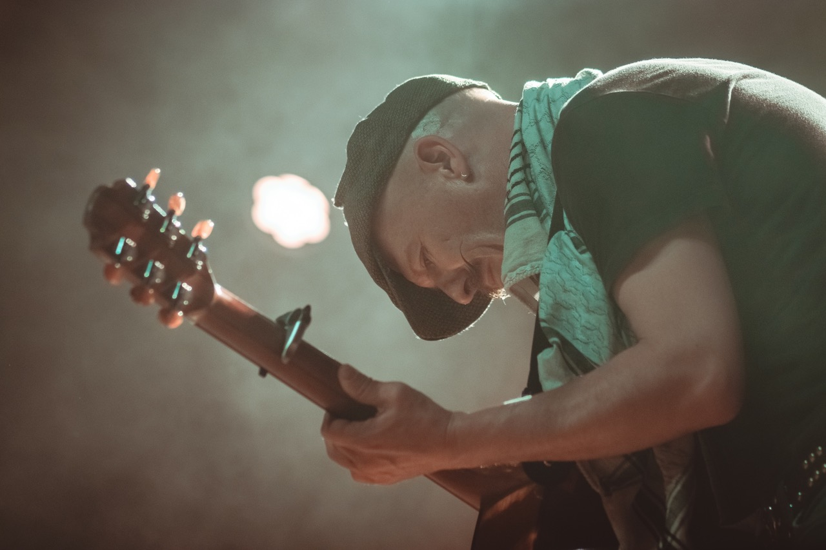

Foy Vance, Webster Hall, New York, May 11, 2022. Download [here](https://www.dropbox.com/home/Artists/Foy%252520Vance/2021) credit Jamie Niesh

[FoyVance.com](https://foyvance.com/)

[Facebook](https://www.facebook.com/foyvancemusic) | [Twitter](https://twitter.com/foyvance) | [Instagram](https://www.instagram.com/foyvance/) | [YouTube](https://www.youtube.com/user/foyvancemusic/featured)

**Press contact:**

Collin Citron | [collin.citron@300elektra.com](mailto:collin.citron@300elektra.com)