Jeris Johnson Unveils Brand New EP
A Summertime Side Quest
LISTEN HERE
+tour dates with Korn, Evanescence, & helmet +
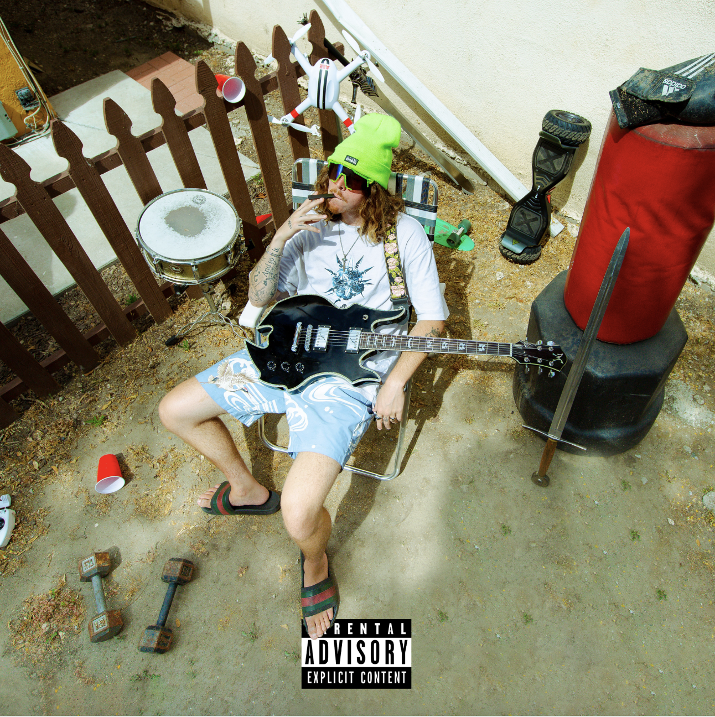
August 12, 2022 – Today, Jeris Johnson reveals his new EP, A Summertime Side Quest – listen HERE.
The Sophomore EP is a vivacious short collection of tracks geared for summer. With the cumulative force of three songs that had gone viral and are now finding a home, the EP showcases yet another side of Jeris Johnson. A Summertime Side Quest is a trio of 'windows-down' singles, all featuring Jeris' signature twang.
Additionally, Jeris will be hitting the road with iconic artists Korn, Evanescence, and Helmet from August 16 through August 28. Buy tickets and check out Jeris’ full list of tour dates HERE.
Recent single "Levitate," off of the upcoming EP, introduced a dreamy and laidback sound from Jeris. The track, initially teased on TikTok, arrived as a surprise to celebrate the EP's impending arrival. Alongside the Hyper-Pop EDM leaning "Hang Loose" and the heavy rock and glitchy sounding "Break!", A Summertime Side Quest solidifies Jeris Johnson as an artist blurring the lines of genre as he propels towards stardom and brings 'future grunge' with him.
With 240 million global streams, Jeris has collaborated with an eclectic mix of iconic artists such as Papa Roach, Trippie Redd, ZillaKami, Bring Me the Horizon and more.
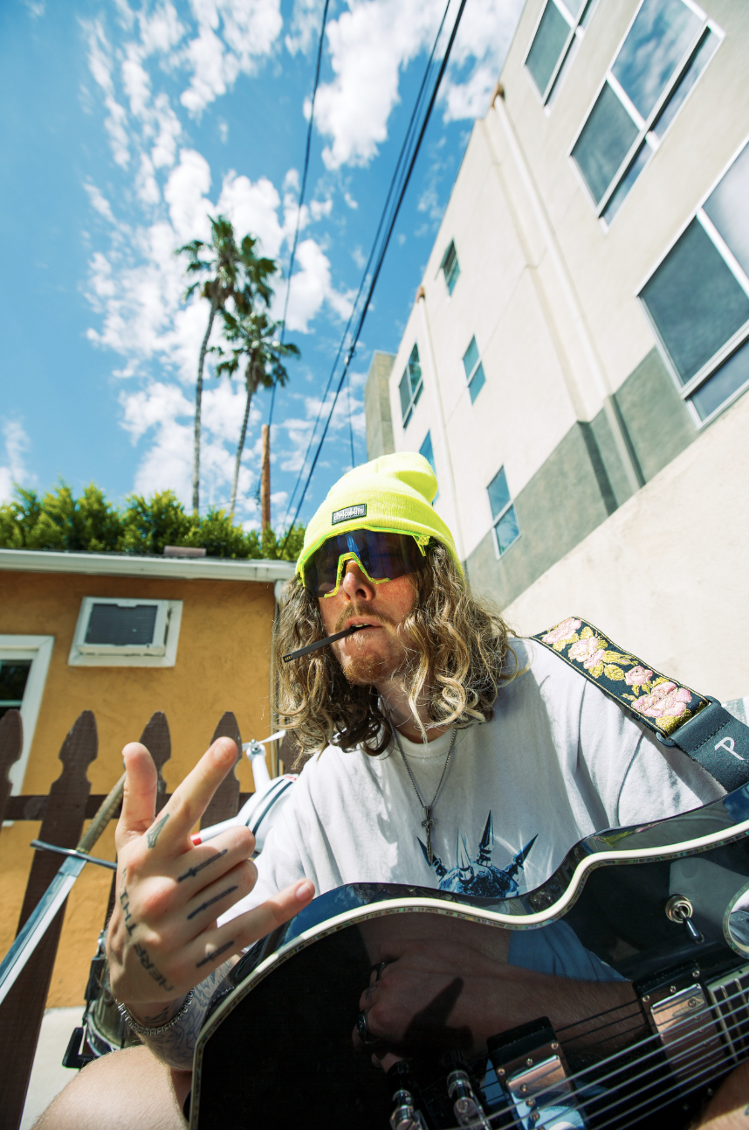
about Jeris Johnson
With a devout cult following on TikTok, Jeris picked up traction on the platform following the success of perfected reworks of classic tracks. Putting his trap flair on iconic hits and accumulating millions of views, he caught the eyes and ears of the critically acclaimed groups themselves. In 2020, Jeris released his single, “Sticks and Stones”, followed by his TikTok viral single “damn!”, which reached critical acclaim. Chad Kroeger of Nickelback then hopped on the track for a remix after playful banter with Jeris via TikTok. Fans were quick to find a similarity in the two so the artists came together for the “damn!” remix. From there on, Jeris covered Papa Roach's "Last Resort" and formed a fast-friendship with the group. Celebrating the 20th anniversary of certified triple platinum hit "Last Resort," Jeris Johnson & Papa Roach united to breathe new life into an iconic track, with “Last Resort (Reloaded)”. The track quickly made its way to #1 on both the Rock iTunes Chart and the Billboard Hard Rock Chart. It continued to be a busy year for Jeris as he then unveiled My Sword, his debut EP, and a slew of music videos all in a couple months time. The burgeoning star also released "Can You Feel My Heart" with Bring Me The Horizon. Adding to an extensive catalog of hard-hitting tracks, Jeris then welcomed Trippie Redd and ZillaKami to the list of acclaimed collaborations / friendships under his belt. Jeris Johnson is breaking into unchartered territory as he redefines genres, pushes boundaries, and creates a whole new sonic wave [coined 'future grunge'].
follow Jeris Johnson:
TikTok | Instagram | Twitter

