LIGHTS DEBUTS “OKAY OKAY” MUSIC VIDEO
WATCH HERE

NEW ALBUM PƎP AVAILABLE NOW
LISTEN HERE

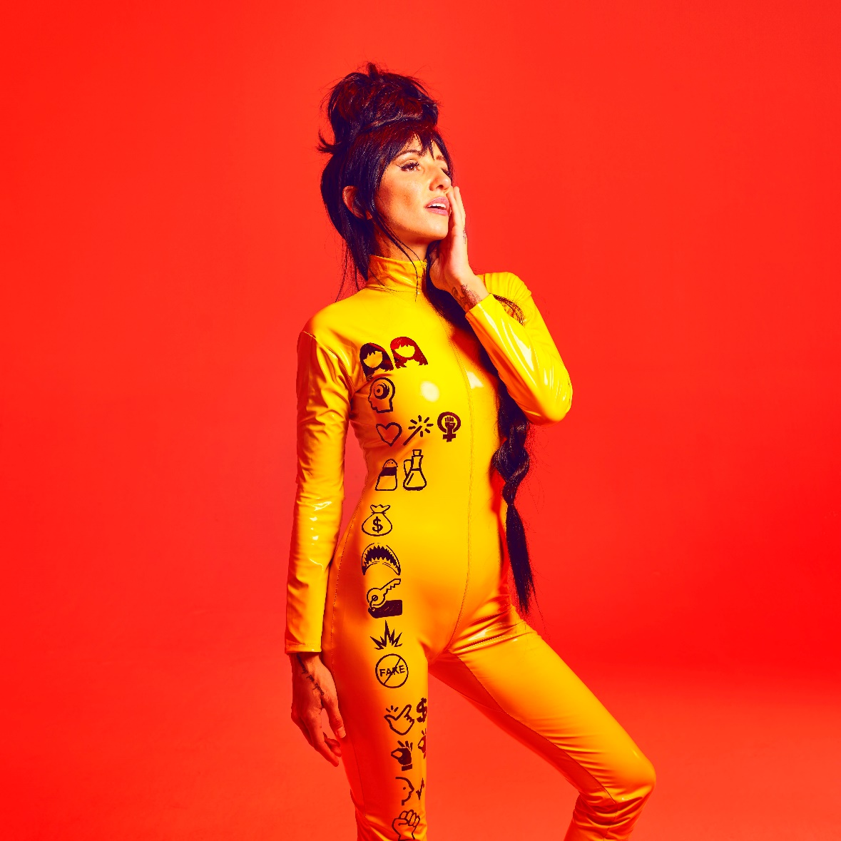

SEPTEMBER 22, 2022 – Alt-pop icon Lights has debuted the official video for “Okay Okay.” The track appears on her critically acclaimed album PƎP, which arrived earlier this year via Fueled By Ramen. Shot and directed by Lights herself, the meta visual finds the artist digitally connecting with multiple alter-egos in search of an idea for the “Okay Okay” music video. The video is streaming now on Lights’ official YouTube channel.

Lights added, “As a big fan of horror movies, I figured it was about time for me to make a horror video concept. I employed a screen-life style production where the whole thing occurs on a computer screen which enabled me to satirize our constant demand for content as well as mix in some spooky horror moments. This was the only video I’ve ever made entirely on my own. A ton of work and planning but really fun to make in the end.”

WATCH “OKAY OKAY” OFFICIAL VIDEO

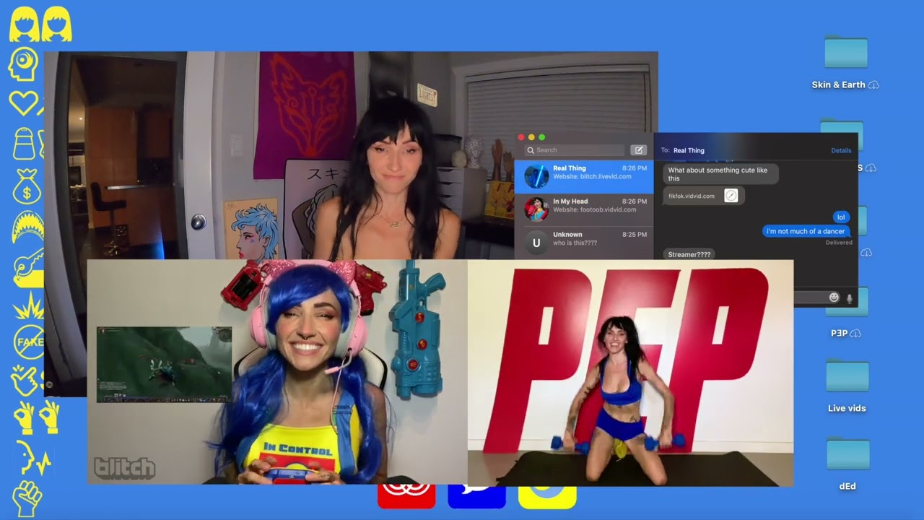

PƎP was heralded by early singles “In My Head (ft. Josh Dun),” “Salt and Vinegar,” “Real Thing feat. Elohim,” “Prodigal Daughter.” The record racked up critical acclaim upon release, with NPR lauding the collection’s “insanely catchy hooks” and tipping the artist as “ready for world domination.” Popcrush raved, “…the LP effortlessly bounds across genres and provides the sonic pep talk we all need,” while Under The Radar attested, “PEP is a gift—cathartic, rebellious, intimate, and alive in its glow.” Single “In My Head (ft. Josh Dun),” premiered via Consequence, who raved about the “anthemic” song and praised the accompanying video which takes “…the unusual and avant garde to a new level.” EDM.com celebrated “Salt and Vinegar” for “bringing [Lights’] artistic vision full circle,” while Consequence attested single “Prodigal Daughter” “…is a driving, infectious pop cut that shows off Lights’ enigmatic and soulful voice… she’s never sounded so uninhibited.” Rock Sound hailed the “vibrantly joyous” track and asserted, “it's Lights at her most dominant, confident and unstoppable.”

Alongside the album release, Lights also shared “The Clinic,” a new side story based off Lights’ Skin&Earth comic series. Written and illustrated exclusively by Lights herself, the entire story is available to read now at www.visittheclinic.com.

About Lights:
Lights is many things all at once: Singer. Songwriter. Producer. Multi-instrumentalist. Comic book author. DJ. Artist. She’s also unabashedly honest and unapologetically confident. Weaving in and out of alternative, indie, electronic, and dance, she makes manic pop irreverent of boundaries, yet reverent of truth. She speaks her heart musically and her mind lyrically. It’s why her shadow over alternative music and culture continues to grow with streams in the hundreds of millions and widespread critical acclaim. Over the course of career thus far, the Canada-born disruptor has garnered four JUNO Awards, including 2020’s “Dance Recording of the Year” for the platinum smash “Love Me” with Felix Cartal and “Pop Album of the Year” for her previous two albums, Skin&Earth and Little Machines. She has sold out tours on multiple continents and powered collaborations with Travis Barker, deadmau5, Kaskade, Steve Aoki, Mike Shinoda of Linkin Park, and more. Now, she captivates like never before, kickstarting a new era with PƎP.

(Album art/tracklisting below)

LIGHTS
PƎP
AVAILABLE NOW
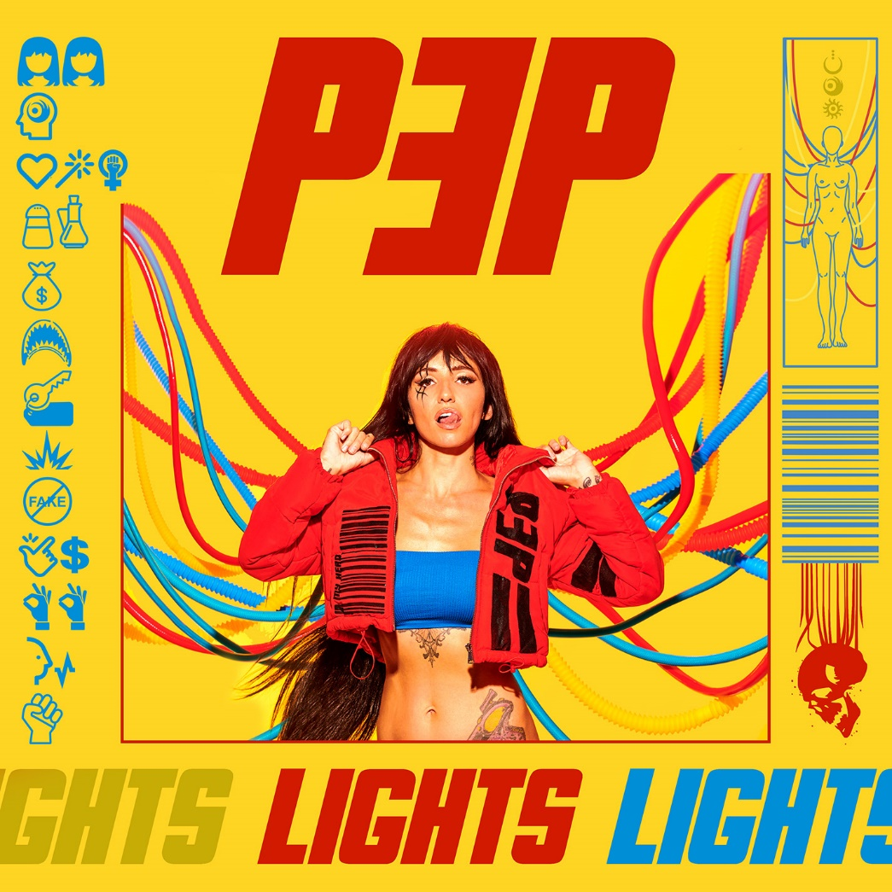

Tracklisting:
- Beside Myself
- In My Head (ft. Josh Dun)
- Prodigal Daughter
- Salt and Vinegar
- Money in the Bag (ft. Kiesza)
- Jaws
- Rent
- Sparky
- Real Thing (feat. Elohim)
- Easy Money
- Okay Okay
- Voices Carry
- Grip

###
CONNECT WITH LIGHTS:
WEBSITE
FACEBOOK
INSTAGRAM
TWITTER
YOUTUBE

Press Contact:
Sarah Goldstein
sarahgoldstein@elektra.com
212-707-2146

