MASKED WOLF SHARES “SAILOR ON THE MOON” FT. IDK AND KAYCYY
LISTEN HERE | WATCH THE VISUALIZER HERE
THE NEW SONG ADDS TO MASKED WOLF’S IMPRESSIVE ROLODEX OF WORK WITH MIKE POSNER, G-EAZY, BRING ME THE HORIZON, BEBE REXHA, ALEX GASKARTH & MORE
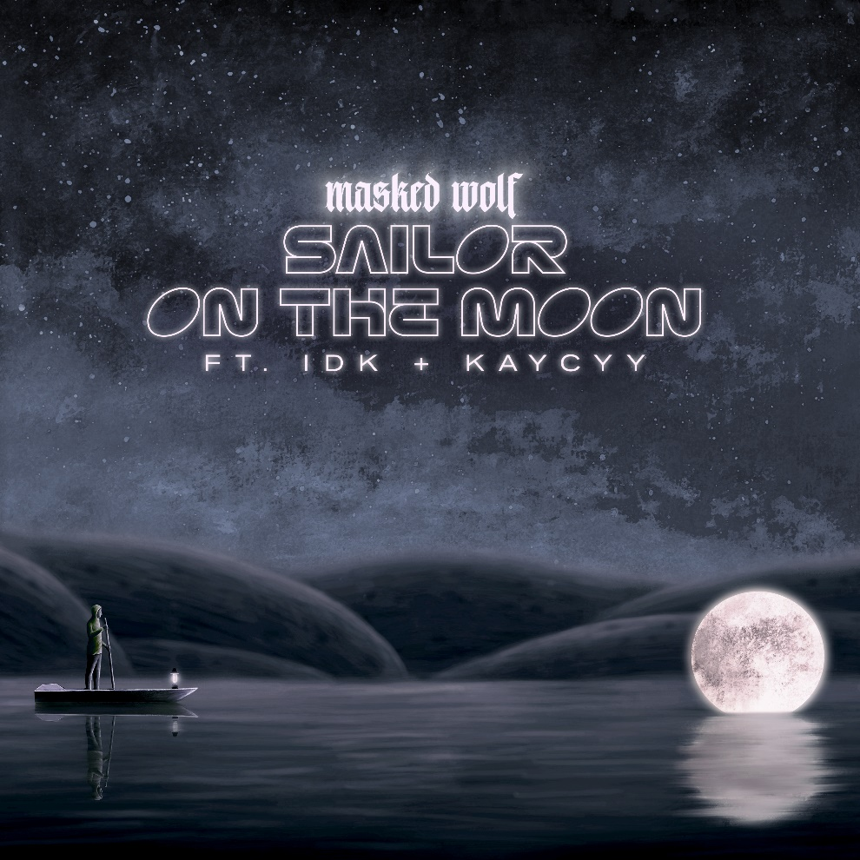
DOWNLOAD HI-RES ARTWORK HERE
MASKED WOLF PRESS ASSETS HERE
(September 16, 2022) – LOS ANGELES, CA) – Multi-Platinum hip-hop artist Masked Wolf today shared his new song “Sailor On The Moon” featuring acclaimed hip-hop artist and producer IDK and rapper/songwriter KayCyy (Kanye West, Lil Wayne, Travis Scott). Complete with smooth, rhythmic beats and triumphant hooks, the track is available now on all streaming services, with a companion visualizer HERE. The new offering continues to build on Masked Wolf’s impressive rolodex of collaborations with Mike Posner, G-Eazy, Bring Me the Horizon, Bebe Rexha, Alex Gaskarth (of All Time Low), and more.
Following the success of the Australian rapper’s debut 17-track mixtape Astronomical – which includes the RIAA Certified double-Platinum smash “Astronaut In The Ocean” – Masked Wolf earned three nominations at this year’s Billboard Music Awards including “Top New Artist,” “Top Viral Song,” and “Top Rap Song.” “Astronaut In The Ocean” continues to be a worldwide phenomenon, surpassing one billion global streams to date, as well as becoming the eighth most-consumed song of 2021.
Masked Wolf made his world television debut last year with a stellar performance of “Astronaut In The Ocean” on The Tonight Show Starring Jimmy Fallon, followed by his first primetime television appearance of the song on The Voice and then on The Kelly Clarkson Show. He also performed Astronomical standout track “Pandemonium” on Jimmy Kimmel Live! and on Dick Clark’s New Year’s Rockin’ Eve with Ryan Seacrest.
About MASKED WOLF:
Transforming from a mild-mannered man by day into an unrestrained beast in the studio, Masked Wolf (aka, Harry Michael) has unassumingly established himself as a powerful, passionate, and primal hip-hop force. After graduating from school, the Sydney, Australia native tirelessly worked in sales to fund recording. He even took out a loan to build a home studio as he cut hundreds of songs and logged thousands of hours in the lab. In 2018, he dropped his independent debut “Speed Racer.” It gathered millions of streams and turned heads across Australia. Following “Night Rider” and “Water Walkin,” he unveiled “Astronaut In The Ocean.” Awash in airy guitar, jagged 808s, neon keys, and deft wordplay, he submerged himself in honest lyricism, facing depression head-on. Re-released via Elektra Records at the top of 2021, “Astronaut In The Ocean” has become a global phenomenon, amassing over one BILLION streams and hitting #1 in 8 countries around the world.

Connect with MASKED WOLF:
MaskedWolf.com
YouTube
Instagram
Twitter
Facebook
TikTok
Connect with IDK:
Website
YouTube
Instagram
Twitter
Facebook
TikTok
Connect with KAYCYY:
Website
YouTube
Instagram
Twitter
TikTok
# # #

MEDIA CONTACTS FOR MASKED WOLF:
Glenn Fukushima
Glenn.Fukushima@300Elektra.com

Nathalie Rubin
Nathalie.Rubin@300Elektra.com

