MILES RELEASES DEBUT EP NEVER HAVE I EVER
FEATURING TRAVIS BARKER ON THE TITLE TRACK
LISTEN HERE | WATCH THE “NEVER HAVE I EVER” MUSIC VIDEO HERE
MILES WILL BE PROVIDING DIRECT SUPPORT FOR PEACH TREE RASCALS ON THEIR FALL NORTH AMERICAN TOUR
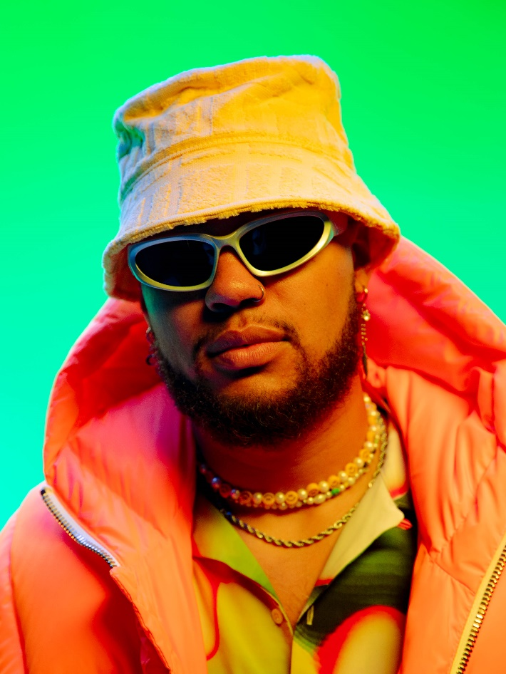
PHOTO CREDIT: Cameron Nisbet
DOWNLOAD HI-RES IMAGE HERE | PRESS ASSETS HERE
(August 26, 2022) – LOS ANGELES, CA – LA-based alt-pop artist and rapper MILES today released his debut EP NEVER HAVE I EVER via Elektra Records. Legendary multi-platinum and GRAMMY® Award-nominated musician Travis Barker is featured on the title track, along with serving as its primary producer. With its arena-ready chorus and upbeat bassline, the fiery pop-rock song reflects MILES’ dynamic, genre-bending sound. The companion music video for “NEVER HAVE I EVER” is also out today. Directed by Abir Hashem and Cameron Nisbet, the visual follows MILES and his friends through a night out in LA. Stream the EP HERE and watch the video HERE.
Mining inspiration from “the trials, tribulations, and heartbreak of moving to one of the craziest cities in America” from his native St. Louis, MILES’ new EP is a relatable body of work when navigating life, relationships, and dating in the modern era. Of the title track, MILES explained, “‘NEVER HAVE I EVER’ felt like the perfect song to record live drums on when we were finalizing the EP. I was so excited when word came back that Travis was going to hop on the track; having him play drums on my song is a huge honor. I can’t wait for everyone to hear this new project and am thankful for everyone involved in it.”
In support of the new EP, MILES will make his live debut across the U.S. and Canada opening for Peach Tree Rascals on the “Does A Fish Know It’s Wet Tour.” MILES will provide direct support for the first leg of dates, which launch on Wednesday, 10/21 in San Diego and stop in major cities such as Brooklyn, Boston, Nashville, and more before wrapping in Detroit on Tuesday, November 8. All tickets are available HERE, with the full routing included below.
MILES bobs and weaves past genre lines with an unpredictable and undeniable style of his own, fusing breezy hip-hop, earthshaking pop, and grimy rock. Slowly, but surely, MILES developed a following online in 2020 before cooking up “WHAT IN TARNATION” back home in St. Louis. Beyond inspiring thousands of TikTok videos, it raked in millions of streams as he inked a deal with Elektra. He maintained his momentum with the captivating, high-energy follow up singles “DESPERADOS” and “MOSH PIT.”
MILES’ debut EP NEVER HAVE I EVER kickstarts an exciting new era for this artist on the ascent. “I’m just a kid from St. Louis who had a crazy dream to go to the city of Angels and make music,” he added. “When you listen to me, I hope you feel like you can live the fullest life you can. I’m waking up every day in a place I love and telling you about my life here.”

NEVER HAVE I EVER
1. MISS INDEPENDENT
2. THE INTERNET (feat. LØLØ)
3. WHEN YOU’RE SOBER
4. HOLLYWOOD
5. NEVER HAVE I EVER (feat. Travis Barker)
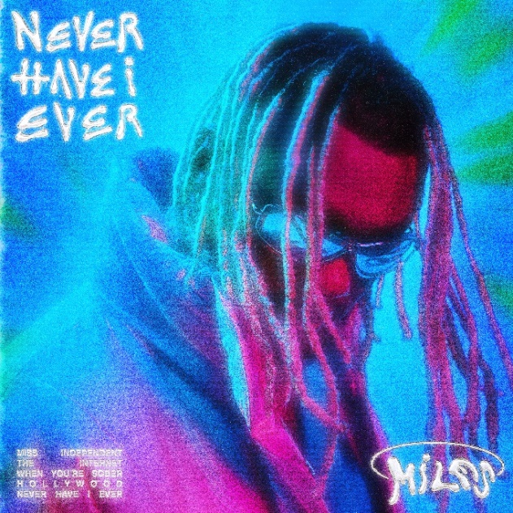
HI-RES ARTWORK HERE
MILES ON TOUR SUPPORTING PEACH TREE RASCALS:
10/21 – San Diego, CA @ Voodoo Room at House of Blues
10/22 – Phoenix, AZ @ Valley Bar
10/25 – Dallas, TX @ The Cambridge Room
10/26 – Austin TX @ Antone’s Nightclub
10/27 – Houston, TX @ The Bronze Peacock at House of Blues
10/29 – Atlanta, GA @ The Loft
10/30 – Nashville, TN @ Exit/In
11/1 – Washington, D.C. @ DC9
11/2 – Brooklyn, NY @ Music Hall of Williamsburg
11/4 – Boston, MA @ Middle East - Downstairs
11/5 – Montreal, QC @ Bar le Ritz PDB
11/6 – Toronto, ON @ The Velvet Underground
11/8 – Detroit, MI @ The Loving Touch
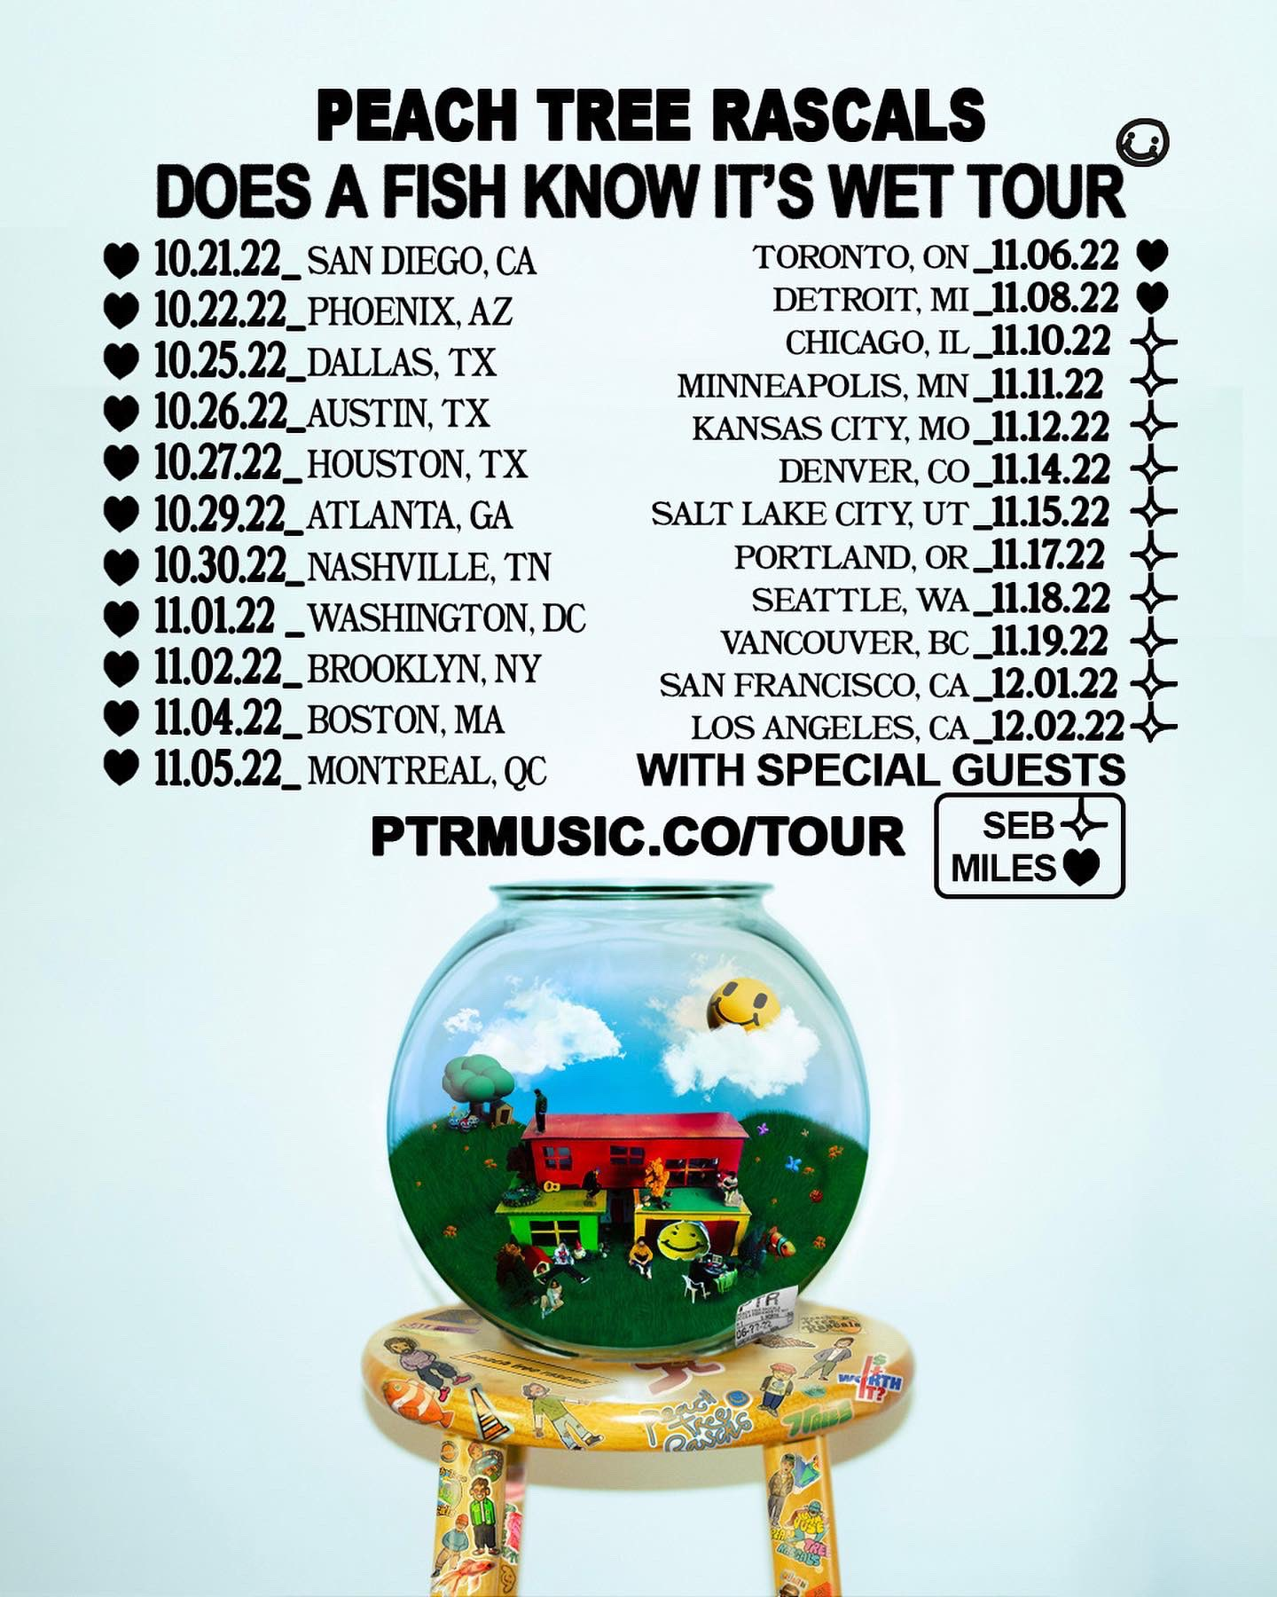
DOWNLOAD TOUR ADMAT HERE
FOLLOW MILES:
Instagram
Twitter
YouTube
TikTok
# # #
PRESS CONTACT FOR MILES:
Nathalie Rubin
Nathalie.Rubin@300Elektra.com

