ONE OK ROCK SHARE NEW SINGLE “LET ME LET YOU GO”

FALL NORTH AMERICAN HEADLINE TOUR GETS UNDERWAY SEPTEMBER 19TH
FEATURING SPECIAL GUESTS YOU ME AT SIX & FAME ON FIRE

NEW ALBUM LUXURY DISEASE ARRIVES WORLDWIDE SEPTEMBER 9TH

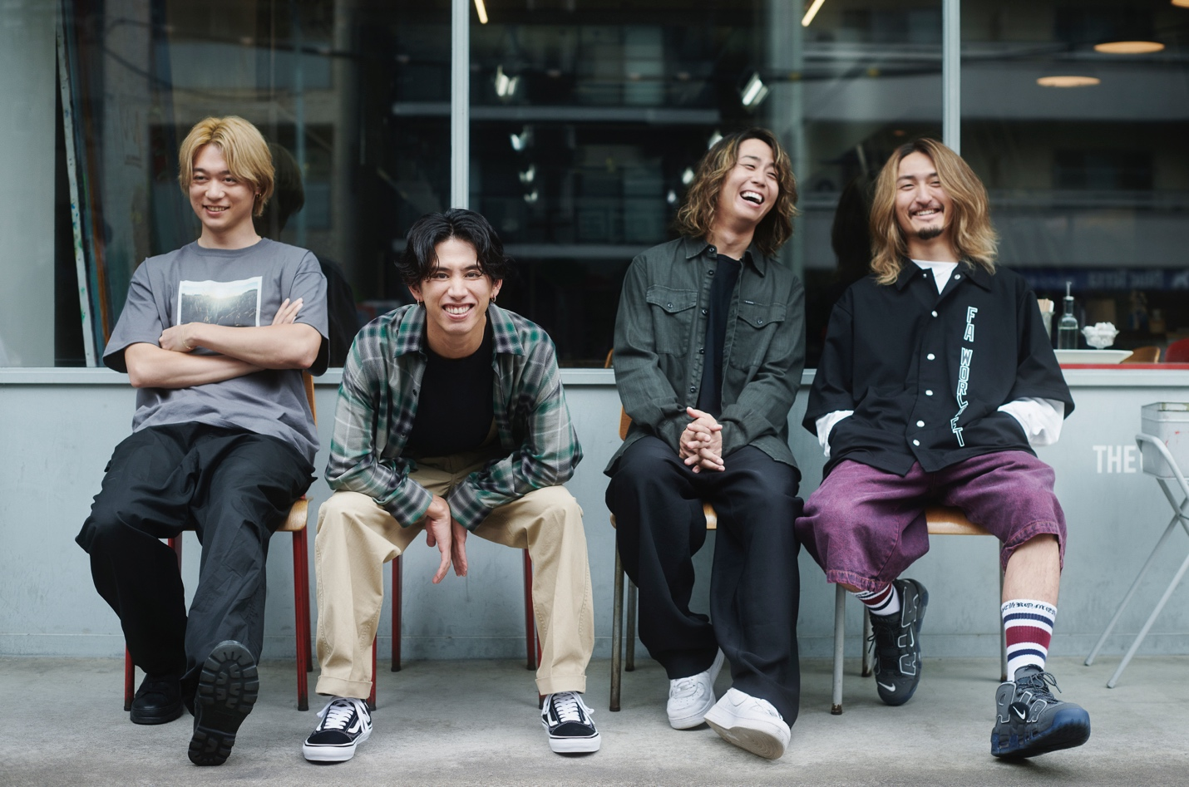

AUGUST 29, 2022 – Beloved at home in Japan and worldwide, Fueled By Ramen band ONE OK ROCK have shared “Let Me Let You Go,” the latest single to be released off their anxiously awaited new full-length album, Luxury Disease, which will arrive on September 9th. Available today on all streaming platforms, “Let Me Let You Go” is accompanied by a Live Documentary Video streaming now on the band’s official YouTube channel.

Luxury Disease is available for pre-order / pre-save at all streaming platforms now. The forthcoming album features the lead single: “Save Yourself” (streaming HERE), which is joined by a Tanu Muino (Harry Styles, Cardi B, Lil Nas X) directed music video streaming on the band’s official YouTube channel.

Produced by Rob Cavallo (Linkin Park, My Chemical Romance), Luxury Disease finds ONE OK ROCK confounding expectations, piling element on element, and putting forth one of the year’s most ambitious rock records [tracklisting / album art below].

This fall ONE OK ROCK will embark on a North American headline tour which will see the group returning to stages in the U.S. and Canada for the first time in over three years. The upcoming tour will feature support from special guests You Me At Six and Fame On Fire, and is set to get underway September 19th at Emo’s in Austin, TX with stops in New York City, Toronto, Chicago, Los Angeles and more [full itinerary below]. Tickets for the tour are on sale now. For tickets and more information on ONE OK ROCK’s fall tour and upcoming international dates, visit www.oneokrock.com.

2021 saw the release of ONE OK ROCK’s singles “Wonder,” “Broken Heart of Gold,” and “Renegades,” the latter of which they co-wrote with international superstar Ed Sheeran. The band also released their Netflix documentary “Flip A Coin,” which gives fans a backstage look at intimate moments from their massive 2020 “Field of Wonder” livestream concert held at ZOZOMARINE Stadium in Chiba, Japan.

ONE OK ROCK’s widely acclaimed 2019 album EYE OF THE STORM established the band as a global force, featuring the singles “Stand Out Fit In,” “Wasted Nights,” and “Change.” Comprised of vocalist Taka, guitarist Toru, drummer Tomoya, and bassist Ryota, ONE OK ROCK is among Japan’s most popular and beloved rock outfits, with each of their last six releases debuting in the nation’s Top 5, including the #1 blockbusters, 35xxxv, AMBITIONS, and EYE OF THE STORM.

ONE OK ROCK
LUXURY DISEASE

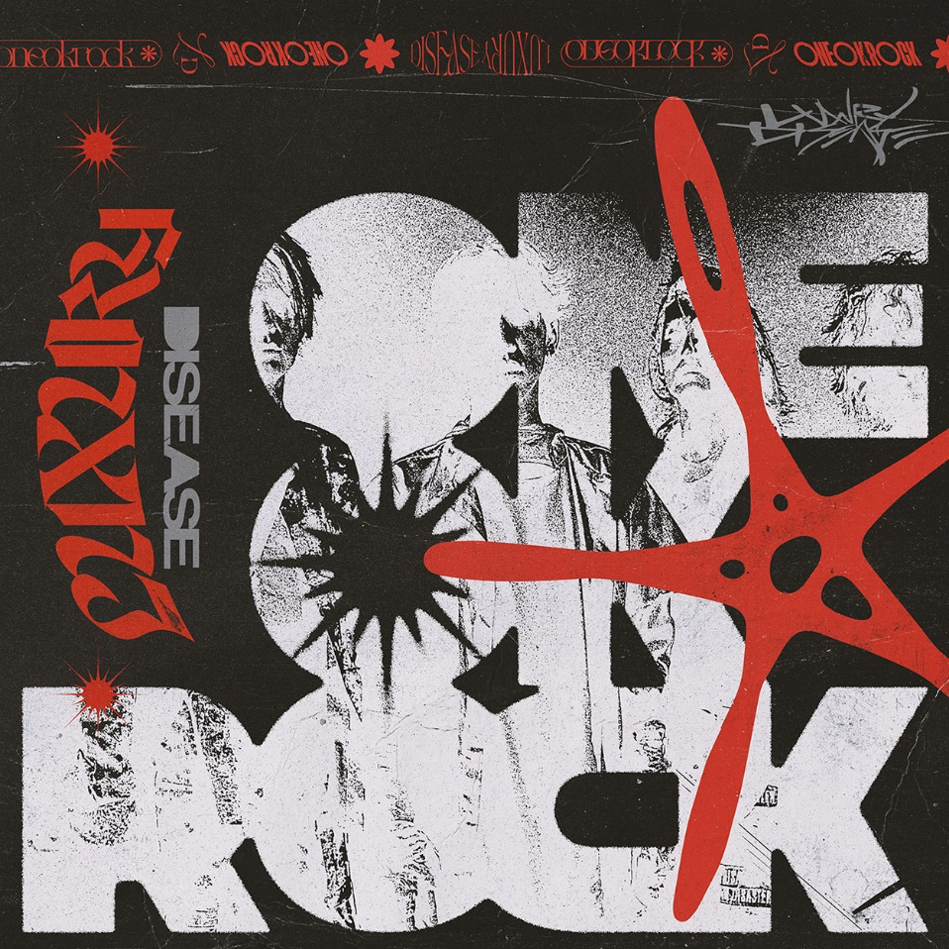

1. Save Yourself
2. Neon
3. Vandalize
4. When They Turn the Lights On
5. Let Me Let You Go
6. So Far Gone
7. Prove
8. Mad World
9. Free Them feat. Teddy Swims
10. Renegades
11. Outta Sight
12. Your Tears are Mine
13. Wonder (Bonus Track)

ONE OK ROCK LUXURY DISEASE NORTH AMERICA 2022
WITH YOU ME AT SIX & FAME ON FIRE

09/19/2022 Austin, TX - Emo’s
09/20/2022 Houston, TX - House of Blues
09/21/2022 Dallas, TX - House of Blues – SOLD OUT
09/23/2022 Orlando, FL - House of Blues – SOLD OUT
09/24/2022 Atlanta, GA - Tabernacle* – SOLD OUT
09/25/2022 Charlotte, NC - The Underground – SOLD OUT
09/27/2022 Philadelphia, PA - Franklin Music Hall
09/28/2022 Silver Spring, MD - The Fillmore
09/30/2022 New York, NY - Hammerstein Ballroom – SOLD OUT
10/01/2022 Boston, MA - House of Blues – SOLD OUT
10/02/2022 Montreal, QC - Club Soda – SOLD OUT
10/04/2022 Toronto, ON - Rebel – SOLD OUT
10/05/2022 Detroit, MI - The Fillmore* – VENUE UPGRADE
10/07/2022 Cleveland, OH - House of Blues
10/08/2022 Chicago, IL - Concord Music Hall – SOLD OUT
10/09/2022 Minneapolis, MN - The Fillmore – SOLD OUT
10/11/2022 Denver, CO - Ogden Theatre
10/12/2022 Salt Lake City, UT - The Complex
10/14/2022 Portland, OR - Roseland Theater
10/15/2022 Vancouver, BC - Harbour Event Centre – SOLD OUT
10/16/2022 Seattle, WA - Showbox SoDo – SOLD OUT
10/19/2022 Oakland, CA - Fox Theater
10/20/2022 Los Angeles, CA - Hollywood Palladium – SOLD OUT

* No Fame On Fire

ABOUT ONE OK ROCK:
Resounding and resonating across boundaries and borders, ONE OK ROCK consistently deliver unpredictable and unshakable anthems. Founded in Tokyo during 2005, the quartet—Taka [vocals], Toru [guitar], Tomoya [drums], and Ryota [bass]—have unassumingly emerged as a global phenomenon and one of Japan’s hottest exports with dozens of international gold and platinum certifications and billions of streams. Beyond six consecutive Top 5 entries and three #1 debuts on the Japanese Top Albums Chart, the group’s global imprint has grown with a foothold stateside. In 2017, AMBITIONS marked their debut on the Billboard 200, while 2019’s Eye of the Storm shot to #2 on Billboard’s Heatseekers Albums chart. They received honors at the Rock Sound Awards and the Alternative Press Music Awards. Joining forces with a cohort of A-list artists, the guys collaborated with Avril Lavigne, 5 SECONDS OF SUMMERS, Kiiara, and more. They stand out as the rare force of nature who can tour alongside either The Smashing Pumpkins or Ed Sheeran—with whom they co-wrote “Renegades” for the film Rurouni Kenshin: The Final. Unable to tour in 2020, the members of ONE OK ROCK worked for months to deliver a globally broadcasted livestream performance which is documented in the NETFLIX film Flip a Coin. Following nearly two decades of steady impact, they get louder than ever on their 2022 full-length offering, Luxury Disease [Fueled By Ramen]. Produced by Rob Cavallo [Linkin Park, My Chemical Romance], ONE OK ROCK continue to evolve on their own terms with stadium-shaking rock spirit and skyscraping hooks amped up on singles “Save Yourself” and “Let Me Let You Go.”

FOLLOW ONE OK ROCK:
Website | TikTok | Facebook | Instagram | Twitter | YouTube | Spotify

