SINGER-SONGWRITER SAM MACPHERSON DEBUTS POIGNANT NEW SINGLE “BACKSEAT (ALL I GOT)”
ANNOUNCES SIGNING TO ELEKTRA RECORDS, IN PARTNERSHIP WITH GROUP PROJECTS
LISTEN HERE | WATCH THE VISUALIZER HERE
OPENING FOR JAKE SCOTT AND THE BROOK & THE BLUFF ON TOUR THIS FALL IN THE U.S.
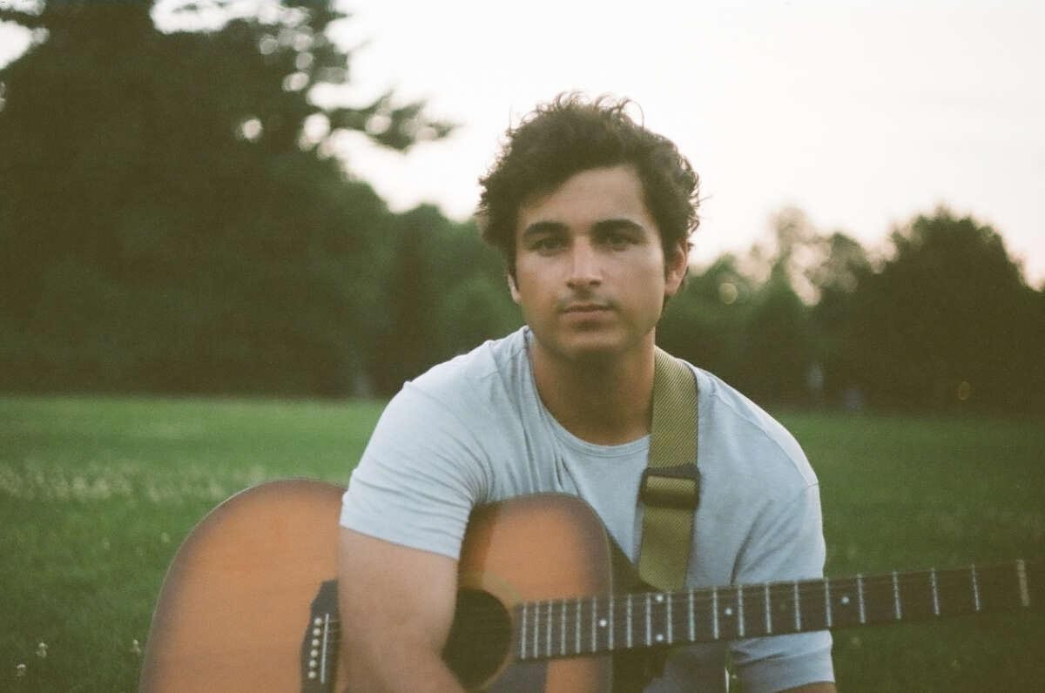
CREDIT: MAXWELL GOLDBERG
DOWNLOAD PRESS IMAGE HERE
“MacPherson accomplishes something that few artists are able to do: He creates a sonic environment that fuels the listener’s introspection.” –EARLY RISING
“MacPherson's vocals and effortless harmonies blanket you with warmth, accompanied by the faint and soft chords on the piano and space-like guitar tones.” –ONES TO WATCH
“…a breath of fresh air in an industry that seems to move at the speed of light.” –LYRICAL LEMONADE
“Crafting vulnerable, cinema-graphic lyrics, MacPherson doesn’t just tell us about his past; he brings us into it.” –ATWOOD MAGAZINE
(September 16, 2022) – LOS ANGELES, CA – LA by-way-of New Jersey singer-songwriter and producer Sam MacPherson has released his new single “Backseat (All I Got),” his debut release with Elektra Records. The project is being supported via a partnership with artist development and marketing company Group Projects. Co-written by MacPherson, Emma Rosen (Normani, Ruel), and Adam Yaron (Christian French, Maddie Zahm), the delicate, yet powerful song hinges on an airy guitar loop punctuated by shimmering keys. Listen to the track HERE and watch the accompanying visualizer HERE.
“‘Backseat (All I Got)’ is about a relationship that’s so hopeless it gives you the confidence to keep delaying calling it off,” MacPherson says. “The idea is, ‘If we know this is going to end, it wouldn’t hurt to drag it out a little longer and enjoy what we can salvage.’ It will inevitably end, but I’m bringing it up before it does. Nobody addresses this when you’re just hooking up. It’s all lust when you should be talking about what it means.”
Regarding his signing, MacPherson added, “We're partnering with Elektra not only because they understand our vision, but because we're genuine fans of the people that work there.”
“From the very first moments of hearing Sam’s songs and then meeting him in-person shortly after, he immediately struck me as an incredibly heartfelt story teller. His approach to songwriting feels classic and new all at the same time,” said Johnny Minardi, VP of A&R at Elektra Entertainment.
Through a nuanced approach and unclouded lens, MacPherson will delve into the quietest moments of a tense goodbye or pan across the trepidation of a torrid, yet doomed relationship in his songs. This unfiltered honesty has quietly affirmed him as a notable artist on the ascent with tens of millions of streams and views and a dedicated following of fans.
“I write from inside of the moment,” he observes. “I put myself back into those memories and think about what I was feeling. I try to bend and push the form of pop music as far as I can with visceral and visual storytelling. I want you to feel like you’re inside of my songs with me.”
Hailing from Red Bank, Sam absorbed the no-nonsense New Jersey spirit from his surroundings, while his songwriter father gave him a love for music. At college, he taught himself how to play guitar, produce, write songs, and record on his own, approaching music with the same grit and determination he brought to athletics as a division one soccer player.
Following early uploads such as “No Bad Memories,” MacPherson gained traction with the alluring, heartbreaking single “Routine” in 2021. Beyond landing on coveted playlists, it generated 6M+ streams and garnered praise among music blogs. He also served up the Songs for Sam EP highlighted by “Last Minute,” which lit up TikTok and surpassed 10M streams. He carried this momentum into 2022 with singles like “Crash Course” and “Rookie.” Simultaneously, he emerged as a sought-after collaborator behind-the-scenes for Stephen Sanchez, Jonah Kagen, Garrett Nash, and more. He notably co-wrote “Heartbreak Hall of Fame” for Quinn Lewis and “You” for VINCINT. Moreover, he shared stages on tour with Chelsea Cutler and Elektra labelmate Jake Scott.
Ultimately, you’ll hang on to every word MacPherson sings. His vision only crystallizes on a series of singles for his major label Elektra Records and much more new music to come.
This fall, MacPherson will once again be joining forces again with Jake Scott, joining him on the first leg of his fall headline tour, which kicks off on Saturday, October 15 in San Diego and hits major cities across the U.S. including Nashville, Austin, Atlanta, among others. He’ll also be performing at Scott’s New York City headline show at Webster Hall on Monday, November 7. Following this run, MacPherson will be opening for The Brook & The Bluff for a slew of dates in November. The full routing is included below, with all tickets available HERE (Jake Scott) and HERE (The Brook & The Bluff).
ABOUT GROUP PROJECTS:
Group Projects is an artist management firm, record label, and publishing company founded by executives Anthony Manker and Cooper Anstett in 2019. Its roster includes management client and fellow Elektra recording artist Jake Scott.

Sam MacPherson’s signing to Elektra marks one of GP’s first expansions as a record label, with the company taking on a development and marketing role to support Elektra’s efforts with Sam MacPherson.

“Sam has an ability to tell stories we’ve all experienced in new and unique ways,” Anstett remarked. “That ability is accompanied by an unparalleled work ethic and a drive to share his music with the world. Group Projects couldn’t be more excited to help make that happen.”
SAM MACPHERSON
“BACKSEAT (ALL I GOT)”
AVAILABLE HERE
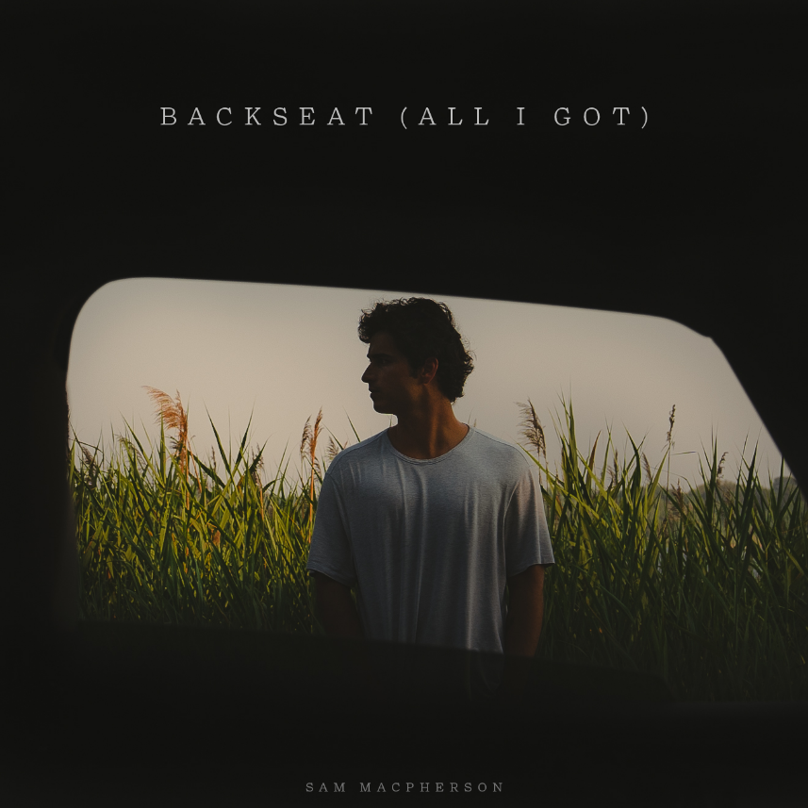
DOWNLOAD HI-RES ARTWORK HERE
SAM MACPHERSON ON TOUR:
*Supporting Jake Scott
^ Supporting Brook & The Bluff
October 15 – San Diego, CA @ The Observatory North Park *
October 16 – Phoenix, AZ @ Crescent Ballroom *
October 18 – Dallas, TX @ House of Blues *
October 19 – Austin, TX @ Scoot Inn *
October 21 – Orlando, FL @ Plaza Live *
October 23 – Birmingham, AL @ Iron City *
October 25 – Nashville, TN @ Marathon Music Works *
October 26 – Charlotte, NC @ The Fillmore *
October 27 – Atlanta, GA @ Variety Playhouse *
November 7 – New York, NY @ Webster Hall *
November 8 – Tulsa, OK @ The Vanguard ^
November 9 – Columbia, MO @ Rose Music Hall ^
November 10 – Lawrence, KS @ The Bottleneck ^
November 11 – Omaha, NE @ Slowdown ^
November 13 – Boulder, CO @ Fox Theatre ^
November 16 – Santa Barbara, CA @ SOhO Music Club ^
November 17 – Santa Ana, CA @ Constellation Room ^
November 20 – Santa Fe, NM @ Meow Wolf ^
FOLLOW SAM MACPHERSON:
Instagram | Twitter | TikTok | Facebook
# # #
MEDIA CONTACT:
Nathalie Rubin
Nathalie.Rubin@300Elektra.com

