SAM RYDER UNVEILS NEW SINGLE “SOMEBODY”
OFFICIAL VIDEO STREAMING NOW

DEBUT ALBUM ARRIVING LATER THIS YEAR

MOST SUCCESSFUL UK DEBUT ACT OF 2022

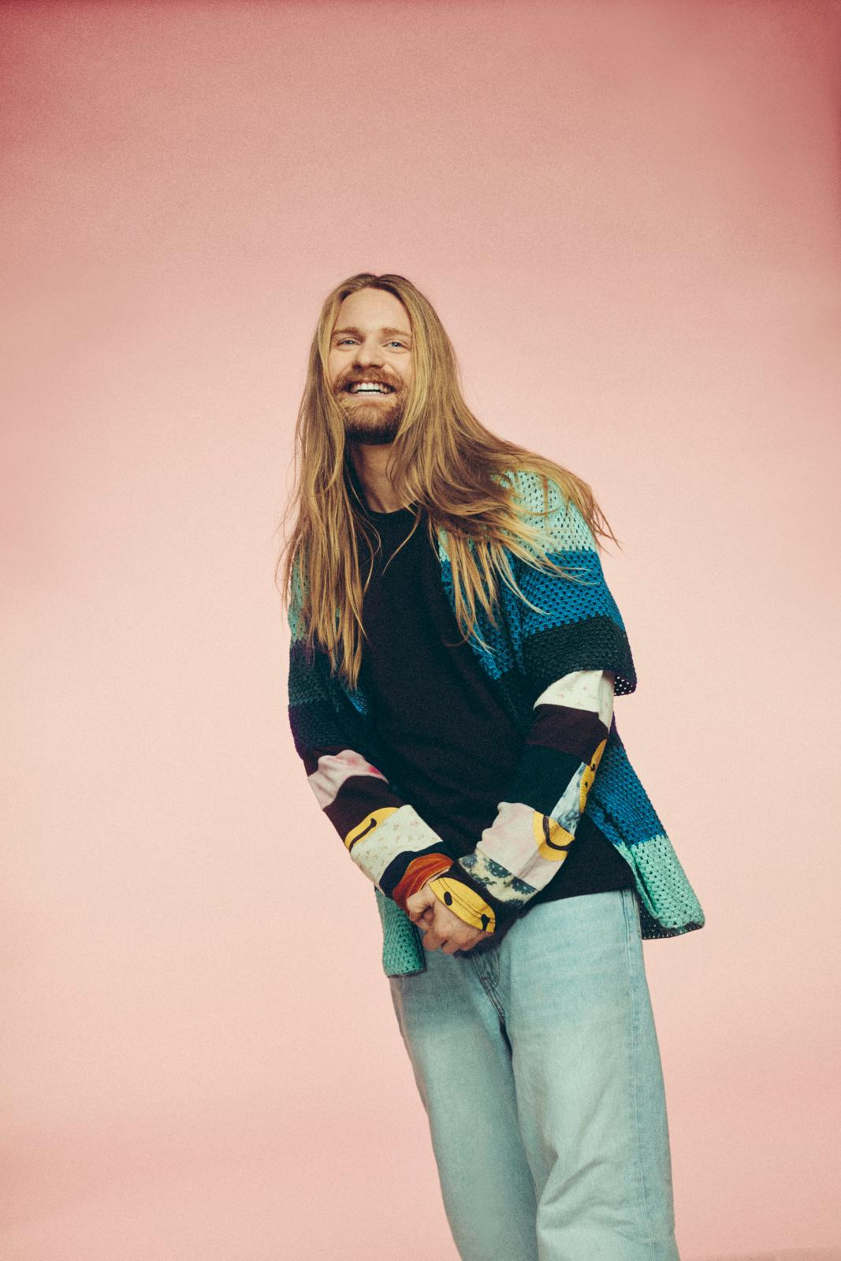
DOWNLOAD PRESS ASSETS HERE

AUGUST 19, 2022 – Following the recent announcement of UK wide tour, Sam Ryder releases his brand-new single “Somebody,” available now on all streaming platforms via Elektra Records/Parlophone Records. An amalgamation of soulful flickers and sunny pop flares, “Somebody” explores the euphoric sensation of summer love. The anthemic track arrives alongside a joyful music video, which is streaming now on Sam’s official YouTube channel.

Sam added on the new single, “Somebody is inspired by YOU! All of the kindness, positivity and joy we’ve experienced so far this year. Ultimately it’s about the joy of giving love and experiencing love.”

“Somebody” is the next chapter in Sam’s ever emerging musical journey after the recent news of his UK tour, which will allow Sam’s burgeoning army of new fans to see him play material from his forthcoming debut album due for release later this year. A consummate showman and natural live performer, Sam spent over a decade honing his craft in various bands on the pub and club circuit before his solo career achieved lift-off.

Sam’s meteoric rise has seen current single “Space Man” etch itself into the UK’s consciousness with stunning performances at Eurovision and the Queen’s Platinum Jubilee. The song reached number two in the UK single charts, becoming the highest charting UK Eurovision entry in over a quarter of a century in the process. “Space Man” is now one of the biggest selling tracks of 2022 with over 300K sales and has seen Sam quickly become a household name and the most successful UK debut act of the year.

The Essex singer-songwriter first rose to prominence during lockdown when his TikTok videos began to attract plaudits from the likes of Alicia Keys, David Guetta, Justin Bieber and Sia. He has gone on to amass 13 million followers and 106m likes on the platform, making him the UK’s biggest artist on TikTok in 2021.

SAM RYDER 2022/2023 LIVE DATES

August 5th 2022 - Hatfield, UK, Hatfield Park
August 26th 2022 - Kingham, UK, The Big Feastival
November 23rd 2022 - London, UK, HERE at Outernet
November 24th 2022 - London, UK, HERE at Outernet
March 17th 2023 - Belfast, UK, Ulster Hall
March 18th 2023 - Dublin, UK, 3Olympia
March 21st 2023 - Manchester, UK, Academy
March 22nd 2023 - Glasgow, UK, Barrowland
March 23rd 2023 - Newcastle, UK, O2 City Hall
March 25th 2023 - Liverpool, UK, O2 Academy
March 26th 2023 - Leeds, UK, O2 Academy
March 28th 2023 - Birmingham, UK, O2 Academy
March 29th 2023 - Cambridge, UK, O2 Academy
March 30th 2023 - London, UK, Eventim Apollo
April 1st 2023 - Cardiff, UK, The Great Hall
April 2nd 2023 - Bristol, UK, O2 Academy
April 4th 2023 - Bournemouth, UK, O2 Academy
April 5th 2023 - Brighton, UK, The Dome

SAM RYDER
“Somebody”
AVAILABLE NOW
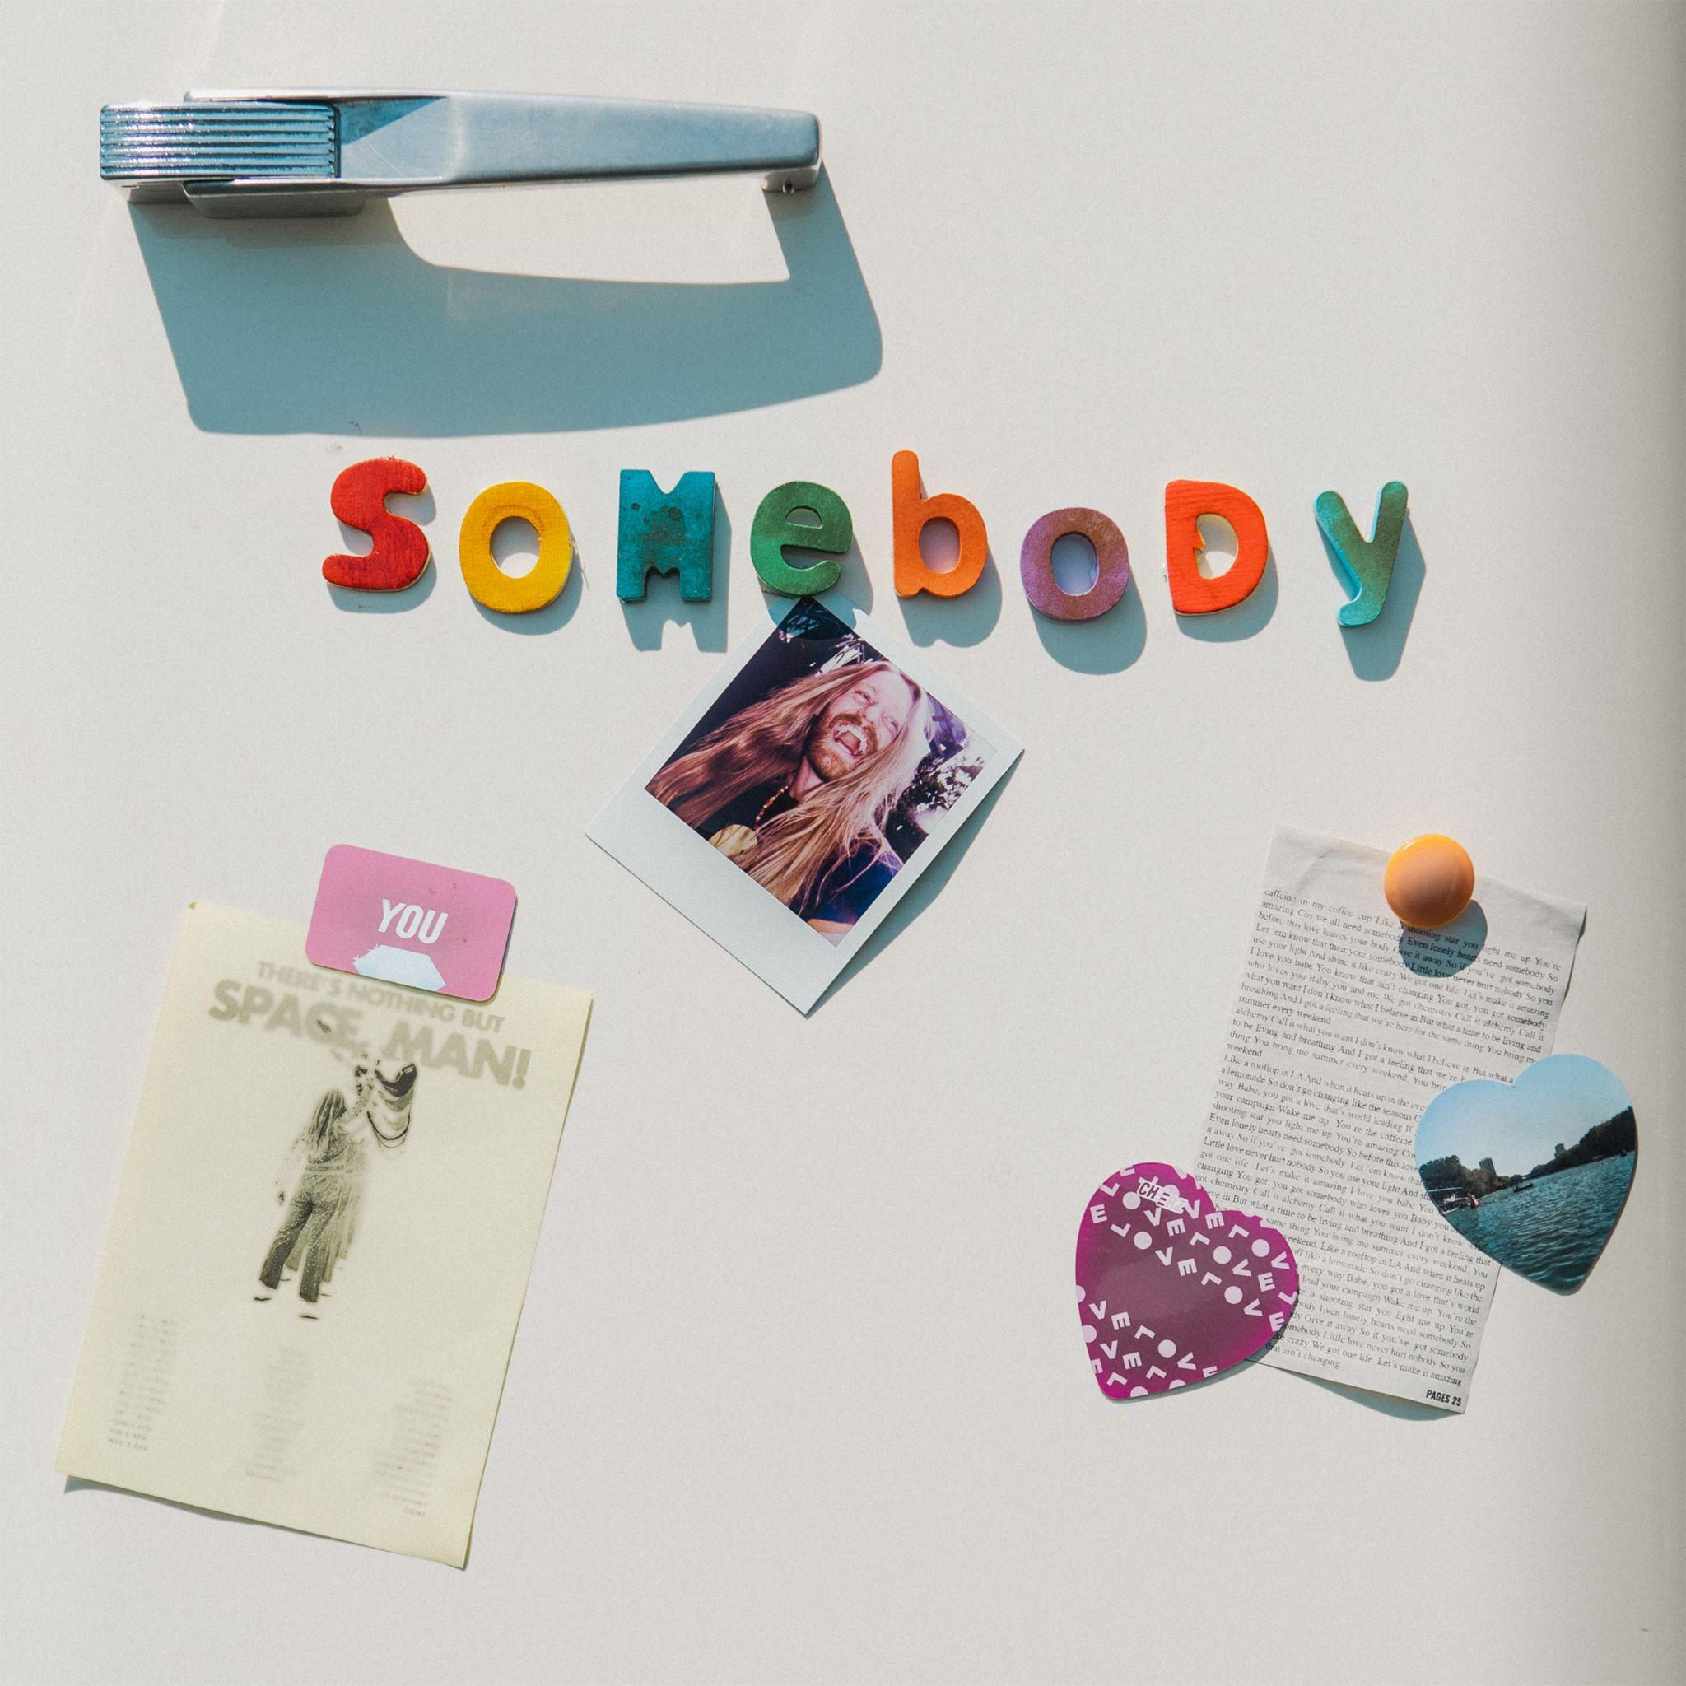

CONNECT WITH SAM RYDER
TikTok | Instagram | Twitter | Facebook

For US press inquiries, contact:
Glenn Fukushima – glennfukushima@elektra.com
Sarah Goldstein – sarahgoldstein@elektra.com

