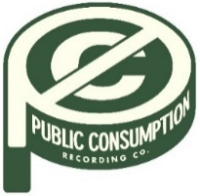
SYDNEY ROSE UNVEILS NEW SINGLE “BEDROOM FLOOR”
OFFICIAL VIDEO STREAMING NOW

U.S. TOUR DATES SUPPORTING ADDISION GRACE CURRENTLY UNDERWAY
AUGUST 26, 2022 – 18-year-old singer/songwriter Sydney Rose has unveiled new single “Bedroom Floor,” a heartfelt ballad about the pain of a loved one going off to college without you. The track arrives alongside an official music video which was shot and directed by Sydney herself. “Bedroom Floor” is available now via Public Consumption, with the video streaming now on Sydney’s official YouTube channel.
Sydney added, “‘Bedroom Floor’ is about my best friend. I wrote the song before my senior year of high school because I knew that I wasn’t going to college and she was. I wanted to lay out my thoughts and fears about the next chapter in our lives and encapsulate that feeling in this song.”
In July, Sydney shared her debut EP You Never Met Me, out now via Public Consumption. The six-track collection arrived to critical acclaim, with PEOPLE Magazine naming her one of their Emerging Artists To Watch and Under The Radar attesting, “‘You Never Met Me’ is the sound of Rose finding herself in her music and introducing herself to the world, tracing all of the messy contours of teenage heartbreak in the process.” Amplify Her Voice also praised the effort, stating “Rose re-discovers different parts of herself on her own, presenting her real self through a delicately honest six-song collection.”
The You Never Met Me EP includes previously released tracks “Phoebe Told Me,” “Things That Don’t Exist (feat. Zachary Knowles),” and “I’ll Never Get Over It” (tracklisting below) and is available on all streaming platforms now.
Sydney is currently supporting Addison Grace’s U.S. tour dates, which kicked off earlier this month. The trek hits The Echo in Los Angeles on September 23rd before wrapping up September 26th in Phoenix, AZ. Tickets for all dates are available now (tour itinerary below).
Earlier this spring, Sydney shared “Phoebe Told Me,” the singer/songwriter’s first release via Public Consumption. With breathy vocals and dreamy style inspired by the song’s namesake (Phoebe Bridgers), the track is a meditation on loving yourself and tuning out the pressures of the outside world. The release was followed by the intimate ballad “Things That Don’t Exist (feat. Zachary Knowles)” in April and “I’ll Never Get Over It” in June, which racked up praise from Sweety High for Sydney’s “gorgeously delicate voice” and arrived alongside a breezy, beachside music video directed by Syd Ostrander.
Sydney Rose initially gained traction via her intimate YouTube channel covers as well as TikTok, where she has amassed over 200k followers on the platform. Her rendition of Sleeping At Last’s “Turning Page” has accumulated over 35 million streams.
(Tour Dates/Single Art Below)

SYDNEY ROSE
2022 U.S TOUR DATES
All dates supporting Addison Grace

AUGUST
26 Philadelphia, PA The Foundry
27 Washington, DC Songbyrd

SEPTEMBER
15 Denver, CO Larimer Lounge
17 Salt Lake City, UT Kilby Court
19 Seattle, WA Madame Lou’s At The Crocodile
20 Portland, OR Polaris Hall
22 Oakland, CA Starline Social Club
23 Los Angeles, CA The Echo
25 San Diego, CA Voodoo Room at House of Blues
26 Phoenix, AZ The Rebel Lounge

SYDNEY ROSE
“Bedroom Floor”
AVAILABLE NOW
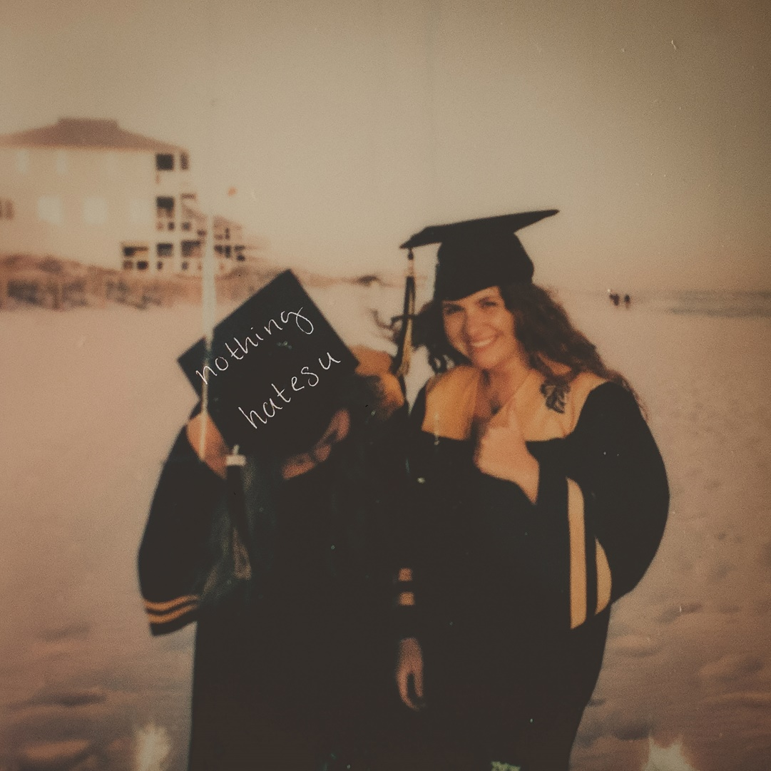

CONNECT WITH Sydney Rose
TIKTOK
YOUTUBE
INSTAGRAM

CONTACT:
Sarah Goldstein
SarahGoldstein@elektra.com

