ALFIE TEMPLEMAN AND THOMAS HEADON ANNOUNCE
NORTH AMERICAN CO-HEADLINE TOUR
DATES KICK OFF NOVEMBER 7TH IN ANAHEIM, CA

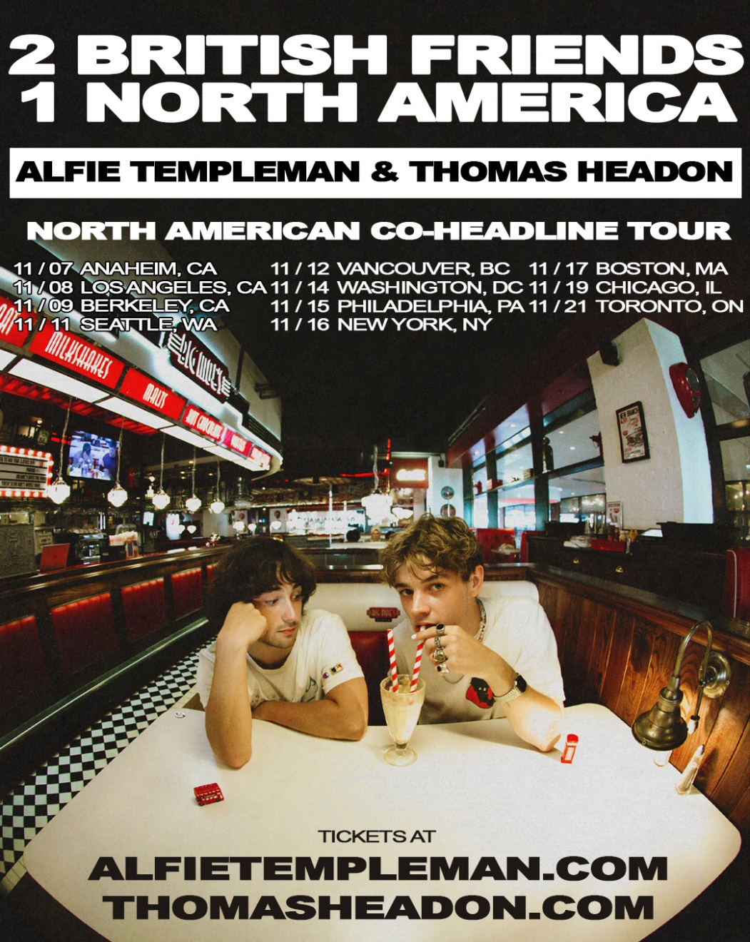
DOWNLOAD PRESS ASSETS HERE
SEPTEMBER 6, 2022 – Rising UK stars Alfie Templeman and Thomas Headon have announced the “2 British Friends 1 North America” tour. The North American co-headline trek kicks off November 7th in Anaheim, CA and includes stops at Los Angeles’ Troubador on November 8th and New York City’s Gramercy Theatre on November 16th before wrapping up in Toronto, ON on November 21st (tour itinerary below). Tickets will be available for presale beginning Wednesday, September 7th at 10am local time, with general onsale beginning Friday, September 9th at 10am local time. For up-to-date ticketing information, please visit www.alfietempleman.com or www.thomasheadon.com.
Templeman and Headon’s friendship began during the pandemic as they each supported the other's work online before meeting in person. Their bond grew stronger when they joined forces on Chloe Moriondo's track "Dizzy" – the song was produced by Alfie and featured both artists. The pair had always discussed a joint tour and ultimately landed on hitting the road together in North America.
“I’m super excited to go on tour with one of my worst enemies, however I love him to death and cannot wait to tour the US with him. We're gonna be in a tour bus together for 3 weeks so please come see us to give us both time apart from each other (we're gonna need it). I've missed the US and everyone out there so much, can't wait to tour parts of it I've never been to before !!!!!!!” – Thomas Headon
“This is a kinda dream tour for me, it feels really special getting to tour the songs we made and sent each other back in 2020. It’s a celebration of breaking free and taking you and your mate’s music on the road together.” – Alfie Templeman
About Alfie Templeman:
Since the release of his debut single “Like An Animal” in 2018, the UK’s Alfie Templeman has pushed boundaries like no other teenager, deftly combining indie-boy-next-door aesthetics with peerless musicianship. Entirely self-taught and playing no less than eleven instruments, his love of universe building, both aesthetically and musically, shone through on 2021’s mini-album Forever Isn’t Long Enough. US audiences got their first taste of Alfie’s live show around its release with his headline tour of North America as well as dates supporting Chloe Moriondo stateside. Acting as both an intimate diary entry and a communal call to arms, Templeman’s debut LP Mellow Moon features the top 5 UK radio hit “Colour Me Blue” and “Broken” which was in rotation at Sirius XM Alt Nation among several other stations across the U.S. The track also found love with DSPs, landing on multiple playlists including Lorem, Alt Pop, Indie Pop, Our Gen, The Indie list, Feel Good Indie. The album – on which he played all the instruments and contributed heavily with production and co-production duties – drew attention from, among others, Stereogum, Paste, Billboard, Perez Hilton, and British Vogue. Collaborating with Amazon, Alfie created “Welcome to the Mellow Moon” - a large-scale virtual world purpose built in the #1 best-selling video game of all time, Minecraft. Templeman has over 200 million streams worldwide and is featured on his hero Todd Rundgren’s forthcoming album.
About Thomas Headon:
Born in London and raised in Melbourne, Thomas Headon dreamed of moving back to the city to pursue music and was told by his mom that he had a year to get a “proper job,” otherwise he would have to return home. Arriving in London just before the pandemic hit, Thomas started to build a community online – blowing up on TikTok with 18M likes and nearly 450K followers to date – with his off-kilter live sessions, tongue-in-cheek charm and remarkable songwriting ability. Learning to write and produce on his own in his late teens, Thomas shared his self-written and self-produced debut EP, The Greatest Hits, and dropped The Goodbye EP in 2020, amassing over 50 million streams worldwide. With an incredibly loyal fanbase, Thomas’ blend of playful alternative pop that speaks to the Gen-Z experience has been compared to the likes of the 1975’s Matty Healy, and critically praised by Triple J, naming him a “seriously impressive force in pop music.” Thomas’ EP Victoria arrived earlier this year, which included singles “Strawberry Kisses” and “Nobody Has To Know.” The EP hit #23 on the UK album charts – the highest charting EP of any genre in 2022 so far – and racked up critical acclaim from Dork, Ones To Watch, Euphoria Magazine, and more. Thomas was also handpicked by Elton John to support him at his BST Hyde Park show in London, recently supported Sigrid on her European tour, and played sold-out UK, Australian and North American headline tours.

ALFIE TEMPLEMAN AND THOMAS HEADON
“2 BRITISH FRIENDS 1 NORTH AMERICA”
2022 CO-HEADLINE TOUR DATES

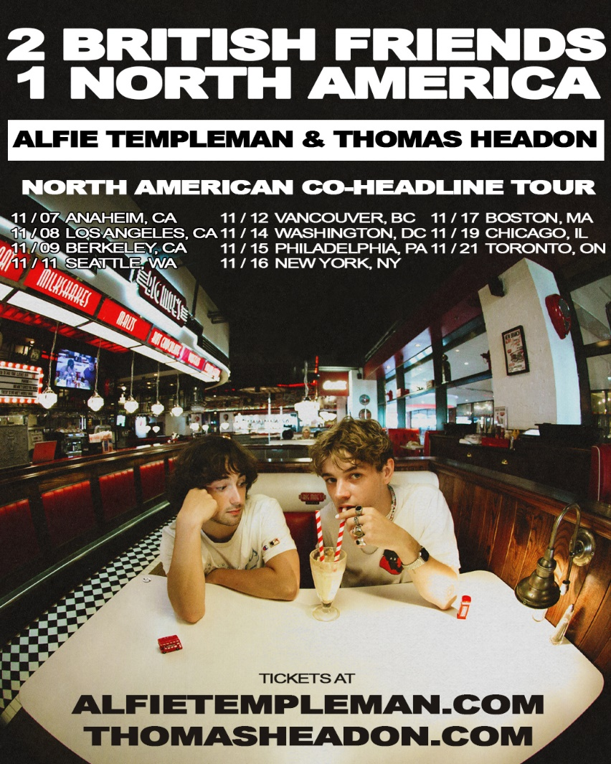
Nov-07 Anaheim, CA Parish @ House Of Blues
Nov-08 Los Angeles, CA Troubadour
Nov-09 Berkeley, CA Cornerstone
Nov-11 Seattle, WA Madame Lou's
Nov-12 Vancouver, BC Rio Theatre
Nov-14 Washington, DC Union Stage
Nov-15 Philadelphia, PA First Unitarian Church
Nov-16 New York, NY Gramercy Theatre
Nov-17 Boston, MA Brighton Music Hall
Nov-19 Chicago, IL Bottom Lounge
Nov-21 Toronto, ON Velvet Underground

CONNECT WITH ALFIE TEMPLEMAN
WEBSITE | INSTAGRAM | TIKTOK | TWITTER | YOUTUBE

CONNECT WITH THOMAS HEADON
WEBSITE | INSTAGRAM | TIKTOK | TWITTER | YOUTUBE

Media Contacts:

For Alfie Templeman, please contact:
Lisa Gottheil
lisag@grandstandhq.com

For Thomas Headon, please contact:
Sarah Goldstein
sarahgoldstein@elektra.com

