TONES AND I SHARES NEW SINGLE “CHARLIE”

PERFORMS “CHARLIE” ON JIMMY KIMMEL LIVE!

OFFICIAL LYRIC VIDEO STREAMING NOW

NORTH AMERICAN LEG OF GLOBAL HEADLINE TOUR
CONTINUES TONIGHT IN LOS ANGELES, CA

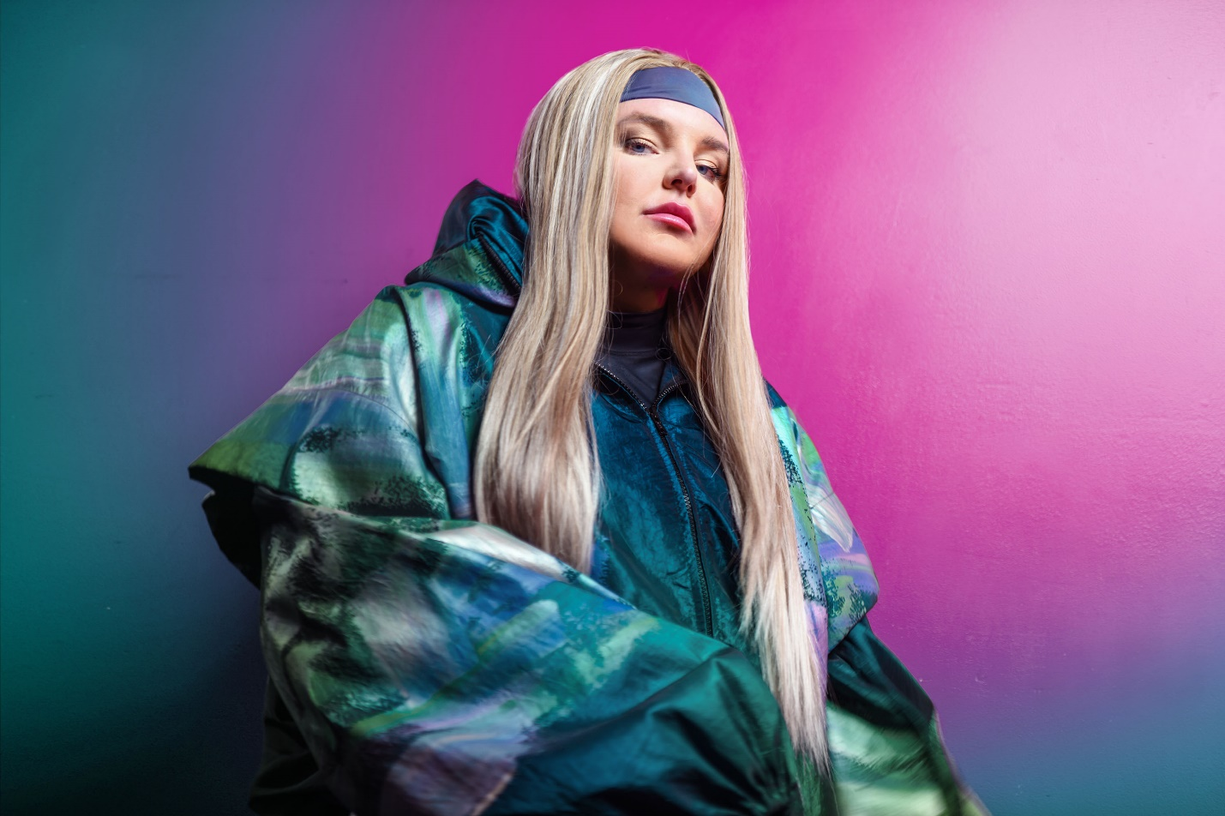
PHOTO CREDIT: GIULIA MCGAURAN

AUGUST 10, 2022 – Global superstar and multi award winning songwriter Tones And I has returned with her new single “Charlie,” which is available today on all streaming platforms and joined by an official lyric video. To celebrate the release, Tones And I delivered a debut TV performance of “Charlie” last night on Jimmy Kimmel Live! - watch it HERE. On the disco-inspired new track, Tones And I sounds bolder and brighter as her voice floods the dancefloor with euphoria.

Elaborating on the new track, Tones And I explained, “’Charlie’ was a song that came out of nowhere, it was done in three hours and we wrote the bass line first. It’s about missing my dog Charlie and other things. It’s a funky jam and I just wanted to have some fun with it.”

“Charlie” arrives on the heels of Tones And I’s recent feature alongside Macklemore on his new single “Chant.” The pair recently debuted the collaboration on Good Morning America with an electrifying performance in New York City’s Central Park – Watch it HERE.

Tones And I is currently in the midst of a massive slate of global festival performances and headline tour dates, with the North American leg of her headline tour continuing tonight in Los Angeles, CA at The Wiltern [full tour itinerary below]. Furthermore, Tones And I is set to join Macklemore on tour this summer (August 16th – September 15th) as a guest performer during his set while he traverses the country alongside Imagine Dragons. For more information on Tones And I’s tour dates and tickets to upcoming shows, visit www.tonesandi.com.

Released in 2021, Tones And I’s debut album Welcome To The Madhouse landed at #1 on Australia’s ARIA Albums Chart continuing an incredible string of successes for Tones And I. The record details an intimately honest and vivid journey from busking in Byron Bay to international stardom to saying goodbye to her best friend. Tones And I weaves it all together into a moving and magnetic 14-track collection written entirely by the Australian artist with her co-producing every song. The album is highlighted by the single “Fly Away,” a poetic and powerful composition which Tones And I delivered performances of on Jimmy Kimmel Live! and The Ellen DeGeneres Show. Welcome To The Madhouse also features “Won’t Sleep,” which arrived alongside a Tones And I, Nick Kozakis and Liam Kelly directed official music video, and “Cloudy Day,” which VARIETY hailed as “the perfect pandemic anthem” with Tones And I performing the song on The Late Show with Stephen Colbert and TODAY.

Tones And I exploded in to pop culture’s consciousness with her global smash “Dance Monkey,” the most Shazamed single of all time, and officially the 3rd most streamed song of all time on Spotify making the track the most streamed song ever by a female artist on the platform. Since its release, the “Dance Monkey” official music video has surpassed 1.8 billion views on YouTube, while the track has eclipsed seven billion streams globally and earned 6x platinum certification from the RIAA in the US as well as multi-platinum or diamond certification in sixteen other countries. “Dance Monkey” is featured on Tones And I’s RIAA gold certified debut EP The Kids Are Coming which earned her four major ARIA Awards including: “Breakthrough Artist,” “Best Female Artist,” “Best Pop Release,” and “Best Independent Release.”

Originally from Australia’s Mornington Peninsula, Tones And I traveled to Byron Bay in early 2018 to take a chance at busking. On the first day she had crowds spilling onto the street. Tones quit her retail job and decided to make Byron her new home where she lived out of her van for a year, honing her songwriting and busking every weekend. A year later, she had one of the biggest songs in the world with her global smash “Dance Monkey.”

[SINGLE ART / TOUR ITINERARY BELOW]

TONES AND I
“CHARLIE” SINGLE ARTWORK

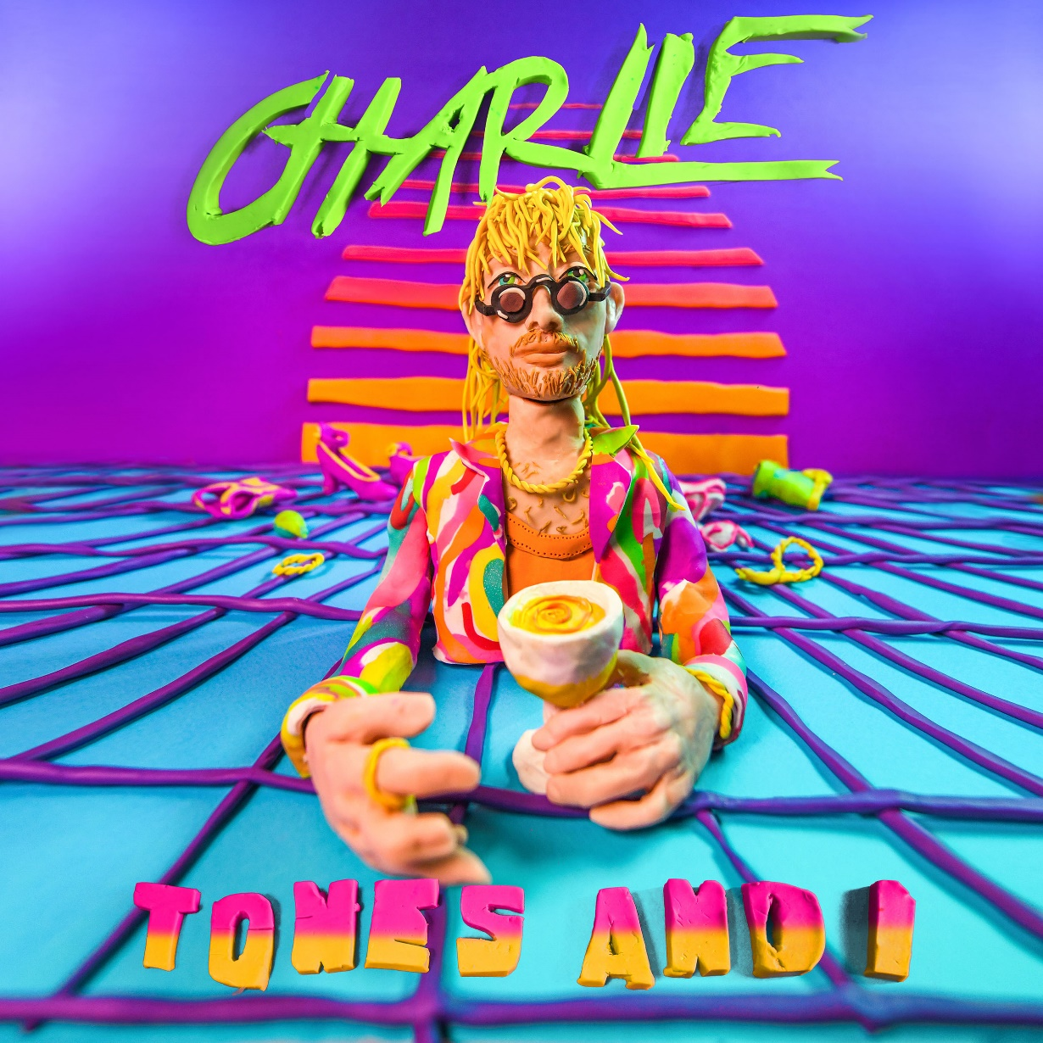

TONES AND I
2022 WORLD TOUR REMAINING DATES

August 10 - Los Angeles, CA - The Wiltern
August 11 - San Diego, CA - SOMA
August 13 - San Francisco, CA - The Independent
August 14 - San Francisco, CA - Bimbo's 365 Club
August 27 - Cheyenne, WY - Edge Fest 2022*
October 9 - Seoul, KR - Slow Life Slow Live 2022*
December 3 - Bathurst, AU - Vanfest 2022*

*Festival Performance

FOR MORE INFORMATION ON TONES AND I:
FACEBOOK / TWITTER / INSTAGRAM / YOUTUBE / SPOTIFY / APPLE MUSIC / AMAZON MUSIC

CONTACT FOR TONES AND I:

Glenn Fukushima
Glenn.Fukushima@300Elektra.com

Ross Anderson
Ross.Anderson@300Elektra.com

