TWENTY ONE PILOTS
GARNER FOUR NEW RIAA CERTIFICATIONS
INCLUDING SECOND CAREER DIAMOND AWARD

ONE OF ONLY 18 ARTISTS EVER TO EARN
MULTIPLE DIAMOND SINGLES CERTIFICATIONS

NORTH AMERICAN HEADLINE ARENA RUN “THE ICY TOUR 2022” UNDERWAY

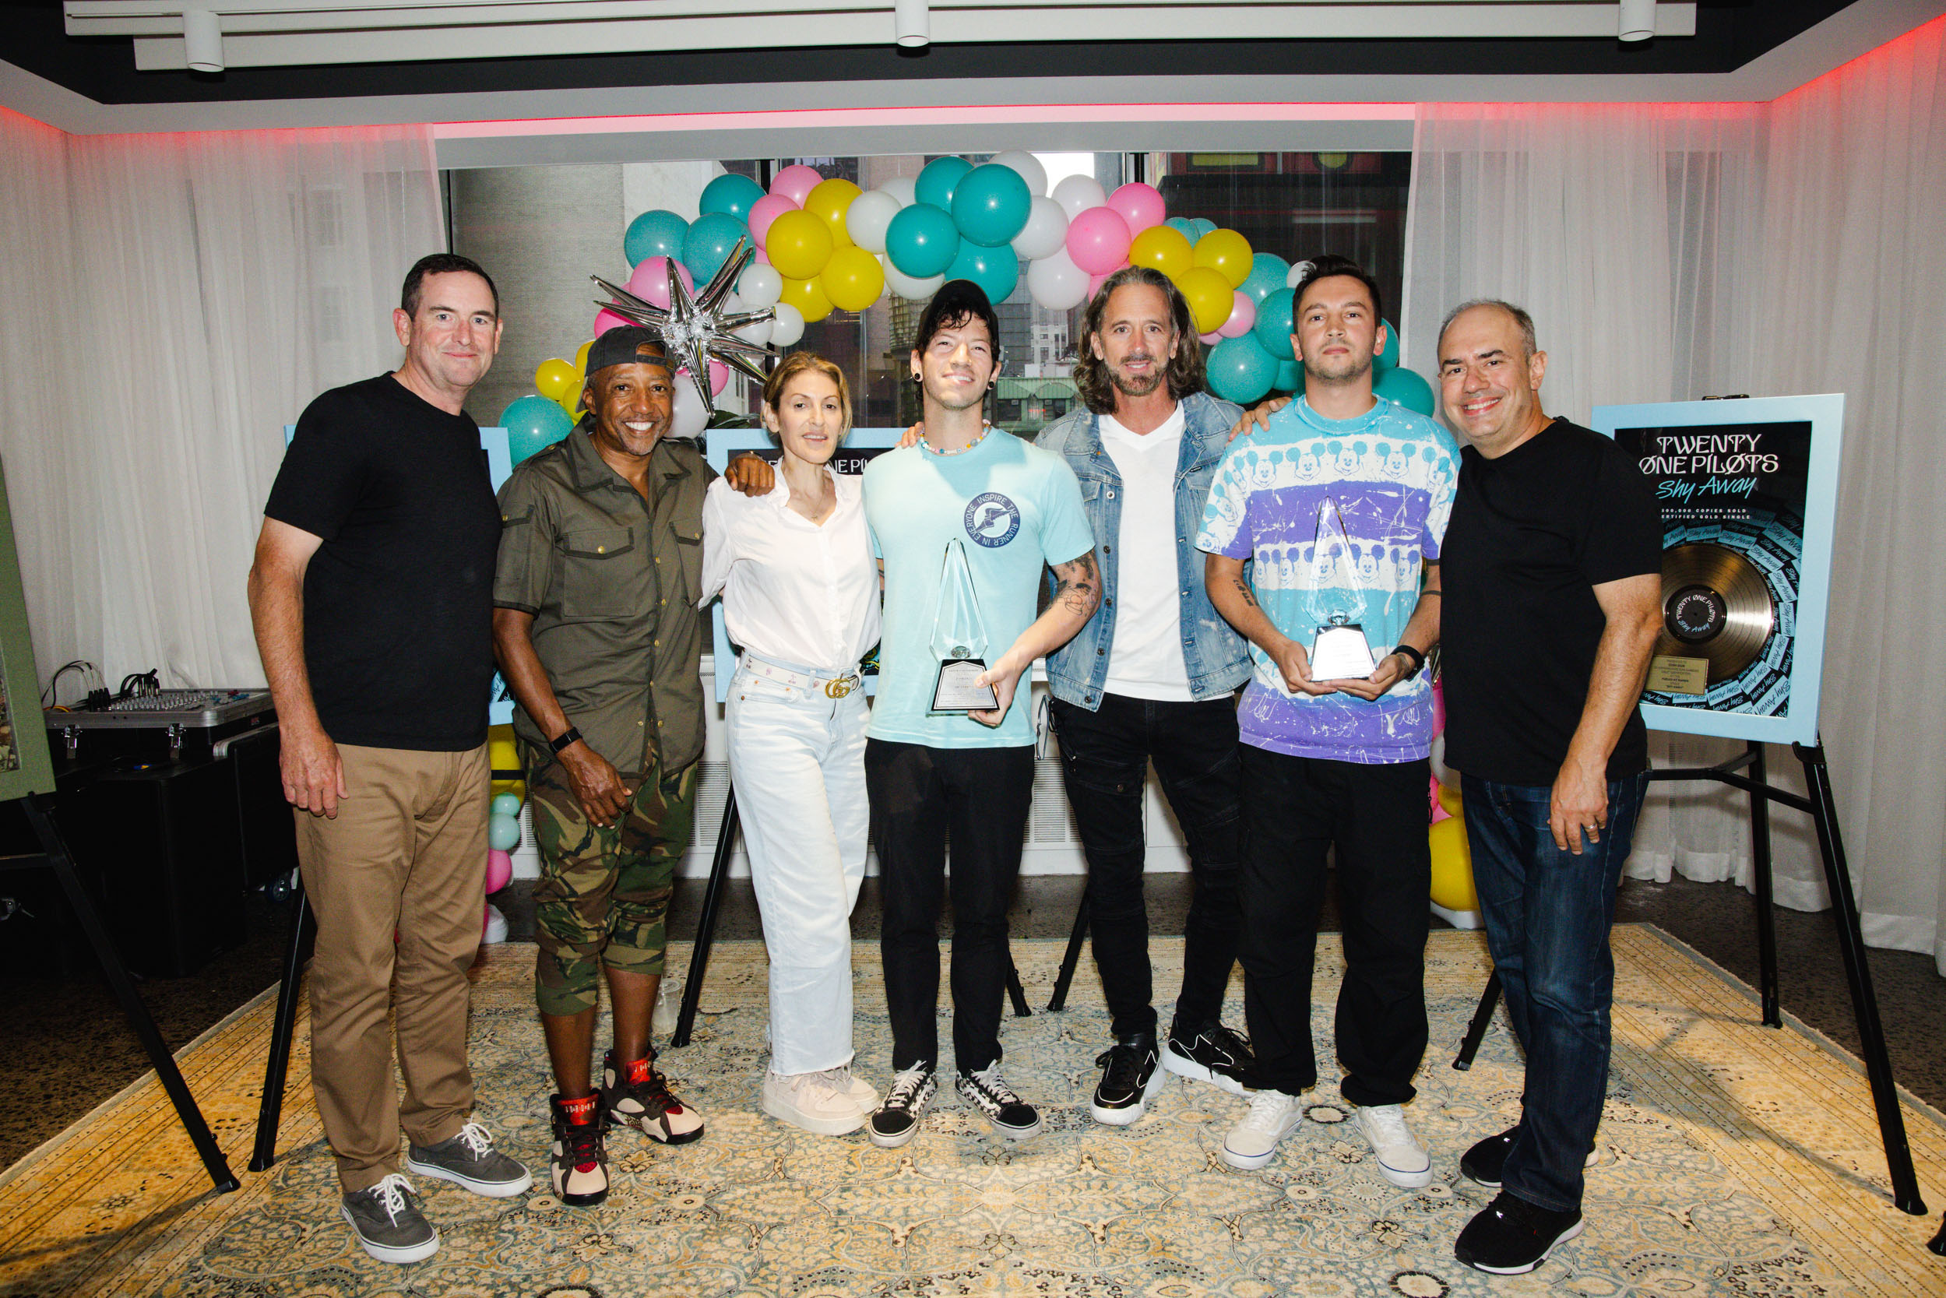
PHOTO CREDIT: ASHLEY OSBORN

(L-R) 300 Elektra Entertainment President Mike Easterlin, 300 Elektra Entertainment Chairman & CEO Kevin Liles, Atlantic Records Chairman & COO Julie Greenwald, Twenty One Pilots’ Josh Dun, Element1 Music Founder Chris Woltman, Twenty One Pilots’ Tyler Joseph, Atlantic Records President of A&R Pete Ganbarg

SEPTEMBER 21, 2022 – GRAMMY® Award winning duo Twenty One Pilots just received multiple new RIAA certifications ahead of their recent sold-out headline show at New York City’s Madison Square Garden. The new awards recognized the Gold certification of their latest album Scaled And Icy, Gold certification of their single “Shy Away,” Platinum certification of their single “Jumpsuit,” and a Diamond certification for their generational anthem “Heathens.” This notably marks the group’s second Diamond award elevating them to rarified air as one of only 18 artists ever to earn multiple Diamond singles certifications.

Twenty One Pilots previously made RIAA history in 2018 when their 5x Platinum 2015 full-length, BLURRYFACE, which features the Diamond certified smash hit “Stressed Out,” became the first album in the digital era with every song receiving a Gold, Platinum, or Multi-Platinum certification from the RIAA. A year later, its 2013 predecessor Vessel repeated the same feat making Twenty One Pilots the first artist / group with two albums to reach this landmark achievement.

This July, Twenty One Pilots shared a special live version “Heathens,” inspired by the opportunity to reimagine the song within the fitting world of Netflix’s original hit series Stranger Things. Filmed on the last stop of their European festival run at Romania’s Electric Castle festival, “Stranger Things // Heathens” (Live from Romania) is joined by an official performance video capturing the surprise live moment from the festival ground’s historic Bánffy Castle – watch it HERE.

Twenty One Pilots are currently traversing North America on “THE ICY TOUR 2022.” The headline arena run is set to continue through late September before concluding with a performance at Seattle’s Climate Pledge Arena on September 24th [full itinerary below]. For complete details on Twenty One Pilots’ upcoming live dates and ticket availability for the “THE ICY TOUR 2022,” visit www.twentyonepilots.com/tour.

Earlier this year, Twenty One Pilots featured on the iconic MTV Unplugged series where they delivered reimagined versions of some of their biggest and most beloved songs from their catalog – Watch it HERE. Furthermore, the duo also hosted the “Twenty One Pilots Cinema Experience” film event, which gathered fans in sold-out cinemas around the globe to watch an extended cut of the duo’s 2021 epic Scaled And Icy album release livestream performance featuring remastered audio / video, and more than 20 minutes of never-before-seen footage.

Scaled And Icy debuted at No. 1 on Billboard's Top “Rock Albums” and “Alternative Albums” charts while landing at No. 3 on the “Billboard 200,” marking the biggest opening week for a rock album in 2021. The record is highlighted by the #1 Alternative Radio hits “The Outside,” “Saturday,” and “Shy Away,” the latter of which ascended to #1 at the format in just three weeks, placing the duo in an elite group of acts with multiple songs to rise to #1 at the format in three weeks or less including: U2, R.E.M., The Cure, Linkin Park, Red Hot Chili Peppers, and Foo Fighters.

Written and largely produced by Tyler Joseph in isolation over the course of 2020 at his home studio, with Dun engineering the album’s drums from across the country, Scaled And Icy is the product of long-distance virtual sessions and finds the duo processing their upended routines along with the prevailing emotions of 2020 - anxiety, loneliness, boredom, and doubt. The duo had to forgo their normal studio sessions but reached a new of level of introspection in the process, adopting a more imaginative and bold approach to their songwriting. The result is a collection of songs that push forward through setbacks and focus on the possibilities worth remembering. Scaled And Icy is Twenty One Pilots’ first studio album in three years and follows their RIAA Platinum certified LP, Trench.

[FORTHCOMING LIVE DATES BELOW]

TWENTY ONE PILOTS
“THE ICY TOUR 2022”
FORTHCOMING DATES
www.twentyonepilots.com/tour

Sep 22 - Portland, OR - Moda Center
Sep 24 - Seattle, WA - Climate Pledge Arena

ABOUT TWENTY ONE PILOTS:
GRAMMY® Award-winning Twenty One Pilots quietly emerged as one of the most successful bands of the 21st century and redefined the sound of a generation. After billions of streams and dozens of multi-Platinum certifications around the world, the history-making Columbus, OH duo—Tyler Joseph and Josh Dun—ascended to a creative and critical high watermark on their new full-length album, Scaled And Icy. The album debuted at No. 1 on Billboard's Top “Rock Albums” and “Alternative Albums” charts, while landing at No. 3 on the “Billboard 200,” marking the biggest opening week for a rock album in 2021. Among a collection of anthems, Scaled And Icy spawned “Shy Away,” which spent eight consecutive weeks at #1 at Alternative Radio, as well as “Saturday” and “The Outside,” both of which also climbed to #1 at Alternative Radio. The RIAA Gold certified Scaled And Icy follows Twenty One Pilots’ 2018 Platinum certified album TRENCH, which features the Platinum singles: “Chlorine,” “My Blood,” and the GRAMMY® Award-nominated Platinum song “Jumpsuit.” The album graced spots on “Best of” year-end lists by Billboard, KERRANG!, Alternative Press, and Rock Sound—who placed it at #1. Formed in 2009, the guys grinded towards this moment following the mainstream breakout of 2015’s BLURRYFACE. Certified 4x Platinum in the U.S., it was declared the first album ever to have every one of its songs certified Gold or Platinum by the RIAA, and garnered a GRAMMY® Award for the Diamond certified “Stressed Out.” In 2019 Twenty One Pilots announced that their 2013 LP Vessel achieved the same Gold & Platinum milestone with every individual track from the album receiving Gold, Platinum or Multi-Platinum certification from the RIAA, making the duo the first artist / group with two albums to reach this landmark achievement. With their second Diamond certification in 2022 for “Heathens,” they also stand out as one of only 18 artists to earn multiple Diamond singles certifications. They launched “THE ICY TOUR 2022” and kicked off another era this year.

###

For more information on Twenty One Pilots, contact:
Ross Anderson | RossAnderson@Elektra.com

Follow Twenty One Pilots:
Official | Facebook | Instagram | Twitter | YouTube

