**WATERPARKS RELEASE**

**“SELF-SABOTAGE FEAT. GOOD CHARLOTTE”**

**LISTEN** [**HERE**](https://waterparks.lnk.to/ssgc) **/ WATCH** [**HERE**](https://www.youtube.com/watch?v=DCyI45-YvY4)

+ “FUCK ABOUT IT FEAT. BLACKBEAR” ARRIVING SOON +

[**PRE-SAVE HERE**](https://waterparks.lnk.to/fuckaboutit)

**+ ON TOUR WITH BLACKBEAR +**

[**TOUR TICKETS HERE**](https://www.waterparksband.com/)+ 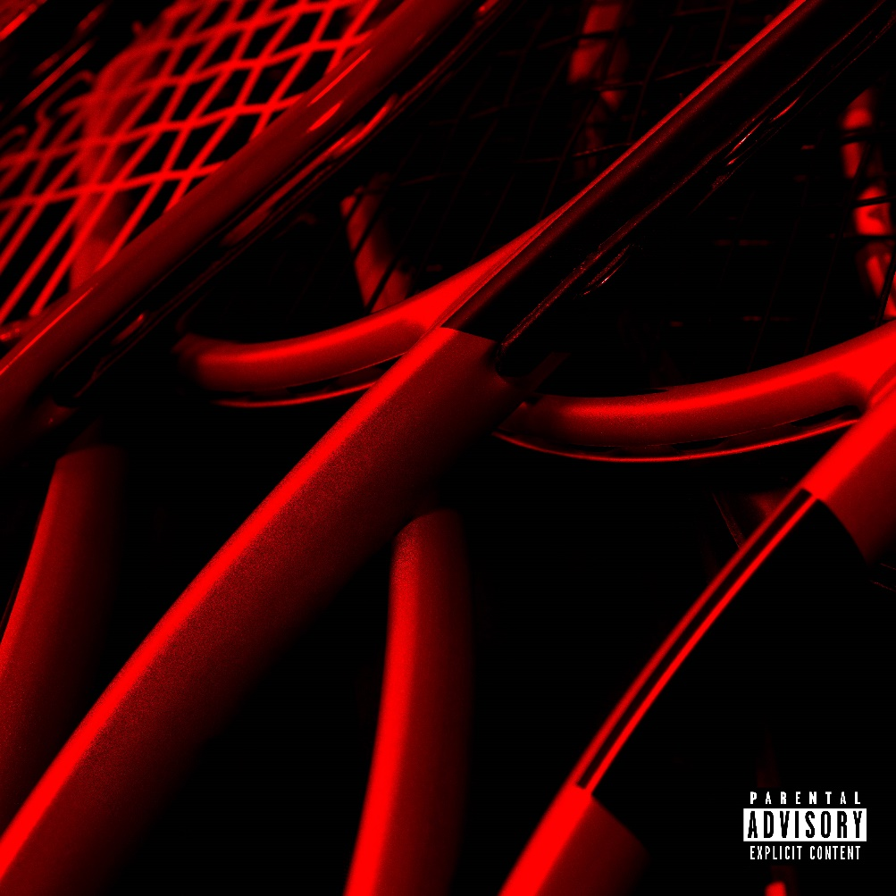

**September 22, 2022** – Today, Waterparks give electric single “SELF-SABOTAGE” a fresh take with a collaboration featuring the iconic group Good Charlotte. Unveiling the track and visualizer today via Fueled by Ramen, the result is an anthemic and spirited track that’s sure to have you on your feet. [**Watch HERE**](https://www.youtube.com/watch?v=DCyI45-YvY4) and [**listen HERE**.](https://waterparks.lnk.to/ssgc)

"SELF-SABOTAGE feat. Good Charlotte” arrives in the wake of the Erik Rojas directed "SELF-SABOTAGE" music video, which cinematically captured the group's day to day life on tour. Accented with vivid hues of color, the tracks snappy guitars and fuzzy electronics underline the manically catchy hook highlighted by Awsten’s wild sky-high register. The spirited vocals and infectiously cheerful guitar riff perfectly contrast with the diary-esque lyrics that detail Awsten’s self-imposed restrictions. “SELF-SABOTAGE” is yet another illustration of the trio’s uncanny knack for the unpredictable.

Additionally, Waterparks announce “FUCK ABOUT IT (feat. blackbear)” available to pre-save [**HERE**](https://waterparks.lnk.to/fuckaboutit). This highly anticipated single follows the group’s current direct support run on blackbear's *Nothing Matters Tour –* tickets available [**HERE**](https://www.waterparksband.com/). Waterparks recently concluded their headlining Sad Summer Tour dates, and embarked on dates featuring My Chemical Romance, before they headed on tour with blackbear.

Following Waterparks Fueled by Ramen debut “FUNERAL GREY,” the trio continues into their newest era. This era sees Waterparks step into a more mature sound and look, elevating the image and sonics that have already accumulated over half a billion career streams to date, with over 2MM monthly listeners and 400,000 Spotify followers. Their last album, *Greatest Hits*, debuted with over 15,000 album-unit equivalents in the US, earning it the no. 5 spot on Billboard’s Alt/Rock chart.

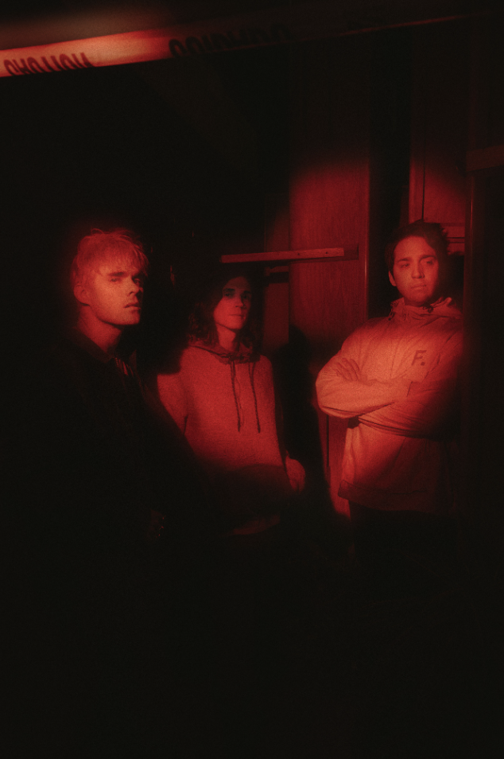

Credit: Jawn Rocha

[Download Hi-Res Promo Images](https://300.box.com/s/p3khg0n8o1jbwz1xbo456igivrcyrl7t) [**here**](https://300.app.box.com/s/p3khg0n8o1jbwz1xbo456igivrcyrl7t)

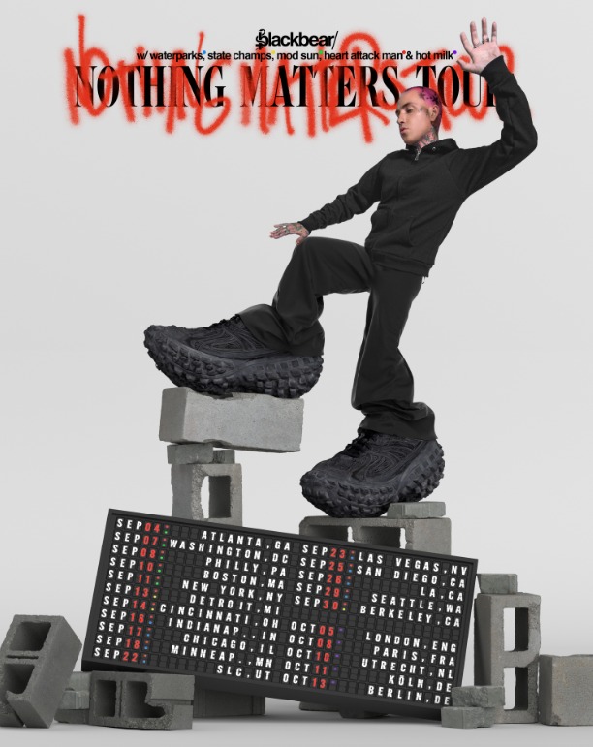

**WATERPARKS   
"FUCK ABOUT IT (FEAT. BLACKBEAR)"**[**PRE-SAVE HERE**](https://waterparks.lnk.to/fuckaboutit)

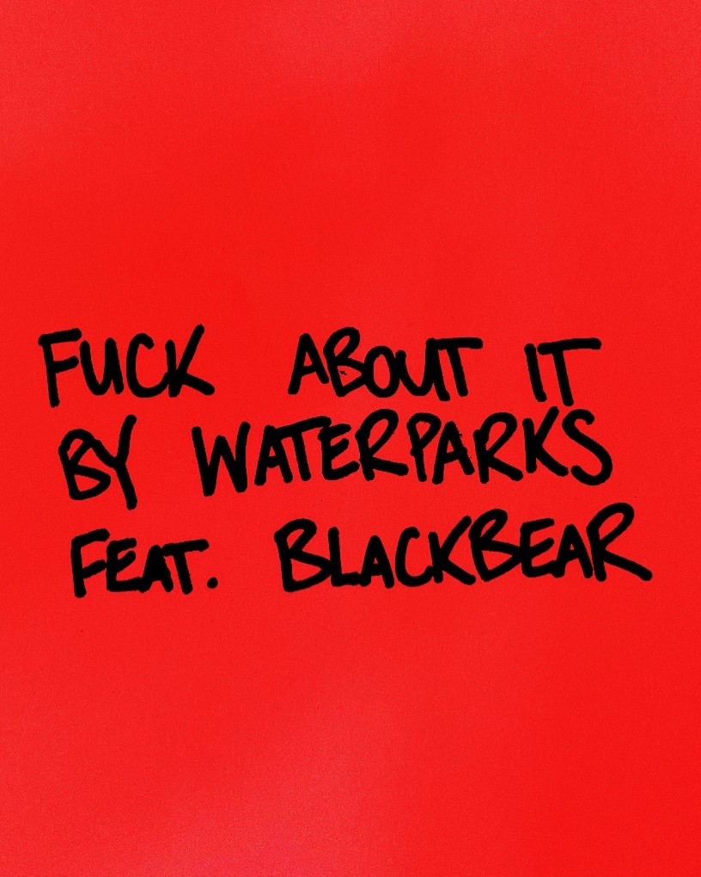

**ABOUT WATERPARKS**

Waterparks, composed of **Awsten Knight** [vocals, guitar], **Otto Wood** [drums], and **Geoff Wigington** [guitar]—manically move forward, shucking and jiving between fits of rock, alternative, and electronic with pop ambition and hip-hop’s bold and blatant disregard for the rules. The Houston trio has landed the covers of **Alternative Press**, **V Magazine**, **Kerrang!**, **Rock Sound, and more** and have garnered support from **Spotify, Apple Music,** and **Amazon Music,** finding themselves on numerous New Music Fridays and countless rock/alt playlists. The band has also **topped the Billboard 200 chart.** Waterparks’ unique and genre-blending sound puts them in a lane all their own, melding rock, pop, hip-hop, alternative, indie, electronic, and even R&B.

**KEEP UP WITH WATERPARKS**

[**TikTok**](https://www.tiktok.com/@awstenmadeatiktokalright?lang=en) | [**Instagram**](https://www.instagram.com/waterparks/?hl=en) | [**Twitter**](https://twitter.com/WATERPARKS)