WATERPARKS RELEASE OFFICIAL MUSIC VIDEO FOR
“SELF-SABOTAGE”
WATCH HERE
TOUR TICKETS HERE
+UPCOMING TOUR DATES WITH BLACKBEAR+
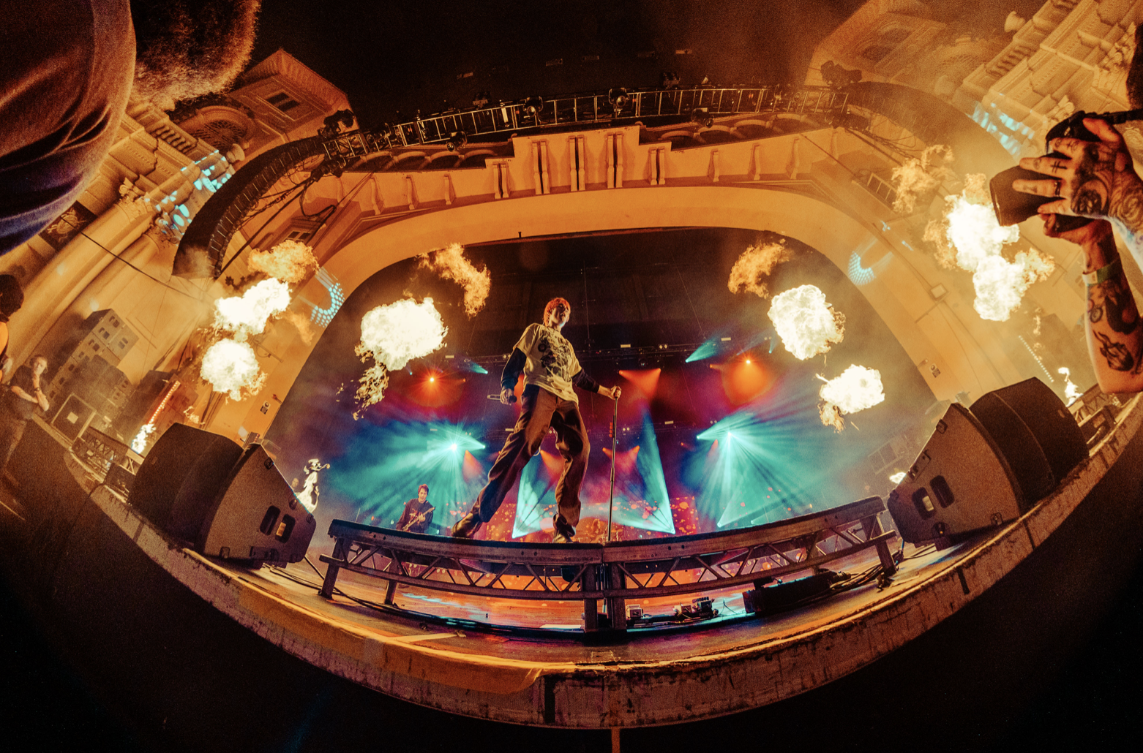
August 8, 2022 – Today, Waterparks unveil the music video for single “SELF-SABOTAGE,” via Fueled by Ramen. Watch HERE and listen HERE.
Directed by Erik Rojas, the "SELF-SABOTAGE" visual is a cinematic display of the group's day to day life on tour. Accented with vivid hues of color, the anthem's snappy guitars and fuzzy electronics underline the manically catchy hook highlighted by Awsten’s wild sky-high register. The spirited vocals and infectiously cheerful guitar riff perfectly contrast with the diary-esque lyrics that detail Awsten’s self-imposed restrictions. “SELF-SABOTAGE” is yet another illustration of the trio’s uncanny knack for the unpredictable.
The group are set to embark on additional tour dates in September as direct support on blackbear's Nothing Matters Tour. Waterparks recently concluded their headlining Sad Summer Tour dates, and are embarking on dates featuring My Chemical Romance, before heading on tour with blackbear. Check out the full list of tour dates HERE.
Following Waterparks Fueled by Ramen debut “FUNERAL GREY,” the trio continues into their newest era. This era sees Waterparks step into a more mature sound and look, elevating the image and sonics that have already accumulated over half a billion career streams to date, with over 2MM monthly listeners and 400,000 Spotify followers. Their last album, Greatest Hits, debuted with over 15,000 album-unit equivalents in the US, earning it the no. 5 spot on Billboard’s Alt/Rock chart.
"I loved collaborating with Awsten and Jawn on this one. The Waterparks live experience is so high energy and unique, and capturing its beautiful chaos for this video felt like the perfect visual pairing for SELF-SABOTAGE.”
- Erik Rojas
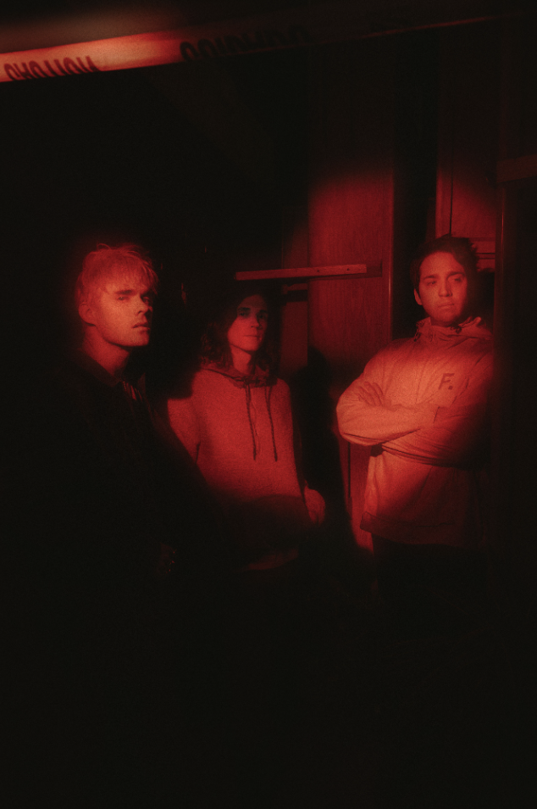
Credit: Jawn Rocha
Download Hi-Res Promo Images here
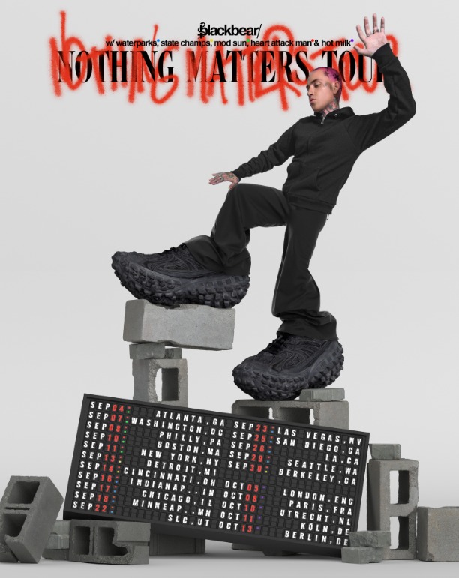
ABOUT WATERPARKS
Waterparks, composed of Awsten Knight [vocals, guitar], Otto Wood [drums], and Geoff Wigington [guitar]—manically move forward, shucking and jiving between fits of rock, alternative, and electronic with pop ambition and hip-hop’s bold and blatant disregard for the rules. The Houston trio has landed the covers of Alternative Press, V Magazine, Kerrang!, Rock Sound, and more and have garnered support from Spotify, Apple Music, and Amazon Music, finding themselves on numerous New Music Fridays and countless rock/alt playlists. The band has also topped the Billboard 200 chart. Waterparks’ unique and genre-blending sound puts them in a lane all their own, melding rock, pop, hip-hop, alternative, indie, electronic, and even R&B.

KEEP UP WITH WATERPARKS
TikTok | Instagram | Twitter

