FOR IMMEDIATE RELEASE
SEPTEMBER 2, 2022

FLOR RETURN WITH NEW SINGLE “EVERY NIGHT”
LISTEN HERE | WATCH HERE

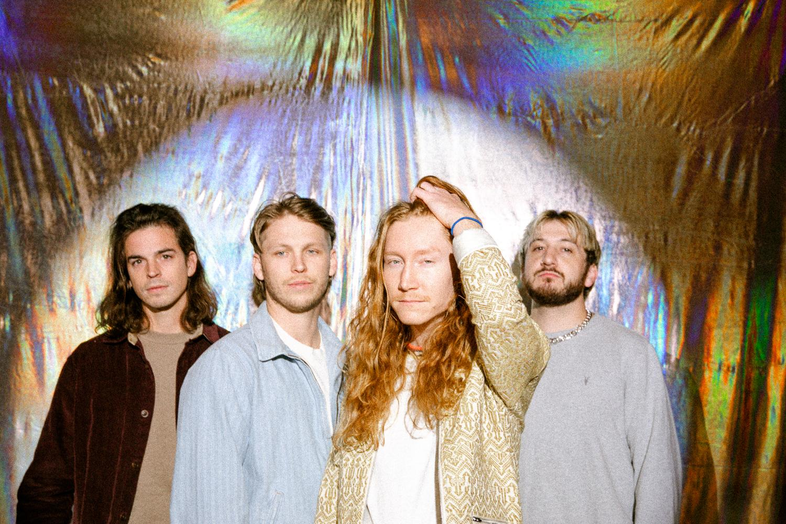
(Photo credit: Ashley Osborn)

FUTURE SHINE TOUR KICKS OFF THIS MONTH ACROSS NORTH AMERICA
TICKETS AVAILABLE HERE

NEW ALBUM FUTURE SHINE AVAILABLE NOW VIA FUELED BY RAMEN
LISTEN HERE

Hood River, OR alt-pop band flor have unveiled their new single “Every Night”. The anthemic track is available to stream and download beginning today via Fueled By Ramen HERE. Watch a visualizer for the song on flor’s official YouTube channel HERE.

The release of “Every Night” represents a full circle moment for the quartet, as the track's genesis originally dates back to 2013. “‘Every Night’ was a song we started writing years ago before we officially became flor. We were going through some old demos earlier this year and all agreed it was time to give the song the Future Shine spin, and finally release it,” shares frontman Zach Grace. “When we were working on Future Shine, we all got into a room together to tap into the spirit of our early days as a band, so it felt fitting to revisit an old song before our tour kicks off. We can’t wait to play this one live!”

flor’s latest album Future Shine was released in May on Fueled By Ramen, and is available to stream and download now HERE. Physicals and limited edition merch bundles are available now exclusively through flor’s online store HERE. The band recently discussed the album in lengthy features in Rolling Stone, Atwood Magazine, and more. Additionally, flor unveiled an official music video for “Gotta Do Something”. Watch it HERE.

Later this month, flor will launch the Future Shine Tour of North America. The 25-city trek will kick off on September 20 in Orlando, FL, visit major markets coast-to-coast, and wrap on October 26 in Los Angeles, CA. The Wldlfe and good problem will provide support. Tickets are available HERE. A complete list of upcoming tour dates can be found below.

Future Shine represents flor’s most collaborative body of work to date. Feeling uninspired to write while alone during quarantine, Grace gathered his bandmates - Dylan Bauld [bass], McKinley Kitts [guitar], and Kyle Hill [drums] - at Bauld’s Los Angeles studio for a series of writing sessions as soon as it became safe to do so. This time around, they built the bulk of the songs face-to-face, inspired by favorite records from the likes of MGMT, Phoenix, The Killers, and M83.

Across the album’s 11 tracks, flor excavate unshakable melodies from jubilant synths, buoyant beats, and lush guitars as they relay a coming-of-age story all their own. flor previewed Future Shine with the February release of lead single “Play Along”, which Variance Magazine praised as “the perfect introduction to their next chapter as a band.” In March, the band returned with “Skate” and “Big Shot”. The Honey Pop raved, “From the three singles that have been released, it’s clear that this album highlights flor’s musical range and their amazing ability to cover various genres. We are playing all three of these singles on repeat.” Additional praise came for flor’s catalog tracks “heart” and “dancing around”, which were recently featured prominently in Netflix’s Heartstopper and Hello, Goodbye and Everything in Between.

FLOR TOUR DATES
September 20, 2022 - Orlando, FL - The Abbey
September 21, 2022 - Atlanta, GA - The Loft
September 23, 2022 - Carrboro, NC - Cat’s Cradle
September 25, 2022 - Dover, DE - Firefly Music Festival*
September 27, 2022 - Toronto, ON - Axis
September 28, 2022 - Montreal, QC - Le Studio TD
September 30, 2022 - New York, NY - Bowery Ballroom
October 01, 2022 - New York, NY - Bowery Ballroom - SOLD OUT
October 02, 2022 - Boston, MA - Paradise
October 04, 2022 - Pittsburgh, PA - Club AE
October 05, 2022 - Indianapolis, IN - Deluxe @ Old National Centre
October 07, 2022 - Columbus, OH - Newport Music Hall
October 08, 2022 - Chicago, IL - Bottom Lounge
October 09, 2022 - St Paul, MN - Amsterdam
October 11, 2022 - St. Louis, MO - Delmar Hall
October 12, 2022 - Nashville, TN - Eastside Bowl
October 14, 2022 - Houston, TX - Warehouse Live Studio
October 15, 2022 - New Orleans, LA - Parish @ House of Blues
October 16, 2022 - Dallas, TX - Studio at The Factory
October 18, 2022 - Boulder, CO - Fox
October 19, 2022 - Salt Lake City, UT - Soundwell
October 21, 2022 - Portland, OR - Wonder Ballroom
October 22, 2022 - Seattle, WA - Crocodile
October 24, 2022 - Berkeley, CA - Cornerstone
October 25, 2022 - San Diego, CA - Music Box
October 26, 2022 - Los Angeles, CA - The Fonda Theater

*Festival appearance
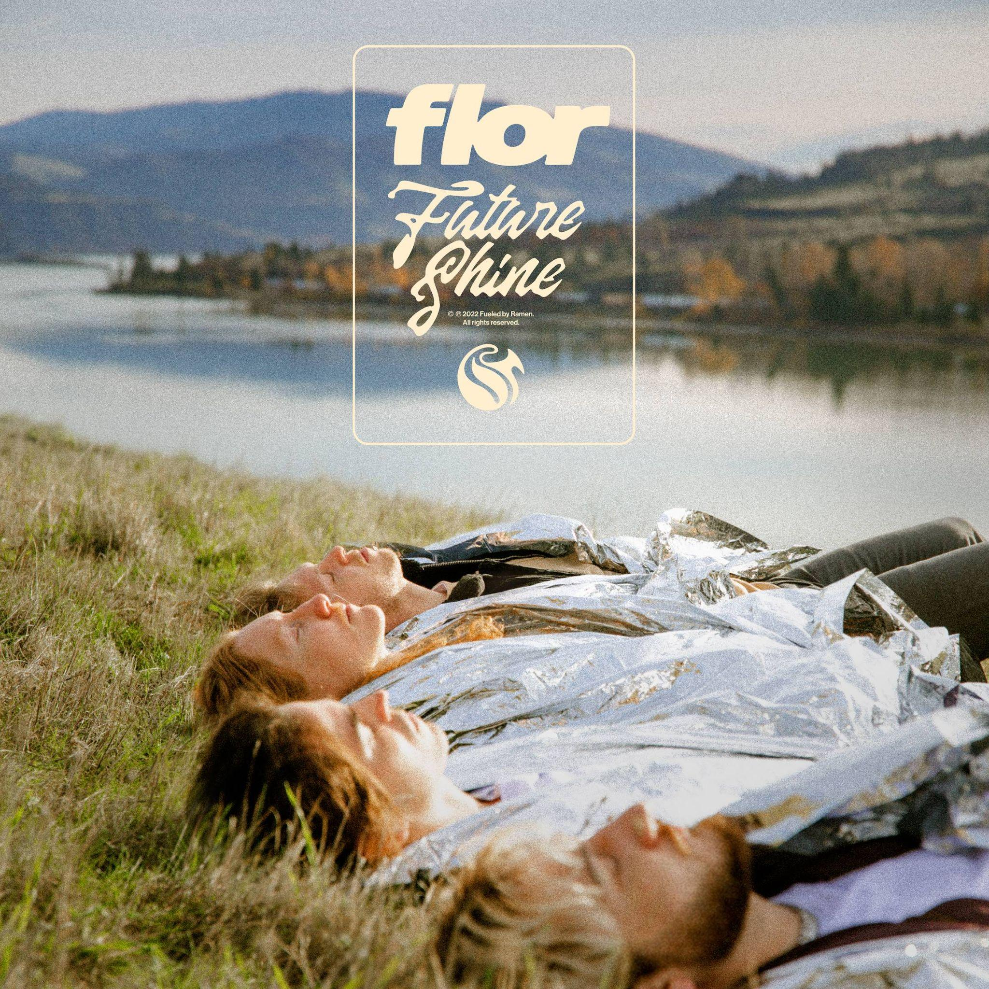

About flor
flor finds light in the promise of a new day. The Hood River, OR quartet—Zach Grace [vocals, guitar], Dylan Bauld [bass], McKinley Kitts [guitar], and Kyle Hill [drums]—excavate unshakable melodies from jubilant synths, buoyant beats, and lush guitars as they relay a coming-of-age story all their own. The story began as high school kids in McKinley’s garage. The band quietly generated hundreds of millions of streams in the wake of their 2016 debut come out. you’re hiding. In 2019, ley lines only accelerated their momentum buoyed by tracks including “white noise,” “slow motion,” and “dancing around”. Critical acclaim followed from Nylon, Billboard, Paste, and Ones To Watch who hailed the album as “an exhilarating balancing act.” They concluded a successful headline tour at the top of 2020 only to face the harsh reality of the Global Pandemic with the rest of us. Once it became safe enough to do so, the musicians congregated back in Los Angeles at Dylan’s studio for a series of writing sessions. This time around, they built the bulk of the songs face-to-face together inspired by favorite records from the likes of MGMT, Phoenix, The Killers, and M83. Now, flor shines brighter than ever on their third full-length album, Future Shine [Fueled By Ramen].

https://www.florsounds.com/
Facebook | Twitter | Instagram | YouTube

Press contacts:
Collin Citron / collin.citron@300elektra.com
Sydney Worden / sydney.worden@300elektra.com

