ALL TIME LOW SHARE NEW SINGLE “SLEEPWALKING”

OFFICIAL MUSIC VIDEO STREAMING NOW

HEADLINING LONDON’S WEMBLEY ARENA ON MARCH 17TH

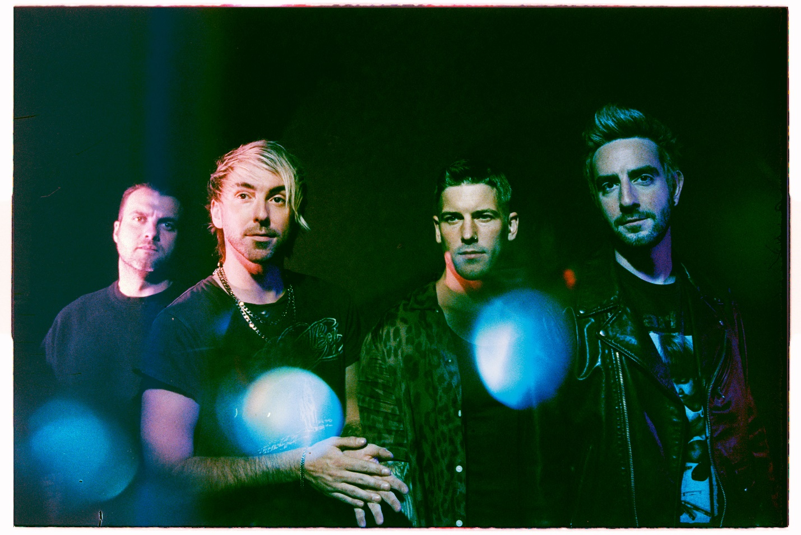
PHOTO CREDIT: ASHLEY OSBORN

OCTOBER 7, 2022 – Multi-platinum selling Fueled By Ramen band All Time Low have shared their new single “Sleepwalking.” Available today on all streaming platforms, “Sleepwalking” is accompanied by a Eduoardo Ranaboldo directed official music video streaming on the band’s official YouTube channel and marks the first new release from the band since 2021.

Regarding the song, vocalist and guitarist Alex Gaskarth shared, "'Sleepwalking' is a reflection on time spent away from whatever it is that makes you feel alive, on time lost to the weight of dragging feet and drifting thoughts. As we were working on this song, we considered our place in a changing world-- We realized just how affected we were as individuals by time spent away from our most familiar life-lines, and how grateful we are now to come together with those people, places and things... our friends, families, touring, shows, art and the energy and perspective that comes with real, raw connection. Our time spent away from our most beloved dreams felt like being on cruise-control, going through the motions in a trance. We are so grateful to be here now, sharing this song, this sentiment, this energy, and most of all this band with you. Thank you for being here and for being with us as we continue this journey together.”

Furthermore, All Time Low recently announced a special one-off headline show at London’s iconic Wembley Arena which will take place on March 17th. Tickets for the date are on sale now at www.alltimelow.com.

All Time Low recently took home “Alternative Rock Song of the Year” at the iHeartRadio Music Awards for the record-breaking platinum-certified smash “Monsters” [feat. blackbear]. The song previously clinched #1 on the Billboard Alternative Airplay Chart for an unprecedented 18 weeks, emerging as the longest charting song ever at the Modern Rock format.

Last year, the band served up the standalone single, “Once In A Lifetime,” which reached the Top 5 at Alternative Radio and attracted critical acclaim. NME hailed it as “reflective” and “hopeful,” and KERRANG! dubbed it “anthemic and infectious.”

All Time Low’s latest studio album Wake Up, Sunshine was released in April of 2020 and debuted at #1 on Billboard’s Top Rock Albums Chart. Billboard proclaimed, “The album is All Time Low’s most vibrant set to date, combining the band’s rambunctious spirit with roaring guitars and anthemic melodies.” Forbes praised the collection as “an album that crackles with youthful exuberance and the energy of a live show,” while Nylon declared “All Time Low just wants their new album to make you feel good.” Wake Up, Sunshine is available physically and digitally now HERE.

About All Time Low:
All Time Low have undeniably, albeit unassumingly carved out their own corner of popular culture. The multi-platinum Maryland quartet have toppled charts, sold out arenas worldwide, and served up a series of instantly irresistible anthems in the process. Their catalog consists of five consecutive Top 10 albums on the Billboard Top 200 in addition to picking up multi-platinum, platinum, and gold certifications. Their influence remains pervasive: 5 Seconds of Summer have covered their tunes, Cheat Codes and Pierce the Veil have jumped at the chance to collaborate, and they’ve contributed music to films by visionaries such as Tim Burton and Diablo Cody. Speaking to their impact, Rolling Stone even named So Wrong, It’s Right among its “50 Greatest Pop Punk Albums.” In 2020, they ascended to a new commercial and critical high watermark with their eighth full-length LP, Wake Up, Sunshine. Following a #1 debut on the Top Rock Albums chart, it spawned the biggest hit of the band’s career thus far, “Monsters” [feat. blackbear]. It clinched #1 on the Billboard Alternative Airplay Chart for an unprecedented 18 weeks, emerging as the longest charting song ever at the Modern Rock format. In addition to going platinum, it notably garnered “Alternative Rock Song of the Year” at the 2022 iHeartRadio Music Awards, while superstar Demi Lovato teamed up with the group for the Official Remix. Meanwhile, the mainstream came to them as they delivered show-stopping performances everywhere from Bonnaroo and Firefly to The Late Late Show with James Corden, Jimmy Kimmel Live!, Ellen, Good Morning America, and beyond. Now, All Time Low kick off another era with “Sleepwalking” and more to come.

ALLTIMELOW.COM
FACEBOOK
TWITTER
YOUTUBE
INSTAGRAM
FUELEDBYRAMEN.COM

All Time Low Press Contacts:
Ross Anderson / RossAnderson@Elektra.com
Collin Citron / CollinCitron@Elektra.com

