**CAFUNÉ ANNOUNCE 2023 NORTH AMERICAN HEADLINE TOUR**

**DATES GET UNDERWAY FEBRUARY 21ST IN TORONTO**

**PRE-SALE TICKETS AVAILABLE OCTOBER 12TH AT 10:00AM ET**

**BREAKOUT HIT “TEK IT” GOES TOP 10 AT ALTERNATIVE RADIO**

**DEBUT ALBUM *RUNNING* OUT NOW**



**PHOTO CREDIT: COREY SMITH-WEST**

*“Delicate, dazed indie-pop” -* ***THE FADER***

*“Blonde-esque minimalist guitar swoon” –* ***STEREOGUM***

*“Dreamy new sophisti-pop” -* ***GORILLA VS. BEAR***

*“Infectious and bittersweet”* - ***BILLBOARD***

*“Mesmerizing bedroom pop.”* - ***UPROXX***

**OCTOBER 11, 2022 –** Cafuné - the NYC-based duo of singer/songwriter Sedona Schat and writer/producer Noah Yoo - have announced details of a 2023 North American headline tour. The upcoming date are set to get underway February 21st in Toronto, ON and continue through late March with stops in Chicago, Seattle, Los Angeles, Nashville, New York City and other major markets across the U.S. [Full Itinerary Below]. Pre-sale tickets for the tour will be available beginning tomorrow, October 12th, at 10:00AM ET with general on-sale starting October 14th at 10:00AM local time. For tickets and more information on Cafuné’s upcoming tour dates, visit [www.wearecafune.xyz](http://www.wearecafune.xyz).

Earlier this month Cafuné wrapped a multi-leg tour of the U.S. supporting CHVRCHES, in addition to performing two sold-out headline shows at Brooklyn’s Elsewhere and Los Angeles’ Genghis Cohen. The dates saw the band celebrating their recent signing to Elektra Records and their breakout hit “[Tek It](https://youtu.be/7RWbq-lbBlk),” which has amassed over 260 million global streams to date. “Tek It” currently sits inside the Top 20 on *Billboard*’s “Hot Rock & Alternative Songs” while moving into the Top 10 on *Mediabase’*s “Alternative Chart.”

The band also recently shared an official music video for their song “Running” which is directed by Jo Gennet and streaming now on their YouTube channel – [Watch it HERE](https://youtu.be/iwVdqS2-uGs). “Running” serves as the title track off Cafuné’s [debut album](https://cafune.lnk.to/Running), which was released in 2021 via their own Aurelians Club label. A cassette variant of *Running* - the first-ever physical offering of the album – along with several other limited edition merch items are available now in the band’s [official webstore](https://cafune.limitedrun.com/).

Sedona Schat and Noah Yoo have been recording alternative pop songs together as Cafuné since their days as NYU students in the mid-2010s. Self-produced and almost entirely recorded by the duo at their homes, mostly during the pandemic, their debut album *Running* is a record born in isolation. It peers out at a world that feels like it’s on the precipice of disaster, considering what it means to get older, to carve out a future for yourself. It’s a labor of the duo’s friendship, of doing the work and trying to figure out what the way forward is, even when it seems like there’s no end in sight. It’s a record of growing old and growing up, of making something you can move to—whether you’re alone in a room, in a sweaty club with all of your friends, or driving away to someplace better.

[Tour Itinerary / Admat Below]

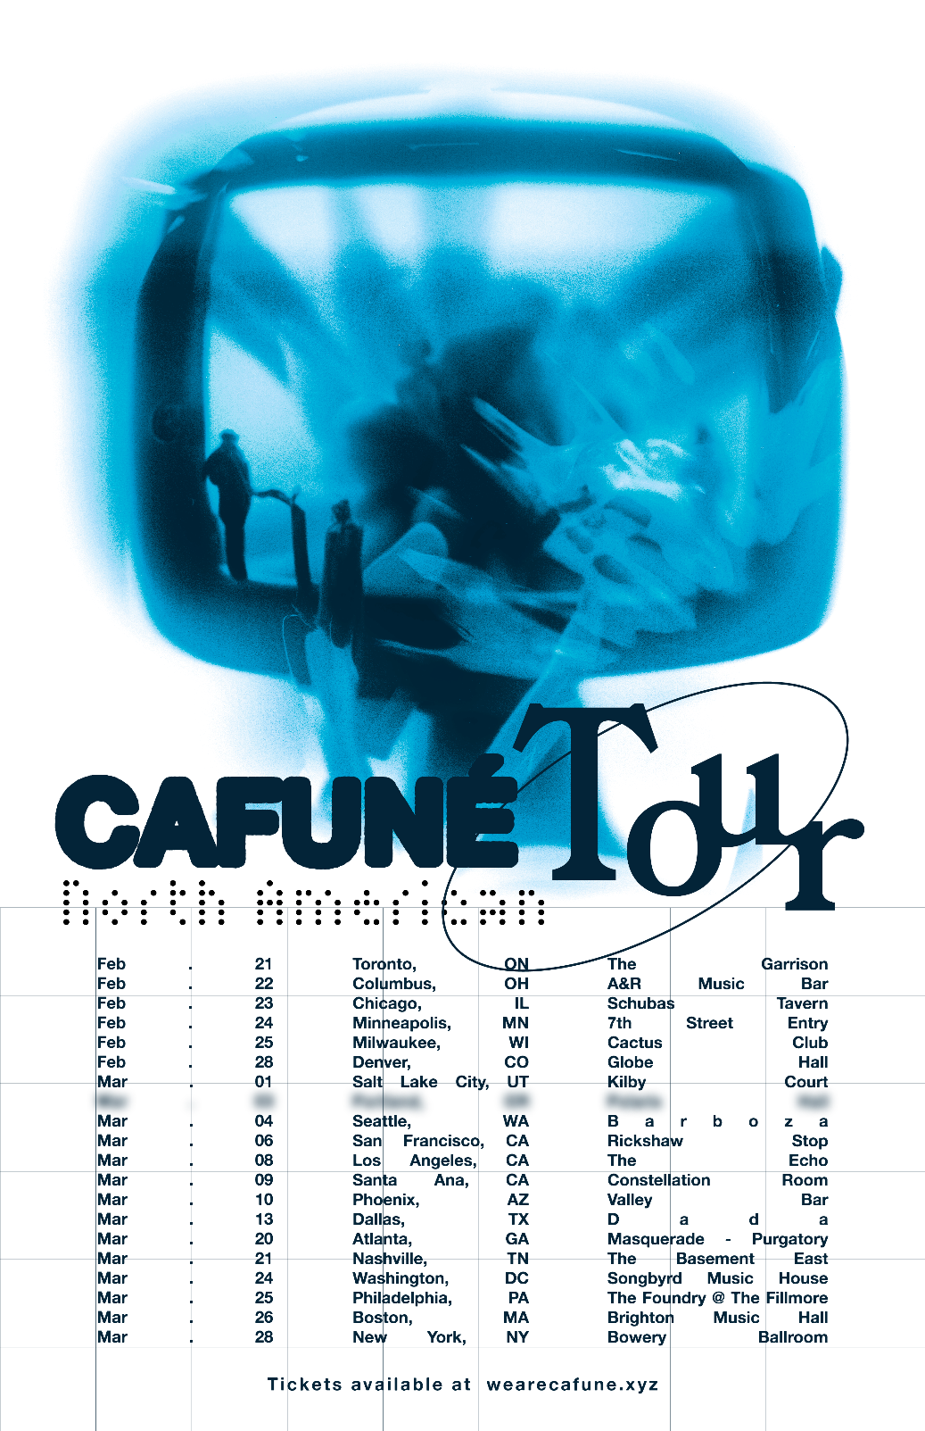

Feb 21 - The Garrison - Toronto, Canada

Feb 22 - A&R Music Bar - Columbus, OH

Feb 23 - Schubas Tavern - Chicago, IL

Feb 24 - 7th Street Entry - Minneapolis, MN

Feb 25 - Cactus Club - Milwaukee, WI

Feb 28 - Globe Hall - Denver, CO

Mar 1 - Kilby Court - Salt Lake City, UT

Mar 4 - Barboza - Seattle, WA

Mar 6 - Rickshaw Stop - San Francisco, CA

Mar 8 - The Echo - Los Angeles, CA

Mar 9 - Constellation Room - Santa Ana, CA

Mar 10 - Valley Bar - Phoenix, AZ

Mar 13 - Dada - Dallas, TX

Mar 20 - The Masquerade - Atlanta, GA

Mar 21 - The Basement East - Nashville, TN

Mar 24 - Songbyrd Music House and Record Cafe - Washington, DC

Mar 25 - The Foundry at The Fillmore - Philadelphia, PA

Mar 26 - Brighton Music Hall - Boston, MA

Mar 28 - The Bowery Ballroom - New York, NY

**CONNECT WITH CAFUNÉ:**

[Website](http://www.wearecafune.xyz/) | [Instagram](https://www.instagram.com/wearecafune/?hl=en) | [Twitter](https://twitter.com/wearecafune?lang=en) | [TikTok](https://www.tiktok.com/@wearecafune?lang=en) | [Facebook](https://www.facebook.com/wearecafune) | [YouTube](https://www.youtube.com/c/CAFUN%C3%89nyc) | [Spotify](https://open.spotify.com/artist/581C5Qwl87TskfBEzuoisu) | [Apple Music](https://music.apple.com/us/artist/cafun%C3%A9/947078210)

**CAFUNÉ PRESS CONTACT:**

Ross Anderson | [Ross.Anderson@300Elektra.com](mailto:Ross.Anderson@300Elektra.com)

Sydney Worden | [Sydney.Worden@300Elektra.com](mailto:Sydney.Worden@300Elektra.com)