CHLOE MORIONDO UNLEASHES NEW ALBUM SUCKERPUNCH

“PLASTIC PURSE” OFFICIAL VIDEO STREAMING NOW
WATCH HERE

NORTH AMERICAN FALL HEADLINE TOUR DATES
KICK OFF OCTOBER 12TH IN COLUMBUS, OH

DOWNLOAD PRESS ASSETS HERE

“…relentlessly catchy” – THE NEW YORK TIMES

“…one of indie pop’s brightest rising stars” – TEEN VOGUE

“On her new record, she flies full force into hyperpop, drum ‘n’ bass, and an exuberant electronic palette”
– NYLON

“…Moriondo dials up the volume and chaos levels for her third record, and the resulting tracks are some of her most gripping to date.” – CONSEQUENCE
OCTOBER 7, 2022 – Rising star Chloe Moriondo has unleashed new album SUCKERPUNCH. The 13-track collection is available now via Public Consumption/Fueled By Ramen. In celebration of the release, Moriondo has also shared an official music video for “Plastic Purse,” which is streaming now on Chloe’s official YouTube channel. The Willy-Wonka-meets-Lord-Of-The-Flies visual finds mad scientist Moriondo shrinking boys to fight for survival inside of her titular plastic purse.

Next week, Chloe will head out on the “SUCKERPUNCH” tour – a U.S. fall headline run featuring support from Dreamer Isioma. The five-week trek kicks off October 12th in Columbus, OH, making stops at The Regent in Los Angeles on October 26th and Irving Plaza in New York City on November 10th before wrapping up with a hometown performance at The Majestic in Detroit, MI on November 19th. Tickets for all dates are available now (tour itinerary below). For up-to-date ticketing information, please visit www.chloemoriondo.com.
SUCKERPUNCH was preceded by critically acclaimed singles “Cdbaby<3” and “Fruity.” The artist also appeared as DORK Magazine’s October cover star, which arrived alongside a five-star review of SUCKERPUNCH, praising the record as “bold and extravagant with a refreshing dose of silliness.” The drum-and-bass-inspired “Cdbaby<3” was celebrated by Teen Vogue, who touted, “…the thumping, hypnotic track perfectly showcases why Chloe is one of indie pop's brightest rising stars.” Billboard raved, “Lots of modern pop artists aspire to evoke the highs of top-quality drum-and-bass, but Chloe Moriondo actually gets there,” while NYLON praised the “…delirious new drum ‘n’ bass jam.”
The sticky-sweet summer anthem “Fruity” racked up praise from The New York Times, Pitchfork, Billboard, V Magazine, UPROXX, Alternative Press and more. The New York Times applauded the “relentless catchy” track as “an exhilarating pivot to hyperpop,” while Billboard exclaimed “Moriondo’s ready for you to get a sugar rush off this delectable pop track.” “It’s skittish, explosive, and enthused” raved UPROXX, while FLOOD Magazine crowned “Fruity” as “a sugar-rush anthem for the end of summer.” V Magazine attested, “…it’s time to unwrap the singer’s latest treat and take a bite—It’s going to be one sweet season.”
Working with producers/co-writers including Oscar Scheller (Rina Sawayama, PinkPantheress, Charli XCX), David Pramik (Machine Gun Kelly, Oliver Tree), and Teddy Geiger (Caroline Polachek, Olivia O’Brien), SUCKERPUNCH signals a new era for Moriondo and marks a bold leap forward from the understated indie-pop and jittery pop-punk of her 2021 offering, Blood Bunny.
In support of SUCKERPUNCH, Chloe and creative director Samantha Caballero conceptualized the entire range of merchandise in collaboration with WMX (Warner Music Group’s in-house Artist & Fan Experiences team). Arriving with three different themes – “Fruity”, “Cdbaby<3” and “SUCKERPUNCH” – each collection includes apparel, accessories, and a signed CD from Chloe that provides fans a taste of the bright and colorful vibes from her latest project. Fans can purchase all merch at www.chloemoriondo.com.
Earlier this year, Moriondo was included in Billboard’s prestigious “21 Under 21” list and shared Blood Bunny Deluxe, which included her long-awaited single and video “Hell Hounds,” alternate and acoustic versions of album tracks – including a rendition of “I Eat Boys” featuring dodie – original voice memos, and a studio version of Chloe’s early pandemic ballad, “Living Virtually.” In April, Chloe shared the puppy luv EP, a collection of canine-themed songs. The five-track collection was heralded by the charming, breezy single “sammy,” and accompanied by an official music video starring Moriondo’s own pet dog (the titular Sammy). UPROXX praised the “wholesome” track, while Billboard hailed it as “a pure bump of joy.” Consequence attested “sammy” is “adorable and heartwarming.” The puppy luv EP is available now via Public Consumption/Fueled By Ramen.
About Chloe Moriondo:
Chloe Moriondo professes to be an “internet kid,” yet she tackles overwhelming infatuation, listless daydreams, and first love with keen empathy that’s unsearchable online. With relatable, confessional lyrics and idiosyncratic humor, the singer-songwriter has built a devoted fanbase of millions, sharing their authentic self to create a genuine connection with their listeners. Last May, Moriondo shared her critically acclaimed major-label debut album Blood Bunny via Public Consumption/Fueled By Ramen, which landed on “Best Albums of 2021” lists from The New York Times and Billboard. The release was also crowned a “Critic’s Pick” by The New York Times, who exclaimed, “On the robust and vividly plain-spoken ‘Blood Bunny,’ Moriondo…is a pop-punk whiz, deftly hopping between musical approaches from spare to lushly produced, and emphasizing intimate, cut-to-the-bone lyrics.” Chloe has also racked up praise from Billboard, Pitchfork, The FADER, PAPER, UPROXX, Refinery29, them., and more. Following Blood Bunny’s release, Moriondo made her television debut performing “Bodybag” on Jimmy Kimmel LIVE!, and appeared soon after on The Late Late Show With James Corden, where they played a dynamic rendition of “I Want To Be With You.”
[Tour Itinerary / Album Art / Tracklisting below]
###

CHLOE MORIONDO
2022 HEADLINE TOUR DATES
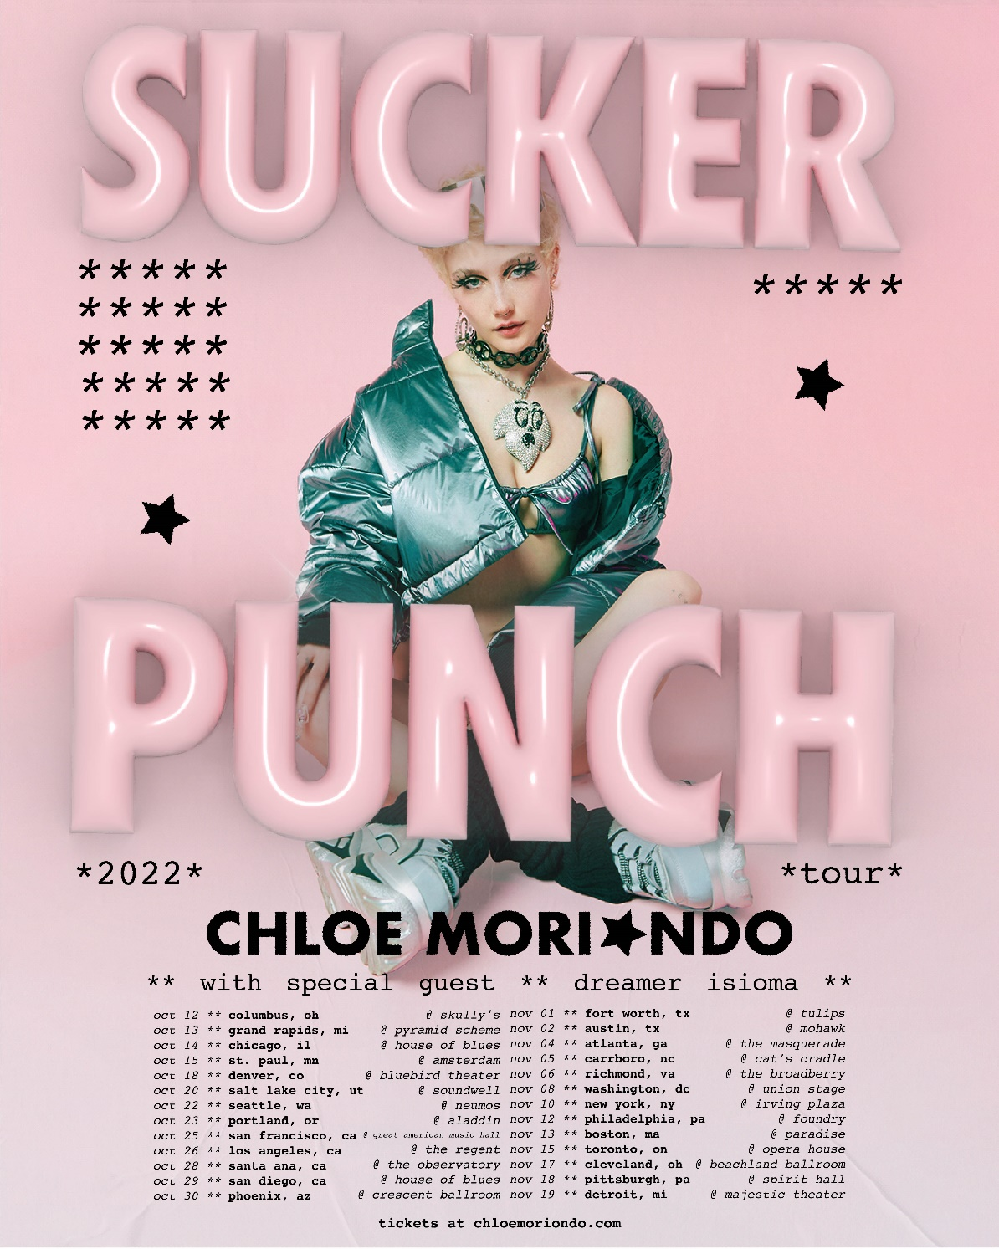

OCTOBER
12 Columbus, OH Skully's
13 Grand Rapids, MI Pyramid Scheme
14 Chicago, IL House Of Blues
15 St. Paul, MN Amsterdam
18 Denver, CO Bluebird
20 Salt Lake City, UT Soundwell
22 Seattle, WA Neumos
23 Portland, OR Aladdin
25 San Francisco, CA Great American Music Hall
26 Los Angeles, CA The Regent
28 Santa Ana, CA The Observatory
29 San Diego, CA House of Blues
30 Phoenix , AZ Crescent Ballroom

NOVEMBER
1 Fort Worth, TX Tulips
2 Austin, TX Mohawk
4 Atlanta, GA The Masquerade
5 Carrboro, NC Cat's Cradle
6 Richmond, VA The Broadberry
8 Washington, DC Union Stage
10 New York, NY Irving Plaza
12 Philadelphia, PA Foundry
13 Boston, MA Paradise
15 Toronto, ON Opera House
17 Cleveland, OH Beachland Ballroom
18 Pittsburgh, PA Spirit Hall
19 Detroit, MI Majestic Theater

Chloe Moriondo
SUCKERPUNCH
AVAILABLE NOW

Tracklisting:
- Popstar
- Fruity
- Trophy
- Knockout
- Hell Hounds
- Hotel For Clowns
- DRESS UP
- Plastic Purse
- Celebrity
- Cdbaby<3
- Hearteyes
- Diet Heartbreak
- Cry

CONNECT WITH Chloe Moriondo
www.chloemoriondo.com
YOUTUBE
INSTAGRAM
TWITTER
FACEBOOK

CONTACT:
Sarah Goldstein
SarahGoldstein@elektra.com

For press inquiries regarding WMX and Chloe’s merchandise:
wmx@hunt-gather.com

