FOR IMMEDIATE RELEASE
SEPTEMBER 28, 2022

FITZ AND THE TANTRUMS ANNOUNCE NEW ALBUM
LET YOURSELF FREE
ARRIVING NOVEMBER 11 | PREORDER HERE

NEW SINGLE “MONEYMAKER” AVAILABLE NOW
LISTEN HERE | WATCH THE LYRIC VIDEO HERE

BAND TO EMBARK ON LET YOURSELF FREE TOUR THIS WINTER
TICKETS ON SALE THIS FRIDAY AT 10:00AM LOCAL TIME HERE

PERFORMING “SWAY” ON THE KELLY CLARKSON SHOW TODAY - WATCH HERE

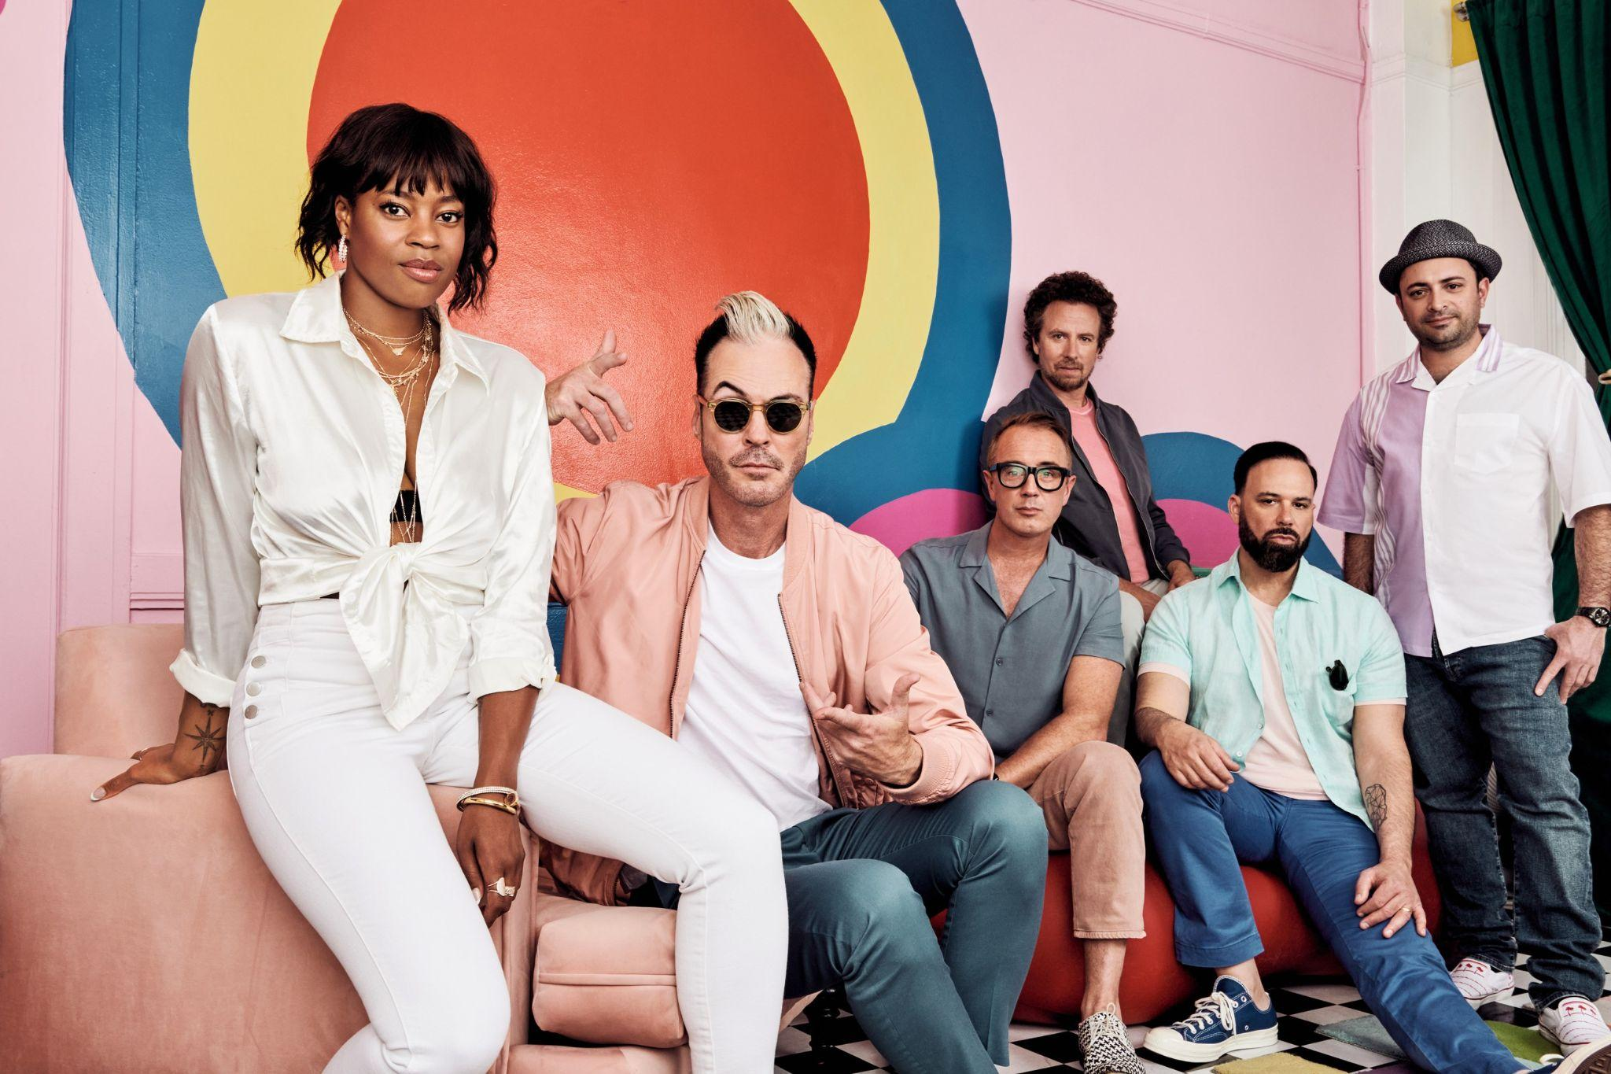
Photo credit: Lindsey Byrnes

Multi-Platinum band Fitz and The Tantrums have announced their brand new studio album Let Yourself Free will arrive on November 11 via Elektra Records. The album is available for pre-order beginning today HERE (album art/tracklisting below). To herald the announcement, the band has also unveiled their infectious new single “Moneymaker”. The song is available to stream and download beginning today HERE. Watch a lyric video for the track on the band’s YouTube channel HERE.

“We are so excited for the world to hear our fifth studio album!” shares frontman Michal “Fitz” Fitzpatrick. “For this record we really wanted to pull from our earliest influences and bring the through line of this band full circle. Tracks like ‘Silver Platter’ and ‘Steppin’ On Me’ really are a nod to our first album Pickin’ up the Pieces, while tracks like ‘Moneymaker’ take that influence and blast it into the future!”

Fitz and The Tantrums have also announced they will embark on the Let Yourself Free Tour this winter. The 17-city trek will kick off on January 21 in Portland, OR, visit major markets across the US, and wrap on February 16 in Ft. Lauderdale, FL. Special guest BabyJake will provide support. Tickets will be available to the public beginning this Friday, September 30 at 10:00am local time. A complete list of upcoming live dates and ticket information can be found HERE.

Citi is the official presale credit card of the Let Yourself Free Tour. As such, Citi cardmembers will have access to purchase presale tickets beginning Wednesday, September 28 at 5:00 PM ET / 2:00 PM PT until Thursday, September 29 at 10:00 PM local time through Citi Entertainment. For complete presale details visit www.citientertainment.com.

Fitz and The Tantrums previewed Let Yourself Free with the June release of the album’s hit lead single “Sway”. The song and its vibrant official music video arrived to critical acclaim from Rolling Stone, E! News, Entertainment Tonight, and more. Last month, the band delivered the song’s network television debut performance on ABC’s Good Morning America. Watch it HERE.

This afternoon, Fitz and The Tantrums will return to network television to deliver a special performance of “Sway” on The Kelly Clarkson Show. Tune in to NBC to catch the performance (check local listings) or watch it now on the band’s YouTube channel HERE.

Let Yourself Free follows Fitz and The Tantrums’ 2019 album All the Feels, which featured the top 10 hit “I Just Wanna Shine” and was supported by national television appearances on Jimmy Kimmel LIVE!, Good Morning America, and Live with Kelly and Ryan. In 2021, Fitz and The Tantrums’ frontman Michael “Fitz” Fitzpatrick released his first-ever solo album Head Up High under the moniker FITZ. FITZ performed the album’s infectious title track on The Ellen DeGeneres Show, The Late Late Show with James Corden, and Good Morning America.

Stay tuned for more from Fitz and The Tantrums very soon.

FITZ AND THE TANTRUMS - LET YOURSELF FREE
PREORDER NOW

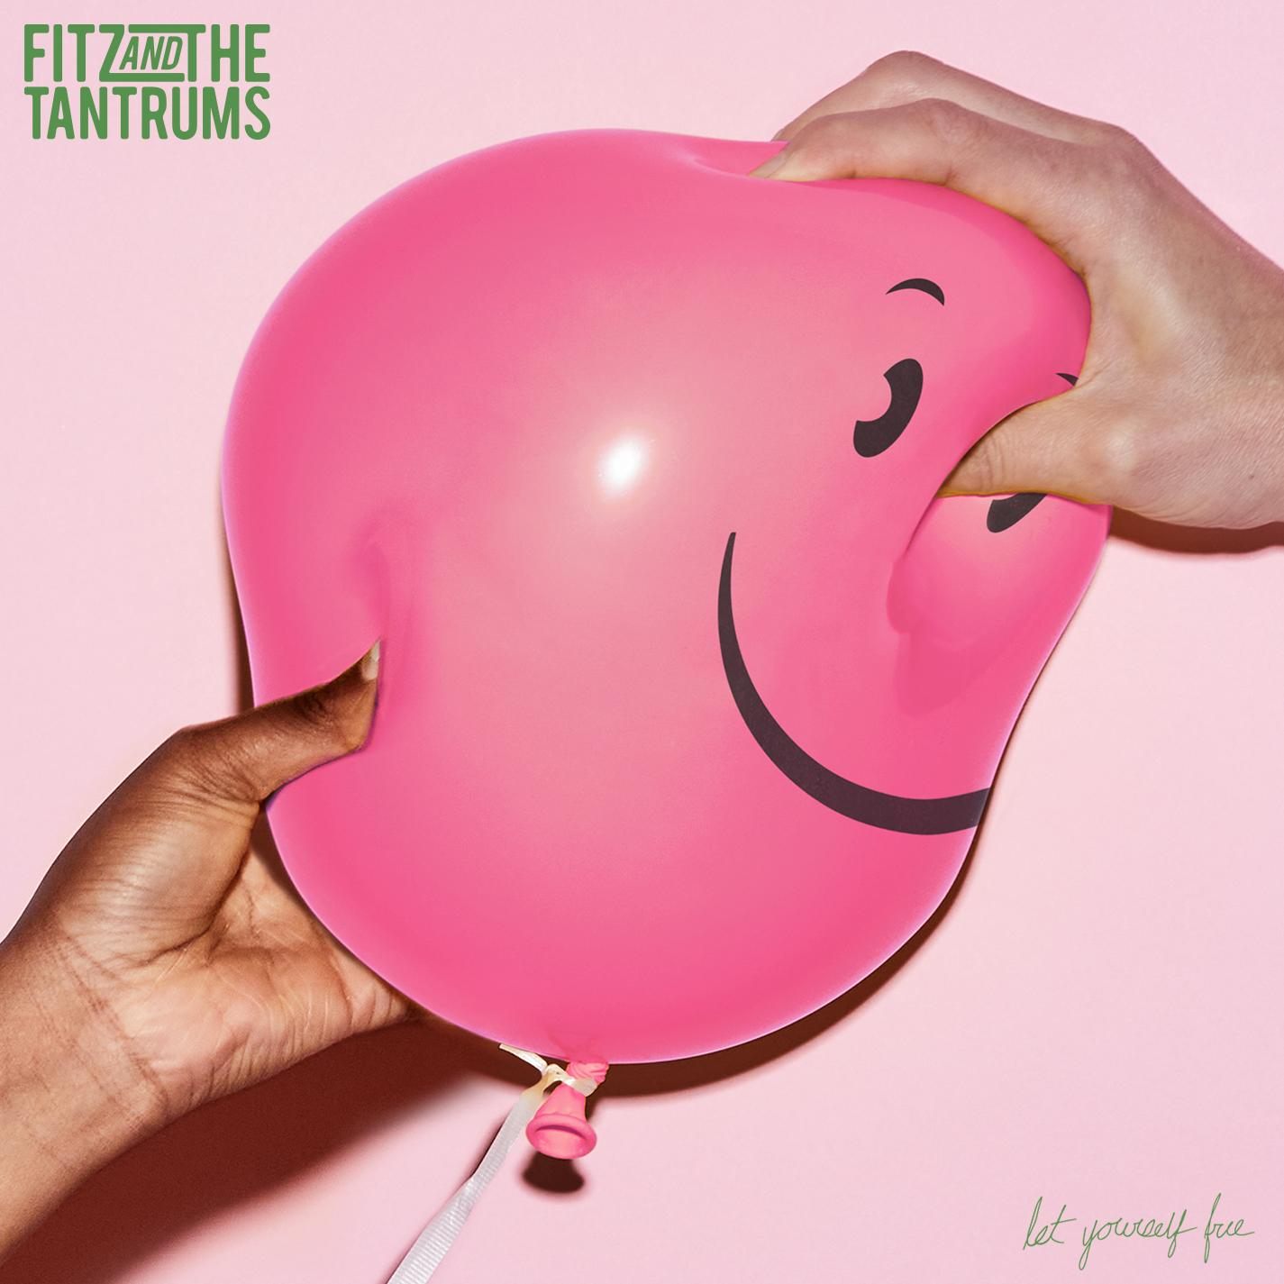

Let Yourself Free Tracklisting
1. Good Intentions
2. Heaven
3. Sway
4. Silver Platter
5. Let Yourself Free
6. Moneymaker
7. AHHHH!
8. Good Nights
9. Big Love
10. Is It Love
11. Steppin’ On Me
12. Someday

Let Yourself Free Tour Dates
January 21st, 2023 - Portland, OR - Roseland Theater
January 22nd, 2023 - Seattle, WA - The Showbox
January 24th, 2023 - Sacramento, CA - Ace of Spades
January 25th, 2023 - San Francisco, CA - The Regency Ballroom
January 27th, 2023 - Los Angeles, CA - The Belasco
January 28th, 2023 - Phoenix, AZ - Talking Stick Resort
January 31st, 2023 - Omaha, NE - The Admiral
February 2nd, 2023 - Chicago, IL - The Vic Theater
February 3rd, 2023 - Madison, WI - The Sylvee
February 4th, 2023 - Detroit, MI - Saint Andrew’s Hall
February 6th, 2023 - Washington, DC - 9:30 Club
February 8th, 2023 - New York, NY - Webster Hall
February 10th, 2023 - Boston, MA - Big Night Live
February 11th 2023 - Philadelphia, PA - Union Transfer
February 13th, 2023 - Atlanta, GA - Buckhead Theatre
February 14th, 2023 - Nashville, TN - Brooklyn Bowl Nashville
February 16th, 2023 - Ft. Lauderdale, FL - Culture Room

ABOUT FITZ AND THE TANTRUMS:
Multi-platinum artists Fitz and The Tantrums have energized popular music and culture with a series of unshakable, undeniable, and ubiquitous anthems and albums. Since 2008, the Los Angeles collective have magnified the scope of pop with a dash of indie, a dose of soul, and a whole lot of dancefloor-ready bounce. Their catalog spans fan favorite records such as Pickin’ up the Pieces [2010], More Than Just A Dream [2013], the gold-certified Fitz and The Tantrums [2016], and All the Feels [2019]. Along the way, they’ve impressively tallied just shy of 4 billion streams and counting powered by enduring hits such as the triple-platinum “HandClap,” platinum “Out of My League” and “The Walker,” and gold “Moneygrabber.” As an inescapable presence, their music has notably coursed through the mainstream conversation, soundtracking films on NETFLIX and campaigns for CVS Wellness, Sunchips, Sofi, Xfinity, Walmart, Norwegian Cruise Line, Lays, and Wells Fargo, to name a few. Beyond standout performances everywhere from Coachella and Bonaroo to numerous late-night television shows, they’ve consistently sold out some of the most iconic venues in the world, including The Forum and Red Rocks Amphitheatre. Not to mention, they’ve incited the applause from Rolling Stone, Billboard, People, and more. In 2021, Fitz and The Tantrums frontman Michael “Fitz” Fitzpatrick released his first-ever solo album Head Up High under the moniker FITZ. Meanwhile, co-lead vocalist Noelle Scaggs founded Diversify The Stage to help foster more diverse, inclusive, equitable, and accessible concerts, events, and touring workforces for historically marginalized and underrepresented communities. Fitz and The Tantrums once again leap forward with their bold, bright, and buoyant new album Let Yourself Free.

Fitz and The Tantrums are: Michael “Fitz” Fitzpatrick (vocals), Noelle Scaggs (vocals), James King (saxophone, flute), Jeremy Ruzumna (keyboards), Joseph Karnes (bass), and John Wicks (drums, percussion).

https://www.fitzandthetantrums.com/
Facebook | Instagram | Twitter | YouTube | TikTok

# # #

PRESS CONTACT:

Glenn Fukushima (National)
GlennFukushima@elektra.com

Collin Citron (National)
CollinCitron@elektra.com

Sydney Worden (Tour/Online)
SydneyWorden@elektra.com

