WATERPARKS UNVEIL NEW TRACK
“FUCK ABOUT IT”
FEAT. BLACKBEAR
LISTEN HERE
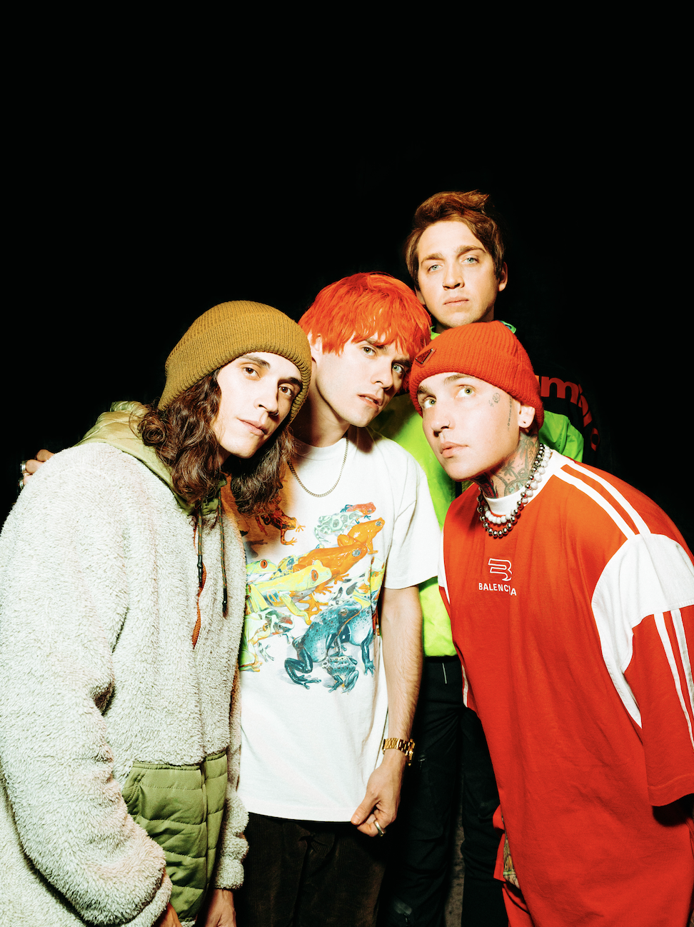
October 14, 2022 – Today, Waterparks and blackbear unveil their track “FUCK ABOUT IT” via Fueled by Ramen. Listen HERE.
Arriving in the wake of the Nothing Matters cross country tour, the track packages the artist's incendiary stage presence into an infectious anthem that will blast you right out of any seasonal (or otherwise) blues with a tale of a dysfunctional relationship. Waterparks and blackbear sing about the extreme way of communicating, in this particular hot & cold relationship. "FUCK ABOUT IT" marks the first time the two iconic artists have come together.
It's been a busy time for Waterparks, who have released a string of tracks in the midst of various global tour dates. Most recently, the trio's electric single “SELF-SABOTAGE” was given a fresh take with a collaboration featuring Good Charlotte. The track also received a dance remix from MCD4. The original track exhibits spirited vocals and an infectiously cheerful guitar riff that perfectly contrasts with the diary-esque lyrics, which visualize Awsten’s self-imposed restrictions.
"SELF-SABOTAGE" followed up Waterparks Fueled by Ramen debut “FUNERAL GREY” and marked the trio continuing into their newest era. This era sees Waterparks step into a more mature sound and look, elevating the image and sonics that have already accumulated over half a billion career streams to date, with over 2MM monthly listeners and 400,000 Spotify followers. Their last album, Greatest Hits, debuted with over 15,000 album-unit equivalents in the US, earning it the no. 5 spot on Billboard’s Alt/Rock chart.
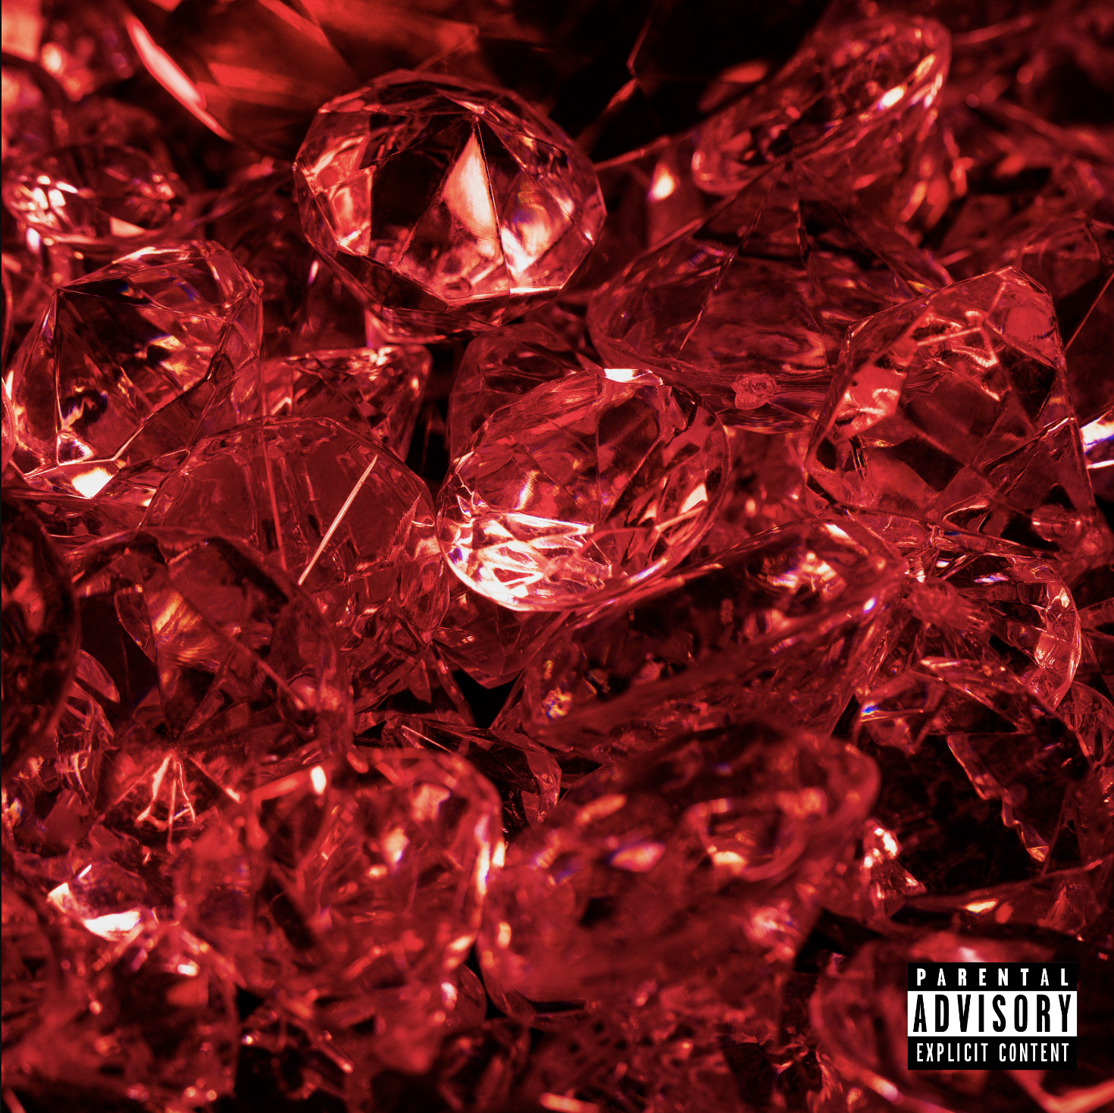

ABOUT WATERPARKS
Waterparks, composed of Awsten Knight [vocals, guitar], Otto Wood [drums], and Geoff Wigington [guitar]—manically move forward, shucking and jiving between fits of rock, alternative, and electronic with pop ambition and hip-hop’s bold and blatant disregard for the rules. The Houston trio has landed the covers of Alternative Press, V Magazine, Kerrang!, Rock Sound, and more and have garnered support from Spotify, Apple Music, and Amazon Music, finding themselves on numerous New Music Fridays and countless rock/alt playlists. The band has also topped the Billboard 200 chart. Waterparks’ unique and genre-blending sound puts them in a lane all their own, melding rock, pop, hip-hop, alternative, indie, electronic, and even R&B.
KEEP UP WITH WATERPARKS
TikTok | Instagram | Twitter

ABOUT blackbear
Since first crashing onto the scene in the mid-2010s, blackbear has defied all expectations, effortlessly mixing his hedonistic hellraising and maniac humor with deeply heartfelt emotion. Delivering an outrageously catchy hybrid of pop and hip-hop and alt-R&B, the L.A.-based artist has released five studio albums in the last six years alone, including 2019’s magnum opus ANONYMOUS, and 2020’s gold-certified everything means nothing which rose to #15 on the Billboard 200 Chart. The first glimpse at his latest metamorphosis, the fantastically zeitgeisty anthem “hot girl bummer” dropped in August 2019, reaching #5 at Top 40 radio and earning platinum certification from the RIAA—eventually emerging as blackbear’s most successful smash since 2017’s double-platinum “do re mi.”
Establishing himself as one of the most sought-after artists for collaborations in the industry, blackbear has recently been featured alongside Travis Barker on Avril Lavigne’s newest song, “Love It When You Hate Me,” which has been nominated for a 2022 MTV VMA for “Best Alternative,” Machine Gun Kelly’s “make up sex” and All Time Low’s “Monsters” which took home this year’s iHeartRadio Music Award for “Alternative Song of the Year.” In 2021, he collaborated with Machine Gun Kelly on their hit single titled “my ex’s bestfriend” which received the MTV Video Music Award for “Best Alternative Video” and spent multiple weeks #1 at radio. He’s produced and written hit songs for leading artists in the music industry such as Billie Eilish, Ellie Goulding, Maroon 5, G-Eazy, Justin Bieber, Kane Brown and Charlie Puth.
KEEP UP WITH blackbear
TikTok | Instagram | Twitter

