JAKE SCOTT WANTS YOU TO HAVE A “GOOD DAY”
LISTEN TO THE POSITIVE NEW POP TRACK HERE | WATCH THE VISUALIZER HERE
U.S. HEADLINE TOUR KICKS OFF ON SATURDAY, 10/15 IN SAN DIEGO – WITH SUPPORT FROM LABELMATES BRYNN CARTELLI AND SAM MACPHERSON
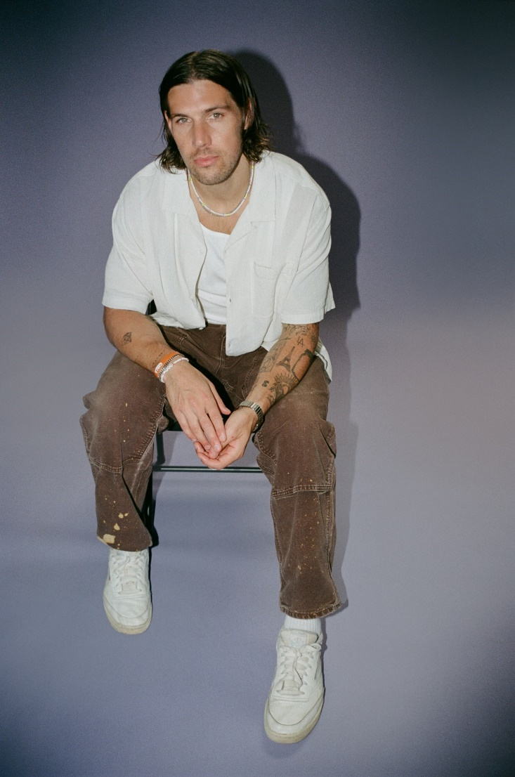
DOWNLOAD HI-RES PRESS IMAGE HERE
CREDIT: RACHEL PALUMBO
“With a knack for catchy melodies, his songs make for easy listening supported by buoyant pop production, heartfelt narratives, and a buttery voice to boot.” –BILLBOARD
“… rounded out by lyrical sincerity.” –CONSEQUENCE OF SOUND
“Scott is humble, but extremely talented” –AMERICAN SONGWRITER
“Be it ‘Texas Girl’ or ‘She’s Not You,’ we want to scream the words and dance around any room we’re in when we hear his tracks. That’s a tell-tale sign of a star.” –THE HONEY POP
Named one of PEOPLE MAGAZINE’s Emerging Artists (Spring 2022)
(October 7, 2022) – LOS ANGELES, CA – Pop singer-songwriter Jake Scott today released his new single “Good Day” – a funky, optimistic track about the importance of having a positive outlook. Co-written by Scott, Noah Conrad (Niall Horan), Josh Kerr (Kelsea Ballerini), and Daniel Silberstein (Sasha Alex Sloan), the feel-good song is available on all streaming platforms, with a companion visualizer available HERE.
Of the new track, Scott commented: “‘Good Day’ is about the simple joy of waking up with nothing to do and nowhere to be. We all live such busy lives, so those days have become more precious than ever. It’s about being a kid again, just for a second.”
In support of “Good Day,” Scott will be embarking on his massive fall Lavender Tour next weekend, which commences on Saturday, October 15 at San Diego’s Observatory North Park. With many dates already at a low-ticket warning, the trek stops in major cities including Nashville, Philadelphia, Boston, Chicago, New York, and more, before concluding in Los Angeles at the El Rey Theatre on Sunday, November 20. Additionally, Elektra Records labelmates and singer-songwriters Brynn Cartelli and Sam MacPherson will be providing direct support. The upcoming run of shows was also launched due to popular demand, after Scott completely sold out his first-ever headline tour earlier this year. The full routing is included below, with all tickets available on JakeScottMusic.com.
Scott added, “The Lavender Tour is a huge milestone for me. These are the biggest rooms I’ve played yet and I’m so excited about the show we’ve put together with Brynn and Sam, who are awesome. I promise I’m going to give you everything I’ve got!”
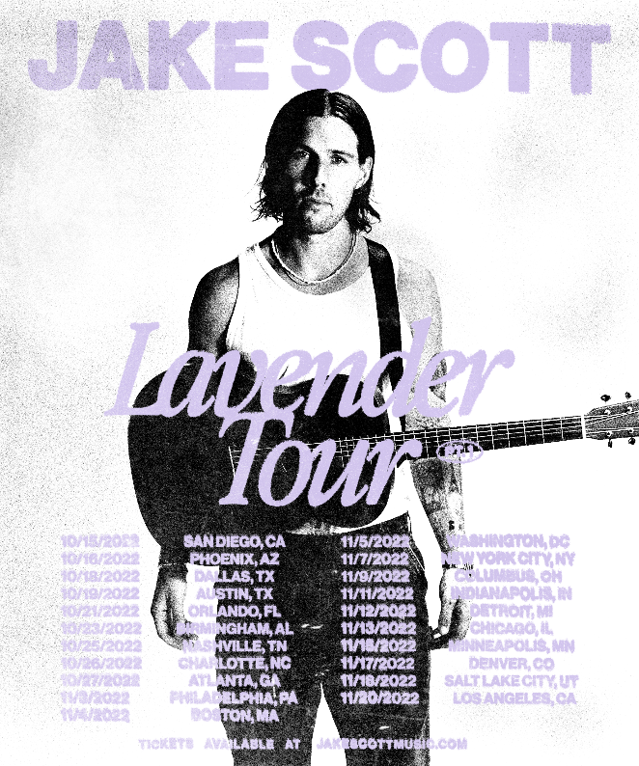
HI-RES TOUR ADMAT AVAILABLE HERE
Earlier this year, Scott made his national television debut on The Kelly Clarkson Show – performing his anthemic, anecdotal track “Texas Girl.” Additionally, his 2021 collaboration with multi-Platinum country star Russell Dickerson – “She Likes It” – became RIAA Certified Gold and has amassed 100M+ total streams in the U.S. alone. The song is currently in the Top 30 and climbing at Country Radio, and in July, Scott and Dickerson delivered a stellar live performance of the track on Good Morning America. Watch it HERE. Along with being a featured artist on “She Likes It,” Scott co-produced, mixed, and co-wrote the song with Dickerson – underscoring his skill as a dynamic musician and producer.
“Good Day” marks an exciting new chapter in Scott’s career, as he recently achieved 500M+ total career streams. He is also currently in the studio working on his much-anticipated debut album with Elektra Records. More details will be revealed soon.
ABOUT JAKE SCOTT:
Delivering impactful anthems with impressive consistency and grinding tirelessly, Jake Scott has quietly arrived as a proven pop maverick with a dynamic style and a whole lot to say. Born in Fayetteville, Arkansas and currently based in Los Angeles, the artist initially transformed into an independent phenomenon before signing with Elektra Records in 2021. Beyond co-writing for the likes of Jason Mraz, Aloe Blacc, and Carrie Underwood, he unveiled music at a prolific pace before doubling down and dropping one song per month from the beginning of 2018 through the end of 2020. Audiences embraced favorites such as “Like No One Does,” “Tuesdays,” “Favorite T-Shirt,” “She,” and “I Don’t Miss You.” In addition to building a diehard fan base, gathering millions of streams, attracting hundreds of thousands of followers across social media, and racking up praise in the press, Scott also has an impressive touring history – sharing the stage with LANY and Ben Rector, and selling out his first headline tour across North America in early 2022.
JAKE SCOTT
“GOOD DAY”
AVAILABLE HERE
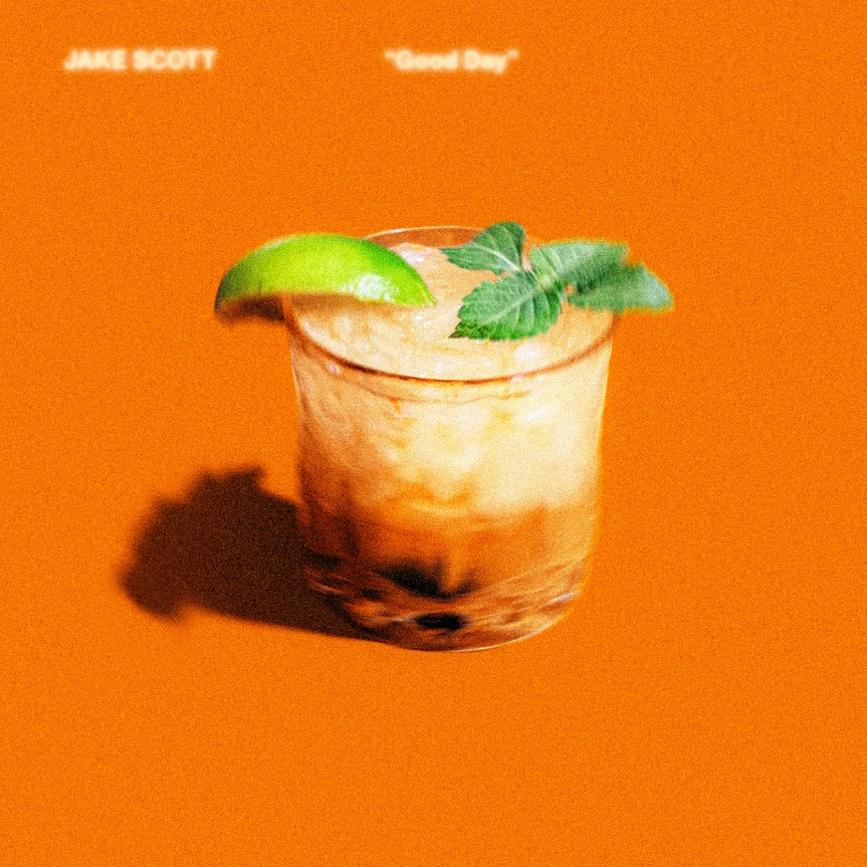
DOWNLOAD HI-RES ARTWORK HERE
JAKE SCOTT | THE LAVENDER TOUR:
October 15 – San Diego, CA @ The Observatory North Park
October 16 – Phoenix, AZ @ Crescent Ballroom [LOW TICKETS]
October 18 – Dallas, TX @ House of Blues [LOW TICKETS]
October 19 – Austin, TX @ Scoot Inn
October 21 – Orlando, FL @ Plaza Live
October 23 – Birmingham, AL @ Iron City
October 25 – Nashville, TN @ Marathon Music Works [LOW TICKETS]
October 26 – Charlotte, NC @ The Fillmore [LOW TICKETS]
October 27 – Atlanta, GA @ Variety Playhouse [LOW TICKETS]
November 3 – Philadelphia, PA @ Brooklyn Bowl
November 4 – Boston, MA @ Royale
November 5 – Washington, D.C. @ 9:30 Club [LOW TICKETS]
November 7 – New York, NY @ Webster Hall [LOW TICKETS]
November 9 – Columbus, OH @ Newport Music Hall
November 11 – Indianapolis, IN @ Deluxe at Old National Centre [LOW TICKETS]
November 12 – Detroit, MI @ Majestic Theater
November 13 – Chicago, IL @ House of Blues [LOW TICKETS]
November 15 – Minneapolis, MN @ First Avenue
November 17 – Denver, CO @ Gothic Theatre [LOW TICKETS]
November 18 – Salt Lake City, UT @ The Union [LOW TICKETS]
November 20 – Los Angeles, CA @ El Rey Theatre
FOLLOW JAKE SCOTT:
WEBSITE | INSTAGRAM | FACEBOOK | TWITTER | YOUTUBE | TIKTOK
# # #
JAKE SCOTT MEDIA CONTACTS:
Ross Anderson, Nathalie Rubin, & Sydney Worden
Ross.Anderson@300Elektra.com | Nathalie.Rubin@300Elektra.com | Sydney.Worden@300Elektra.com

