Jeris Johnson Unveils "Kryptonite (Reloaded)”
LISTEN HERE
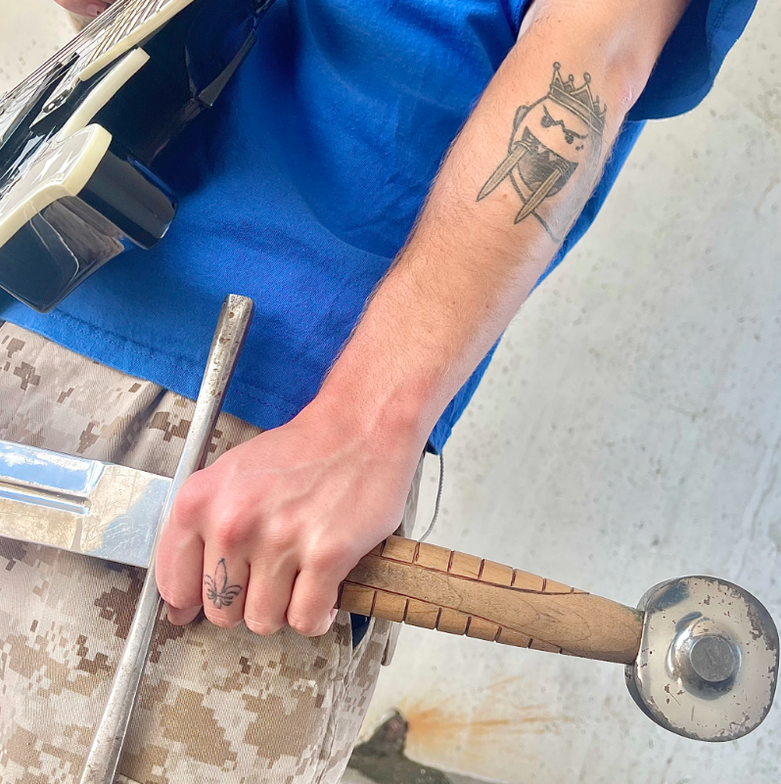
October 28, 2022 – Today, Jeris Johnson unveils “Kryptonite (Reloaded)”. The captivating re-work gives iconic track, “Kryptonite,” a fresh take with the inclusion of Jeris’ throaty vocals and his signature “reloaded” twist. Listen to “Kryptonite (Reloaded)” HERE.
Adding to a catalogue of “reloaded” remixes, these re-interpretations have helped catapult Jeris into the limelight as he’s made a name for himself putting his trademarked twist on celebrated tracks. “Kryptonite (Reloaded)” has already found acclaim on TikTok, joining a long list of ~break-the-internet~ singles from the artist.
Of the track, Jeris exclaims, “I wanted to make something a little more “rock” while still maintaining my usual genre bending brilliance. Explosive guitars and live drums, and I had hella fun tracking all of them. First time I’ve been able to play live drums on one of my songs, so that was cool. And of course, I had to relearn the iconic riff from the OG song, which is like one of the first guitar riffs everybody learns when you first pick up the axe. Infamous guitar center riff. Anyways, shoutout 3 Doors Down for letting me bring their track into the future and put my own spin on it.”
This Summer, Jeris Johnson released his Sophomore EP, A Summertime Side Quest. Featuring 3 vivacious tracks, the short collection was geared for summertime shenanigans. With the cumulative force of three songs that had gone viral and found a home, the EP showcases yet another side of Jeris Johnson. A Summertime Side Quest is a trio of 'windows-down' singles, all featuring Jeris' signature twang. Additionally, Jeris recently hit the road with Korn, Evanescence, and Helmet. Jeris Johnson is an artist blurring the lines of genre as he propels towards stardom and brings 'future grunge' with him.
With 240 million global streams, Jeris has collaborated with an eclectic mix of artists such as Papa Roach, Trippie Redd, ZillaKami, Bring Me the Horizon and more.
about Jeris Johnson
With a devout cult following on TikTok, Jeris picked up traction on the platform following the success of perfected reworks of classic tracks. Putting his trap flair on iconic hits and accumulating millions of views, he caught the eyes and ears of the critically acclaimed groups themselves. In 2020, Jeris released his single, “Sticks and Stones”, followed by his TikTok viral single “damn!”, which reached critical acclaim. Chad Kroeger of Nickelback then hopped on the track for a remix after playful banter with Jeris via TikTok. Fans were quick to find a similarity in the two so the artists came together for the “damn!” remix. From there on, Jeris covered Papa Roach's "Last Resort" and formed a fast-friendship with the group. Celebrating the 20th anniversary of certified triple platinum hit "Last Resort," Jeris Johnson & Papa Roach united to breathe new life into an iconic track, with “Last Resort (Reloaded)”. The track quickly made its way to #1 on both the Rock iTunes Chart and the Billboard Hard Rock Chart. It continued to be a busy year for Jeris as he then unveiled My Sword, his debut EP, and a slew of music videos all in a couple months time. The burgeoning star also released "Can You Feel My Heart" with Bring Me The Horizon. Adding to an extensive catalog of hard-hitting tracks, Jeris then welcomed Trippie Redd and ZillaKami to the list of acclaimed collaborations / friendships under his belt. Jeris Johnson is breaking into unchartered territory as he redefines genres, pushes boundaries, and creates a whole new sonic wave [coined 'future grunge'].
follow Jeris Johnson:
TikTok | Instagram | Twitter

