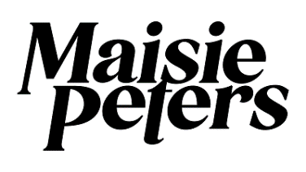

**UNVEILS OFFICIAL MUSIC VIDEO FOR “NOT ANOTHER ROCKSTAR”**

[**WATCH HERE**](https://youtu.be/VjGqTT0drP8)

**RECENTLY ANNOUNCED AS SUPPORT ON SELECT DATES OF**

**ED SHEERAN’S ‘+ - = ÷ x’ NORTH AMERICAN STADIUM TOUR**

**FALL 2022 NORTH AMERICAN HEADLINE TOUR KICKS OFF NEXT MONTH WITH SOLD OUT SHOWS IN NEW YORK, TORONTO AND SAN FRANCISCO; CHICAGO VENUE UPGRADED DUE TO OVERWHELMING DEMAND**

**ROAD TO BRIXTON DATES SOLD OUT WITHIN ONE MINUTE**

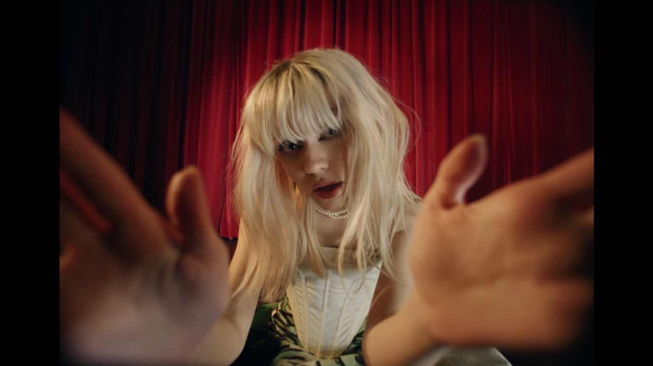

**PRESS ASSETS** [**HERE**](https://warnermusicgroup.box.com/s/6qjsy34tn3qhs0j4xjptp1061tdmje3g)

**(October 19th, 2022**) – British pop singer-songwriter **Maisie Peters** has unveiled the official music video for her new track, “**Not Another Rockstar**”. Shot from the imagined lens of a paparazzi camera, the Avesta Keshtmand-directed video finds Maisie and her rockstar boyfriend trying to avoid the invasion of privacy, but as Maisie tries to hide, her fame-hungry boyfriend has an ulterior motive. Watch the official video [**HERE**](https://www.youtube.com/watch?v=VjGqTT0drP8).

Written by Maisie, alongside Ines Dunn (*Mimi Webb, Griff*) and producer Joe Rubel, “Not Another Rockstar” follows a series of recent fan-focused track drops including “[Cate’s Brother](https://www.youtube.com/watch?v=LJDr2kpkTMQ)”, “[Blonde](https://www.youtube.com/watch?v=0lxs3oAoQbc)” and “[Good Enough](https://www.youtube.com/watch?v=E87oYUfI3WY)”, each of which see her explore different stages of relationships with intimate but typically relatable tact. Upon the release of “[Not Another Rockstar](https://maisiepeters.lnk.to/Not-Another-Rockstar)” earlier this month, the new single garnered praise from **Billboard**, **Uproxx**, **Entertainment Tonight** and more.

Just back from supporting Ed Sheeran’s 54-date + - = ÷ x European stadium tour, Maisie was recently announced as the opener on select dates of Ed’s + - = ÷ x North American Stadium tour for summer 2023. Next month, Maisie will return to the states for her “i’m telling the whole of america tour.” The 5-date North American headline run kicks off on November 4th with a sold-out show at Hammerstein Ballroom in New York and makes stops in Toronto (SOLD OUT), Chicago (VENUE UPGRADED), and San Francisco (SOLD OUT) before wrapping at The Wiltern in Los Angles on November 14th. After selling out London’s O2 Academy Brixton in under an hour, Maisie recently announced the ‘Road To Brixton’ shows - a 7-date run of intimate gigs across the UK which sold out within just one minute of the general sale last Friday. For tickets and more information on Maisie’s upcoming tours please visit [www.maisiepeters.co.uk](http://www.maisiepeters.co.uk).

In August Maisie shared sister tracks “[Blonde](https://www.youtube.com/watch?v=0lxs3oAoQbc)” - a pop-rock banger - and “[Good Enough](https://www.youtube.com/watch?v=E87oYUfI3WY),” Maisie’s most vulnerable ballad to date. **V Magazine** hailed “Blonde” as *“the epitome of a fun breakup anthem*,” while **Teen Vogue** stated the track “*fits perfectly into a hot girl summer playlist.*” Co-written and produced by GRAMMY Award winner Dan Nigro (*Olivia Rodrigo, Carly Rae Jepsen, Caroline Polacheck*), “Good Enough” received praise from **Entertainment Tonight**, **Genius**, **Atwood Magazine** and more.

Earlier this summer Maisie took the stage at CBS’s *Late Late Show with James Corden* for an electrifying performance of her viral single “Cate’s Brother”. The episode was part of Corden’s special run of shows from London and landed in the midst of a 5 night stand at London’s Wembley Stadium supporting Ed Sheeran’s ‘+ - = ÷ x Tour’. Watch the performance [HERE](https://www.youtube.com/watch?v=a19k-4MdmJc).

Released in May, “[Cate’s Brother](https://www.youtube.com/watch?v=LJDr2kpkTMQ)” arrived to critical acclaim as **Billboard** praised the track as “*fantastic*” adding *“the storytelling beneath the wiry pop-rock production is top-notch”* while **People** declared Maisie as “*pop’s next big thing*.” **Consequence of Sound** described the track as “*vibrant, playful and fun*” and hailed, “*If there was ever any doubt that Peters can oscillate between more delicate, introspective tracks over to crowd-ready bops like this, let ‘Cate’s Brother’ be the end of the conversation*.” Based on a true story, Maisie initially teased the track live from a studio session in February and with an overwhelming response from her fanbase, continued working on the song in real time, sharing everything from [Cate’s first listen reaction](https://www.tiktok.com/@maisiehpeters/video/7068758286622838021?is_copy_url=1&is_from_webapp=v1&lang=en) to [debut performances](https://youtu.be/NoPBggFLr3U).

Before amassing over half a billion global streams, Maisie spent time honing her craft in sessions across London, LA and Nashville, creating songs for her 2021 debut album ‘You Signed Up For This’ alongside the likes of Ed Sheeran, Steve Mac, Fred again.., Johnny McDaid, Miranda Cooper, and producers Joe Rubel (*Tom Grennan, Benjamin Francis Leftwich*), Afterhrs (*Niall Horan, GRACEY*), Rob Milton (*Easy Life, Holly Humberstone*) and Brad Ellis (*Jorja Smith, Little Mix*). With an innate gift for storytelling, crafting relatable, diary-entry songs, ‘You Signed Up For This’ is both Maisie’s coming of age story and a love letter to girlhood; penned with the wit, charm and quiet confidence that has seen her ascend from busking on the streets of Brighton to signing with Ed Sheeran’s Gingerbread Man Records and selling out her entire 2022 North American ‘*You Signed Up For This*’ tour. Maisie has since ushered in a new era of sound and songwriting with her viral track “Cate’s Brother” and sister singles “Blonde” and “Good Enough,” while continuing work on the follow up to her critically acclaimed debut album.

**i’m telling the whole of america tour**

Friday, November 4, 2022 - New York, NY - Hammerstein Ballroom **[SOLD OUT]**

Sunday, November 6, 2022 – Toronto, ON - The Phoenix **[SOLD OUT]**

Tuesday, November 8, 2022 – Chicago, IL - Riviera Theatre **[VENUE UPGRADE]**

Friday, November 11, 2022 - San Francisco, CA - The Fillmore **[SOLD OUT]**

Monday, November 14, 2022 - Los Angeles, CA - The Wiltern

**Road To Brixton**

Friday, April 14, 2023 - Newcastle University - Newcastle, UK **[SOLD OUT]**

Saturday, April 15, 2023 - Assembly Rooms - Edinburgh, UK **[SOLD OUT]**

Tuesday, April 18, 2023 – Leadmill - Sheffield, UK **[SOLD OUT]**

Wednesday, April 19, 2023 - O2 Academy Leicester - Leicester, UK **[SOLD OUT]**

Friday, April 21, 2023 – UEA - Norwich, UK **[SOLD OUT]**

Saturday, April 22, 2023- O2 Academy Oxford - Oxford, UK **[SOLD OUT]**

Sunday, April 23, 2023 – Tramshed - Cardiff, UK **[SOLD OUT]**

Thursday, April 27, 2023 - O2 Academy Brixton - London, UK **[SOLD OUT]**

**+ - = ÷ x North American Tour**

Saturday, August 26, 2023 – Seattle, WA - Lumen Field

Saturday, September 2, 2023 – Vancouver, BC - BC Place

Saturday, September 9, 2023 - Las Vegas, NV - Allegiant Stadium

Saturday, September 16, 2023 - Santa Clara, CA - Levi's Stadium

Saturday, September 23, 2023 – Inglewood, CA - SoFi Stadium

**MAISIE PETERS**

**“NOT ANOTHER ROCKSTAR”**

[**AVAILABLE NOW**](https://maisiepeters.lnk.to/Not-Another-Rockstar)

**CONNECT WITH MAISIE:**

[YouTube](https://www.youtube.com/channel/UCJvnOmwPOgeLczo7zLzb5Xg) | [Instagram](https://www.instagram.com/maisiehpeters/?hl=en) | [Twitter](https://twitter.com/maisiehpeters) | [Facebook](https://www.facebook.com/maisiepetersmusic) | [TikTok](https://www.tiktok.com/@maisiehpeters?)

**For more information please contact:**

[glennfukushima@elektra.com](mailto:glennfukushima@elektra.com)

[rossanderson@elektra.com](mailto:rossanderson@elektra.com)

[sydneyworden@elektra.com](mailto:sydneyworden@elektra.com)