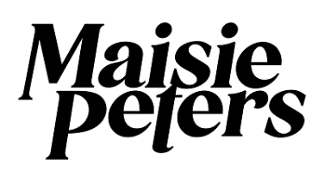
UNVEILS NEW SINGLE “NOT ANOTHER ROCKSTAR”
LISTEN HERE

OFFICIAL VIDEO COMING FRIDAY, OCTOBER 14TH

RECENTLY ANNOUNCED AS SUPPORT ON SELECT DATES OF
ED SHEERAN’S ‘+ - = ÷ x’ NORTH AMERICAN STADIUM TOUR

FALL 2022 NORTH AMERICAN HEADLINE TOUR KICKS OFF NEXT MONTH WITH SOLD OUT SHOWS IN NEW YORK, TORONTO AND SAN FRANCISCO; CHICAGO VENUE UPGRADED DUE TO OVERWHELMING DEMAND

PRESS ASSETS HERE

(October 7th, 2022) – British pop singer-songwriter Maisie Peters has unveiled her new single “Not Another Rockstar.” Listen HERE. The official music video will arrive on Friday, October 14th.

Written by Maisie, alongside Ines Dunn (Mimi Webb, Griff) and producer Joe Rubel, “Not Another Rockstar” follows a series of recent fan-focused track drops including ‘Cate’s Brother’, ‘Blonde’ and ‘Good Enough’, each of which see her explore different stages of relationships with intimate but typically relatable tact.

Maisie explains: “I wrote ‘Not Another Rockstar’ about my very debatable track record with men. The song aims to make fun at me and my decisions and them and their guitars, and it feels right that I wrote it with Ines who is my best friend because she was literally rolling her eyes at every line like ‘too real’. I hope everyone comes out of this song realising the true rockstar was in fact me. Obviously. No longer the rockstar’s girlfriend, we are the whole rockstar these days, girls.”

Just back from supporting Ed Sheeran’s 54-date + - = ÷ x European stadium tour, Maisie was recently announced as the opener on select dates of Ed’s + - = ÷ x North American Stadium tour for summer 2023. Next month, Maisie will return to the states for her “i’m telling the whole of america tour.” The 5-date North American headline run kicks off on November 4th with a sold-out show at Hammerstein Ballroom in New York and makes stops in Toronto (SOLD OUT), Chicago (VENUE UPGRADED), and San Francisco (SOLD OUT) before wrapping at The Wiltern in Los Angles on November 14th. After selling out London’s O2 Academy Brixton in under an hour, Maisie has today announced the ‘Road To Brixton’ shows - a 7-date run of intimate gigs across the UK. For tickets and more information on Maisie’s upcoming tours please visit www.maisiepeters.co.uk.

In August Maisie shared sister tracks “Blonde” - a pop-rock banger - and “Good Enough,” Maisie’s most vulnerable ballad to date. V Magazine hailed “Blonde” as “the epitome of a fun breakup anthem,” while Teen Vogue stated the track “fits perfectly into a hot girl summer playlist.” Co-written and produced by GRAMMY Award winner Dan Nigro (Olivia Rodrigo, Carly Rae Jepsen, Caroline Polacheck), “Good Enough” received praise from Entertainment Tonight, Genius, Atwood Magazine and more.

Earlier this summer Maisie took the stage at CBS’s Late Late Show with James Corden for an electrifying performance of her viral single “Cate’s Brother”. The episode was part of Corden’s special run of shows from London and landed in the midst of a 5 night stand at London’s Wembley Stadium supporting Ed Sheeran’s ‘+ - = ÷ x Tour’. Watch the performance HERE.

Released in May, “Cate’s Brother” arrived to critical acclaim as Billboard praised the track as “fantastic” adding “the storytelling beneath the wiry pop-rock production is top-notch” while People declared Maisie as “pop’s next big thing.” Consequence of Sound described the track as “vibrant, playful and fun” and hailed, “If there was ever any doubt that Peters can oscillate between more delicate, introspective tracks over to crowd-ready bops like this, let ‘Cate’s Brother’ be the end of the conversation.” Based on a true story, Maisie initially teased the track live from a studio session in February and with an overwhelming response from her fanbase, continued working on the song in real time, sharing everything from Cate’s first listen reaction to debut performances.

Before amassing over half a billion global streams, Maisie spent time honing her craft in sessions across London, LA and Nashville, creating songs for her 2021 debut album ‘You Signed Up For This’ alongside the likes of Ed Sheeran, Steve Mac, Fred again.., Johnny McDaid, Miranda Cooper, and producers Joe Rubel (Tom Grennan, Benjamin Francis Leftwich), Afterhrs (Niall Horan, GRACEY), Rob Milton (Easy Life, Holly Humberstone) and Brad Ellis (Jorja Smith, Little Mix). With an innate gift for storytelling, crafting relatable, diary-entry songs, ‘You Signed Up For This’ is both Maisie’s coming of age story and a love letter to girlhood; penned with the wit, charm and quiet confidence that has seen her ascend from busking on the streets of Brighton to signing with Ed Sheeran’s Gingerbread Man Records and selling out her entire 2022 North American ‘You Signed Up For This’ tour. Maisie has since ushered in a new era of sound and songwriting with her viral track “Cate’s Brother” and sister singles “Blonde” and “Good Enough,” while continuing work on the follow up to her critically acclaimed debut album.

i’m telling the whole of america tour
Friday, November 4, 2022 - New York, NY - Hammerstein Ballroom [SOLD OUT]
Sunday, November 6, 2022 – Toronto, ON - The Phoenix [SOLD OUT]
Tuesday, November 8, 2022 – Chicago, IL - Riviera Theatre [VENUE UPGRADE]
Friday, November 11, 2022 - San Francisco, CA - The Fillmore [SOLD OUT]
Monday, November 14, 2022 - Los Angeles, CA - The Wiltern

Road To Brixton
Friday, April 14, 2023 - Newcastle University - Newcastle, UK
Saturday, April 15, 2023 - Assembly Rooms - Edinburgh, UK
Tuesday, April 18, 2023 – Leadmill - Sheffield, UK
Wednesday, April 19, 2023 - O2 Academy Leicester - Leicester, UK
Friday, April 21, 2023 – UEA - Norwich, UK
Saturday, April 22, 2023 - O2 Academy Oxford - Oxford, UK
Sunday, April 23, 2023 – Tramshed - Cardiff, UK
Thursday, April 27, 2023 - O2 Academy Brixton - London, UK

+ - = ÷ x NORTH AMERICAN TOUR
Saturday, August 26, 2023 – Seattle, WA - Lumen Field
Saturday, September 2, 2023 – Vancouver, BC - BC Place
Saturday, September 9, 2023 - Las Vegas, NV - Allegiant Stadium
Saturday, September 16, 2023 - Santa Clara, CA - Levi's Stadium
Saturday, September 23, 2023 – Inglewood, CA - SoFi Stadium

MAISIE PETERS
“NOT ANOTHER ROCKSTAR”
AVAILABLE NOW
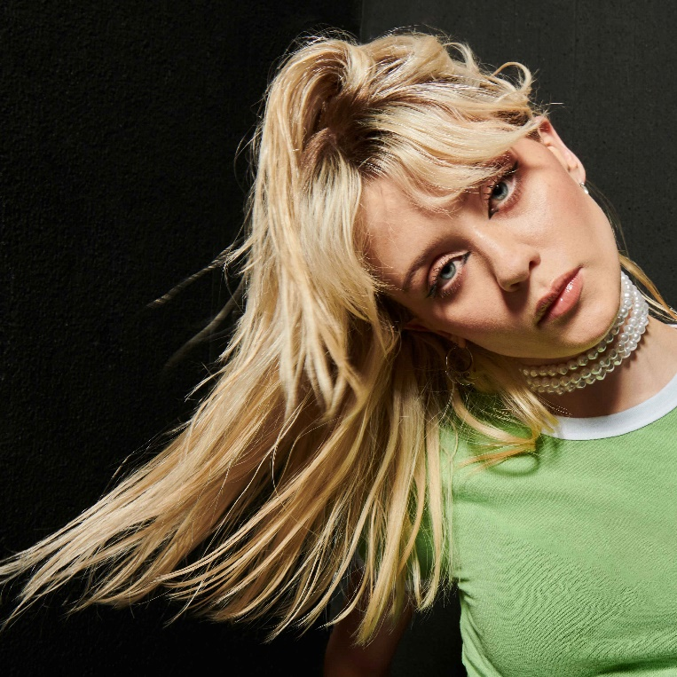

CONNECT WITH MAISIE:
YouTube | Instagram | Twitter | Facebook | TikTok

For more information please contact:
glennfukushima@elektra.com
rossanderson@elektra.com
sydneywordern@elektra.com

