NEW RULES ANNOUNCE U.S. HEADLINE TOUR
DATES KICK OFF NOVEMBER 30 IN PHILADELPHIA, PA

GO THE DISTANCE EXTENDED MIXTAPE AVAILABLE NOW

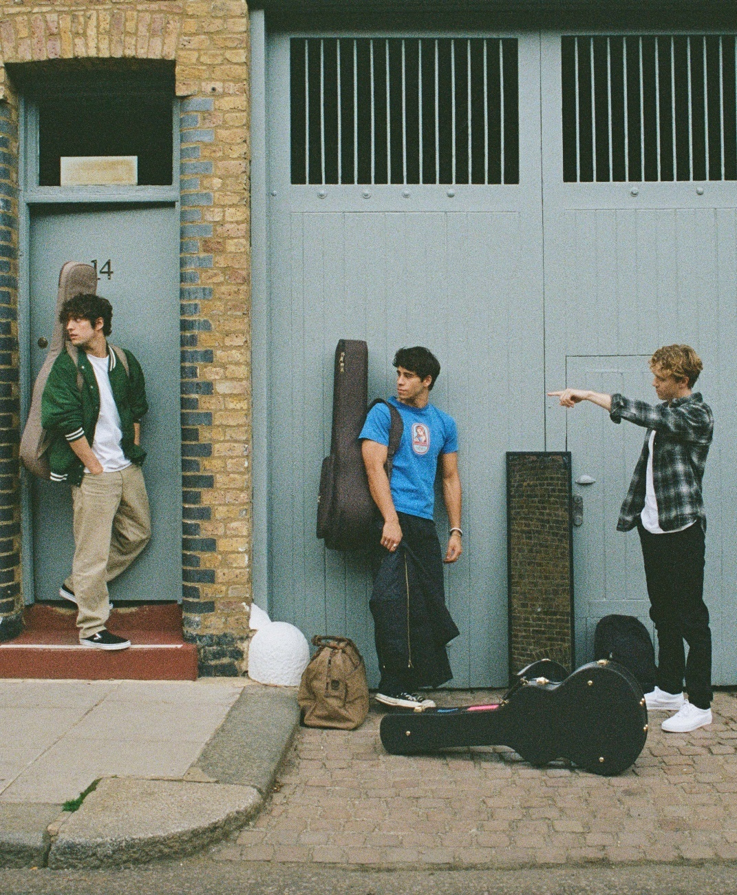
SEPTEMBER 27, 2022 – UK/Irish trio New Rules have announced a U.S. headline tour. The run kicks off November 30 in Philadelphia, PA and hits New York City’s famed Bowery Ballroom on December 1 before concluding in Atlanta, GA on December 7 (tour itinerary below). Fans can sign up for the band’s Planet Fans Access-All-Areas pass to access presale tickets, which will be available beginning Wednesday, September 28 at 9am local time. General onsale begins Friday, September 30 at 10am ET. For up-to-date ticketing information, please visit www.newrulesband.com.

The band added, “We can’t wait to come back and play more shows in the US this year and see some cities we’ve never visited before (and eat all their food). We met so many lovely New Rules fans around our last sold out shows who we miss now so we’re so excited do it all again.”
This summer, New Rules released Go The Distance (Extended Version), available now via Elektra Records. The extended mixtape includes stripped-down versions of “Go The Distance” and “Love You Like That” and live offerings of “Drunk Texts” and “Lucky Me.” The offering also arrived alongside a live video for “Lucky Me,” which is streaming now on the band’s official YouTube channel.
In June, the group shared their debut mixtape Go The Distance, which racked up praise from PEOPLE Magazine, who named the trio one of their Emerging Artists To Watch. Rolling Stone UK applauded the mixtape’s “pop-driven earworms,” while Sweety High attested New Rules are “going places.” The band celebrated the release with their intimate “New Songs For New People” debut U.S. headline shows, which included sold-out performances at New York City’s Mercury Lounge and The Moroccan Lounge in Los Angeles. New Rules also performed two sold-out hometown shows in Dublin, Ireland and London, UK in August.
The mixtape was heralded by title track “Go The Distance,” produced by Sir Nolan [Selena Gomez, Tate McRae, Shawn Mendes] and co-produced and co-written with Kieran Shudall of Circa Waves. The single – which bounces between a slick bass line, handclaps, and glossy synths – is accompanied by an official lyric video on the band’s official YouTube channel.
Last fall, the group announced their signing to Elektra Records and shared new singles “Really Wanna Dance With You” and “Cheers.” The tracks racked up praise, with Sweety High celebrating the “catchy chorus and … beat that's impossible to resist,” of “Really Wanna Dance With You” while Wonderland Magazine attested “New Rules are set to become the next big thing.” Entirely written and co-produced by the band, the group’s 2022 name songs EP ignited a flurry of activity on TikTok.
About New Rules:
For New Rules, three guitars and three voices converge upon one stadium-size sound. The London-based trio—Alec McGarry, Nathan Lambert, and Ryan Meaney—elevate pop to the rafters fueled by singer-songwriter soul, rock ‘n’ roll spirit, and a whole lot of personality. With Ryan from Ireland, Alec from Hertfordshire, and Nathan from Chelmsford, the boys initially met online, bonding over similar backgrounds playing music on street corners, uploading covers online, and penning original material. The musicians congregated in London and introduced New Rules with “Call It” and “Fix Somebody” during 2019. Beyond hitting the road with Julia Michaels, Little Mix, and Picture This, they’ve sold out successive headline tours. Following the viral success of “Pasta” and “Emily,” they caught the attention of Elektra Records and signed to the label in 2021. This summer, the trio released their debut mixtape Go The Distance, which racked up praise from PEOPLE Magazine, Entertainment Weekly, Rolling Stone UK, and more, in addition to selling out UK shows and their first-ever US dates earlier this year.
(Tour Itinerary/Mixtape Art/Tracklisting below)

NEW RULES 2022 U.S. HEADLINE TOUR DATES

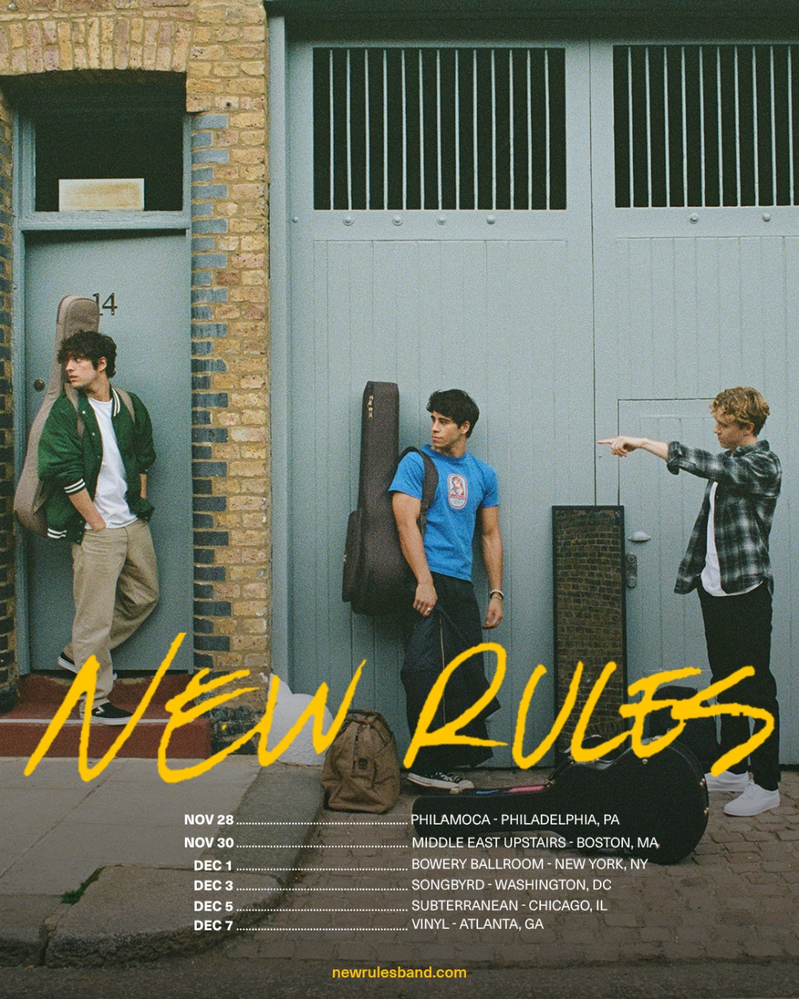

11/28 Philadelphia, PA Philamoca
11/30 Boston, MA Middle East Upstairs
12/1 New York, NY Bowery Ballroom
12/3 Washington, DC Songbyrd
12/5 Chicago, IL Subterranean
12/7 Atlanta, GA Vinyl

NEW RULES
Go The Distance (Extended Version)
AVAILABLE NOW
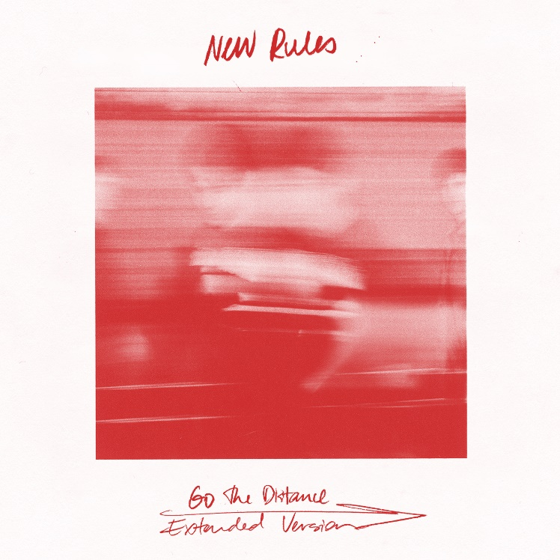

Tracklisting:
- Go The Distance
- Love You Like That
- RIDE
- Where To Find Me
- Drunk Texts
- Lucky Me
- Fireaway
- Pasta
- Go The Distance – Stripped
- Love You Like That – Stripped
- Drunk Texts (Live from Manchester, UK)
- Lucky Me (Live from LA)

###
CONNECT WITH NEW RULES
Official Website
Instagram
TikTok
Twitter
Facebook
YouTube

Press Contact:
Sarah Goldstein
sarahgoldstein@elektra.com

