RAINBOW KITTEN SURPRISE EXTENDS DECEMBER U.S. HEADLINE TOUR

DATES KICK OFF DECEMBER 3 IN CHICAGO; CULMINATE DECEMBER 19 IN NEW ORLEANS

RE-SCHEDULED UK/EU TOUR DATES KICK OFF MARCH 2023 IN PARIS

ALL UPCOMING TICKETS ON SALE HERE

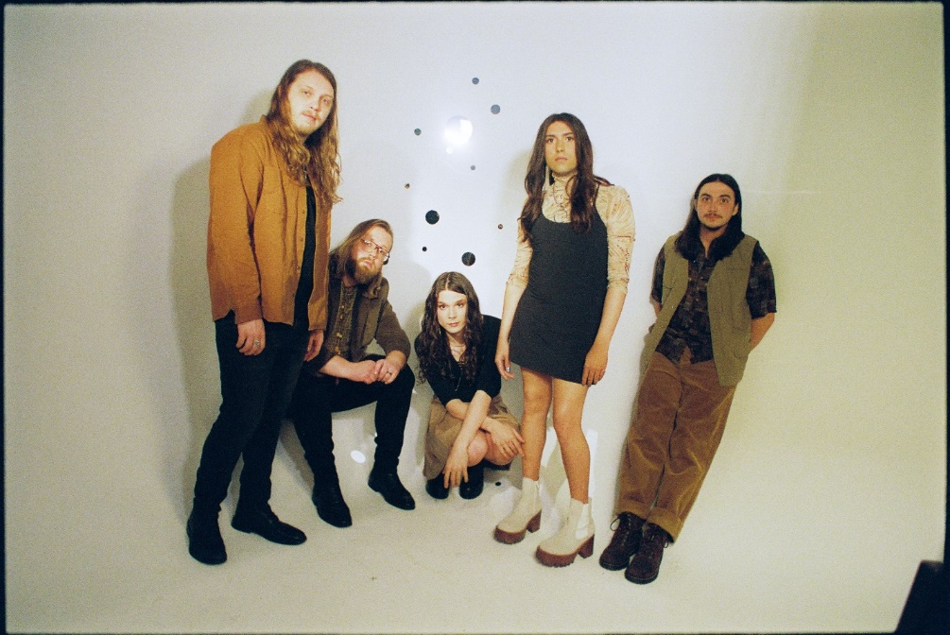
(photo credit: Aubrey Denis; download HERE)

Today, genre-defying, Nashville-based quintet and live sensations Rainbow Kitten Surprise have announced new dates for their highly anticipated US headline run this December. The tour kicks off with a previously announced (and already sold-out) night in Chicago on December 3 before traversing the Midwest and Southern US – closing out in New Orleans, Louisiana on December 19 (full routing enclosed). Support on this run will come from Nashville indie-rock group twen.

They’ve also announced a rescheduled run of UK/EU tour dates, set for March/April 2023. Each previously announced show on this spring tour has been upgraded to a larger venue, in order to accommodate high demand.

Kicking off on March 15, 2023 in Paris, France, the band will stop in cities including London, Berlin, and Amsterdam, before culminating on April 3 in Dublin, Ireland. Additionally, four new shows have been added in Zurich, Vienna, Prague, and Glasgow.

All dates are on sale now; tickets + additional information for all upcoming shows can be found here.

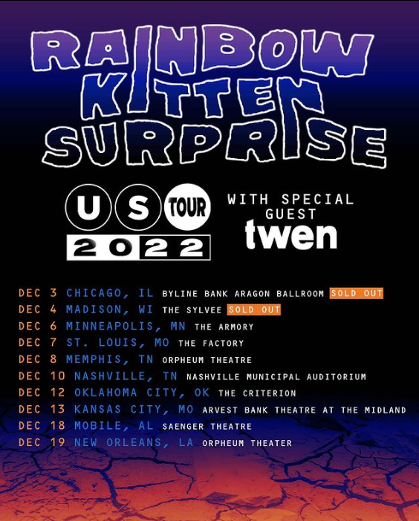

The newly announced dates follow the band’s 2022 entirely sold-out North American headline tour, which included back-to-back sold-out nights at The Caverns in Pelham, TN and a triumphant two-night return to Red Rocks Amphitheater in Morrison, CO, which sold-out in a matter of minutes of being announced. Always a festival favorite, Rainbow Kitten Surprise topped the lineups at Shaky Knees Festival in Atlanta, GA and Bottle Rock Festival in Napa, CA.

This past May, the band released the emotionally charged track “Work Out,” marking the band’s first new music in nearly two years. The song’s beautiful melody-line and effervescent vibe stands in stark juxtaposition to its poignant lyrics about the difficult relationships – of all sorts – that people struggle with. “Work Out” arrived alongside a lyric video, handwritten by RKS frontperson Ela Melo (watch here). The stunning official visual was directed by Joey Brodnax and released this June (watch here).

###

ABOUT RAINBOW KITTEN SURPRISE:
As if channeling another dimension where genres simply don’t exist, Rainbow Kitten Surprise finds harmony in unpredictability – weaving together lyrical poetry, hummable melodies, and a rush of instrumental eccentricities. Now boasting over 1 billion global streams across platforms, the band first began building their devoted fanbase with independent albums SEVEN + MARY (2013) and RKS (2015). The band’s breakout full-length debut for Elektra, HOW TO: FRIEND, LOVE, FREEFALL, arrived in 2018. Produced by GRAMMY® Award-winner Jay Joyce (Cage The Elephant, Sleeper Agent), the album featured RIAA-certified Gold single “It’s Called: Freefall,” earned widespread praise from Billboard, TIME, Vice, and NPR who described their sound as “…a mix of jam and indie and whatever else you can throw into the soup…very earnest, beautiful, political, loving rock n’ roll,” and saw the band make several national television appearances, including performances on “CBS Saturday Morning,” “The Late Show with Stephen Colbert,” and PBS’s “Austin City Limits.” After gracing the bills of Bonnaroo, Lollapalooza, and Osheaga, to name a few, RKS moved 80,000 tickets of their own on their sold-out Friend, Love, Freefall Tour, earmarked by a packed night at Red Rocks Amphitheatre and three consecutive gigs in Athens, GA – as chronicled on their first official live album, LIVE FROM ATHENS GEORGIA, released in 2021. Most recently, two longtime fan-favorite tracks began to take off organically on TikTok, with “It’s Called: Freefall” and “Cocaine Jesus” experiencing massive upticks after user-created content on the platform went viral – resulting in over 11 million *weekly* streams for the band. The songs now boast 108 and 94 million streams, respectively.

Rainbow Kitten Surprise is: Ela Melo (she/her; lead vocals), Darrick “Bozzy” Keller (he/him; guitar, vocals), Ethan Goodpaster (he/him; lead guitar, vocals), Charlie Holt (they/them; bass, vocals), Jess Haney (he/him; drums).

RAINBOW KITTEN SURPRISE – UPCOMING LIVE DATES:
= twen supporting
* Support TBA

DECEMBER
Sat, December 3rd – Chicago, IL – Byline Bank Aragon Ballroom = sold out
Sun, December 4th – Madison, WI – The Sylvee = sold out
Tue, December 6th – Minneapolis, MN – The Armory =
Thur, December 7th – St. Louis, MO – The Factory =
Fri, December 8th – Memphis, TN – Orpheum Theatre =
Sat, December 10th – Nashville, TN – Nashville Municipal Auditorium =
Mon, December 12th – Oklahoma City, OK – The Criterion =
Tue, December 13th – Kansas City, MO – Arvest Bank Theatre at the Midland =
Sun, December 18th – Mobile, AL – Saenger Theatre =
Mon, December 19th – New Orleans, LA – Orpheum Theater =

MARCH 2023
Wed, March 15th – La Machine Du Moulin Rouge – Paris, France * upgraded venue
Thur, March 16th – Dynamo Saal – Zurich, Switzerland * new show
Sat, March 18th – Vienna, Austria – Flex * new show
Sun, March 19th – Munich, Germany – Technikum * upgraded venue
Mon, March 20th – Prague, Czech Republic – MeetFactory * new show
Wed, March 22nd – Warsaw, Poland – Progresja * upgraded venue
Thur, March 23rd – Berlin, Germany – Columbia Theater * upgraded venue
Sat, March 25th – Amsterdam, Netherlands – Melkweg * upgraded venue
Sun, March 26th – Hamburg, Germany – Gruenspan * upgraded venue
Mon, March 27th – Cologne, Germany – Kantine * upgraded venue
Wed, March 29th – Manchester, UK – Academy * upgraded venue
Thur, March 30th – Birmingham, UK – O2 Institute * upgraded venue
Fri, March 31st – London, UK – Roundhouse * upgraded venue

APRIL 2023
Sun, April 2nd – Glasgow, UK – Garage * new show
Mon, April 3rd – Dublin, Ireland – The Academy * upgraded venue

For more ticket information and tour updates, please visit [www.rksband.com/tour].

###

For more information, please visit:
RAINBOWKITTENSURPRISE.COM
FACEBOOK * TWITTER * INSTAGRAM * YOUTUBE * SPOTIFY

PRESS CONTACTS:
Glenn Fukushima | GlennFukushima@elektra.com
Libby Kober | Libby.Kober@atlanticrecords.com

