THE FRONT BOTTOMS
ANNOUNCE CHAMPAGNE JAM 2022
WITH SPECIAL FRIENDS JOYCE MANOR, TITUS ANDRONICUS,
SOUL GLO, SLOTHRUST, KEVIN DEVINE & MORE

TWO NIGHT YEAR-END BASH SET FOR DECEMBER 16TH & 17TH AT THE FILLMORE CAMPUS

PRE-SALE TICKETS AVAILABLE TODAY

GENERAL ON SALE BEGINS SEPTEMBER 29TH AT 11:00AM ET

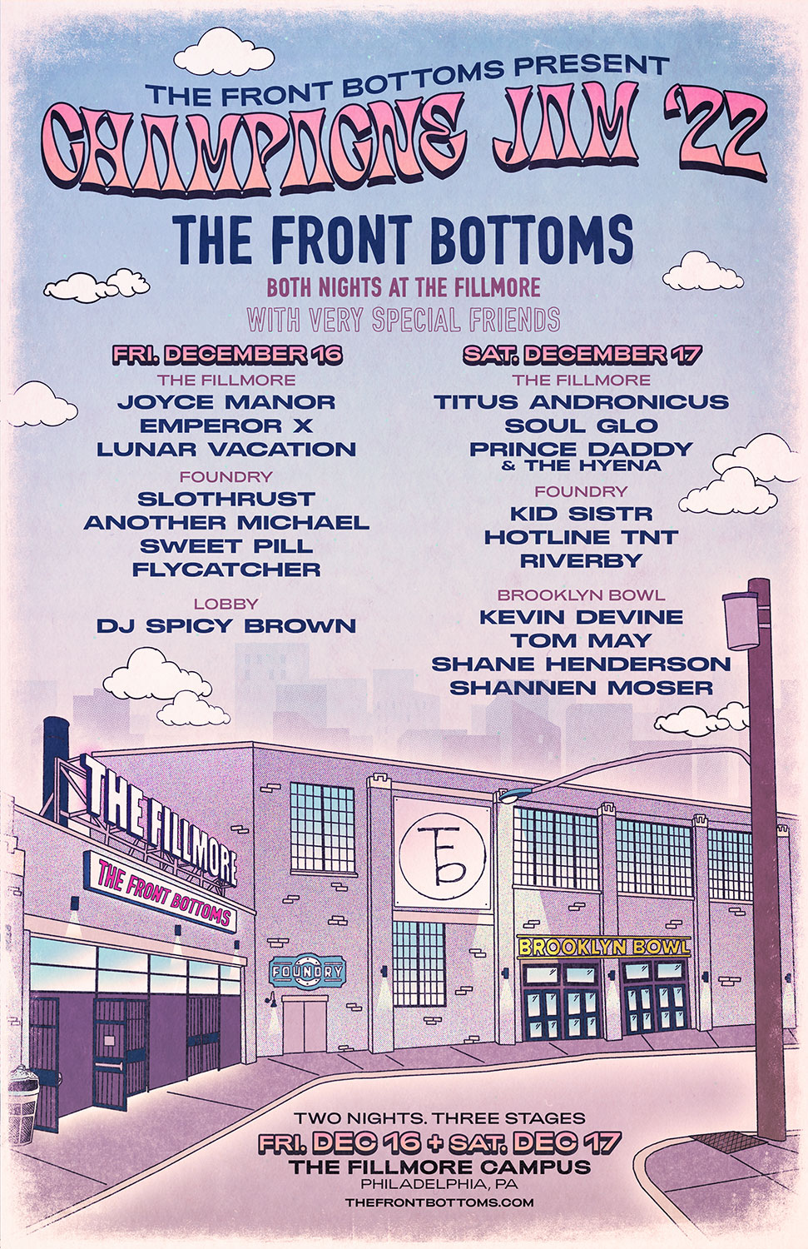

SEPTEMBER 27, 2022 – Fueled By Ramen band The Front Bottoms have announced details of the 2022 iteration of their popular year-end bash, Champagne Jam. This year, the annual holiday festival will happen across two nights - December 16th and December 17th - at The Fillmore Campus in Philadelphia, PA, and will see The Front Bottoms headlining each night at The Fillmore with special friends Joyce Manor, Titus Andronicus, Soul Glo, Slothrust, Kevin Devine and more delivering performances across the campus’ three stages.

Pre-sale tickets for Champagne Jam 2022 are available now to members of The Front Bottoms’ Motorcycle Club, with general on sale for tickets starting Friday, September 29th at 11:00AM ET. For tickets and more information visit, www.thechampagnejam.com.

Earlier this month The Front Bottoms released the Theresa EP, which features the singles “More Than It Hurts You” and “Hello World.” The five song collection serves as the third installment of the band’s popular Grandma EP series and features new recordings of never before released fan favorite songs.

In support of Theresa, The Front Bottoms are currently out on a headline tour across North America which will feature support from special guests The Joy Formidable and Mobley. For tickets and more information on the upcoming dates, visit www.thefrontbottoms.com.

Last year, The Front Bottoms shared the standalone singles “Lover Boy” and “Voodoo Magic,” the latter of which the band enlisted Matt Skiba of Blink-182 and Alkaline Trio to play guitar on.

Comprised of guitarist/vocalist Brian Sella and drummer Mathew Uychich, The Front Bottoms have gripped listeners and press around the world with their ragged honesty and emotional urgency. In 2020, The Front Bottoms released their celebrated album, In Sickness & In Flames, a twelve song collection produced by Mike Sapone. NME attested, “In Sickness & In Flames is a defining work that showcases a sonic universe, rather than a structured set of songs, expertly capturing the inescapable tension of 2020.” A.V. Club declared, “The Front Bottoms are as vibrant as ever on In Sickness & In Flames, a reliably great collection of folk-punk anthems that rattle the soul with crunchy riffs, electrifying hooks, and Brian Sella’s idiosyncratic lyricism, which remains as amiable as it is anxiety-ridden.” UPROXX added “In Sickness & In Flames features the band’s biggest choruses to date, anchored with hooks and deeply personal songwriting that will turn heads,” while The FADER hailed it as, “a celebration of sorts for a band perennially on the fringes of a major breakthrough.” The Alternative detailed, “While In Sickness & In Flames was written prior to the pandemic, so much of it feels so tethered to our present collective experience, from the introspection and reflective growth that is showcased in the songwriting, to the sweeping highs and lows of the music itself. This album is the perfect companion piece to the anxiety of standing in the face of uncertainty.”

[Tour Itinerary Below]

2022 NORTH AMERICAN TOUR DATES
WITH SPECIAL GUESTS THE JOY FORMIDABLE & MOBLEY

9/27 Salt Lake City, UT Union
9/28 Boise, ID Knitting Factory
9/30 Spokane, WA Knitting Factory
10/1 Tacoma, WA Temple Theater
10/3 Reno, NV Cargo
10/4 Santa Cruz, CA Catalyst
10/5 Los Angeles, CA Hollywood Forever Cemetery
10/7 Riverside, CA Riverside Music Hall
10/8 San Diego, CA The Observatory North Park
10/9 Ventura, CA Majestic Theater
10/11 Tucson, AZ Rialto
10/12 Albuquerque, NM El Rey Theater
10/15 Austin, TX Austin City Limits#
10/17 New Orleans, LA HOB NOLA
10/18 Birmingham, AL Iron City
10/19 Charlotte, NC Fillmore
10/20 Baltimore, MD Ram’s Head
12/3-4 Phoenix, AZ Zona Music Festival#
12/16 Philadelphia, PA Champagne Jam 2022#
12/17 Philadelphia, PA Champagne Jam 2022#
# Festival Date

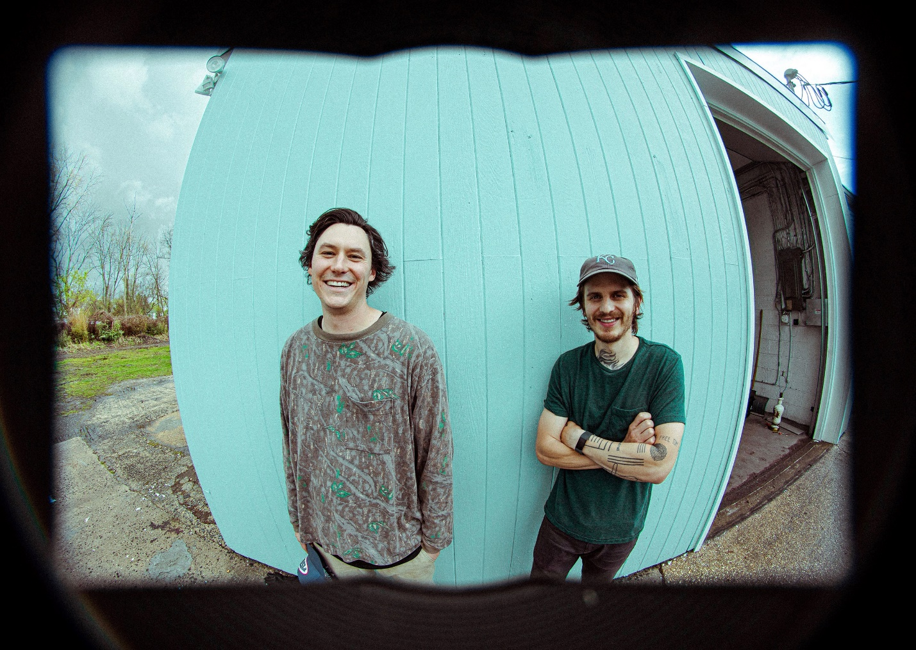
PHOTO CREDIT: MARK JAWORSKI

CONNECT WITH THE FRONT BOTTOMS:
WWW.THEFRONTBOTTOMS.COM
FACEBOOK
INSTAGRAM
TWITTER
WWW.FUELEDBYRAMEN.COM

FOR MORE INFORMATION, CONTACT:
ROSS.ANDERSON@300ELEKTRA.COM
SYDNEY.WORDEN@300ELEKTRA.COM

