jxdn Announces New Single
“Sober”
Available Everywhere Friday, November 11
Pre-Save “Sober” Now

Breakout Star to Play Exclusive Run of Intimate Live Shows:
November 7 – Los Angeles
November 14 – Chicago
November 16 – New York City

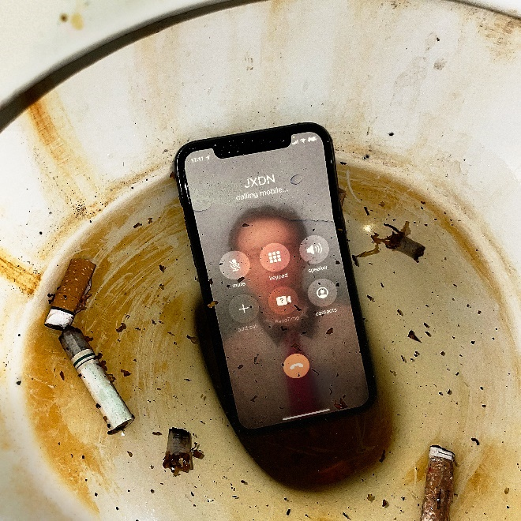
“Sober” Teaser Art: Download Here (Credit: Joe Perez)

October 20, 2022 – Today, breakout artist jxdn announced that his brand-new single “Sober” will be released everywhere on Friday, November 11 via Travis Barker’s DTA Records – pre-save the single HERE. “Sober” was written by jxdn, Travis Barker, Mike Posner and Andrew Goldstein; it was produced by Barker and Goldstein.

To celebrate the release, jxdn will play three exclusive shows at legendary clubs across the country:
- Monday, November 7 – Los Angeles, CA @ The Roxy
- Monday, November 14 – Chicago, IL @ Subterranean
- Wednesday, November 16 – Brooklyn, NY @ Baby’s All Right

Ticket details for the show will be available tomorrow, October 21 – keep an eye out at http://www.jxdnmusic.com/tour for all information.

“I want to have fun. No rules. I want to remind people how empowering music can make you feel,” jxdn shares. “This is the beginning of a New Era for myself. This song doesn’t sound like the next, and the one after sounds different too. I’m making music for everyone now. You don’t have to be ready, because I already am.”

The release of “Sober” will mark the beginning of the newest chapter of jxdn music, with the emerging rockstar currently at work on his sophomore album. jxdn most previously released a two-track EP titled 28 (Songs For Cooper) in June, in honor of his late best friend Cooper Noriega, who passed away on June 9, 2022.

This weekend, jxdn will hit the Black Stage at the highly anticipated When We Were Young Festival in Las Vegas, playing from 2:20-2:50pm on both Saturday, October 22, and Sunday, October 23. He will return to the festival on its third and final day, Saturday, October 29.

In April and May, jxdn embarked on his debut headline TELL ME ABOUT TOMORROW WORLD TOUR U.S. dates, performing for thousands of fans across the country, including sold out dates in New York City, Chicago, Pittsburgh, Atlanta, among others. The tour was in support of his critically-acclaimed debut album Tell Me About Tomorrow, released July 2021, and its expanded version, Tell Me About Tomorrow (Deluxe), released December 2021.

Tell Me About Tomorrow – produced by Barker – was met with wide critical acclaim, with NYLON hailing, “an album that both cements his place in the current pop-punk revival and shows that he’s only getting started,” and SPIN praising, “a deliriously catchy pop-punk effort.” Additionally, the album earned jxdn a #3 Alternative New Artist Albums, #5 Top New artist Albums, and #11 Digital Albums on the Billboard charts.

jxdn's rapid ascent to rock stardom has taken the music industry by storm, having racked up more than 915 million global streams to date, multiple songs flying up the Billboard charts, playing major festivals – including the main stage at Lollapalooza to a massive crowd – and serving as direct support on Machine Gun Kelly’s “Tickets To My Downfall” U.S. Tour in Fall 2021. He was included in Variety’s Power of Young Hollywood 2021 Music impact list, and Billboard’s 21 Under 21 list for the two consecutive years he was eligible (2020 and 2021), in addition to garnering nominations for both a MTV VMA and MTV EMA in 2021.

connect with jxdn:
instagram | twitter | tik tok | youtube | spotify | apple music | jxdnmusic.com

About jxdn:
Born in Dallas as Jaden Hossler, jxdn (pronounced jay-den) initially gained prominence on TikTok, parlaying his massive following into a breakout music career. In January 2020, he independently released “Comatose”, which landed on more than 40 global charts. His explosive success quickly garnered the attention of Travis Barker, who signed him as the first artist on his imprint, DTA Records, a worldwide joint venture with Elektra Music Group. He released his RIAA Gold-certified label debut single “Angels & Demons” in May 2020 followed by “So What!” in July, both of which landed in the Top 10 of Billboard’s Hot Rock & Alternative Song’s Chart; with “So What!” notably peaking at #20 on Alternative Radio. Cementing his rising rockstar status, jxdn debuted at No. 9 on Rolling Stone’s Breakthrough 25 chart, was featured as Billboard’s August 2020 Chartbreaker. In 2021, he joined Machine Gun Kelly as direct support on his sold-out Tickets to My Downfall tour and played inaugural solo sets at festivals like Lollapalooza, Austin City Limits and Firefly Music Festival. Additionally, jxdn has garnered critical acclaim from GRAMMY.com, Entertainment Weekly, MTV News, Alternative Press, NYLON, VMAN, Consequence of Sound, PEOPLE and Forbes, among others. He has performed on Jimmy Kimmel Live! and The Ellen DeGeneres Show and has been nominated for a MTV Video Music Award, MTV EMA and iHeartRadio Music Award. jxdn has been included in Billboard’s 2020 and 2021 annual “21 Under 21” list, and Variety’s 2021 Power of Young Hollywood Music Impact list. jxdn has surpassed 915 million worldwide streams to date and reaches more than 22 million followers across social platforms. His highly anticipated July 2021 debut album Tell Me About Tomorrow – hailed as a record that “both cements [jxdn’s] place in the current pop-punk revival - and shows that he’s only getting started” (NYLON) – and its Deluxe version, released December 2021, are available everywhere now. jxdn embarked on his debut headline TELL ME ABOUT TOMORROW WORLD TOUR across the U.S. in April and May of 2022. For more information, visit www.jxdnmusic.com.
Elektra Music Group
Glenn Fukushima & Ross Anderson
GlennFukushima@elektra.com | RossAnderson@elektra.com

