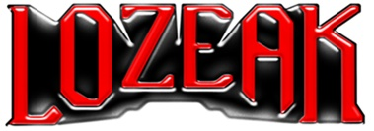

lozeak SHARES NEW ALT-POP SINGLE “XO”
LISTEN HERE

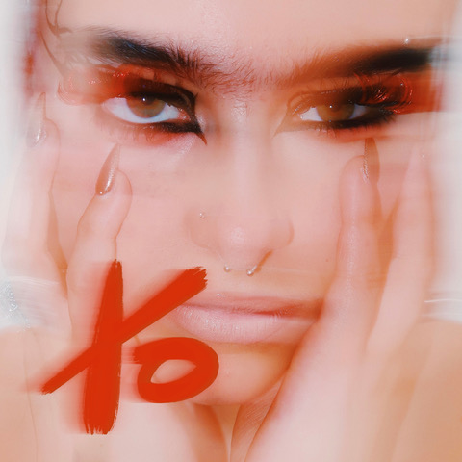
DOWNLOAD HI-RES ARTWORK HERE | PRESS ASSETS HERE

“Keep your eyes open for this one this year.” – ROCK SOUND
“…a force to be reckoned with” – WONDERLAND

“A future rockstar in waiting” – THE LINE OF BEST FIT

“…breaking boundaries with her genre-less vibe and no-rules style” – TMRW

(October 12, 2022) – LOS ANGELES, CA – With a growing global fanbase, London-based artist lozeak today released her addictive new alt-pop single “XO” – available on all streaming services. “XO” showcases lozeak’s talent for writing infectious, alt-pop anthems that are as diverse as her musical influences – everything from Hole, Kasabian, and Radiohead, to Avril Lavigne, Britney Spears, and Sugababes. The track was co-written with Jason Gil (Katy Perry, Doja Cat, Bebe Rexha, Lil Uzi Vert) and is the latest example of how lozeak is leading a new wave of British artists who are shaping the contemporary sound of emo.

lozeak has already cultivated a huge online (over 611k followers and 48 million likes on TikTok alone) with her debut singles being streamed over 3.7 million times to date. Her music is winning over famous fans, with Bring Me The Horizon’s Oli Sykes, Radio 1’s Jack Saunders and Frank Carter all championing her sound (with both Oli and Jack recently inviting her to perform at their respective club nights). Tastemaker publications like Dazed, Rock Sound, Stylist, and Wonderland have also tipped her as an artist to watch.

The story of lozeak starts in 2003 in Norwich with two music-obsessed parents blasting drum and bass awaiting the birth of their second child in an attempt to imbue rhythm and a flare for music into her DNA. It worked. A childhood spent exploring the sounds of Luther Vandross, Madonna, and Amy Winehouse gave way to her teenage years when she transitioned to artists like Avril Lavigne, Kehlani and Radiohead – inspiring her grungy, rock-pop edge of today. With a huge online fanbase eagerly awaiting her next move, she is quickly establishing herself as an artist on the rise.

Connect with lozeak:
Instagram
Twitter
TikTok
YouTube

# # #

PRESS CONTACT:
Nathalie Rubin
Nathalie.Rubin@300Elektra.com

