TURNSTILE ANNOUNCE NORTH AMERICAN FALL TOUR

“THE TURNSTILE LOVE CONNECTION TOUR”
TO FEATURE SPECIAL GUESTS SNAIL MAIL & JPEGMAFIA

SHARE “NEW HEART DESIGN” OFFICIAL MUSIC VIDEO

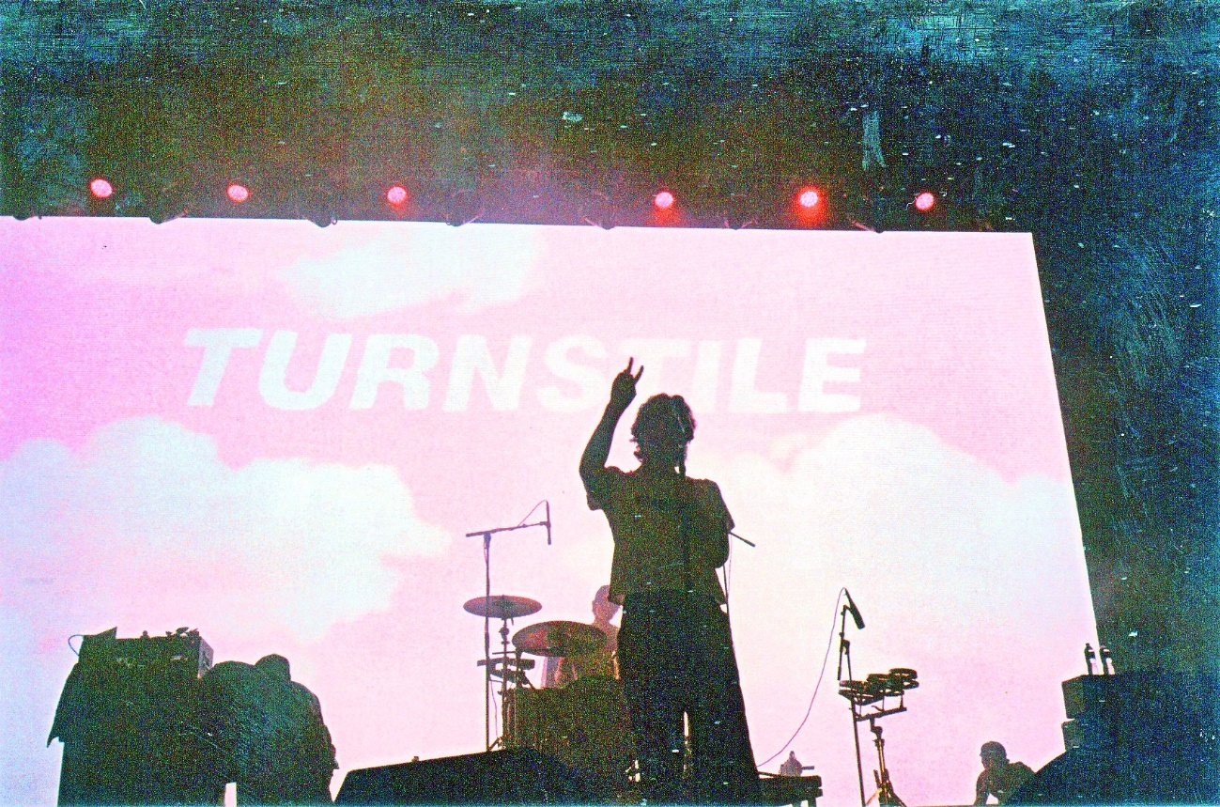
PHOTO CREDIT: ALEXIS GROSS

JUNE 21, 2022 – TURNSTILE have announced a fall headline tour of North America which will see the Baltimore band continuing their wildly successful “TURNSTILE LOVE CONNECTION TOUR” alongside special guests and hometown acts Snail Mail and JPEGMAFIA. The upcoming tour kicks off on October 3rd at NYC’s Brooklyn Mirage and includes stops in Asbury Park, Orlando, St. Louis, Louisville, Chicago and more [tour itinerary below]. Pre-sale tickets for the tour will be available starting tomorrow, June 22nd at 10:00AM local time with general on-sale for tickets beginning Thursday, June 23rd at 10:00AM local time. For tickets and more information on TURNSTILE’s fall tour and upcoming international dates, visit www.turnstilehardcore.com.

TURNSTILE have also shared an official music video for “NEW HEART DESIGN,” which is featured on their widely celebrated album GLOW ON. Shot on 16mm film during the sold-out first leg of “THE TURNSTILE LOVE CONNECTION TOUR,” the clip is directed by TURNSTILE’s own Brendan Yates and frequent collaborator Ian Hurdle - Watch it HERE.

TURNSTILE made their return to network TV last month performing “BLACKOUT” on The Tonight Show starring Jimmy Fallon - Watch it HERE. The performance follows TURNSTILE’s recent appearances on Jimmy Kimmel Live!, Late Night with Seth Meyers, and NPR’s Tiny Desk (Home) Concert Series.

Recorded with producer Mike Elizondo and co-produced by TURNSTILE vocalist Brendan Yates, GLOW ON staked its claim as one of 2021’s top releases, earning “Best of” honors from: NPR, Rolling Stone, Pitchfork, Billboard, Stereogum, SPIN, Vulture, The FADER, The Ringer, The Washington Post, Los Angeles Times, Esquire, FLOOD, Uproxx, Consequence, Paste, Revolver and more. It found TURNSTILE once again charting new ground for hardcore, expanding stylistic boundaries and celebrating new possibilities. 15 tracks devoid of borders, boundaries, or entry obstacles, only abundant imagination, heart, and grooves plucked from all corners of the musical spectrum.

GLOW ON features “MYSTERY”- which reached Top 5 at Alternative Radio - “HOLIDAY,” “NO SURPRISE,” and “T.L.C. (TURNSTILE LOVE CONNECTION),” all four of which appear on TURNSTILE’s TURNSTILE LOVE CONNECTION EP and companion short film. GLOW ON also includes guest features from Blood Orange on “ALIEN LOVE CALL,” and “LONELY DEZIRES,” with additional vocal contributions on “ENDLESS.”

Selected as Stereogum’s Album Of The Week, Senior Editor Tom Breihan wrote “Before GLOW ON, TURNSTILE were already a truly special band, a ray of exploding energy. With this album, they’ve hit dizzy new heights…They’ve made a classic. I can’t even imagine what they’ll do next.” Pitchfork awarded the album ‘Best New Music’ attesting “The Baltimore band’s spectacular fourth record is all groove, riffs, and passion,” with The Recording Academy noting “The through line of all this is a lack of fear—of pushback, of resistance, of excommunication—that defines TURNSTILE.” NPR observed, “TURNSTILE has the ability to lure even the most poptimistic listener with spectacular hooks,” and Vulture hailed GLOW ON as “one of the best rock albums of the year.” Billboard affirmed “Ready or not, TURNSTILE is breaking through,” with FLOOD hailing the album as “An unforgettable magnum Opus.”

Comprised of Brendan Yates (Vocals), Franz Lyons (Bass/Vocals), Brady Ebert (Guitars), Pat McCrory (Guitars), and Daniel Fang (Drums), TURNSTILE’s brand of youth-minded, youth-driven hardcore punk is intent on breaking down barriers, sonically and ideologically.

[TOUR ITINERARY / ADMAT BELOW]

“THE TURNSTILE LOVE CONNECTION TOUR”
Featuring Special Guests Snail Mail & JPEGMAFIA

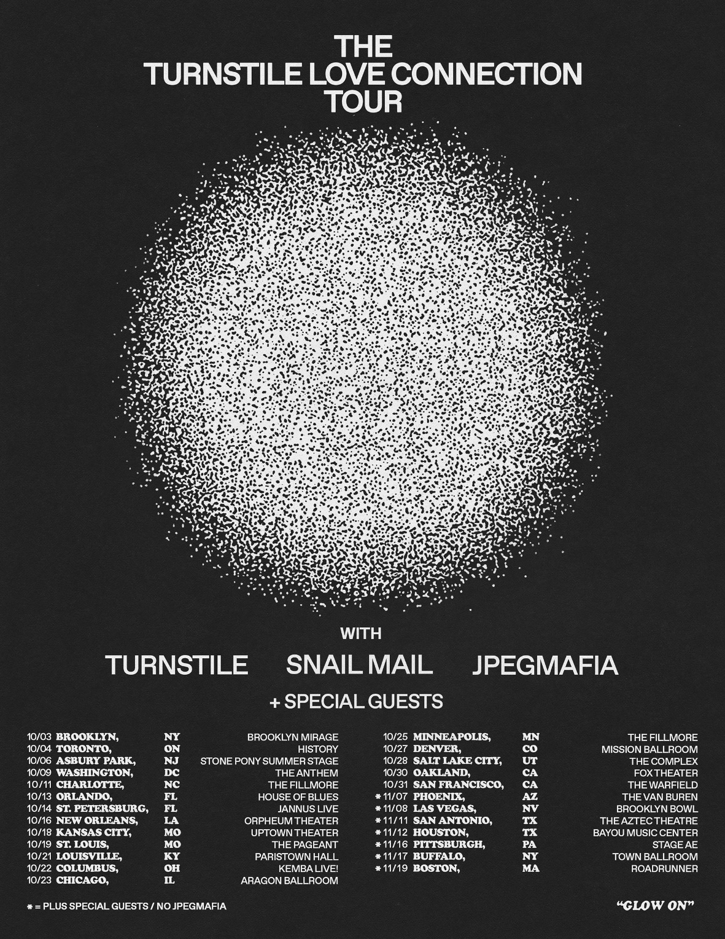

October 3 - Brooklyn, NY – The Brooklyn Mirage
October 4 - Toronto, ON - HISTORY
October 6 - Asbury Park, NJ - Stone Pony Summer Stage^
October 9 - Washington, DC - The Anthem
October 11 - Charlotte, NC - The Fillmore
October 13 - Orlando, FL - House of Blues*
October 14 - St. Petersburg, FL - Jannus Live
October 16 - New Orleans, LA - Orpheum Theater
October 18 - Kansas City, MO - Uptown Theater
October 19 - St. Louis, MO - The Pageant
October 21 - Louisville, KY - Old Forester's Paristown Hall
October 22 - Columbus, OH - KEMBA Live!
October 23 - Chicago, IL - Byline Bank Aragon Ballroom*
October 25 - Minneapolis, MN - The Fillmore*
October 27 - Denver, CO - Mission Ballroom
October 28 - Salt Lake City, UT - The Complex
October 30 - Oakland, CA - Fox Theater
October 31 - San Francisco, CA - The Warfield
November 7 - Phoenix, AZ - The Van Buren*
November 8 - Las Vegas, NV - Brooklyn Bowl*
November 11 - San Antonio, TX - The Aztec Theatre*
November 12 - Houston, TX - Bayou Music Center*
November 16 - Pittsburgh, PA - Stage AE *
November 17 - Buffalo, NY - Town Ballroom*
November 19 - Boston, MA - Roadrunner*

* PLUS SPECIAL GUESTS / NO JPEGMAFIA
^ NO SNAIL MAIL

Connect with TURNSTILE:
WEBSITE / INSTAGRAM / FACEBOOK / TWITTER / YOUTUBE / SPOTIFY / APPLE MUSIC

