TURNSTILE RELEASE NEW ALBUM GLOW ON

SOLD-OUT HEADLINE TOUR UNDERWAY

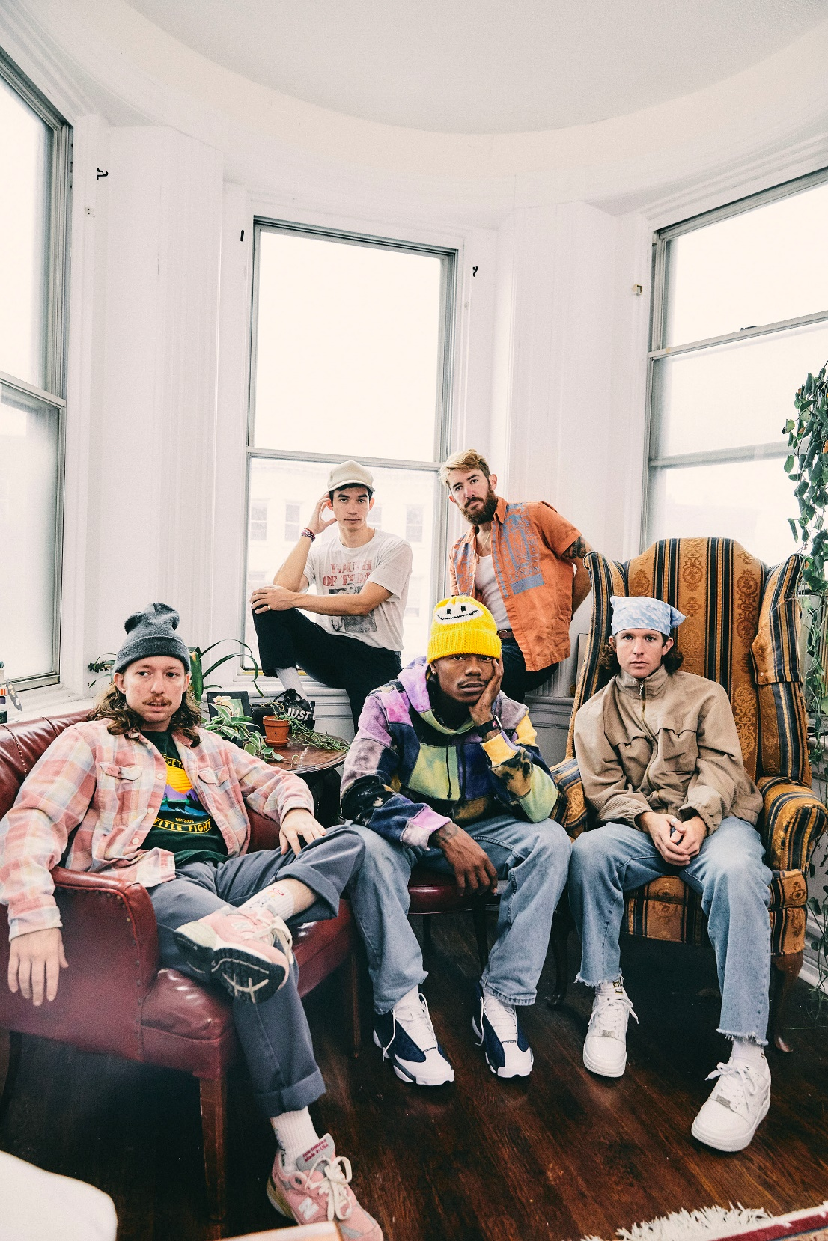
PHOTO CREDIT: JIMMY FONTAINE

AUGUST 27, 2021 – TURNSTILE have released their widely-anticipated new album GLOW ON, which is available today on all streaming platforms.

Recorded with producer Mike Elizondo and co-produced by TURNSTILE vocalist Brendan Yates, GLOW ON
finds TURNSTILE once again charting new ground for hardcore, expanding stylistic boundaries and celebrating new possibilities. GLOW ON is 15 tracks devoid of borders, boundaries, or entry obstacles, only abundant imagination, heart, and grooves plucked from all corners of the musical spectrum.

GLOW ON includes the singles “FLY AGAIN,” “BLACKOUT,” “HOLIDAY,” “NO SURPRISE,” “MYSTERY,” and “T.L.C. (TURNSTILE LOVE CONNECTION),” the latter four of which appear on TURNSTILE’s recent TURNSTILE LOVE CONNECTION EP and companion short film. GLOW ON also includes guest features from Blood Orange on “ALIEN LOVE CALL,” “LONELY DEZIRES,” with additional vocal contributions on “ENDLESS.”

Selected as Stereogum’s Album Of The Week, Senior Editor Tom Breihan wrote “Before GLOW ON, TURNSTILE were already a truly special band, a ray of exploding energy. With this album, they’ve hit dizzy new heights…They’ve made a classic. I can’t even imagine what they’ll do next.” “The through line of all this is a lack of fear—of pushback, of resistance, of excommunication—that defines TURNSTILE” noted The Recording Academy, while NPR remarked, “TURNSTILE has the ability to lure even the most poptimistic listener with spectacular hooks.” The New York Times applauded “ALIEN LOVE CALL” (feat. Blood Orange) as a “shoegaze space-soul collaboration” with PASTE attesting “the band can downshift from ‘explosive’ to ‘dreamy’ without missing a beat.” Rolling Stone praised “MYSTERY” for its “no-nonsense barrage of chugging power chords, stadium-sized rock drums, and scorching guitar solos,” with The Guardian affirming “It takes around 45 seconds of GLOW ON’s thrusting, anthemic opener ‘MYSTERY’ to realise that TURNSTILE are no longer just a great hardcore punk band, but a great rock one, too.”

Bringing superhuman energy to the stage, TURNSTILE are currently out on a run of sold-out headline dates, which continues tomorrow August 28th in Garden Grove, CA and concludes with a hometown performance on September 16th in Baltimore, MD. Later this fall they are set for a series of festival performances, including Dover, Delaware’s Firefly Music Festival (9/23), Louisville, Kentucky’s Louder Than Life (9/24), Indianola, Iowa’s Knotfest (9/25), and more with a nationwide tour alongside $uicideboy$, Chief Keef, Slowthai and more kicking off on October 1st in Alpharetta, GA at Ameris Bank Amphitheatre. Full Tour dates can be found HERE.

Always more appeal than demand, more liberation than limitation, TURNSTILE extended their hand in 2018 with TIME & SPACE. Recorded with producer Will Yip, TIME & SPACE marked Turnstile’s Roadrunner Records debut and saw the band exploding the most outsized tropes of hardcore with tremendous heart. The album earned “Best of 2018” honors from The New Yorker, The New York Times, Rolling Stone, NPR Billboard and more, with GQ naming TIME & SPACE one of “The Best Albums That Shaped the 2010s.”

Reminding us that all music is dance music, TURNSTILE linked up with Australian producer Mall Grab in 2020 to release SHARE A VIEW, a collaborative EP of three reimagined TIME & SPACE tracks – “Generator,” “Real Thing,” and “I Don’t Wanna Be Blind.”

Comprised of Brendan Yates (Vocals), Franz Lyons (Bass/Vocals), Brady Ebert (Guitars), Pat McCrory (Guitars), and Daniel Fang (Drums), TURNSTILE’s brand of youth-minded, youth-driven hardcore punk is intent on breaking down barriers, sonically and ideologically.

GLOW ON
ALBUM ARTWORK + TRACKLIST

1. MYSTERY
2. BLACKOUT
3. DON’T PLAY
4. UNDERWATER BOI
5. HOLIDAY
6. HUMANOID / SHAKE IT UP
7. ENDLESS
8. FLY AGAIN
9. ALIEN LOVE CALL (FEAT. BLOOD ORANGE)
10. WILD WRLD
11. DANCE-OFF
12. NEW HEART DESIGN
13. T.L.C. (TURNSTILE LOVE CONNECTION)
14. NO SURPRISE
15. LONELY DEZIRES (FEAT. BLOOD ORANGE)

Connect with TURNSTILE:
WEBSITE / INSTAGRAM / FACEBOOK / TWITTER / YOUTUBE / SPOTIFY / APPLE MUSIC

