WATCH TURNSTILE PERFORM ON JIMMY KIMMEL LIVE!

SOLD-OUT “TURNSTILE LOVE CONNECTION TOUR” UNDERWAY

PERFORMING AT COACHELLA APRIL 16TH & 23RD

NEW ALBUM GLOW ON AVAILABLE EVERYWHERE

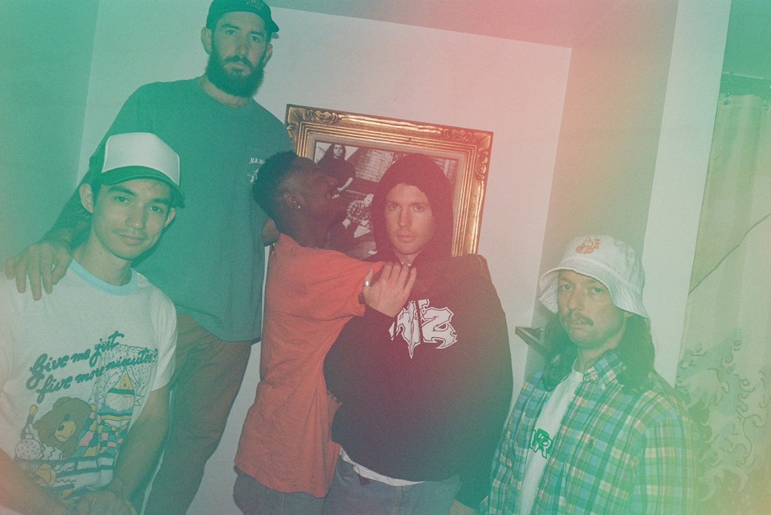
PHOTO CREDIT: JIMMY FONTAINE

MARCH 2, 2022 – TURNSTILE made their return to network TV last night performing on Jimmy Kimmel Live! The band delivered a performance of “MYSTERY” for the show’s broadcast and performed “BLACKOUT,” “DON’T PLAY,” and “HOLIDAY” for a separate off-air three song livestream. Watch all of the performances HERE.

TURNSTILE recently shared an official music video for “UNDERWATER BOI,” which is featured on their widely celebrated new album GLOW ON. The animated clip was directed and edited by the band’s own Daniel Fang and was captured within the world of the 2003 MMORPG (massively multiplayer online role-playing game) “Second Life” - Watch it HERE.

Last week TURNSTILE kicked off their sold-out North American headline tour in support GLOW ON. Deemed “THE TURNSTILE LOVE CONNECTION TOUR,” the trek features support from special guests Citizen, Ceremony, Ekulu, and Truth Cult [full itinerary below]. Furthermore, the band are set to perform on Saturday April 16th and 23rd at the Coachella Valley Music & Arts Festival in Indio, CA. For more information on TURNSTILE’s upcoming tour dates, visit www.turnstilehardcore.com.

This past January TURNSTILE debuted their NPR “Tiny Desk (Home) Concert” performance which is streaming now on NPR Music’s YouTube channel – Watch it HERE. TURNSTILE also recently made their late night TV debut performing “MYSTERY” and “T.L.C. (TURNSTILE LOVE CONNECTION)” on Late Night with Seth Meyers. Both tracks are featured on the band’s 2021 album GLOW ON which staked its claim as one last year’s top releases, earning “Best of 2021” honors from: NPR, Rolling Stone, Pitchfork, Billboard, Stereogum, SPIN, Vulture, The FADER, The Ringer, The Washington Post, Los Angeles Times, Esquire, FLOOD, Uproxx, Consequence, Paste, Revolver and more.

Recorded with producer Mike Elizondo and co-produced by TURNSTILE vocalist Brendan Yates, GLOW ON
finds TURNSTILE once again charting new ground for hardcore, expanding stylistic boundaries and celebrating new possibilities. GLOW ON is 15 tracks devoid of borders, boundaries, or entry obstacles, only abundant imagination, heart, and grooves plucked from all corners of the musical spectrum.

GLOW ON includes the singles “FLY AGAIN,” “BLACKOUT,” “HOLIDAY,” “NO SURPRISE,” “MYSTERY,” and “T.L.C. (TURNSTILE LOVE CONNECTION),” the latter four of which appear on TURNSTILE’s TURNSTILE LOVE CONNECTION EP and companion short film. GLOW ON also includes guest features from Blood Orange on “ALIEN LOVE CALL,” “LONELY DEZIRES,” with additional vocal contributions on “ENDLESS.”

Selected as Stereogum’s Album Of The Week, Senior Editor Tom Breihan wrote “Before GLOW ON, TURNSTILE were already a truly special band, a ray of exploding energy. With this album, they’ve hit dizzy new heights…They’ve made a classic. I can’t even imagine what they’ll do next.” Pitchfork awarded the album ‘Best New Music’ attesting “The Baltimore band’s spectacular fourth record is all groove, riffs, and passion,” with The Recording Academy noting “The through line of all this is a lack of fear—of pushback, of resistance, of excommunication—that defines TURNSTILE.” NPR observed, “TURNSTILE has the ability to lure even the most poptimistic listener with spectacular hooks,” and Vulture hailed GLOW ON as “one of the best rock albums of the year.” Billboard affirmed “Ready or not, TURNSTILE is breaking through,” with FLOOD hailing the album as “An unforgettable magnum Opus.”

Comprised of Brendan Yates (Vocals), Franz Lyons (Bass/Vocals), Brady Ebert (Guitars), Pat McCrory (Guitars), and Daniel Fang (Drums), TURNSTILE’s brand of youth-minded, youth-driven hardcore punk is intent on breaking down barriers, sonically and ideologically.

[TOUR ITINERARY BELOW]

“THE TURNSTILE LOVE CONNECTION TOUR”
4/26 – 5/29 with Citizen, Ceremony, Ekulu, and Truth Cult

4/16 - Indio, CA - Coachella #
4/23 - Indio, CA - Coachella #
4/25 - Englewood, CO - Gothic Theatre (SOLD OUT)
4/26 - Englewood, CO - Gothic Theatre (SOLD OUT)
4/27 - Salt Lake City, UT - Soundwell (SOLD OUT)
4/29 - Vancouver, BC - The Rickshaw Theatre (SOLD OUT)
4/30 - Seattle, WA - The Showbox (SOLD OUT)
5/2 - Portland, OR - Roseland Theater (SOLD OUT)
5/4 - Albuquerque, NM - El Rey Theatre (SOLD OUT)
5/6 - Austin, TX - Stubb’s Waller Creek Amphitheater (SOLD OUT)
5/7 - Dallas, TX - Amplified Live (SOLD OUT)
5/9 - Atlanta, GA - The Masquerade (SOLD OUT)
5/10 - Nashville, TN - Brooklyn Bowl (SOLD OUT)
5/12 - Milwaukee, WI - The Rave (VENUE UPGRADED)
5/13 - Minneapolis, MN - Varsity Theater (SOLD OUT)
5/14 - Lawrence, KS - The Granada Theater** (SOLD OUT)
5/17 - Detroit, MI - Majestic Theatre (SOLD OUT)
5/18 - Cleveland, OH - Agora Theatre (SOLD OUT)
5/19 - Toronto, ON - The Phoenix Concert Theatre (SOLD OUT)
5/21 - Worcester, MA – Palladium (SOLD OUT)
5/22 - Queens, NY - Knockdown Center* (SOLD OUT)
5/23 - Brooklyn, NY - Brooklyn Steel (SOLD OUT)
5/24 - Philadelphia, PA - The Fillmore Philadelphia (SOLD OUT)
5/26 - Washington, DC- 9:30 Club (SOLD OUT)
5/29 - Washington, DC- 9:30 Club (SOLD OUT)

* With Beach Fossils and Special Interest
**No Ceremony
# Festival

Connect with TURNSTILE:
WEBSITE / INSTAGRAM / FACEBOOK / TWITTER / YOUTUBE / SPOTIFY / APPLE MUSIC

