TURNSTILE ANNOUNCE 2022 NORTH AMERICAN TOUR

“THE TURNSTILE LOVE CONNECTION TOUR”
TO FEATURE SPECIAL GUESTS CITIZEN, CEREMONY, EKULU, TRUTH CULT, COCO & CLAIR CLAIR

TICKET PRE-SALES BEGIN NOVEMBER 16TH
GENERAL ON-SALE STARTS NOVEMBER 19TH

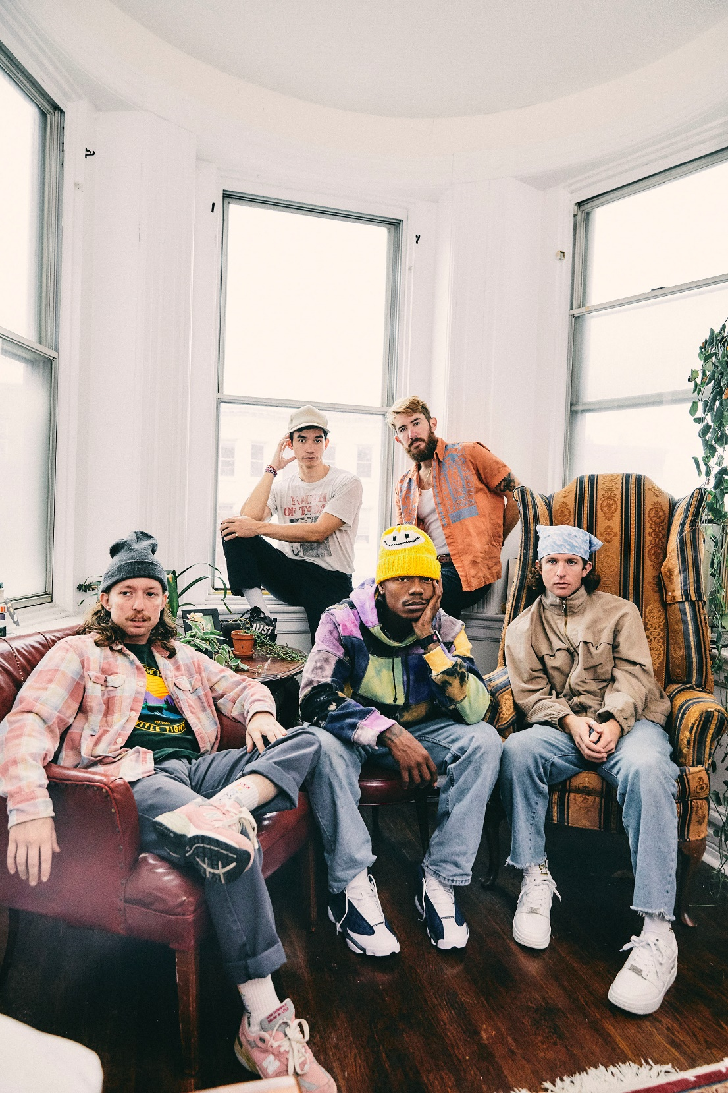
PHOTO CREDIT: JIMMY FONTAINE

NOVEMBER 15, 2021 – TURNSTILE have announced a run of 2022 North American headline tour dates in support of their acclaimed new album GLOW ON. Deemed “THE TURNSTILE LOVE CONNECTION TOUR,” the upcoming spring run will feature special guests Citizen, Ceremony, Ekulu, Truth Cult, and Coco & Clair Clair. Set to kick off with a pair of one-off West Coast dates in San Francisco, CA (2/23) and Los Angeles. CA (2/24), the tour will pick up on April 26th in Englewood, CA and continue through a performance on May 26th in Washington, DC [tour itinerary below]. Pre-sale tickets for the tour will be available starting tomorrow, November 16th at 10:00AM local time with general on-sale for tickets beginning Friday, November 19th at 10:00AM local time. For tickets and more information on TURNSTILE’s upcoming international tour dates, visit www.turnstilehardcore.com.

Recorded with producer Mike Elizondo and co-produced by TURNSTILE vocalist Brendan Yates, GLOW ON
finds TURNSTILE once again charting new ground for hardcore, expanding stylistic boundaries and celebrating new possibilities. GLOW ON is 15 tracks devoid of borders, boundaries, or entry obstacles, only abundant imagination, heart, and grooves plucked from all corners of the musical spectrum.

GLOW ON includes the singles “FLY AGAIN,” “BLACKOUT,” “HOLIDAY,” “NO SURPRISE,” “MYSTERY,” and “T.L.C. (TURNSTILE LOVE CONNECTION),” the latter four of which appear on TURNSTILE’s TURNSTILE LOVE CONNECTION EP and companion short film. GLOW ON also includes guest features from Blood Orange on “ALIEN LOVE CALL,” “LONELY DEZIRES,” with additional vocal contributions on “ENDLESS.”

Selected as Stereogum’s Album Of The Week, Senior Editor Tom Breihan wrote “Before GLOW ON, TURNSTILE were already a truly special band, a ray of exploding energy. With this album, they’ve hit dizzy new heights…They’ve made a classic. I can’t even imagine what they’ll do next.” Pitchfork awarded the album ‘Best New Music’ attesting “The Baltimore band’s spectacular fourth record is all groove, riffs, and passion,” with The Recording Academy noting “The through line of all this is a lack of fear—of pushback, of resistance, of excommunication—that defines TURNSTILE.” NPR observed, “TURNSTILE has the ability to lure even the most poptimistic listener with spectacular hooks,” and Vulture hailed GLOW ON as “one of the best rock albums of the year.” Billboard affirmed “Ready or not, TURNSTILE is breaking through,” with FLOOD hailing the album as “An unforgettable magnum Opus.”

Always more appeal than demand, more liberation than limitation, TURNSTILE extended their hand in 2018 with TIME & SPACE. Recorded with producer Will Yip, TIME & SPACE marked Turnstile’s Roadrunner Records debut and saw the band exploding the most outsized tropes of hardcore with tremendous heart. The album earned “Best of 2018” honors from The New Yorker, The New York Times, Rolling Stone, NPR Billboard and more, with GQ naming TIME & SPACE one of “The Best Albums That Shaped the 2010s.”

Reminding us that all music is dance music, TURNSTILE linked up with Australian producer Mall Grab in 2020 to release SHARE A VIEW, a collaborative EP of three reimagined TIME & SPACE tracks – “Generator,” “Real Thing,” and “I Don’t Wanna Be Blind.”

Comprised of Brendan Yates (Vocals), Franz Lyons (Bass/Vocals), Brady Ebert (Guitars), Pat McCrory (Guitars), and Daniel Fang (Drums), TURNSTILE’s brand of youth-minded, youth-driven hardcore punk is intent on breaking down barriers, sonically and ideologically.

[TOUR ITINERARY BELOW]

“THE TURNSTILE LOVE CONNECTION TOUR”
2/23 – 2/24 with Citizen and Coco & Clair Clair
4/26 – 5/26 with Citizen, Ceremony, Ekulu, and Truth Cult

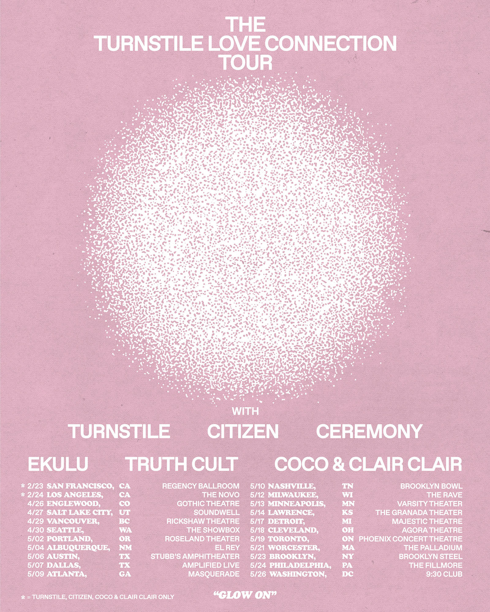

2/23 - San Francisco, CA - The Regency Ballroom
2/24 - Los Angeles, CA - The Novo
4/26 - Englewood, CO - Gothic Theatre
4/27 - Salt Lake City, UT - Soundwell
4/29 - Vancouver, BC - The Rickshaw Theatre
4/30 - Seattle, WA - The Showbox
5/2 - Portland, OR - Roseland Theater
5/4 - Albuquerque, NM - El Rey Theatre
5/6 - Austin, TX - Stubb’s Waller Creek Amphitheater
5/7 - Dallas, TX - Amplified Live
5/9 - Atlanta, GA - The Masquerade
5/10 - Nashville, TN - Brooklyn Bowl
5/12 - Milwaukee, WI - The Rave
5/13 - Minneapolis, MN - Varsity Theater
5/14 - Lawrence, KS - The Granada Theater**
5/17 - Detroit, MI - Majestic Theatre
5/18 - Cleveland, OH - Agora Theatre
5/19 - Toronto, ON - The Phoenix Concert Theatre
5/21 - Worcester, MA - Palladium
5/23 - Brooklyn, NY - Brooklyn Steel
5/24 - Philadelphia, PA - The Fillmore Philadelphia
5/26 - Washington, DC- 9:30 Club

**No Ceremony

Connect with TURNSTILE:
WEBSITE / INSTAGRAM / FACEBOOK / TWITTER / YOUTUBE / SPOTIFY / APPLE MUSIC

