RAINBOW KITTEN SURPRISE ANNOUNCES ‘LIVE IN COLORADO’ 4-NIGHT STAND SET FOR THIS JULY

2 NIGHTS EACH AT RED ROCKS AMPHITHEATRE + DILLON AMPHITHEATER KICK OFF JULY 2ND

PRESALES LAUNCH WEDNESDAY, JANUARY 18TH @ 10AM LOCAL TIME
GENERAL ONSALE BEGINS FRIDAY, JANUARY 20TH @ 10AM LOCAL TIME

GENRE-DEFYING QUINTET TO TOUR SOUTH AFRICA & UK/EU THIS SPRING

SLOTS AT 2023 MARQUEE FESTIVALS INCLUDING BONNAROO & HANGOUT

HEADLINING CHARLESTON’s HIGH WATER FESTIVAL IN APRIL

ALL UPCOMING TICKETS ON SALE HERE

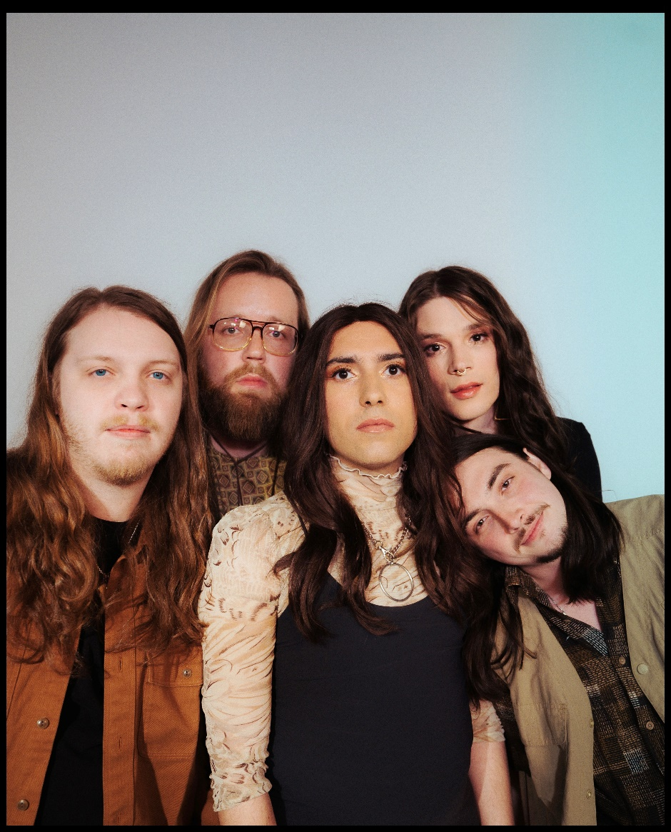
(photo credit: Aubrey Denis; download HERE)

Today, genre-defying, Nashville-based quintet and live sensations Rainbow Kitten Surprise have announced ‘Live in Colorado,’ a four-night run set around this summer’s July 4th holiday with two nights at Morrison, CO’s iconic Red Rocks Amphitheatre (July 5th & 6th) and two nights at Dillon, CO’s Dillon Amphitheater (July 2nd & 3rd). Fellow Nashville-based outfit The Brook & the Bluff will support all four dates. Full ticketing information for all upcoming dates can be found here.

‘Live in Colorado’ marks yet another return to Red Rocks for the band, following their most recent sold-out, two-night stand in July of 2022. Fans can look forward to this summer’s exclusive VIP ticket offering, which will include one general admission or premium reserved ticket within the first 10 rows of the venue and early entry, as well as merch items including embroidered bag tags, limited edition Red Rocks lenticular posters, holographic fanny packs, commemorative ‘Live in Colorado’ VIP laminates, and more.

Additionally, Rainbow Kitten Surprise has partnered with PLUS1 so that $1 from every ticket sold will go to local food banks working to fight hunger and food insecurity in their communities. Presales begin tomorrow, Wednesday, January 18th at 10am local time and general onsale will begin this Friday, January 20th at 10am local time.

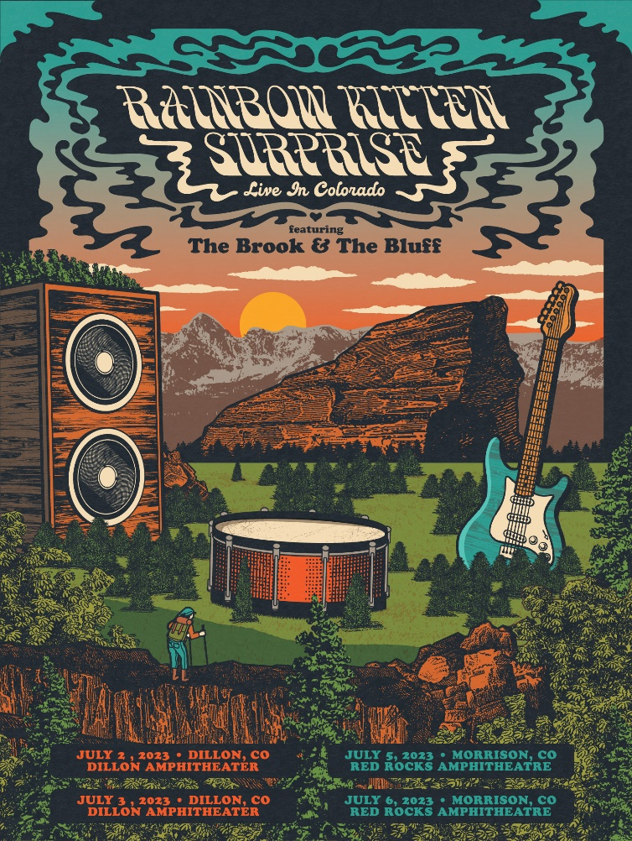
(admat credit: Justin Helton; download HERE)

Today’s announcement follows the band’s 2022 entirely sold-out North American headline tour, which included back-to-back sold-out nights at The Caverns in Pelham, TN, their triumphant two-night return to Red Rocks, which sold-out in a matter of minutes of being announced, and a December US routing that included stops in Nashville, Chicago, and New Orleans, culminating with this year’s beloved RKS New Year’s Eve residency at The Eastern in Atlanta, GA.

This spring, the band will traverse South Africa and the UK/EU for a highly-anticipated run of international tour dates – with the latter set of shows having been upgraded to larger venues in order to accommodate ever-increasing demand. Kicking off on March 10th in Cape Town, Africa, the band will perform in cities including Paris (March 15th), Berlin (March 23rd), Amsterdam (March 25th), and London (March 31st), before the tour wraps on April 4th after two consecutive nights in Dublin, Ireland. The entirety of this international run is nearly sold-out.

Always a festival favorite, Rainbow Kitten Surprise will appear at Bonnaroo and Hangout Music Festival this summer, in addition to headlining Charleston, South Carolina’s High Water Festival alongside Beck and Wilco in April. Last year, the band topped lineups at Atlanta’s Shaky Knees Festival, Napa, CA’s Bottle Rock Festival, and Rothbury, MI’s Electric Forest.

2022 saw the band achieve RIAA-gold certification on standout single “It’s Called: Freefall,” as well as release the emotionally charged track “Work Out,” marking their first new music in nearly two years. The song’s beautiful melody-line and effervescent vibe stands in stark juxtaposition to its poignant lyrics about the difficult relationships – of all sorts – that people struggle with. “Work Out” arrived alongside a lyric video, handwritten by RKS frontperson Ela Melo (watch here). The stunning official visual was directed by Joey Brodnax and released last June (watch here).

Also in 2022, Rainbow Kitten Surprise raised over $170k for food banks in local tour markets, LGBTQ+ causes, and mental health initiatives.

###

ABOUT RAINBOW KITTEN SURPRISE:
As if channeling another dimension where genres simply don’t exist, Rainbow Kitten Surprise finds harmony in unpredictability – weaving together lyrical poetry, hummable melodies, and a rush of instrumental eccentricities. Now boasting over 1 billion global streams across platforms, the band first began building their devoted fanbase with independent albums SEVEN + MARY (2013) and RKS (2015). The band’s breakout full-length debut for Elektra, HOW TO: FRIEND, LOVE, FREEFALL, arrived in 2018. Produced by GRAMMY® Award-winner Jay Joyce (Cage The Elephant, Sleeper Agent), the album featured RIAA-certified Gold single “It’s Called: Freefall,” earned widespread praise from Billboard, TIME, Vice, and NPR who described their sound as “…a mix of jam and indie and whatever else you can throw into the soup…very earnest, beautiful, political, loving rock n’ roll,” and saw the band make several national television appearances, including performances on “CBS Saturday Morning,” “The Late Show with Stephen Colbert,” and PBS’s “Austin City Limits.” After gracing the bills of Bonnaroo, Lollapalooza, and Osheaga, to name a few, RKS moved 80,000 tickets of their own on their sold-out Friend, Love, Freefall Tour, earmarked by a packed night at Red Rocks Amphitheatre and three consecutive gigs in Athens, GA – as chronicled on their first official live album, LIVE FROM ATHENS GEORGIA, released in 2021. Most recently, two longtime fan-favorite tracks began to take off organically on TikTok, with “It’s Called: Freefall” and “Cocaine Jesus” experiencing massive upticks after user-created content on the platform went viral – amassing 180k+ total videos utilizing the sound and resulting in over 11 million *weekly* streams for the band. The songs now boast over 226 and 116 million streams, respectively.

Rainbow Kitten Surprise is: Ela Melo (she/her; lead vocals), Darrick “Bozzy” Keller (he/him; guitar, vocals), Ethan Goodpaster (he/him; lead guitar, vocals), Charlie Holt (they/them; bass, vocals), Jess Haney (he/him; drums).

RAINBOW KITTEN SURPRISE – UPCOMING LIVE DATES:
* Festival Performance
= The Brook & the Bluff supporting

MARCH 2023
Fri, March 10th – Cape Town, South Africa – Kirstenbosch National Botanical Garden
Sat, March 11th – Johannesburg, South Africa – Mark Park Sports Club
Wed, March 15th – Paris, France – La Maroquinerie
Thurs, March 16th – Zurich, Switzerland – Dynamo
Sat, March 18th – Vienna, Austria – Flex
Sun, March 19th – Munich, Germany – Technikum
Mon, March 20th – Prague, Czech Republic – MeetFactory
Wed, March 22nd – Warsaw, Poland – Progresja
Thurs, March 23rd – Berlin, Germany – Columbia Theater
Sat, March 25th – Amsterdam, Netherlands – Melkweg
Sun, March 26th – Hamburg, Germany – Gruenspan
Mon, March 27th – Cologne, Germany – Die Kantine
Wed, March 29th – Manchester, UK – Manchester Academy
Thurs, March 30th – Birmingham, UK – O2 Institute2
Fri, March 31st – London, UK – Roundhouse

APRIL 2023
Sun, April 2nd – Glasgow, UK – Galvanizers Yard
Mon, April 3rd – Dublin, Ireland – The Academy, Middle Abbey Street
Tues, April 4th – Dublin, Ireland – The Academy, Middle Abbey Street
Sat, April 15th – Sun, April 16th – North Charleston, South Carolina – High Water Festival *

MAY 2023
Fri, May 19th – Sun, May 21st – Gulf Shores, AL – Hangout Music Festival *

JUNE 2023
Sat, June 16th – Manchester, TN – Bonnaroo Music & Arts Festival *

JULY 2023
Sun, July 2nd – Dillon, CO – ‘Live in Colorado’ @ Dillon Amphitheater =
Mon, July 3rd – Dillon, CO – ‘Live in Colorado’ @ Dillon Amphitheater =
Wed, July 5th – Morrison, CO – ‘Live in Colorado’ @ Red Rocks Amphitheatre =
Thurs, July 6th – Morrison, CO – ‘Live in Colorado’ @ Red Rocks Amphitheatre =

For more ticket information and tour updates, please visit [www.rksband.com/tour].

###

For more information, please visit:
RAINBOWKITTENSURPRISE.COM
FACEBOOK * TWITTER * INSTAGRAM * YOUTUBE * SPOTIFY

PRESS CONTACTS:
Glenn Fukushima | GlennFukushima@elektra.com
Libby Kober | Libby.Kober@atlanticrecords.com

