JXDN ANNOUNCES
I HOPE THIS NEVER ENDS TOUR

35+ Date Headline Trek Launches February 2023
Tickets On Sale Now

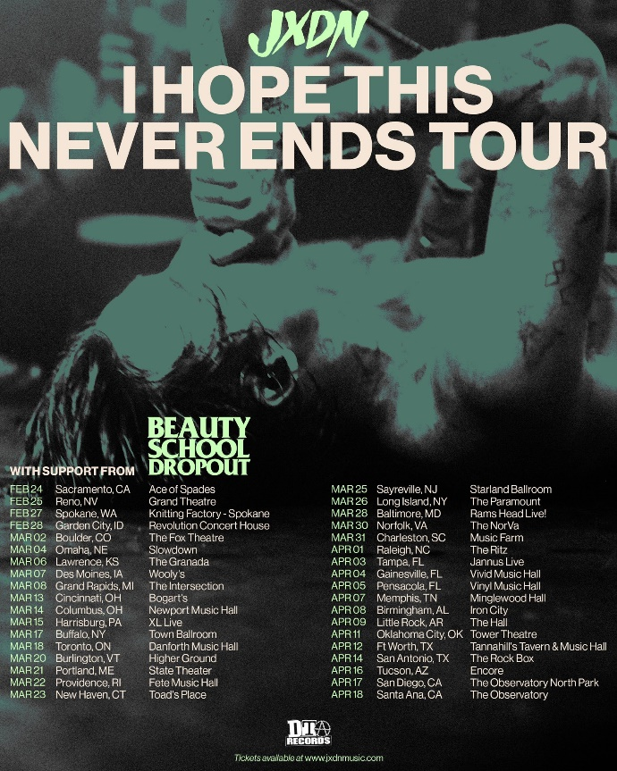
DOWNLOAD TOUR ADMAT HERE

December 16, 2022 – Breakout artist jxdn will kick off the new year with his just announced headline I HOPE THIS NEVER ENDS TOUR, building on the momentum of his rapid rockstar ascent.

Kicking off February 24, 2023 in Sacramento, CA, the 35+ date trek will feature support from Beauty School Dropout and travel through cities like Toronto, Baltimore, Charleston, Tampa, Memphis, Fort Worth, and San Diego before concluding with an international stop in Mexico City on April 21, 2023. Tickets to the 35+ date trek are on sale now at www.jxdnmusic.com. Full dates below.

jxdn recently completed a sold out intimate live run of club shows in LA, Chicago and NYC following the release of his latest single “Sober” last month. The release of “Sober” marks the beginning of the newest chapter of jxdn music, with the emerging rockstar currently at work on his sophomore album.

The I HOPE THIS NEVER ENDS TOUR marks jxdn’s second headline tour; in April and May, jxdn embarked on his debut headline TELL ME ABOUT TOMORROW WORLD TOUR U.S. dates, performing for thousands of fans across the country, including sold out dates in New York City, Chicago, Pittsburgh, Atlanta, among others. The tour was in support of his critically acclaimed debut album Tell Me About Tomorrow, released July 2021, and its expanded version, Tell Me About Tomorrow (Deluxe), released December 2021 on DTA Records.

Tell Me About Tomorrow – produced by Travis Barker – was met with wide critical acclaim, with NYLON hailing, “an album that both cements his place in the current pop-punk revival and shows that he’s only getting started,” and SPIN praising, “a deliriously catchy pop-punk effort.” Additionally, the album earned jxdn a #3 Alternative New Artist Albums, #5 Top New artist Albums, and #11 Digital Albums on the Billboard charts.

jxdn's rapid ascent to rock stardom has taken the music industry by storm, having racked up more than 915 million global streams to date, multiple songs flying up the Billboard charts, playing major festivals – including the main stage at Lollapalooza to a massive crowd – and serving as direct support on Machine Gun Kelly’s “Tickets To My Downfall” U.S. Tour in Fall 2021. He was included in Variety’s Power of Young Hollywood 2021 Music impact list, and Billboard’s 21 Under 21 list for the two consecutive years he was eligible (2020 and 2021), in addition to garnering nominations for both a MTV VMA and MTV EMA in 2021.

jxdn – I HOPE THIS NEVER ENDS TOUR 2023
Date | City | Venue
February 24, 2023 | Sacramento, CA | Ace of Spades
February 25, 2023 | Reno, NV | Grand Theatre
February 27, 2023 | Spokane, WA | Knitting Factory – Spokane
February 28, 2023 | Garden City, ID | Revolution Concert House
March 2, 2023 | Boulder, CO | The Fox Theatre
March 4, 2023 | Omaha, NE | Slowdown
March 6, 2023 | Lawrence, KS | The Granada
March 7, 2023 | Des Moines, IA | Wooly’s
March 8, 2023 | Grand Rapids, MI | The Intersection
March 13, 2023 | Cincinnati, OH | Bogart’s
March 14, 2023 | Columbus, OH | Newport Music Hall
March 15, 2023 | Harrisburg, PA | XL Live
March 17, 2023 | Buffalo, NY | Town Ballroom
March 18, 2023 | Toronto, ON | Danforth Music Hall
March 20, 2023 | Burlington, VT | Higher Ground
March 21, 2023 | Portland, ME | State Theater
March 22, 2023 | Providence, RI | Fete Music Hall
March 23, 2023 | New Haven, CT | Toad’s Place
March 25, 2023 | Sayreville, NJ | Starland Ballroom
March 26, 2023 | Long Island, NY | The Paramount
March 28, 2023 | Baltimore, MD | Rams Head Live!
March 30, 2023 | Norfolk, VA | The NorVa
March 31, 2023 | Charleston, SC | Music Farm
April 1, 2023 | Raleigh, NC | The Ritz
April 3, 2023 | Tampa, FL | Jannus Live
April 4, 2023 | Gainesville, FL | Vivid Music Hall
April 5, 2023 | Pensacola, FL | Vinyl Music Hall
April 7, 2023 | Memphis, TN | Minglewood Hall
April 8, 2023 | Birmingham, AL | Iron City
April 9, 2023 | Little Rock, AR | The Hall
April 11, 2023 | Oklahoma City, OK | Tower Theatre
April 12, 2023 | Ft Worth, TX | Tannahill’s Tavern & Music Hall
April 14, 2023 | San Antonio, TX | The Rock Box
April 16, 2023 | Tucson, AZ | Encore
April 17, 2023 | San Diego, CA | The Observatory North Park
April 18, 2023 | Santa Ana, CA | The Observatory
April 21, 2023 | Mexico City, MX | Pabellón Oeste

connect with jxdn:
instagram | twitter | tik tok | youtube | spotify | apple music | jxdnmusic.com

jxdn Press Contact:
full coverage communications
Natasha Desai | natasha@fullcov.com

