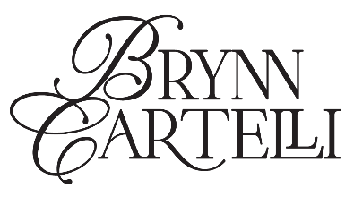

**BRYNN CARTELLI SHARES LIVELY NEW SONG “CONVERTIBLE IN THE RAIN”  
  
LISTEN** [**HERE**](https://brynncartelli.lnk.to/CITR) **| WATCH THE OFFICIAL MUSIC VIDEO** [**HERE**](https://youtu.be/kDZwK3Y0dCs) **CURRENTLY ON TOUR SUPPORTING JAKE SCOTT | HEADLINE SHOW AT NYC’S MERCURY LOUNGE ON 12/2  
  
MORE NEW MUSIC COMING SOON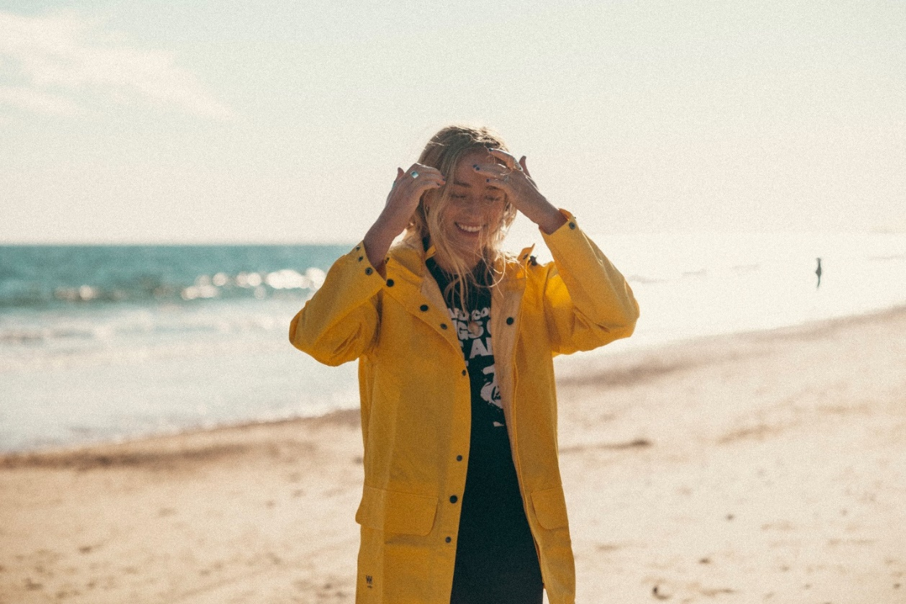 CREDIT: KAYLA EBNER | HI-RES ASSETS** [**HERE**](https://www.dropbox.com/scl/fo/ckvjiup5ma8zw931o3gev/h?dl=0&rlkey=d6krhtv69exrnoiqdzbksrv5a)*“…with a maturity far beyond her years”* **–PEOPLE***“…marvelous debut”***–AMERICAN SONGWRITER***“Cartelli’s voice is wildly impressive”* **–THE WASHINGTON POST***“The control in Cartelli’s voice is mesmerizing”* **–ATWOOD MAGAZINE**

**(November 4, 2022) – LOS ANGELES, CA –** Acclaimed 19-year-old singer-songwriter [**Brynn Cartelli**](https://www.instagram.com/brynncartelli/?hl=en) today shared her breezy, lively new song **“Convertible in the Rain.”** Complete with diaristic lyricism and guitar-driven pop melodies, the track underscores Cartelli’s eloquent songcraft. The single is available on [all streaming platforms](https://brynncartelli.lnk.to/CITR), along with an accompanying music video, available [**HERE**](https://youtu.be/kDZwK3Y0dCs). Paying homage to her New England roots, the visual was filmed on the beaches of Rhode Island.  
  
Regarding the song’s inspiration, Cartelli elaborated, *“‘Convertible in the Rain’ was written in retrospect, as many of my story-songs are… I had a clear mind about this night, about how much it meant to me, and how exhilarating it is to be young and in love. Playing this song on tour brings me back to my childhood in New England… and the production is heavily inspired by the songs I grew up listening to there. Once again, I am nervously exhilarated to be opening up my diary for everyone to hear.”*  
  
Cartelli is currently on tour in the U.S. with Elektra labelmate and fellow pop singer-songwriter **Jake Scott.** The dates continue this evening with a hometown show for Cartelli in Boston, MA at Royale, and hits major cities including New York, Washington, D.C., and Chicago, before wrapping in Los Angeles on Sunday, November 20. On Friday, December 2, she will also be playing a special headline show at New York City’s Mercury Lounge. All tickets are available on [Cartelli’s official website](https://www.brynncartelli.com/tour/). On this trek, fans can hear Cartelli perform songs from her stellar 2021 debut EP [*Based on a True Story*](https://brynncartelli.lnk.to/BOATS), along with 2022 standout singles “[Gemini](https://brynncartelli.lnk.to/gemini)” and “[Girl Code](https://brynncartelli.lnk.to/girlcode),” which received praise in the press. ***V Magazine*** stated, “Cartelli’s floaty vocals and soft guitar backing make ‘Girl Code’ stand out amongst her earlier work,” while ***LA Magazine*** noted “Her words perfectly complement her gentle guitar instrumentals for a track that radiates both youthfulness and maturity.”At age 15, Cartelli’s vocals captivated viewers nationwide when she was crowned the winner of **Season 14 of NBC’s *The Voice*** (on Team Kelly) and emerged as the youngest champion in the show’s history – still holding this title to date. Afterwards, she garnered a nomination at the *People’s Choice Awards*, and captivated audiences with stellar performances on the *TODAY Show,* *Macy’s Thanksgiving Day Parade*, *The Kelly Clarkson Show,* and more. Fan-favorite track “[If I Could](https://brynncartelli.lnk.to/IfICould)” – co-penned with **Ben Abraham (Demi Lovato, Sara Bareilles)** – has also amassed over 15M+ global streams to date. Cartelli has shared the stage with many industry staples as well, providing support on tour for the likes of **Kelly Clarkson, OneRepublic,** and **Maroon 5**.   
  
Cartelli is putting the final touches on her next project with Elektra Entertainment. More details to be revealed soon.

**BRYNN CARTELLI  
“CONVERTIBLE IN THE RAIN”**[**AVAILABLE HERE**](https://brynncartelli.lnk.to/CITR)

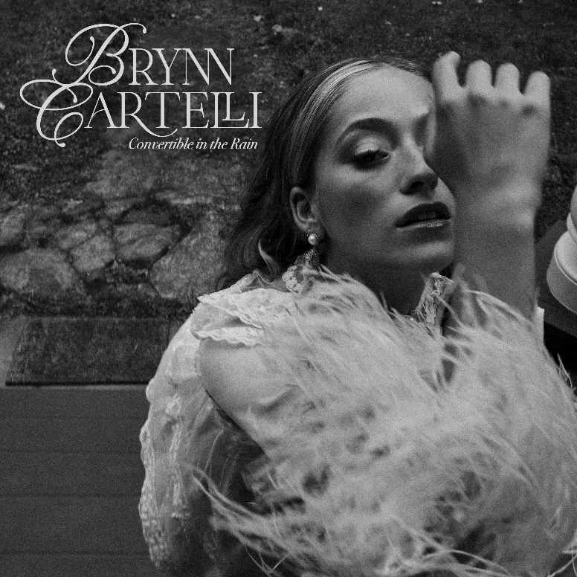

**BRYNN CARTELLI ON TOUR:**   
November 4 – Boston, MA @ Royale *  
November 5 – Washington, D.C. @ 9:30 Club **[LOW TICKETS]** *  
November 7 – New York, NY @ Webster Hall **[LOW TICKETS]** *  
November 9 – Columbus, OH @ Newport Music Hall *  
November 11 – Indianapolis, IN @ Deluxe at Old National Centre **[LOW TICKETS]** *  
November 12 – Detroit, MI @ Majestic Theater *  
November 13 – Chicago, IL @ House of Blues **[LOW TICKETS]** *  
November 15 – Minneapolis, MN @ First Avenue*  
November 17 – Denver, CO @ Gothic Theatre **[LOW TICKETS]** *  
November 18 – Salt Lake City, UT @ The Union **[LOW TICKETS]** *  
November 20 – Los Angeles, CA @ El Rey Theatre * **CONNECT WITH BRYNN CARTELLI:**[Website](https://www.brynncartelli.com/) | [Facebook](https://www.facebook.com/brynncartellimusic/) | [Twitter](https://twitter.com/brynncartelli) | [Instagram](https://www.instagram.com/brynncartelli) | [TikTok](https://www.tiktok.com/@brynnzzyy?lang=en) | [YouTube](https://www.youtube.com/channel/UCYTkCGwgKNfUTS3heQZL1zA)# # # **MEDIA CONTACTS:**Glenn Fukushima, Nathalie Rubin, & Sydney Worden  
[Glenn.Fukushima@300Elektra.com](mailto:Glenn.Fukushima@300Elektra.com) | [Nathalie.Rubin@300Elektra.com](mailto:Nathalie.Rubin@300Elektra.com) |  
[Sydney.Worden@300Elektra.com](mailto:Sydney.Worden@300Elektra.com)

