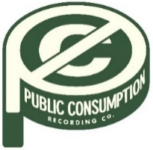
SYDNEY ROSE ANNOUNCES NEW EP
THIS KIND OF THING DOESN’T LAST
ARRIVING NOVEMBER 11TH

NEW SINGLE “CHARLIE” STREAMING NOW

OCTOBER 13, 2022 – 19-year-old singer/songwriter Sydney Rose has announced her new EP This Kind Of Thing Doesn’t Last. The project is set for arrival on November 11th and is heralded by new single “Charlie,” which is streaming now. Opening with sparse piano, the track builds to a stunning crescendo as Rose encapsulates her anxiety with the repeated refrain, “I feel like I’m getting bad again.” The five-song collection, written solely by Rose, includes previously released track “Bedroom Floor,” a heartfelt ballad about the pain of a loved one going off to college without you (full tracklisting below). This Kind Of Thing Doesn’t Last is available for presave now via Public Consumption.
Sydney added, “I wrote ‘Charlie’ after a very emotional night of graduating high school and watching my favorite movie, The Perks of Being a Wallflower. I wanted to encapsulate the feelings that both myself and the main character Charlie have felt throughout our lives, and the fear of getting in a bad place in our lives again.
I am so so so sosososo excited to announce my next EP and for people to listen to it. I wrote every song by myself, and I feel like I captured the emotional feelings of change and worry throughout every song. I finally feel like I am in a place where i know what I want to write and what I want it to sound like.”
Last month, Sydney wrapped up dates supporting Addison Grace’s U.S. tour. Over the summer, the artist shared her debut EP You Never Met Me, out now via Public Consumption. The project included previously released singles “Phoebe Told Me,” “Things That Don’t Exist (feat. Zachary Knowles),” and “I’ll Never Get Over It” and arrived to critical acclaim, with PEOPLE Magazine naming her one of their Emerging Artists To Watch and Under The Radar attesting, “‘You Never Met Me’ is the sound of Rose finding herself in her music and introducing herself to the world, tracing all of the messy contours of teenage heartbreak in the process.” Amplify Her Voice also praised the effort, stating “Rose re-discovers different parts of herself on her own, presenting her real self through a delicately honest six-song collection.”
Sydney Rose initially gained traction via her intimate YouTube channel covers as well as TikTok, where she has amassed over 200k followers on the platform. Her rendition of Sleeping At Last’s “Turning Page” has accumulated over 35 million streams.
(Tracklisting/EP Art Below)

SYDNEY ROSE
This Kind Of Thing Doesn’t Last EP – OUT NOVEMBER 11TH
PRESAVE NOW
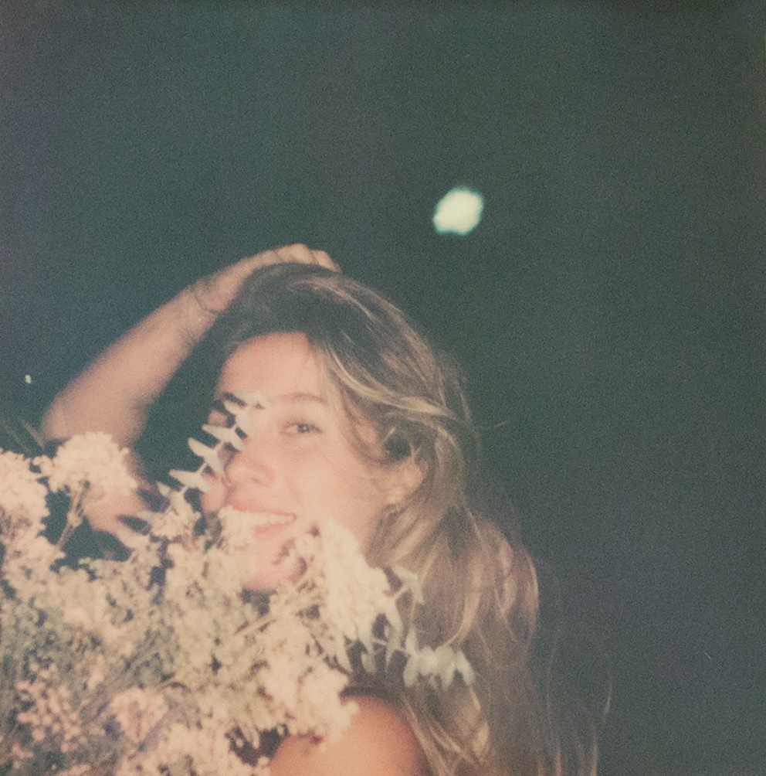
Tracklisting:
- Too Fast
- Bedroom Floor
- If I Were a Dog
- Less than Lovers
- Charlie

CONNECT WITH Sydney Rose
TIKTOK
YOUTUBE
INSTAGRAM

CONTACT:
Sarah Goldstein
SarahGoldstein@elektra.com

