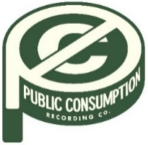
SYDNEY ROSE SHARES NEW EP
THIS KIND OF THING DOESN’T LAST

“TOO FAST” OFFICIAL VIDEO STREAMING NOW

Download Press Assets HERE
NOVEMBER 11, 2022 – 19-year-old singer/songwriter Sydney Rose has debuted her new EP This Kind Of Thing Doesn’t Last. On the five-track collection written solely by Rose, the Georgia-native opens up about growing up, friendship, mental health, and longing, with songs unfolding like a handwritten diary. The release also arrives alongside a self-directed official music video for focus track “Too Fast,” which is streaming now on Sydney Rose’s official YouTube channel. This Kind Of Thing Doesn’t Last is available on all streaming platforms now via Public Consumption.
The EP was heralded by singles “Charlie,” and “Bedroom Floor,” a heartfelt ballad about the pain of a loved one going off to college without you (full tracklisting below). Opening with sparse piano, “Charlie” builds to a stunning crescendo as Rose encapsulates her anxiety with the repeated refrain, “I feel like I’m getting bad again.” Last week, Rose shared a cover of “Silent Night,” as part of A Very Cozy Christmas – an all-women curated and created holiday album out now via Elektra Entertainment.
In September, Sydney wrapped up dates supporting Addison Grace’s U.S. tour. Over the summer, the artist shared her debut EP You Never Met Me, out now via Public Consumption. The project included previously released singles “Phoebe Told Me,” “Things That Don’t Exist (feat. Zachary Knowles),” and “I’ll Never Get Over It” and arrived to critical acclaim, with PEOPLE Magazine naming her one of their Emerging Artists To Watch and Under The Radar attesting, “‘You Never Met Me’ is the sound of Rose finding herself in her music and introducing herself to the world, tracing all of the messy contours of teenage heartbreak in the process.” Amplify Her Voice also praised the effort, stating “Rose re-discovers different parts of herself on her own, presenting her real self through a delicately honest six-song collection.”
Sydney Rose initially gained traction via her intimate YouTube channel covers as well as TikTok, where she has amassed over 200k followers on the platform. Her rendition of Sleeping At Last’s “Turning Page” has accumulated over 35 million streams.
(Tracklisting/EP Art Below)

SYDNEY ROSE
This Kind Of Thing Doesn’t Last EP
AVAILABLE NOW
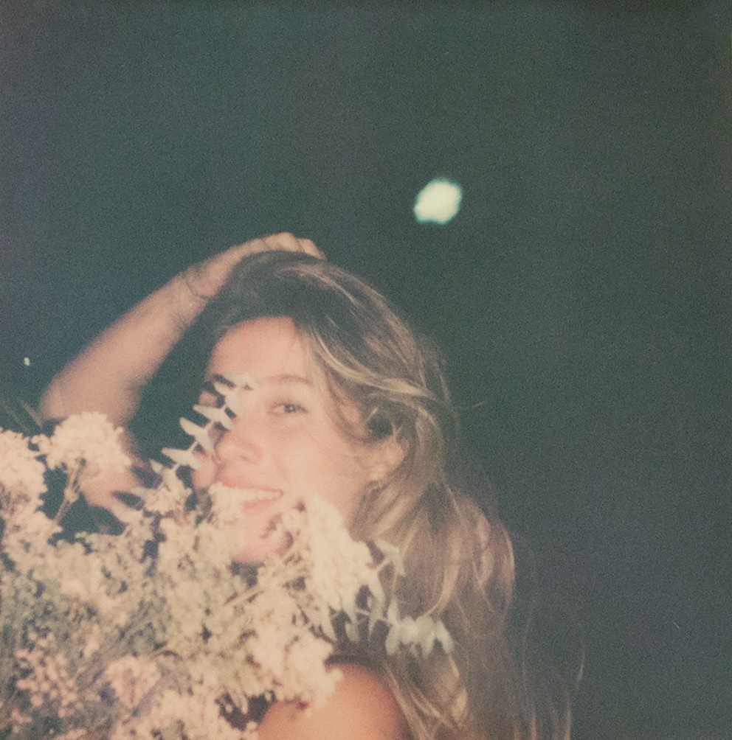
Tracklisting:
- Too Fast
- Bedroom Floor
- If I Were a Dog
- Less than Lovers
- Charlie

CONNECT WITH Sydney Rose
TIKTOK
YOUTUBE
INSTAGRAM

CONTACT:
Sarah Goldstein
SarahGoldstein@elektra.com

