SYDNEY ROSE DEBUTS NEW SINGLE “TELL HIM I MISS HIM”
LISTEN HERE

Download Press Assets HERE
JANUARY 20, 2023 – 19-year-old singer/songwriter Sydney Rose has debuted new single “Tell Him I Miss Him.” The wistful track opens with sparse guitar, while its moving refrain “I miss the kid you used to be” lends itself to many interpretations. “Tell Him I Miss Him” is streaming on all platforms now via Public Consumption.
Sydney expanded on the song, “‘Tell Him I Miss Him’ was initially written from the perspective of a fictional character who has had a best friend all his life, but over time the friend changed in ways he couldn’t control. The song can be about a parent, loved one, or friend. People grow and change constantly and sometimes all you can do is sit and watch. You wish for things to be as easy as they were when you were younger.”
Sydney shared her latest EP This Kind Of Thing Doesn’t Last in November. On the five-track collection written solely by Rose, the Georgia-native opened up about growing up, friendship, mental health, and longing, with songs unfolding like a handwritten diary. The release arrived alongside a self-directed official music video for focus track “Too Fast.” This Kind Of Thing Doesn’t Last is available on all streaming platforms now via Public Consumption.
The EP was heralded by singles “Charlie,” and “Bedroom Floor,” a heartfelt ballad about the pain of a loved one going off to college without you (full tracklisting below). “Charlie” builds to a stunning crescendo as Rose encapsulates her anxiety with the repeated refrain, “I feel like I’m getting bad again.” In the fall, Rose shared a cover of “Silent Night,” as part of A Very Cozy Christmas – an all-women curated and created holiday album out now via Elektra Entertainment.
In September, Sydney wrapped up dates supporting Addison Grace’s U.S. tour. Over the summer, the artist shared her debut EP You Never Met Me, out now via Public Consumption. The project included previously released singles “Phoebe Told Me,” “Things That Don’t Exist (feat. Zachary Knowles),” and “I’ll Never Get Over It” and arrived to critical acclaim, with PEOPLE Magazine naming her one of their Emerging Artists To Watch and Under The Radar attesting, “‘You Never Met Me’ is the sound of Rose finding herself in her music and introducing herself to the world, tracing all of the messy contours of teenage heartbreak in the process.” Amplify Her Voice also praised the effort, stating “Rose re-discovers different parts of herself on her own, presenting her real self through a delicately honest six-song collection.”
Sydney Rose initially gained traction via her intimate YouTube channel covers as well as TikTok, where she has amassed over 200k followers on the platform. Her rendition of Sleeping At Last’s “Turning Page” has accumulated over 45 million streams.
(Single Art Below)

SYDNEY ROSE
“Tell Him I Miss Him”
AVAILABLE NOW
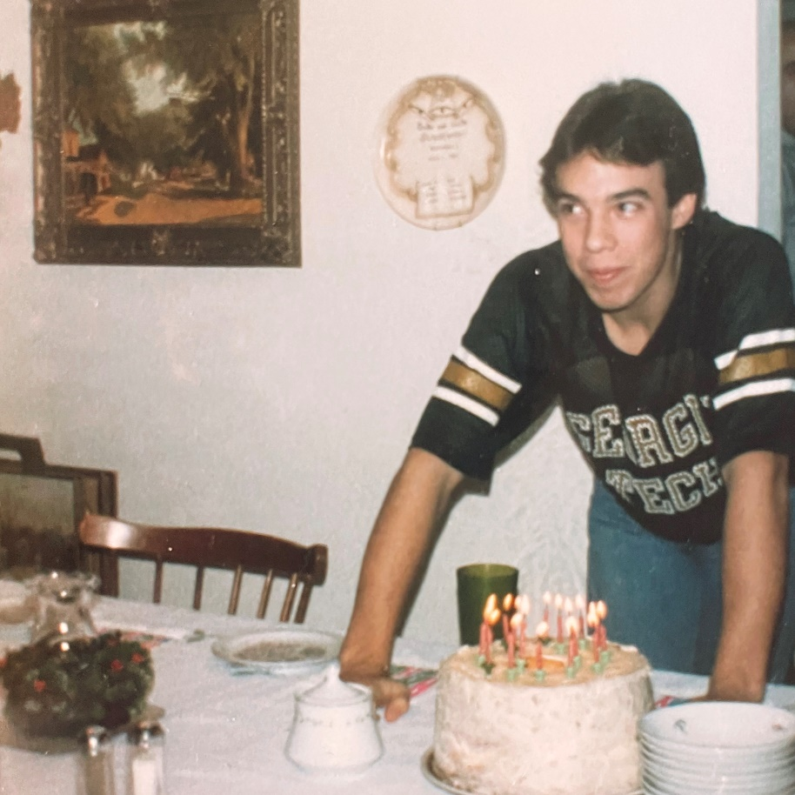

CONNECT WITH Sydney Rose
TIKTOK
YOUTUBE
INSTAGRAM

CONTACT:
Sarah Goldstein
SarahGoldstein@elektra.com

