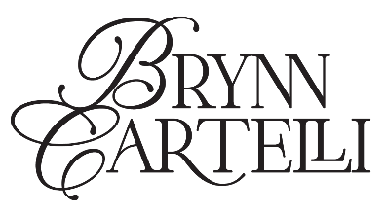
BRYNN CARTELLI RELEASES HEARTBREAKING, YET EMPOWERING NEW SINGLE “SECONDHAND SMOKE”
LISTEN HERE | WATCH THE VISUALIZER HERE
PERFORMING “SECONDHAND SMOKE” ON THE KELLY CLARKSON SHOW TODAY!
CARTELLI’S NEXT FULL-LENGTH PROJECT WILL BE ANNOUNCED VERY SOON…
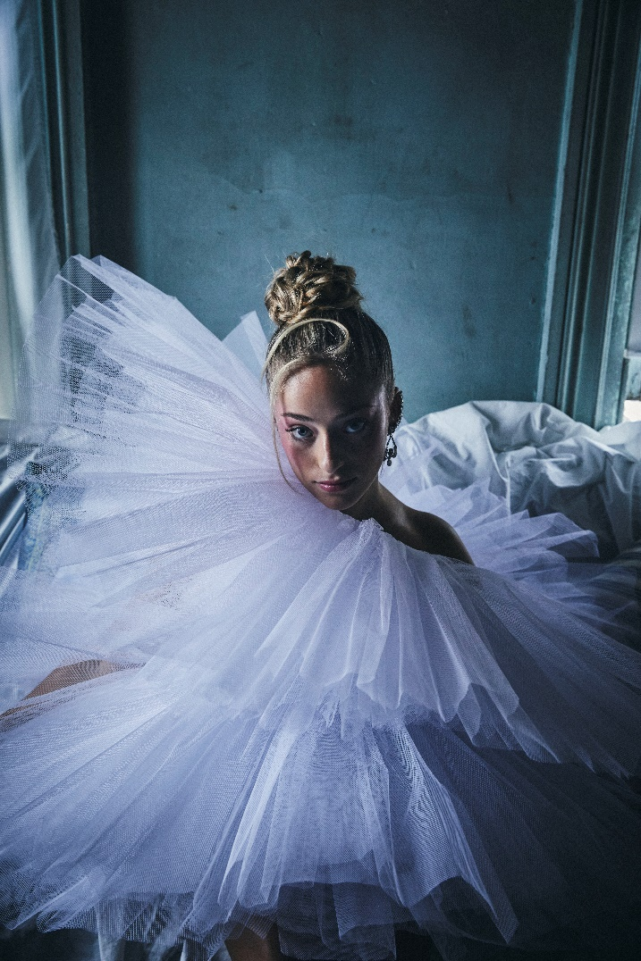
DOWNLOAD HI-RES PRESS IMAGE HERE
(CREDIT: JIMMY FONTAINE)
“ethereal… floaty vocals” –V MAGAZINE
“…with a maturity far beyond her years” –PEOPLE
“…marvelous debut” –AMERICAN SONGWRITER
“Cartelli’s voice is wildly impressive” –THE WASHINGTON POST
“… radiates both youthfulness and maturity.” –LA MAGAZINE
(February 23, 2023) – LOS ANGELES, CA – Acclaimed 19-year-old singer-songwriter Brynn Cartelli today released her poignant new single “Secondhand Smoke.” A heartbreaking, yet empowering track about finding freedom from a toxic situation, the effort highlights Cartelli’s mature songcraft and knack at penning emotive, high-impact pop music. After teasing the song on TikTok for months leading up to its release, “Secondhand Smoke” has already become a favorite among fans, with non-stop pleas for Cartelli to share the full offering. The single is available now on all streaming platforms, paired with an accompanying visualizer. An official music for “Secondhand Smoke” will also be ready for fans to watch very soon.
Cartelli commented, “I wrote ‘Secondhand Smoke’ during a challenging time in my life where I was trying to escape a certain situation; I was feeling anxious since I hadn’t moved past that period yet. The song came about in anticipation for the hopeful future of freedom I knew was coming next. I hope listeners feel free from a painful relationship or place when they hear this song.”
In celebration of “Secondhand Smoke,” Cartelli will also be performing the track on The Kelly Clarkson Show today (local listings HERE).
Cartelli recently wrapped a slew of tour dates at the top of the year supporting Adam Melchor in New York and Boston, along with an intimate headline show in Los Angeles last week at the Hotel Café. This adds to the musician’s already-notable touring history, where she’s shared stages with Kelly Clarkson, OneRepublic, Maroon 5, and labelmate Jake Scott.
Following the release of her striking 2021 debut EP Based on a True Story, Cartelli shared a trio of standout singles last year – “Gemini,” “Girl Code,” and “Convertible in the Rain” – underscoring her remarkable vocal range that impressed viewers nationwide when she was crowned the winner of Season 14 of NBC’s The Voice. Cartelli emerged as the youngest champion in the show’s history, and still holds this title to date. Along with garnering a subsequent nomination at the People’s Choice Awards, Cartelli captivated audiences with performances on the TODAY Show, Macy’s Thanksgiving Day Parade, The Kelly Clarkson Show, and more.
Cartelli is currently in the studio working on new original music for her next project. More details will be revealed very soon…

BRYNN CARTELLI
“SECONDHAND SMOKE”
AVAILABLE HERE
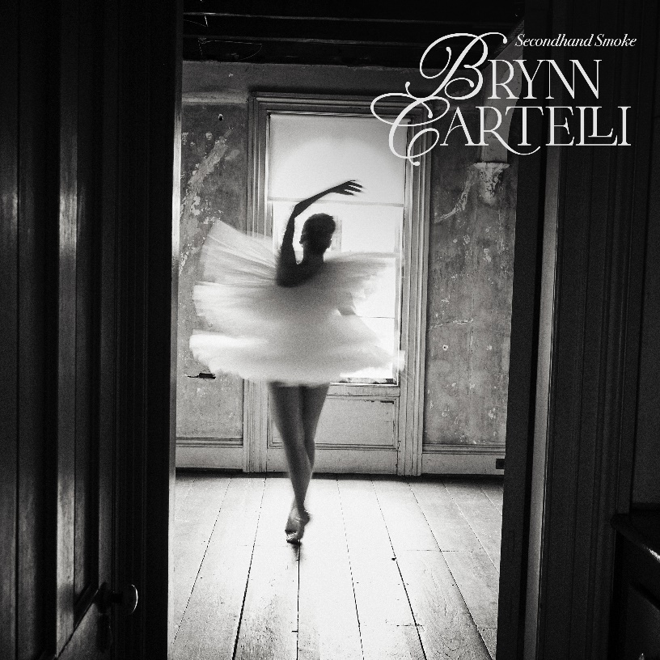
DOWNLOAD HI-RES ARTWORK HERE
CONNECT WITH BRYNN CARTELLI:
Website | Facebook | Twitter | Instagram | TikTok | YouTube
# # #
For more information on Brynn Cartelli, please contact:
Glenn Fukushima, Nathalie Rubin, & Sydney Worden
Glenn.Fukushima@300Elektra.com | Nathalie.Rubin@300Elektra.com |
Sydney.Worden@300Elektra.com

