Brittney Spencer Announces Signing + Releases First EP With Elektra
‘if i ever get there: a day at blackbird studio’
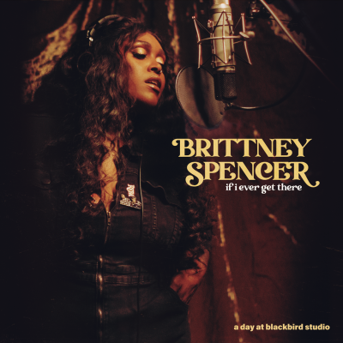
﻿EP AVAILABLE NOW
Today (11.4) “Nashville’s new star” (CBS This Morning) Brittney Spencer announces her signing with Elektra. A People Magazine “Hollywood One to Watch" and CMT Award nominee, Spencer shares her if i ever get there: a day at blackbird studio EP. Her debut release with Elektra, the project is a taste of what’s to come and a gift to her fans as she records her full-length debut album. Read more via Billboard HERE.
“Last month, I spent a day at Blackbird Studio recording a live EP,” Spencer shared on socials. “These three songs are some of my favorites to perform live, and they reflect a lot of where my head and heart have been lately – a little sad girl fall, a little gleeful nostalgia. I’ve been touring with some of my absolute heroes, getting to partner with brands I love like Victoria’s Secret (like, what?!), and just being a person feeling my way through my ever-changing, stupid life. Still, writing and creating music has been my honest guide, my emotional safety and my best companion this year, my album is close to finished now! In the meantime, I hope you enjoy this musical timestamp my friends and I made at Blackbird.”
The three-track EP – recorded live from Blackbird Studio in Nashville, TN and produced by Daniel Tashian (Kacey Musgraves, Little Big Town, Brett Eldredge) – showcases Brittney’s stellar ability to draw in an audience from her first breath to the last note. The project’s lead single – a cover of The Chick’s “cowboy take me away” – has become a staple at Spencer’s electric live shows, paying tribute to her musical heroes in a beautiful reimagining of the iconic track. The collection also boasts two standout original tracks, the coy breakup ballad “better as friends,” penned by Spencer and country artist Hailey Whitters (Alan Jackson, Brandi Carlile), and the heart-wrenching “a hundred years,” which she co-wrote alongside Ashley Ray (Little Big Town, Lori McKenna) and Sean McConnell (Brothers Osbourne, Rascal Flatts).
Alongside the EP, Spencer shares the official studio performance video of “cowboy take me away.”
Listen to ‘if i ever get there’
Listen to “cowboy take me away”
“We were instantly moved by Brittney’s astounding talent and infectious spirit as soon as we met her,” shares Breanna Duncan, Senior Manager of A&R, Elektra. “She has a natural ability to connect with listeners with her brilliant vocal delivery and her gift at capturing emotions through her songwriting is just remarkable. Brittney Spencer is an absolute gem in the music scene and we couldn’t be more excited that she has chosen Elektra as her label home”.
“Brittney Spencer is a very special artist, songwriter and person. We are honored that she has put her trust in the Activist team to manage her quickly developing career” says Matt Maher, Founding Partner of Activist Artists Management.
Activist Partner Caitlin Stone adds, “We are excited for Brittney to begin releasing music and are thrilled for Elektra Records to be her label home. She is so incredibly talented, which is more than evident on this EP, and we can’t wait for her full-length debut album.”
The announcement follows a monumental year for Spencer, who was recently unveiled as one of the faces of Victoria’s Secret’s ‘Undefineable’ global campaign alongside Bella Hadid, Hailey Bieber, Bethann Hardison, Rose Namajunas, and more. All ahead of her debut album, Spencer has made a splash with performances at the 148th Kentucky Derby (where she sang a beautiful rendition of the national anthem), Baltimore’s Preakness Festival, and the Academy of Country Music (ACM) Awards, where she sang a riveting rendition of “These Boots Are Made For Walking” with Brothers Osborne. She has also opened for the likes of Maren Morris, Reba McEntire, Brandi Carlile, Megan Thee Stallion, Willie Nelson, and Nathaniel Rateliff in the UK and Europe.
The Baltimore native released her breakout single “Sober & Skinny” independently in 2021, which garnered more than 2M streams and earned praise from The New York Times, Rolling Stone, CBS Mornings and more.
Spencer is represented by Elektra, Activist Artists Management, UTA, and Shore Fire Media.
'if i ever get there: a day at blackbird studio' Track List:
- a hundred years old (Brittney Spencer, Ashley Ray, Sean McConnell)
- better as friends (Brittney Spencer, Hailey Whitters)
- cowboy take me away (Marcus Hummon, Martha Seidel Maguire)

Digital Press Kit:
https://shorefire.com/roster/brittney-spencer

Management:
Matt Maher | Activist Artists Management | maher@activist.co
Caitlin Stone Jasper | Activist Artists Management | caitlin@activist.co

Press Contacts:
Jaclyn D. Carter | Shore Fire Media | jcarter@shorefire.com
Andrea Evenson | Shore Fire Media | aevenson@shorefire.com
Maria Eilert | Shore Fire Media | meilert@shorefire.com
Glenn Fukushima | Elektra | GlennFukushima@elektra.com

Booking Agent:
Jeffrey Hasson | UTA | jeffrey.hasson@unitedtalent.com

